Xojo TELNET Class

User Documentation

Documentation v1.02



Author: Mike Cotrone

Table of Contents

I. Project Information 3

II. Document Version History 4

III. Project Purpose (Please Read) 5

What this Project IS 5

What this Project ISNT 5

IV. Quick Start Setup 6

Download Project, Copy folders, and Enable GDI 6

Create instantiation of Options and DateTimeWindow 7

IV. Project Option Definitions 10

General Options 10

Clock / Time Options 10

Calendar Options 12

V. How Do I Get the User Selected Results? 14

Calendar Date(s) Selection 14

Calendar Recurring Selection Type 15

User Time Selection 16

VI. How Do I Use the “SelectedTime” Custom Event? 17

SelectedTime Parameters 17

Example Code 17

VII. How Do I Close This Chooser Now That It’s Open? 18

Resizing the DateTimeWindow 18

Resizing the Date_Time_Container 19

Change Setup Methods 19

Add a new PushButton 21

VIII. Appendix: OOP Structure 22

# Project Information

|  |  |
| --- | --- |
| Development Model: | Open Source |
| Version Control Repository: | GitHub |
| Repository Type: | Public |
| Link to Repository: | https://github.com/mikecotrone/TELNET_Class_Xojo |
| Project File Format: | “Xojo Binary” (.xojo_binary_project) |
| License: | [BSD-3 Clause](http://opensource.org/licenses/BSD-3-Clause) |
| Affiliation: | This project is authored and maintained by Intelligent Visibility, Inc. |
| Author: | Mike Cotrone |
| Code Contributors: | Mike Cotrone |
| Doc Contributors | Mike Cotrone |

# Document Version History

|  |  |  |
| --- | --- | --- |
| Version 1.0.1 | March 10, 2013 | Initial basic documentation on Github |
| Version 1.0.2 | June 9, 2014 | Created a Formal TELNET Class Usage Document |
|  |  |  |
|  |  |  |
|  |  |  |
|  |  |  |

# Project Purpose (Please Read)

The purpose of this project was to create a TELNET implementation for the Xojo Coding language. The goal was to implement ONLY the currently useful TELNET RFC implementations into this project.

## What this Project IS:

This project contains TWO Project folders to utilize.

Folder #1: TELNET_ClassOnly

This project contains only the based TELNET class to copy over to your existing Xojo project. The reason for creating this project was to remove the “Demo Project” code as for some it was diluting the main TELNET code.

Folder #2: TELNET_DemoProject

This is a full demo project that incorporates a real life application example with the TELNET class.

# Quick Start Setup

## Download Project, Copy folders, and Enable GDI

1. Download the project at <https://github.com/mikecotrone/CalendarTimeChooser> by clicking the “Download ZIP” button on the bottom right hand side of the page
2. Open “CalendarTimeChooser.xojo_project” with the Xojo IDE
3. Copy all Folders that begin with “1 – 5” to your destination project (*Note: You probably do not want the “Demo Window” folder for your destination project*)

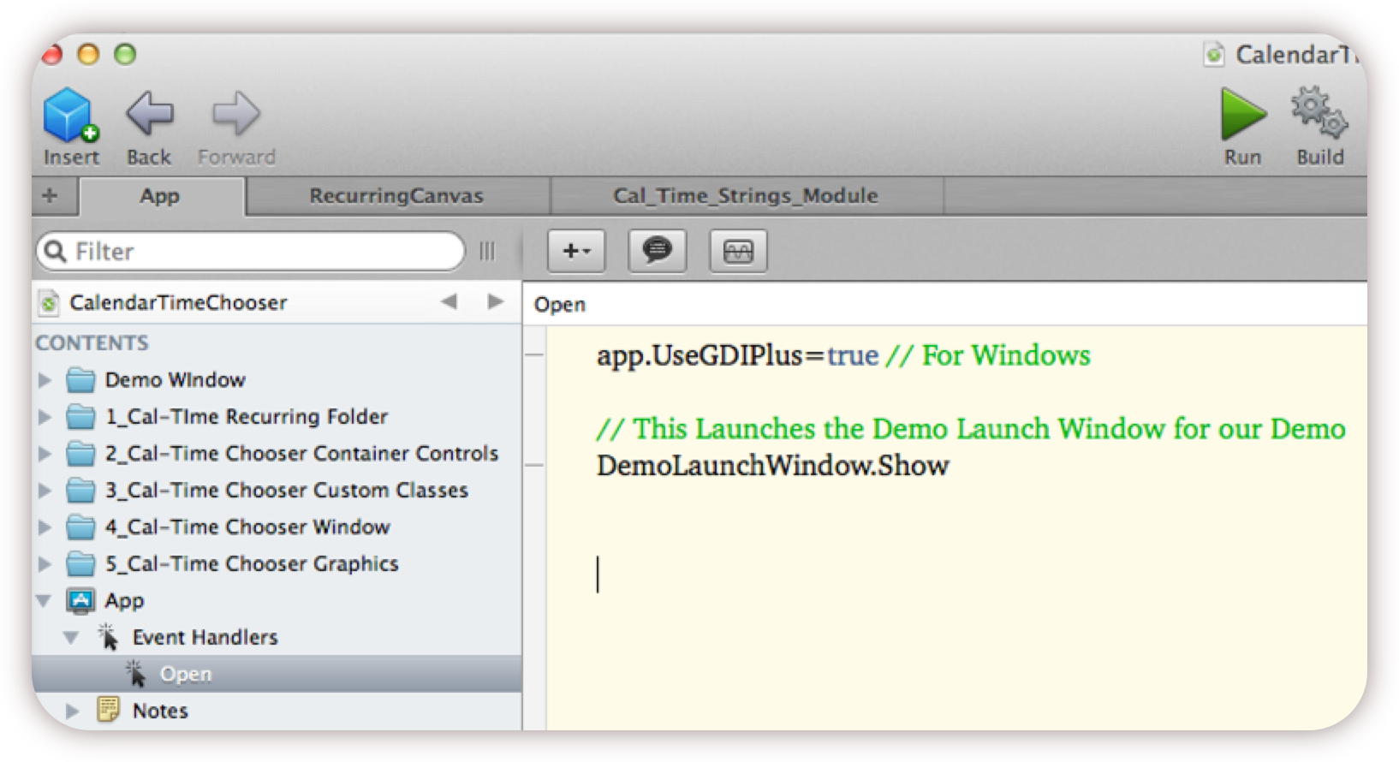

Figure 1. Depicts the six (6) folders that comprise the “Calendar and Time Chooser” project

1. Enable “GDI Plus” in your destination project (*for example: copy “app.UseGDIPlus=True” to your destination project app.open event*)

## Create instantiation of Options and DateTimeWindow

There are many ways to accomplish this step, but for this quick start example I will use a “PushButton” control that will be responsible for instantiating the “DateTimeWindow” and its options.

1. From the Xojo IDE drag a new “Class” to your project

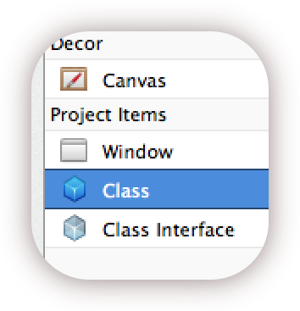

1. Name your new class “QS_PushButton”
2. Change it’s super class to “PushButton”

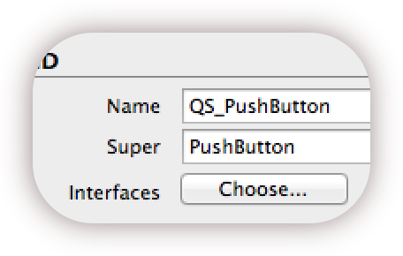

1. Add a new “Property” to the “QS_PushButton” and name it “CalTimeChooser”

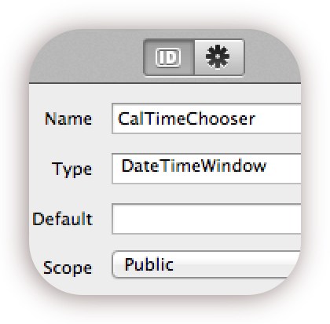

1. Change the “CalTimeChooser” property type to: DateTimeWindow
2. Add a method named “mSetOptions” to the “QS_PushButton”

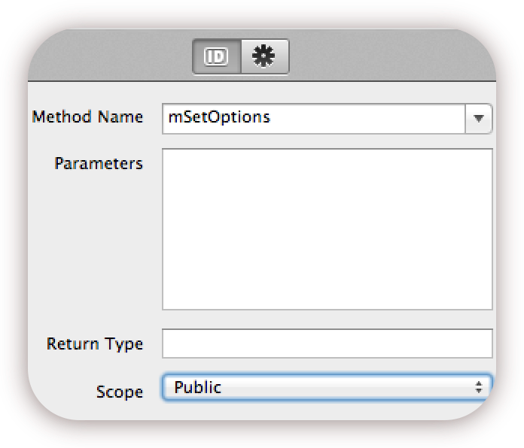

1. Add the following Code to the “mSetOptions” Method based on how you want this tool to behave in your project. (Detailed explanation of each option can be found on page 9)

// Chooser Type:

CalTimeChooser.VisiblePickers=Date_Time_Container.PickerElements.CalendarAndClock

// Chooser Window Back Color

CalTimeChooser.Date_Time_Container1.BackColor = RGB(239,239,239)

// Chooser Time Format

CalTimeChooser.Date_Time_Container1.Time_Container1.TimeMode = 12

// Chooser Clock Face Type

CalTimeChooser.ClockFaceType = Date_Time_Container.ClockFaceType.Chrome

// Chooser Clock Hands Type

CalTimeChooser.UseGraphicalClockHands=True

// Chooser Week Start

CalTimeChooser.WeekStartsOnMonday = False

// Chooser Calendar to include previous/next days on calendar

CalTimeChooser.IncludePrevNextMonthDays = True

// Calendar Localization

CalTimeChooser.LocalizationInt = 0 // 0-English

// Allow User to Select Multiple Calendar Days

CalTimeChooser.AllowMultipleCalendarSelections = False

// Calendar Start Year:: This date integer is your calendar's start date

CalTimeChooser.Date_Time_Container1.Calendar_Container1.Calendar1.StartYear = 1975

CalTimeChooser.Date_Time_Container1.Calendar_Container1.Calendar1.EndYear = 2052

# Appendix: OOP Structure

The following illustration is a depiction of the object-oriented relationships between the windows, containers, and canvas classes.

