Final Portfolio Project - Assignment

Student Identifying Information
Name: Adam Jacobs
Course: CSC500
Module: 8
Date: 10/11/2026

Python Source Code Files Submitted Separately as its Own Attachment in Assignment Portal
Final_project.py and to git
Pseudocode:
Start
Phase 1: Class Structures
ItemToPurchase Class is defined with four attributes that allow items to be created and added to a shopping cart at later time. It stores item information starting at zero and none to be manipulated later and allows for the price and quantity of items to be calculated and displays items total cost perfectly formatted as described. Example: Bottled Water 10 @ $1.00 = $10.00
Attributes:
- Item_name to none - string
- Item_price to 0.0 - float
- Item_quantity to 0 - int
- Item_description to none - string
Key Methods :
- print_item_cost - Item name quantity @ price = item cost
- Multiplying price times quantity
ShoppingCart class is defined with three attributes that allow a customer to hold multiple items, store customer information and allows customers the ability to do the following methods using information stored in the shopping cart and stored data in the ItemToPurchase class.
Attributes:
- customer_name to none - string
- current_date to January 1, 2020 - string
- cart_items - [] list
Key Methods:
- add_item(): that adds an item to a shopping cart
- remove_item(): that removes an item from the shopping cart, else displays Item not found.
- modify_item(): that modifies price or quantity of an existing item in the shopping cart, else displays Nothing modified.
- get_num_items(): Returns the total quantity of all items in shopping cart.
- get_cost_of_cart(): Total cost of all items in the cart
- print_total(): Displays the shopping cart with customer name, date, total number of items, individual item costs, item descriptions and total cost. Else if cart is empty displays shopping cart is empty.
- print_descriptions()prints customers name date and items description
Phase 2: Final Features - User interface
Interactive menu While loop that guides the customer to enter their information and use all the shopping cart methods above. Like adding a new item, changing its quantity, get a running total of items, cost and a total shopping cart view formatted as described.
Customer Journey:
- Enter your name:
- Enters today's date:
- Display interactive menu
- Type a letter to choose an option:
- Adding an item enter the item name, price, quantity, description
- Removing an item just enter the items name
- Modifying a quantity enter the item name and updated new quantity
- Items Descriptions are all items descriptions in cart listed
- Shopping Cart displays customers complete shopping cart, the method to display the shopping cart is the print total cost method. If shopping cart is empty it displays Shopping cart empty.
- While loop continues till customer types q for quit in the interactive menu.

Phase 3: The interactive Menu
#print_menu that allows the user to interact with their cart via the console in the following methods described above
- Display ("MENU")
- Display ("a - Add item")
- Display ("r - Remove item")
- Display ("c - Change quantity")
- Display ("i - Items Descriptions")
- Display ("o - Shopping cart")
- Display ("q - Quit")

****More details on specific logic break down for each method commented within the code before each method! Explanation of for loops and while loops. Including if/else and if/elif statments

Screenshots of code and terminal output below:
Next Page
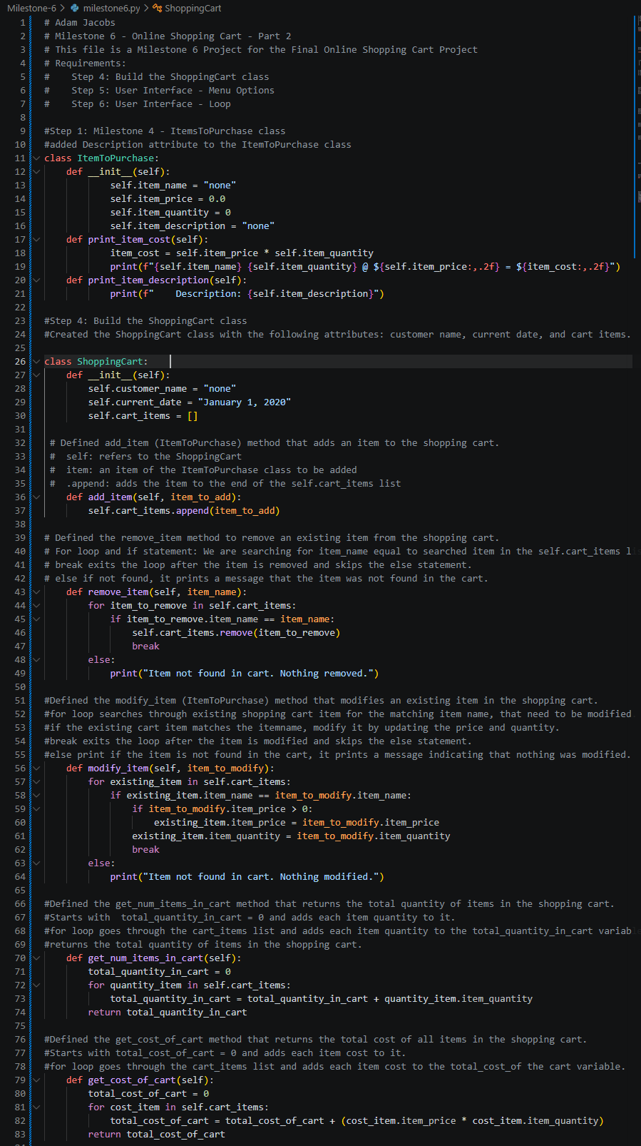
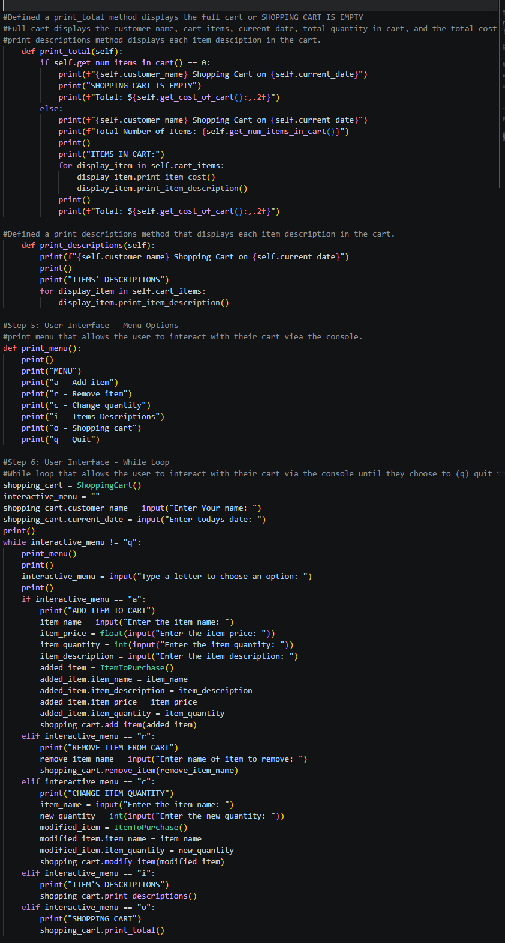
Output Shopping Cart
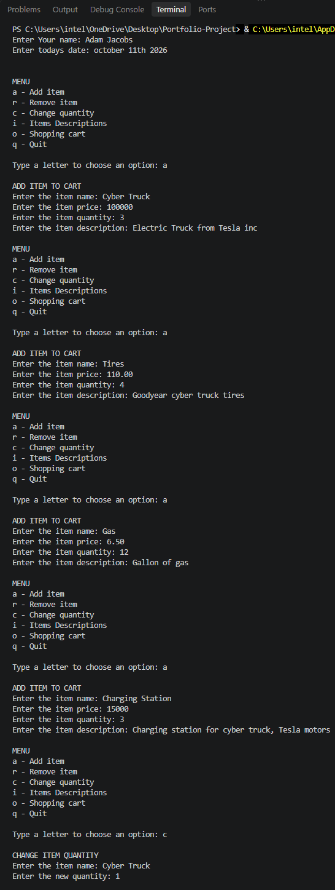Continued to next page
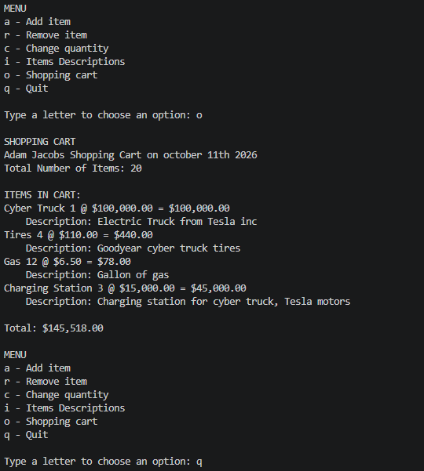

References
zyBooks. (2024). CSC500: Principles of Programming [interactive textbook] Section 1.5. Wiley

