Module 2 Portfolio Milestone - Assignment

Student Identifying Information
Name: Adam Jacobs
Course: CSC500
Module: 2
Date: 9/13/2026

Python Source Code Files Submitted Separately as its Own Attachment in Assignment Portal
Milestone2.py and products.py
Screenshots of code and terminal output below:
Next Page
Notes: I created a products.py and imported products to the milestone2.py file. I didn’t create a dictionary as it wasn’t asked and figured that was beyond the scope of this milestone project. I imagine I will for the final project. Also, I didn’t use if or else to stop a user from adding product names or prices that Aarnt on the product list as I thought it was beyond the scope of this milestone project. Strictly just followed what rubric and instructions wanted me to create and would of built these additional features. Most likely do that for the final project submission. I created the files in git bash which I thought was cool. Though I didn’t put it to git.
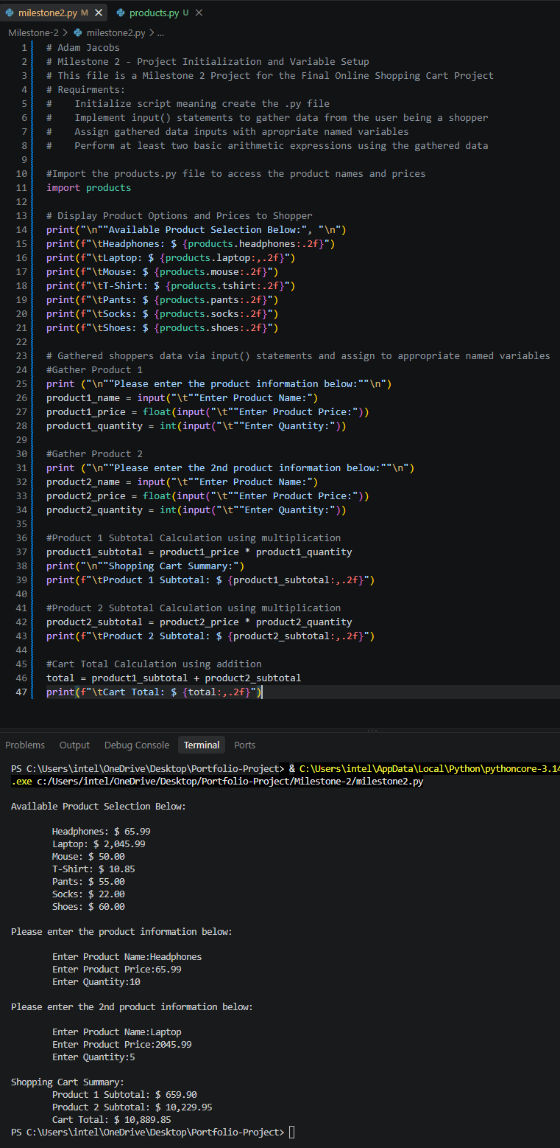
References
zyBooks. (2024). CSC500: Principles of Programming [interactive textbook] Section 1.5. Wiley

