Module 4 Portfolio Milestone - Assignment

Student Identifying Information
Name: Adam Jacobs
Course: CSC500
Module: 4
Date: 9/27/2026

Python Source Code Files Submitted Separately as its Own Attachment in Assignment Portal
Milestone4.py
Pseudocode:
- #Step 1: Build the ItemsToPurchase class
- # Create the ItemToPurchase class with the following attributes: item name, price, and quantity.
- # Created print_item_cost that prints the item name, quantity, price, and total cost of the item
- #Step 2: Main Program Implementation
- # Create a main function that prompts the user to enter 2 item name, price, and quantity
- # Create 2 objects created from user input and stored in the ItemToPurchase class
- #Step 3: Output the Total Cost
- #Creating output of the total cost of the items in the given format
Screenshots of code and terminal output below:
Next Page
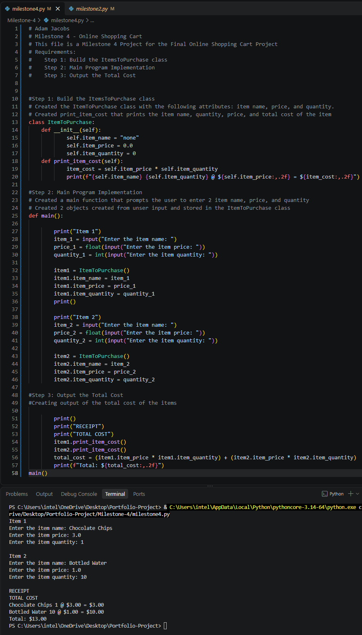
References
zyBooks. (2024). CSC500: Principles of Programming [interactive textbook] Section 1.5. Wiley

