Module 6 Portfolio Milestone - Assignment

Student Identifying Information
Name: Adam Jacobs
Course: CSC500
Module: 6
Date: 10/9/2026

Python Source Code Files Submitted Separately as its Own Attachment in Assignment Portal
Milestone6.py
Pseudocode:
START
Requirements:
Step 4: Build the ShoppingCart class
Step 5: User Interface - Menu Options
Step 6: User Interface – Loop
Step 4: Build the ShoppingCart class
Create the ShoppingCart class with the following attributes: customer name, current date, and cart items.
Define add_item (ItemToPurchase) method that adds an item to the shopping cart.
.append: adds the item to the end of the self.cart_items list
Define the remove_item method to remove an existing item from the shopping cart.
For loop and if statement: We are searching for item_name equal to searched item in the self.cart_items list.
break exits the loop after the item is removed and skips the else statement.
else if not found, it prints a message that the item was not found in the cart.
Define the modify_item (ItemToPurchase) method that modifies an existing item in the shopping cart.
for loop searches through existing shopping cart item for the matching item name, that need to be modified.
if the existing cart item matches the item name, modify it by updating the price and quantity.
break exits the loop after the item is modified and skips the else statement.
else print if the item is not found in the cart, it prints a message indicating that nothing was modified.

Define the get_num_items_in_cart method that returns the total quantity of items in the shopping cart.
Starts with total_quantity_in_cart = 0 and adds each item quantity to it.
for loop goes through the cart_items list and adds each item quantity to the total_quantity_in_cart variable.
returns the total quantity of items in the shopping cart.
Define the get_num_items_in_cart method that returns the total quantity of items in the shopping cart.
Starts with total_quantity_in_cart = 0 and adds each item quantity to it.
for loop goes through the cart_items list and adds each item quantity to the total_quantity_in_cart variable.
returns the total quantity of items in the shopping cart.
Define the get_cost_of_cart method that returns the total cost of all items in the shopping cart.
Starts with total_cost_of_cart = 0 and adds each item cost to it.
for loop goes through the cart_items list and adds each item cost to the total_cost_of the cart variable.
Define a print_total method displays the full cart or SHOPPING CART IS EMPTY
Full cart displays the customer name, cart items, current date, total quantity in cart, and the total cost of all items in the cart.
print_descriptions method displays each item description in the cart.
Define a print_descriptions method that displays each item description in the cart.
Step 5: User Interface - Menu Options
print_menu that allows the user to interact with their cart via the console.
Step 6: User Interface - While Loop
While loop that allows the user to interact with their cart via the console until they choose to (q) quit
END

Screenshots of code and terminal output below:
Next Page
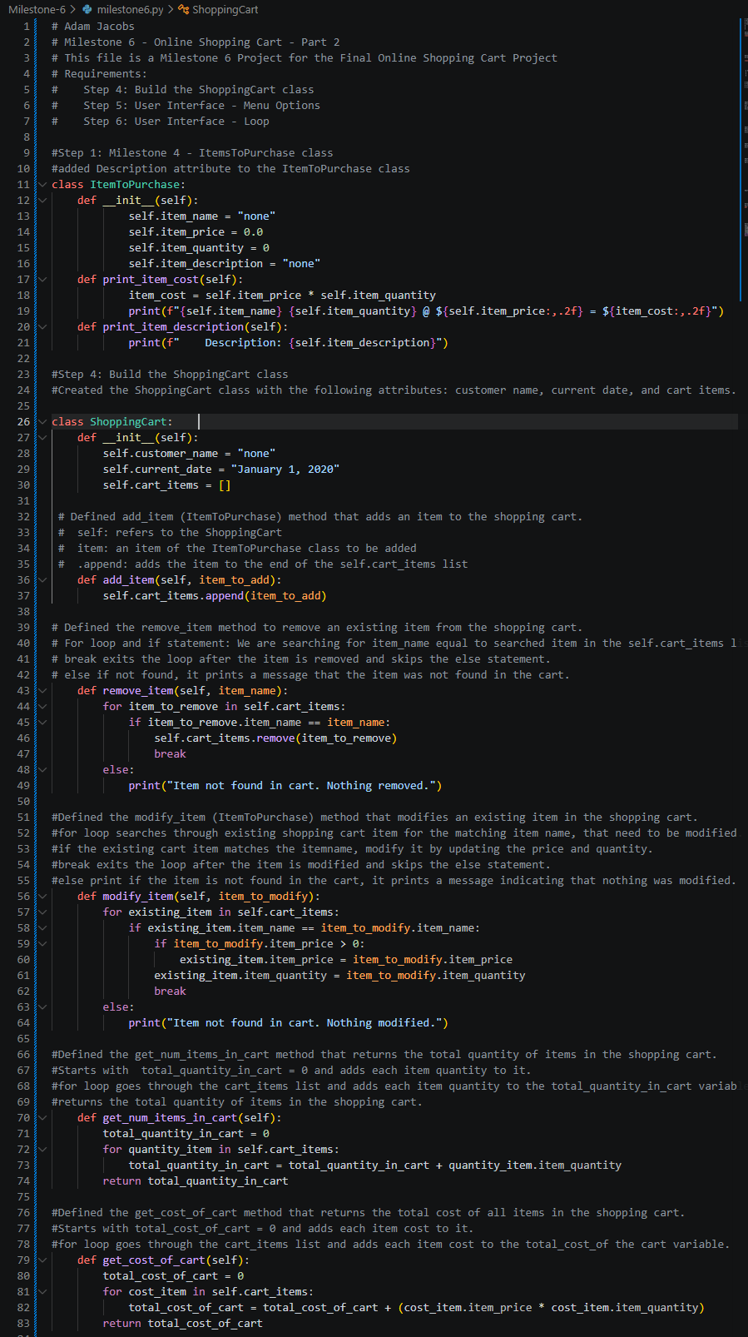
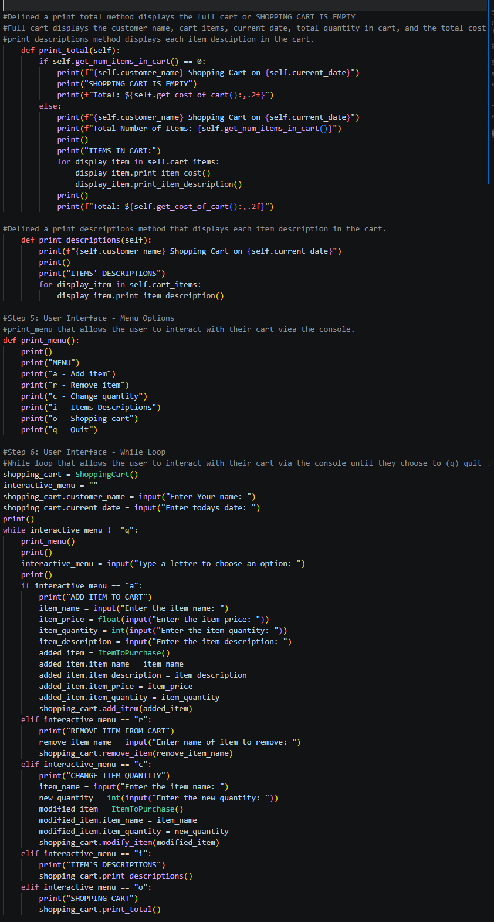
Output Shopping Cart
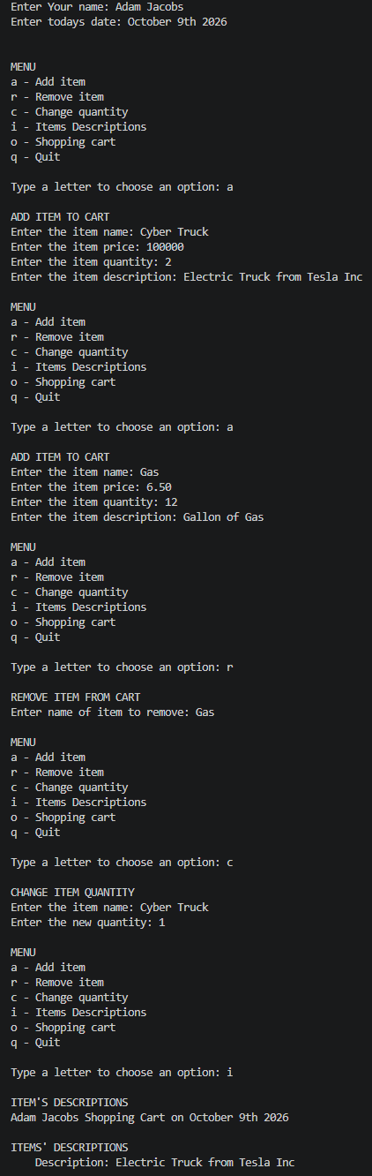Continued to next page
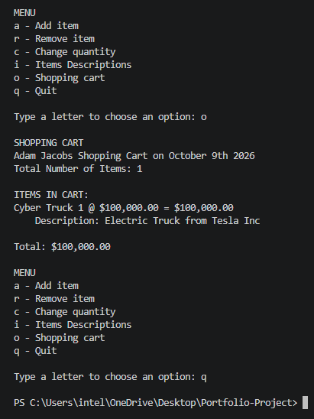

References
zyBooks. (2024). CSC500: Principles of Programming [interactive textbook] Section 1.5. Wiley

