**ACTION PLAN**

|  |  |
| --- | --- |
|  |  |
| **Project Title** | Disaster Crisis Mapping |
| **Project Leader** | Gianna Marie Lanete, Philippines |
| **Project Members** | Gianna Marie Lanete, Philippines  Alberry Jed Rivera, Philippines |
|  |  |
|  |  |
| **Target Partners** | Gawad Kalinga  Various Media Outlets  Universities and Colleges in South-East Asia |
|  | Various Media Outlets  Various Environmental NGOs  Local Barangays  PAGASA |
| **Partner LGUs** | None |
|  |  |
|  |  |
|  | |

# Project Description

The Project aims to plot all the flood prone locations, evacuation centers and hospitals using the customize google map.

Characterization of Disaster Crisis Mapping:

The customize map will be map out by those volunteers who are knowledgeable about their specified places.

Each layers of locations has its own unique color for us to easily identify the locations.

Red – Flood Locations

Green – Hospitals

Brown – Evacuation Centers

Volunteers will only send their emails to me for them to be able to edit the Disaster Map.

# Objectives

* This project aims and gives us specific information for us to be prepare in upcoming natural calamities.
* Reduce the number of deaths that cause by these natural calamities like floods, typhoon, and storm surge.
* It helps us improvise the areas from the past calamities.

# Expected Output

The Proposal is expected to create the following changes in the community which would benefit not only the participants but also the environmental movement as well.

**Improvise the areas that have been affected by the past calamities –** This will help us improvise the problem of the community like the drainage system, lack of trees and etc.

**Increased Environmental Awareness** – Volunteers will be exposed to talks and seminars that concern about our community. The gathering will allow them to be more aware of several issues in different locations.

**Unity between local or international governments, colleges and organizations -** volunteers are not just limited locally but also internationally. There will be an interaction between local and international volunteers. As they exchange their ideas in their community, we will become aware globally. It gives them strong connections to the government and organizations.

**ACTUAL OUTPUT OF DISASTER MAPPING**

**Link:** [**https://www.google.com/maps/d/edit?mid=zVzm0h1fijx8.kaVarv7YfN7I**](https://www.google.com/maps/d/edit?mid=zVzm0h1fijx8.kaVarv7YfN7I)

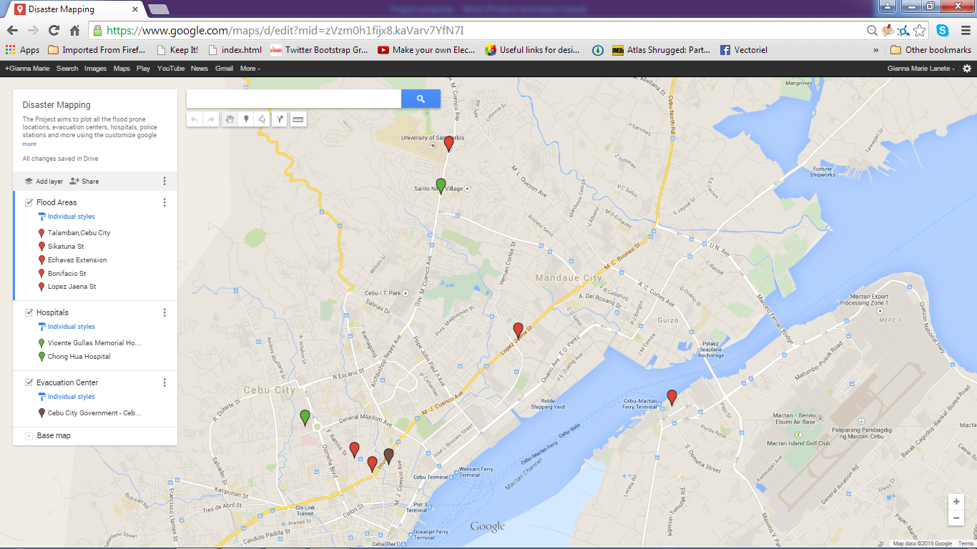

**LEGENDS:**

