


Database Principles
CW

Group 04
CW Group contribution statement

Group 04

 | UP2255832 | UP2287200 | UP2306492
ERD Design
Reflective Analysis
Data Dictionary
Document writing
Brainstorming
SQL Coding
DDT
Percentage Allocation | 33% | 33% | 33%
Signature |  | Robin | 

Contribution Description

UP NUMBER | Description (if not equally counted) | Signature
UP2287200 |  | Robin Hellberg Säkkinen
UP2306492 |  | 
UP2255832 |  | 

- Entity Relationship Diagram (ERD)
A PDF version of the ERD has been attached, as the lovely online word distorts image, even when exporting in the highest resolution.
  - Assumptions

Parts, suppliers, part usage and part transfers
The ‘parts’ table will record basic information about parts. Each part has a category, which makes filtering/organising parts on an application interface easier. It also helds the price the parts are sold for customers.

Each part can be supplied by one or many suppliers. The business may choose a different supplier for the same part, either because of a better price, or another supplier is not supplying anymore. We record unit cost, which the supplier sells it for the business, and also a minimum order quantity, considering that not every supplier might enforce a minimum order quantity.
We also record the suppliers, with optional primary contact – a person who is the primary contact for the business. The purpose of the ‘is_active’ field is to ensure that we do not want to order from suppliers that do not supply anymore.
Parts per branch is also tracked in branch_parts table, to provide a clearer insight how many parts per branch the business have in stock.

We considered the possibility that there might be a need of transferring parts from one branch to another. That transfer should be tracked, therefore we created the part_transfers table, which keeps track of who requested and approved the transfer, and also from which branch to which branch, alongside with transfer status.

Job tracking
Our design supports detailed tracking of jobs and services. Each booking can have multiple services. A service of a booking is assigned to a staff, and to a specific bay. We keep track of when that work started and ended, and its status. It supports the same staff working on the same booking service over a span of multiple days – in case they cannot finish it immediately. For each such job, the part usage is also recorded - so we can keep track who worked on what, when, and what parts they consumed for that job. Each job can also have additional services – services that were not booked, but are necessary because the worker found an issue that needs to be fixed.

Service packages
Apart from single services, there is a possibility to have packages that includes multiple services. Therefore customers can book for a whole package, rather than individual services.

Customer memberships
Customers can have a membership. Each membership has discounts for specific services. Each discount can be either percentage based, for example 10% off of a wind screen repair, or a fixed price, for example £10 off of a wind screen repair. A customer can have only one membership at a time.

Service discounts
Each service can have a fixed amount of discount, within a fixed period. It is recorded in a separate table. This can allow the business to run promotions for specific services.

Separate branch managers table
Even though we have roles, and staff_roles , we decided that creating a separate branch_managers table will allow better tracking of who is the manager of which branch and since when. It also allows to keep track of managers in the past.

Handling customer feedback
An initial feedback belongs to a booking, and written by the customer.
To this, either a staff or a customer can reply to, and further replies can be done to a previous reply, keeping a feedback history (circular reference). The foreign key on feedback_replies for staff or customer can be nullable, and the one who is doing the reply will be filled out.

- Data Dictionary

cities
Attribute_Name | KEY | INDEX | Data Type & Size | Domains  &  Constraints | FK Reference | Description
city_id | PK | Y | SERIAL
city_name |  |  | VARCHAR(50)

suppliers
Attribute_Name | KEY | INDEX | Data Type & Size | Domains  &  Constraints | FK Reference | Description
sup_id | PK | Y | SERIAL
sup_city | FK | Y | INT | NOT NULL | cities.city_id
sup_name |  | Y | VARCHAR(100) | NOT NULL
sup_contact_name |  |  | VARCHAR(60) |  |  | Name of the person who’s the primary contact for the car business
sup_contact_phone |  |  | CHAR(15) |  |  | Phone number of the primary contact
sup_company_phone |  |  | CHAR(15) | NOT NULL |  | The general enquiry phone number of the supplier
sup_address_first |  |  | VARCHAR(100) | NOT NULL
sup_address_second |  |  | VARCHAR(100)
sup_postcode |  | Y | CHAR(8) | NOT NULL
is_active |  |  | BOOL |  |  | Whether it is an active supplier or not (can purchase or not from them)

part_categories
Attribute_Name | KEY | INDEX | Data Type & Size | Domains  &  Constraints | FK Reference | Description
part_cat_id | PK | Y | SERIAL
part_cat_name |  |  | VARCHAR(50) | NOT NULL

parts
Attribute_Name | KEY | INDEX | Data Type & Size | Domains  &  Constraints | FK Reference | Description
part_id | PK | Y | SERIAL
part_cat_id | FK | Y | INT | NOT NULL | part_categories.part_cat_id
part_name |  | Y | VARCHAR(100) | NOT NULL
part_description |  |  | TEXT
part_price |  |  | DECIMAL(10,2) | NOT NULL |  | The unit price the car business sells it for its customers

part_suppliers
Attribute_Name | KEY | INDEX | Data Type & Size | Domains  &  Constraints | FK Reference | Description
sup_id | PK/FK | Y | INT | NOT NULL | suppliers.sup_id
part_id | PK/FK | Y | INT | NOT NULL | parts.part_id
unit_cost |  | Y | DECIMAL(10,2) | NOT NULL |  | The price the supplier sells it for the business
min_order_qty |  |  | SMALLINT | >= 0 |  | At least 1 if present.

packages
Attribute_Name | KEY | INDEX | Data Type & Size | Domains  &  Constraints | FK Reference | Description
pkg_id | PK | Y | SERIAL
pkg_name |  | Y | VARCHAR(200) | NOT NULL
pkg_desc |  |  | TEXT | NOT NULL
is_active |  |  | BOOL | NOT NULL |  | Non-active packages cannot be purchased by customers.

services
Attribute_Name | KEY | INDEX | Data Type & Size | Domains  &  Constraints | FK Reference | Description
service_id | PK | Y | SERIAL
service_name |  | Y | VARCHAR(200) | NOT NULL
service_desc |  |  | TEXT
service_price |  |  | DECIMAL(10,2) | NOT NULL

package_services
Attribute_Name | KEY | INDEX | Data Type & Size | Domains  &  Constraints | FK Reference | Description
pkg_id | PK/FK | Y | INT | NOT NULL | packages.pkg_id
service_id | PK/FK | Y | INT | NOT NULL | services.service_id

service_discounts
Attribute_Name | KEY | INDEX | Data Type & Size | Domains  &  Constraints | FK Reference | Description
disc_id | PK | Y | SERIAL
service_id | FK | Y | INT | NOT NULL | services.service_id
disc_amount |  |  | DECIMAL(6,2) | NOT NULL
disc_from |  | Y | DATE | NOT NULL |  | Valid from
disc_to |  | Y | DATE | NOT NULL |  | Valid to
is_active |  |  | BOOL | NOT NULL

memberships
Attribute_Name | KEY | INDEX | Data Type & Size | Domains  &  Constraints | FK Reference | Description
mship_id | PK | Y | SERIAL
mship_name |  |  | VARCHAR(30) | NOT NULL
mship_description |  |  | TEXT | NOT NULL
mship_price |  | Y | DECIMAL(8,2) | NOT NULL
mship_duration_days |  | Y | SMALLINT | NOT NULL
mship_pay_period |  |  | ENUM | NOT NULL |  | yearly, monthly, weekly

membership_services
Attribute_Name | KEY | INDEX | Data Type & Size | Domains  &  Constraints | FK Reference | Description
mship_id | PK/FK | Y | INT | NOT NULL | memberships.mship_id
service_id | PK/FK | Y | INT | NOT NULL | services.service_id
discount_type |  |  | ENUM | NOT NULL |  | FIXED;PERCENT, a type can be a fixed amount, or just a percentage
discount_value |  |  | DECIMAL(6,2) | NOT NULL

customers
Attribute_Name | KEY | INDEX | Data Type & Size | Domains  &  Constraints | FK Reference | Description
cust_id | PK | Y | SERIAL | NOT NULL
mship_id | FK |  | INT |  | memberships.mship_id | Nullable because a customer may not have an active membership
cust_city | FK |  | INT | NOT NULL | cities.city_id
mship_start_date |  |  | DATE
mship_end_date |  |  | DATE
mship_auto_renew |  |  | BOOL
cust_fname |  | Y | VARCHAR(50) | NOT NULL
cust_lname |  | Y | VARCHAR(50) | NOT NULL
cust_email |  | Y | VARCHAR(150) | NOT NULL; UNIQUE
cust_contact_num |  |  | CHAR(15) | NOT NULL; UNIQUE
cust_address_first |  |  | VARCHAR(100) | NOT NULL
cust_address_second |  |  | VARCHAR(100)
cust_postcode |  | Y | CHAR(8) | NOT NULL

customer_emergency_contacts
Attribute_Name | KEY | INDEX | Data Type & Size | Domains  &  Constraints | FK Reference | Description
emg_id | PK | Y | SERIAL
cust_id | FK | Y | INT | NOT NULL | customers.cust_id
emg_type |  |  | ENUM | NOT NULL |  | LANDLINE; MOBILE; EMAIL
emg_contact |  |  | VARCHAR(200) | NOT NULL |  | The actual content of the emergency (email, or number)

vehicle_brands
Attribute_Name | KEY | INDEX | Data Type & Size | Domains  &  Constraints | FK Reference | Description
vec_brand_id | PK | Y | SERIAL
vec_brand_name |  |  | VARCHAR(50) | NOT NULL; UNIQUE

vehicles
Attribute_Name | KEY | INDEX | Data Type & Size | Domains  &  Constraints | FK Reference | Description
vec_id | PK | Y | SERIAL
vec_brand_id | FK |  | INT | NOT NULL | vehicle_brands.vec_brand_id
cust_id | FK | Y | INT | NOT NULL | customers.cust_id
vec_model |  |  | VARCHAR(50) | NOT NULL
vec_reg |  | Y | CHAR(7) | NOT NULL; UNIQUE
vec_year |  |  | SMALLINT | NOT NULL
vec_colour |  |  | VARCHAR(10)
vec_vin |  | Y | CHAR(17) | NOT NULL; UNIUQE
vec_fuel_type |  |  | ENUM | NOT NULL |  | PETROL, DIESEL, HYBRID, ELECTRIC

branches
Attribute_Name | KEY | INDEX | Data Type & Size | Domains  &  Constraints | FK Reference | Description
branch_id | PK | Y | SERIAL
branch_city | FK | Y | INT | NOT NULL | cities.city_id
branch_code |  | Y | CHAR(7) | NOT NULL; UNIQUE |  | A unique human-readable branch identifier, eg POGS01, meaning a general service branch in Portsmouth
branch_name |  |  | VARCHAR(100) | NOT NULL; UNIQUE
branch_phone |  |  | CHAR(15) | NOT NULL
branch_email |  |  | VARCHAR(200) | NOT NULL; UNIQUE
branch_address_first |  |  | VARCHAR(100) | NOT NULL
branch_address_second |  |  | VARCHAR(100)
branch_postcode |  | Y | CHAR(8) | NOT NULL

bays
Attribute_Name | KEY | INDEX | Data Type & Size | Domains  &  Constraints | FK Reference | Description
bay_id | PK | Y | SERIAL
branch_id | FK | Y | INT | NOT NULL | branches.branch_id
bay_name |  |  | VARCHAR(50) | NOT NULL
bay_status |  | Y | ENUM | NOT NULL |  | AVAILABLE, OCCUPIED, UNDER_MAINTENANCE, RESERVED, INACTIVE
bay_capacity |  |  | SMALLINT | NOT NULL; >0 |  | Number of vehicles that can fit in one bay

staff
Attribute_Name | KEY | INDEX | Data Type & Size | Domains  &  Constraints | FK Reference | Description
staff_id | PK | Y | SERIAL
branch_id | FK | Y | INT | NOT NULL | branches.branch_id
staff_city | FK | Y | INT | NOT NULL | cities.city_id
staff_code |  |  | CHAR(11) | NOT NULL; UNIQUE |  | Human-readable unique identifier for the staff. Consists of the branch code and staff number. Eg: POGS01-JD01
staff_fname |  | Y | VARCHAR(50) | NOT NULL
staff_lname |  | Y | VARCHAR(50) | NOT NULL
staff_email |  |  | VARCHAR(200) | NOT NULL; UNIQUE |  | Personal email.
staff_work_email |  |  | VARCHAR(200) | NOT NULL; UNIQUE |  | An email assigned by the car company.
staff_mobile |  |  | CHAR(15) | NOT NULL; UNQIUE |  | Personal mobile
staff_work_phone |  |  | CHAR(15) | UNIQUE |  | Work phone number, but not each staff might have it
staff_address_first |  |  | VARCHAR(100) | NOT NULL
staff_address_second |  |  | VARCHAR(100)
staff_postcode |  | Y | CHAR(8) | NOT NULL
hired_at |  |  | DATE | NOT NULL |  | The date when the staff was hired/started working

staff_schedule
Attribute_Name | KEY | INDEX | Data Type & Size | Domains  &  Constraints | FK Reference | Description
schedule_id | PK | Y | SERIAL
staff_id | FK |  | INT | NOT NULL | staff.staff_id
schedule_day |  |  | ENUM | NOT NULL |  | MONDAY, TUESDAY, WEDNESDAY, THURSDAY, FRIDAY, SATURDAY, SUNDAY
schedule_start_time |  |  | TIME | NOT NULL; schedule_start_time < schedule_end_time
schedule_end_time |  |  | TIME | NOT NULL

staff_certifications
Attribute_Name | KEY | INDEX | Data Type & Size | Domains  &  Constraints | FK Reference | Description
staff_cert_id | PK | Y | SERIAL
staff_id | FK |  | INT | NOT NULL | staff.staff_id
cert_level |  |  | ENUM | NOT NULL |  | TRAINEE, LEVEL_1, LEVEL_2, LEVEL_3, MASTER_TECHNICIAN
cert_name |  |  | VARCHAR(100) | NOT NULL

branch_managers
Attribute_Name | KEY | INDEX | Data Type & Size | Domains  &  Constraints | FK Reference | Description
branch_man_id | PK | Y | SERIAL | NOT NULL
branch_id | FK | Y | INT | NOT NULL | branches.branch_id
staff_id | FK |  | INT | NOT NULL | staff.staff_id
assigned_at |  |  | DATE | NOT NULL
is_active |  | Y | BOOL | NOT NULL |  | If the manager is still a manager.

roles
Attribute_Name | KEY | INDEX | Data Type & Size | Domains  &  Constraints | FK Reference | Description
role_id | PK | Y | INT | NOT NULL
role_name |  |  | VARCHAR(50) | NOT NULL

staff_roles
Attribute_Name | KEY | INDEX | Data Type & Size | Domains  &  Constraints | FK Reference | Description
role_id | PK/FK | Y | INT | NOT NULL | roles.role_id
staff_id | PK/FK | Y | INT | NOT NULL | staff.staff_id

bay_inspections
Attribute_Name | KEY | INDEX | Data Type & Size | Domains  &  Constraints | FK Reference | Description
inspection_id | PK | Y | SERIAL | NOT NULL
bay_id | FK | Y | INT | NOT NULL | bays.bay_id
inspected_by | FK |  | INT | NOT NULL | staff.staff_id
inspection_date |  |  | DATE | NOT NULL
inspection_status |  | Y | ENUM | NOT NULL |  | PENDING, IN_PROGRESS, PASSED, FAILED, REINSPECTION_DUE, CANCELLED
inspection_next_due_date |  |  | DATE | NOT NULL
inspection_remarks |  |  | TEXT | NOT NULL

bookings
Attribute_Name | KEY | INDEX | Data Type & Size | Domains  &  Constraints | FK Reference | Description
booking_id | PK | Y | SERIAL | NOT NULL
vec_id | FK | Y | INT | NOT NULL | vehicles.vec_id
branch_id | FK |  | INT | NOT NULL | branches.branch_id
booking_date |  | Y | DATE | NOT NULL
booking_time |  |  | TIME | NOT NULL
booking_comments |  |  | TEXT

booking_packages
Attribute_Name | KEY | INDEX | Data Type & Size | Domains  &  Constraints | FK Reference | Description
booking_id | PK/FK | Y | INT | NOT NULL | bookings.booking_id
pkg_id | PK/FK | Y | INT | NOT NULL | packages.pkg_id

invoices
Attribute_Name | KEY | INDEX | Data Type & Size | Domains  &  Constraints | FK Reference | Description
inv_id | PK | Y | SERIAL | NOT NULL
booking_id | FK | Y | INT | NOT NULL | bookings.booking_id
inv_number |  | Y | CHAR(16) | NOT NULL; UNIQUE |  | Includes the branch number for easier identifying. Example: INV-POGS01-00001
inv_issue_date |  |  | DATE | NOT NULL; inv_issue_date <= inv_due_date
inv_due_date |  | Y | DATE | NOT NULL
inv_total |  |  | DECIMAL(10,2) | > 0 |  | Nullable because it is calculated AFTER creating a new invoice (either via a trigger, or application logic)
inv_discount |  |  | DECIMAL(10,2) | >= 0 |  | Total discount applied (incl membership and other discounts – if applicable)
inv_final |  |  | DECIMAL(10,2) | > 0; inv_final <= inv_total - inv_discount |  | Final amount after discounts applied
inv_status |  | Y | ENUM | NOT NULL |  | PAID, OVERDUE, PENDING

instalments
Attribute_Name | KEY | INDEX | Data Type & Size | Domains  &  Constraints | FK Reference | Description
inst_id | PK | Y | SERIAL | NOT NULL
inv_id | FK | Y | INT | NOT NULL | invoices.inv_id
inst_number |  | Y | SMALLINT | NOT NULL; > 0; UNIQUE (inv_id, inst_number) |  | For example, 2, 3,4, depending how many installments the customer want  An invoice need to have a unique instalment number (eg inv id 1 can have only inst number 1, 2 etc, but cant have double 1 and 1)
inst_due_date |  |  | DATE | NOT NULL
inst_paid_date |  |  | DATE |  |  | The data where the customer paid the amount.
inst_status |  | Y | ENUM |  |  | PENDING, PAID, OVERDUE, CANCELLED

refunds
Attribute_Name | KEY | INDEX | Data Type & Size | Domains  &  Constraints | FK Reference | Description
refund_id | PK | Y | SERIAL | NOT NULL
inv_id | FK | Y | INT | NOT NULL | invoices.inv_id
refunded_by | FK |  | INT | NOT NULL | staff.staff_id | The staff who approved and did the refund
refund_amount |  |  | DECIMAL(10,2) | NOT NULL; > 0
refund_reason |  |  | TEXT |  |  | Why the refund was needed or requested

booking_services
Attribute_Name | KEY | INDEX | Data Type & Size | Domains  &  Constraints | FK Reference | Description
booking_service_id | PK | Y | SERIAL | NOT NULL
booking_id | FK |  | INT | NOT NULL | bookings.booking_id
service_id | FK |  | INT | NOT NULL | services.service_id

jobs
Attribute_Name | KEY | INDEX | Data Type & Size | Domains  &  Constraints | FK Reference | Description
job_id | PK | Y | SERIAL | NOT NULL
staff_id | FK | Y | INT | NOT NULL | staff.staff_id | The assigned staff for the job.
booking_service_id | FK |  | INT | NOT NULL | booking_services.booking_service_id
bay_id | FK |  | INT | NOT NULL | bays.bay_id | The assigned bay for the job.
job_assigned_at |  |  | DATE | NOT NULL; job_assigned_at <= job_due_at |  | The date when the job was assigned to the staff
job_due_at |  | Y | DATE | NOT NULL |  | The latest date the job should be finished
job_start |  |  | TIMESTAMP | job_start < job_end |  | Start time and date of the work
job_end |  |  | TIMESTAMP |  |  | End time and date of the work
job_status |  | Y | ENUM | NOT NULL |  | SCHEDULED; IN_PROGRESS, ON_HOLD, COMPLETED, CANCELLED, FAILED
job_notes |  |  | TEXT

additional_services
Attribute_Name | KEY | INDEX | Data Type & Size | Domains  &  Constraints | FK Reference | Description
job_id | PK/FK | Y | INT | NOT NULL | jobs.job_id
serv_id | PK/FK | Y | INT | NOT NULL | services.service_id
note |  |  | TEXT | NOT NULL |  | A required note why an additional, non-booked service was carried out

branch_parts
Attribute_Name | KEY | INDEX | Data Type & Size | Domains  &  Constraints | FK Reference | Description
branch_id | PK/FK | Y | INT | NOT NULL | branches.branch_id
part_id | PK/FK | Y | INT | NOT NULL | parts.part_id
quantity |  |  | SMALLINT | NOT NULL; >= 0

part_usage
Attribute_Name | KEY | INDEX | Data Type & Size | Domains  &  Constraints | FK Reference | Description
job_id | PK/FK | Y | INT | NOT NULL | jobs.job_id
part_id | PK/FK | Y | INT | NOT NULL | parts.part_id
quantity |  |  | SMALLINT | NOT NULL; > 0

part_transfers
Attribute_Name | KEY | INDEX | Data Type & Size | Domains  &  Constraints | FK Reference | Description
transfer_id | PK | Y | SERIAL | NOT NULL
part_id | FK |  | INT | NOT NULL | parts.part_id
from_branch_id | FK | Y | INT | NOT NULL; from_branch_id <> to_branch_id | branches.branch_id | The branch where the part was transferred from.
to_branch_id | FK | Y | INT | NOT NULL | branches.branch_id | The part where the part was transferred to.
requested_by | FK |  | INT | NOT NULL; requested_by <> approved_by | staff.staff_id | The staff who requested the transfer.
approved_by | FK |  | INT | NOT NULL | staff.staff_id | The staff who approved the transfer.
requested_at |  |  | DATE | NOT NULL; requested_at <= transfer_date
quantity |  |  | SMALLINT | NOT NULL; > 0
transfer_date |  |  | DATE | NOT NULL
transfer_status |  | Y | ENUM | NOT NULL |  | REQUESTED, IN_PROGRESS, COMPLETED, CANCELLED, REJECTED
transfer_note |  |  | TEXT

mot_results
Attribute_Name | KEY | INDEX | Data Type & Size | Domains  &  Constraints | FK Reference | Description
mot_res_id | PK | Y | SERIAL | NOT NULL
booking_id | FK |  | INT | NOT NULL | bookings.booking_id
vec_id | FK | Y | INT | NOT NULL | vehicles.vec_id
staff_id | FK |  | INT | NOT NULL | staff.staff_id | The staff who conducted the test.
test_date |  | Y | DATE | NOT NULL; test_date < expiry_date
expiry_date |  | Y | DATE | NOT NULL
result |  |  | ENUM | NOT NULL |  | PASS, FAIL, PASS_WITH_DEFECTS, FAIL_DANGEROUS
mileage_reading |  |  | INT | NOT NULL; > 0
comments |  |  | TEXT | NOT NULL

customer_feedbacks
Attribute_Name | KEY | INDEX | Data Type & Size | Domains  &  Constraints | FK Reference | Description
cust_fb_id | PK | Y | SERIAL | NOT NULL
cust_id | FK |  | INT | NOT NULL | customer.cust_id
booking_id | FK | Y | INT | NOT NULL | bookings.booking_id
cust_fb_content |  |  | TEXT | NOT NULL

feedback_replies
Attribute_Name | KEY | INDEX | Data Type & Size | Domains  &  Constraints | FK Reference | Description
reply_id | PK | Y | SERIAL | NOT NULL
cust_fb_id | FK | Y | INT | NOT NULL | customer_feedback.cust_fb_id
staff_id | FK |  | INT |  | staff.staff_id | Nullable; only filled if the staff replied
cust_id | FK |  | INT |  | customers.cust_id | Nullable; only filled if the customer replied.
reply_to | FK | Y | INT |  | feedback_replies.reply_id | Circular reference, as a customer or a staff can reply to a previous reply.
reply_content |  |  | TEXT | NOT NULL

- Security

Database roles and privileges has been implemented to enhance security. These are not extensive, and might need additional improvement, however, it demonstrates how different roles could in this car business work.
- Admin
  - The database admin is a superuser, with creating database and role privileges
CREATE USER admin WITH LOGIN SUPERUSER PASSWORD 'admin_1234';
- Owner
  - The owner is also a superuser, however, they are restricted to create roles or databases, as it is the duty and responsibility of database admins
CREATE USER owner WITH SUPERUSER NOCREATEDB NOCREATEROLE LOGIN PASSWORD 'owner_1234';
- Technician
  - There are 3 technician levels: trainee, senior, and master
  - The base role “technician” is the same as trainee technician, and we applied the least privilege principle, meaning they only get access to minimal data, and most of the data they can only read, but cannot create new data or modify. Some views have been created, such as “customer_safe”, or “staff_safe”, which has only minimal information, and doesn’t include sensitive information. The trainee technician has access to these only (so not to base table customers or staff).
CREATE ROLE technician;
GRANT SELECT, INSERT, UPDATE ON bookings TO technician;
GRANT SELECT ON booking_packages TO technician;
GRANT SELECT ON booking_services TO technician;
GRANT SELECT, INSERT, UPDATE ON jobs TO technician;
GRANT SELECT ON bays TO technician;
GRANT SELECT ON parts TO technician;
GRANT SELECT ON part_categories TO technician;
GRANT SELECT, INSERT, UPDATE ON branch_parts TO technician;
GRANT SELECT, INSERT ON part_usage TO technician;
GRANT SELECT ON customer_safe TO technician;
GRANT SELECT ON vehicle_safe TO technician;
GRANT SELECT ON staff_safe TO technician;
GRANT SELECT ON service_discounts TO technician;
GRANT SELECT ON staff_schedule TO technician;
GRANT SELECT ON roles TO technician;
GRANT SELECT ON staff_role_detailed TO technician;
GRANT SELECT ON staff_roles TO technician;
GRANT SELECT ON staff_safe TO technician;
GRANT SELECT ON services TO technician;
GRANT SELECT ON cities TO technician;
GRANT SELECT ON vehicles TO technician;
GRANT SELECT ON vehicle_brands TO technician;
GRANT technician TO trainee_technician;
  - The senior technician inherits all the privileges of the trainee_technician. They can modify some data, but still has only access to some safe views, instead of full views.
CREATE ROLE senior_technician INHERIT;
GRANT trainee_technician TO senior_technician;
GRANT DELETE ON bookings TO senior_technician;
GRANT SELECT, INSERT, UPDATE ON invoices TO senior_technician;
GRANT SELECT, INSERT, UPDATE ON installments TO senior_technician;
GRANT ALL ON vehicle_safe TO senior_technician;
GRANT SELECT ON staff_certifications TO senior_technician;
GRANT ALL ON vehicle_brands TO senior_technician;
  - The master technician inherits all the privileges of the senior_technician. They can conduct MOT tests, and has full access to staff and customer data.
CREATE ROLE master_technician INHERIT;
GRANT senior_technician TO master_technician;
GRANT ALL ON mot_results TO master_technician;
GRANT ALL ON staff TO master_technician;
GRANT ALL ON customers TO master_technician;
- General manager
  - The general manager can be a manager at a branch. They inherit all the privileges of the master_technician, and has access to tables that are supervised by managers, for example parts, staff certifications, staff schedules etc... They should be able to handle critical aspects of the business, such as handling refunds and installments, as well as managing stock, and approving part transfers.
GRANT master_technician TO general_manager;
GRANT ALL ON parts TO general_manager;
GRANT ALL ON part_categories TO general_manager;
GRANT ALL ON branch_parts TO general_manager;
GRANT ALL ON invoices TO general_manager;
GRANT ALL ON refunds TO general_manager;
GRANT ALL ON staff TO general_manager;
GRANT ALL ON cities TO general_manager;
GRANT ALL ON staff_certifications TO general_manager;
GRANT ALL ON staff_schedule TO general_manager;
GRANT ALL ON mot_results TO general_manager;
GRANT ALL ON customers TO general_manager;
- Human resources
  - HR doesn’t inherit from anyone, as it is a special role. They should only have access to tables, that involve staff and data connected to staff, for example schedule, certifications, roles, and branch_managers.
GRANT SELECT ON roles TO human_resources;
GRANT ALL ON staff_roles TO human_resources;
GRANT ALL ON staff TO human_resources;
GRANT ALL ON staff_schedule TO human_resources;
GRANT ALL ON staff_certifications TO human_resources;
GRANT ALL ON branch_managers TO human_resources;
GRANT SELECT ON branches TO human_resources;
GRANT SELECT ON cities to human_resources;
- Data analyst
  - Data analyst doesn’t inherit from anyone as this is also a special role. They only have read-only access on the tables that they need to do statistics. Since many table has additional information, that shouldn’t be accessed by analysts, for those tables separate views were created, all suffixed by _analyst. They still have access to some full table. They mostly need numerical data, as they perform statistics and calculations. Two example queries(Q6, Q7) are in the queries section, demonstrating what kind of calculations they can do with their privileges.
GRANT SELECT ON vehicle_analyst TO data_analyst;
GRANT SELECT ON vehicle_brands TO data_analyst;
GRANT SELECT ON customer_analyst TO data_analyst;
GRANT SELECT ON memberships TO data_analyst;
GRANT SELECT ON membership_services TO data_analyst;
GRANT SELECT ON bookings TO data_analyst;
GRANT SELECT ON booking_services TO data_analyst;
GRANT SELECT ON services TO data_analyst;
GRANT SELECT ON service_discounts TO data_analyst;
GRANT SELECT ON additional_services TO data_analyst;
GRANT SELECT ON packages TO data_analyst;
GRANT SELECT ON booking_packages TO data_analyst;
GRANT SELECT ON bay_analyst TO data_analyst;
GRANT SELECT ON branch_analyst TO data_analyst;
GRANT SELECT ON parts TO data_analyst;
GRANT SELECT ON part_categories TO data_analyst;
GRANT SELECT ON branch_parts TO data_analyst;
GRANT SELECT ON part_suppliers TO data_analyst;
GRANT SELECT ON supplier_analyst TO data_analyst;
GRANT SELECT ON cities TO data_analyst;
GRANT SELECT ON part_transfer_analyst TO data_analyst;
GRANT SELECT ON invoices_analyst TO data_analyst;
GRANT SELECT ON refund_analyst TO data_analyst;
GRANT SELECT ON mot_result_analyst TO data_analyst;
GRANT SELECT ON customer_feedback_analyst TO data_analyst;
The next screenshot is an example where I logged in as data_analyst, and trying to access tables that the role doesn’t have access to (successfully denied), and it shows that the customer_analyst view doesn’t have any personal or sensitive information, just as much as required.
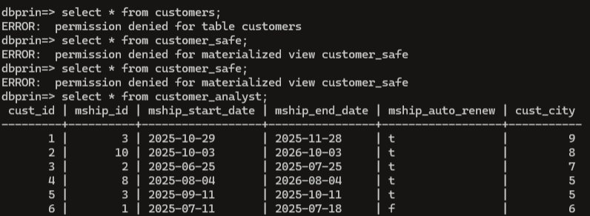

Some views have also been implemented for tables that can have sensitive data, such as staff and customers. For these, a view has been created with the suffix _safe, which hides sensitive information.

Row Level Security (RLS)
Although we haven’t implemented, but we discussed the positive implications of RLS, that could restrict access to certain data, not just certain operations or table.
The most important part , where RLS could come handy is for general technicians (not managers), so they would be able to only see their data, their certifications, and also only to see the jobs and bookings in the branch they work at, and not in other branches.
For customers, it would ensure that they can only see their data, including vehicles and bookings, as customers definitely should not be able to watch records of another customers.
While usually such logic is enforced on application level, it could also be implemented on a database level, making the business logic application independent (for example, switching from Laravel to Next [why would anyone do it however] this business logic would remain unharmed).

- Queries
The queries can be found at the end of our submitted SQL file, above the commented out roles.
- MOT’s that are either expired, or will expire in the next 30 or 7 days. It includes customer name and contact number, that allows the business to send a reminder for the customer about their expiring or expired MOT. It also shows vehicle registration number. The results are ordered by expiry date in a descending order, showing results first that expires in 30 or 7 days. There is an explicit status column, showing clearly if it “Expire in 30 days”, “Expire in 7 days”, or “Expired”. It is useful for the business, because they can contact their customers as a reminder about expiring MOTs, and they can also be prepared if they see some will expire in the next 7 days, they can expect some MOT bookings. This query is using the vehicle_safe and customer_safe views, that exclude sensitive personal information. Some results(the result will differ from the screenshot below if you run the query):
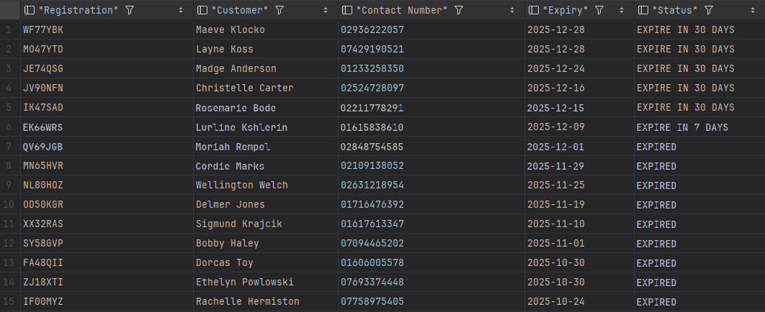
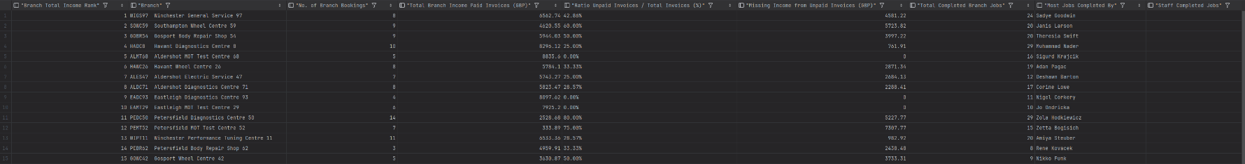
- Performance per branch in 2025. Branches are ranked based on total income (including paid and unpaid invoices), shows bookings in the branch, income from paid invoices, ratio between unpaid and total invoices, the money missing due to unpaid invoices (this includes due and overdue), total completed jobs per branch, the staff in the branch who completed the most jobs, and the number of jobs that staff completed. It is useful for the business, because they can see how each branch is performing in the previous year, so they can plan expansions accordingly, and if one branch is overloaded, they can ask customers to go to a branch in a nearby city. Or, in an unfortunate case, a branch is underperforming a lot, they might decide to close it. It uses the staff_safe view, that has minimal staff information, excluding sensitive ones. Some results:
- This query’s’ main purpose is to view customers spending, visits and whether they have a membership and if not then upsell on their next visit, also the customers are ranked based on their spending with platinum being the customer who has spent the most money. Lastly the status ‘active’ ‘inactive’ and ‘at risk’ indicate when a customer has not booked in a long period of time, if at risk an email can be sent out to try and attract the customer back.
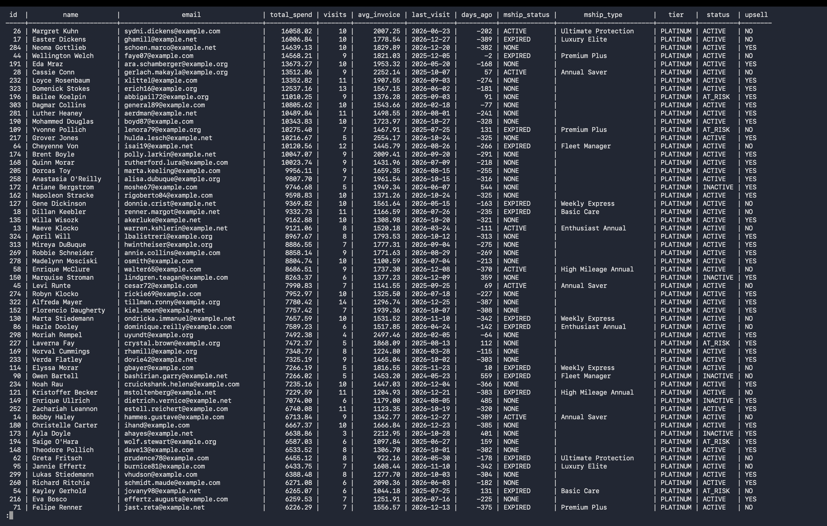

- This query is for managing branch workload, with all branches listed, with each staff per branch, the number of jobs per branch. Average jobs per staff to see which staff member is the highest performer, whilst also seeing which branch has the most pressure in terms of pending jobs and whether it’s a large amount or not. And lastly active jobs to see how many jobs the branch is currently taking on day to day which is very important to visualise over all the branches
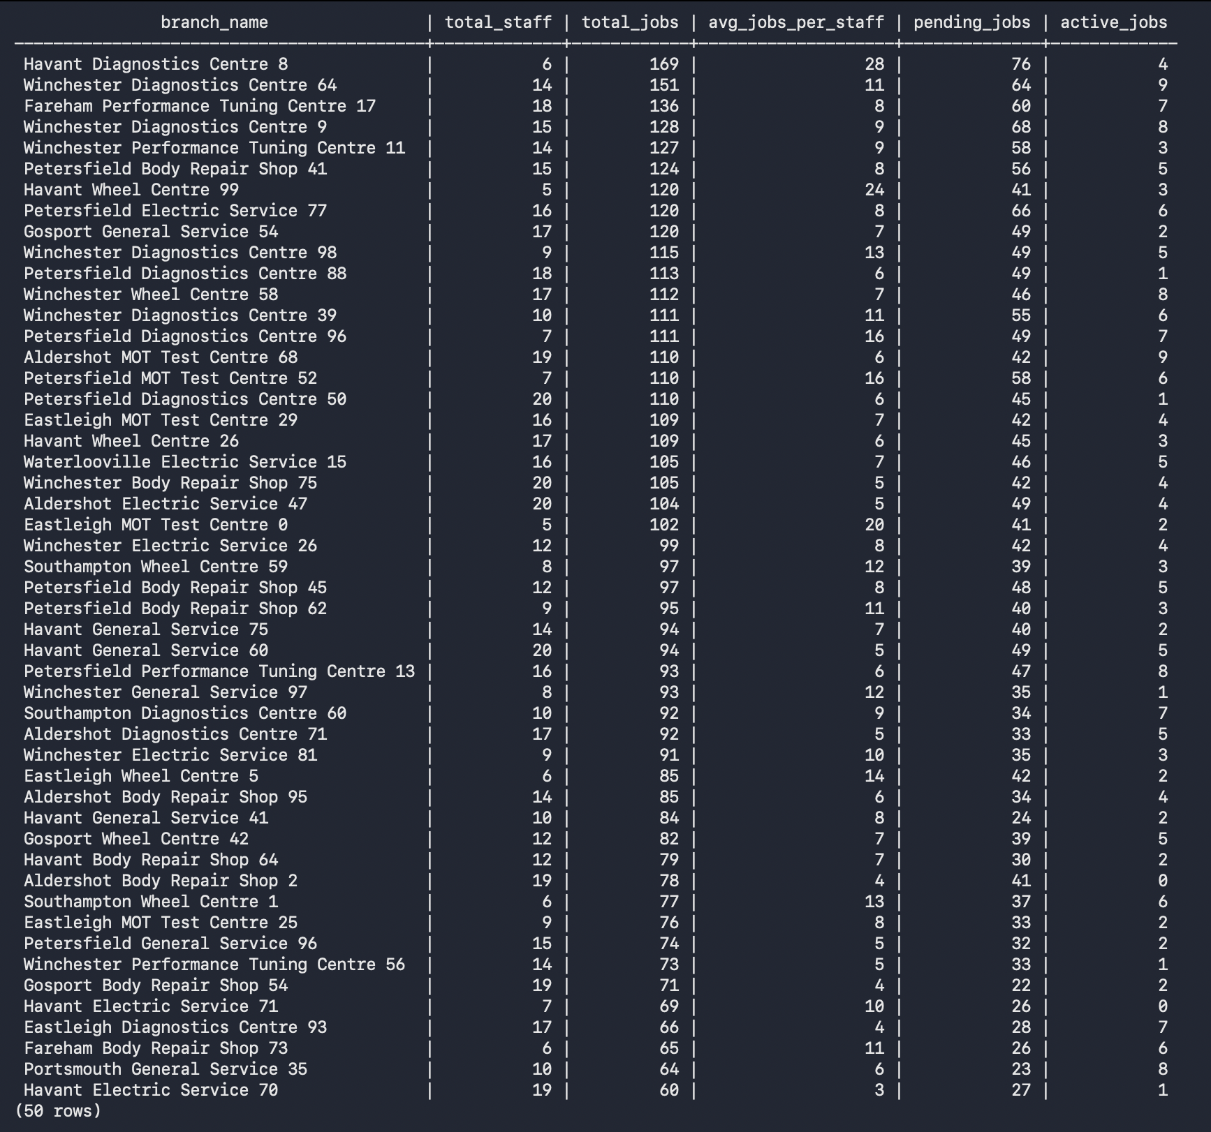

- This query covers the parts being used and connects each part to the specific branch to visualise which parts are being used per branch, this would be useful to see the parts expenses and the most popular parts being used.

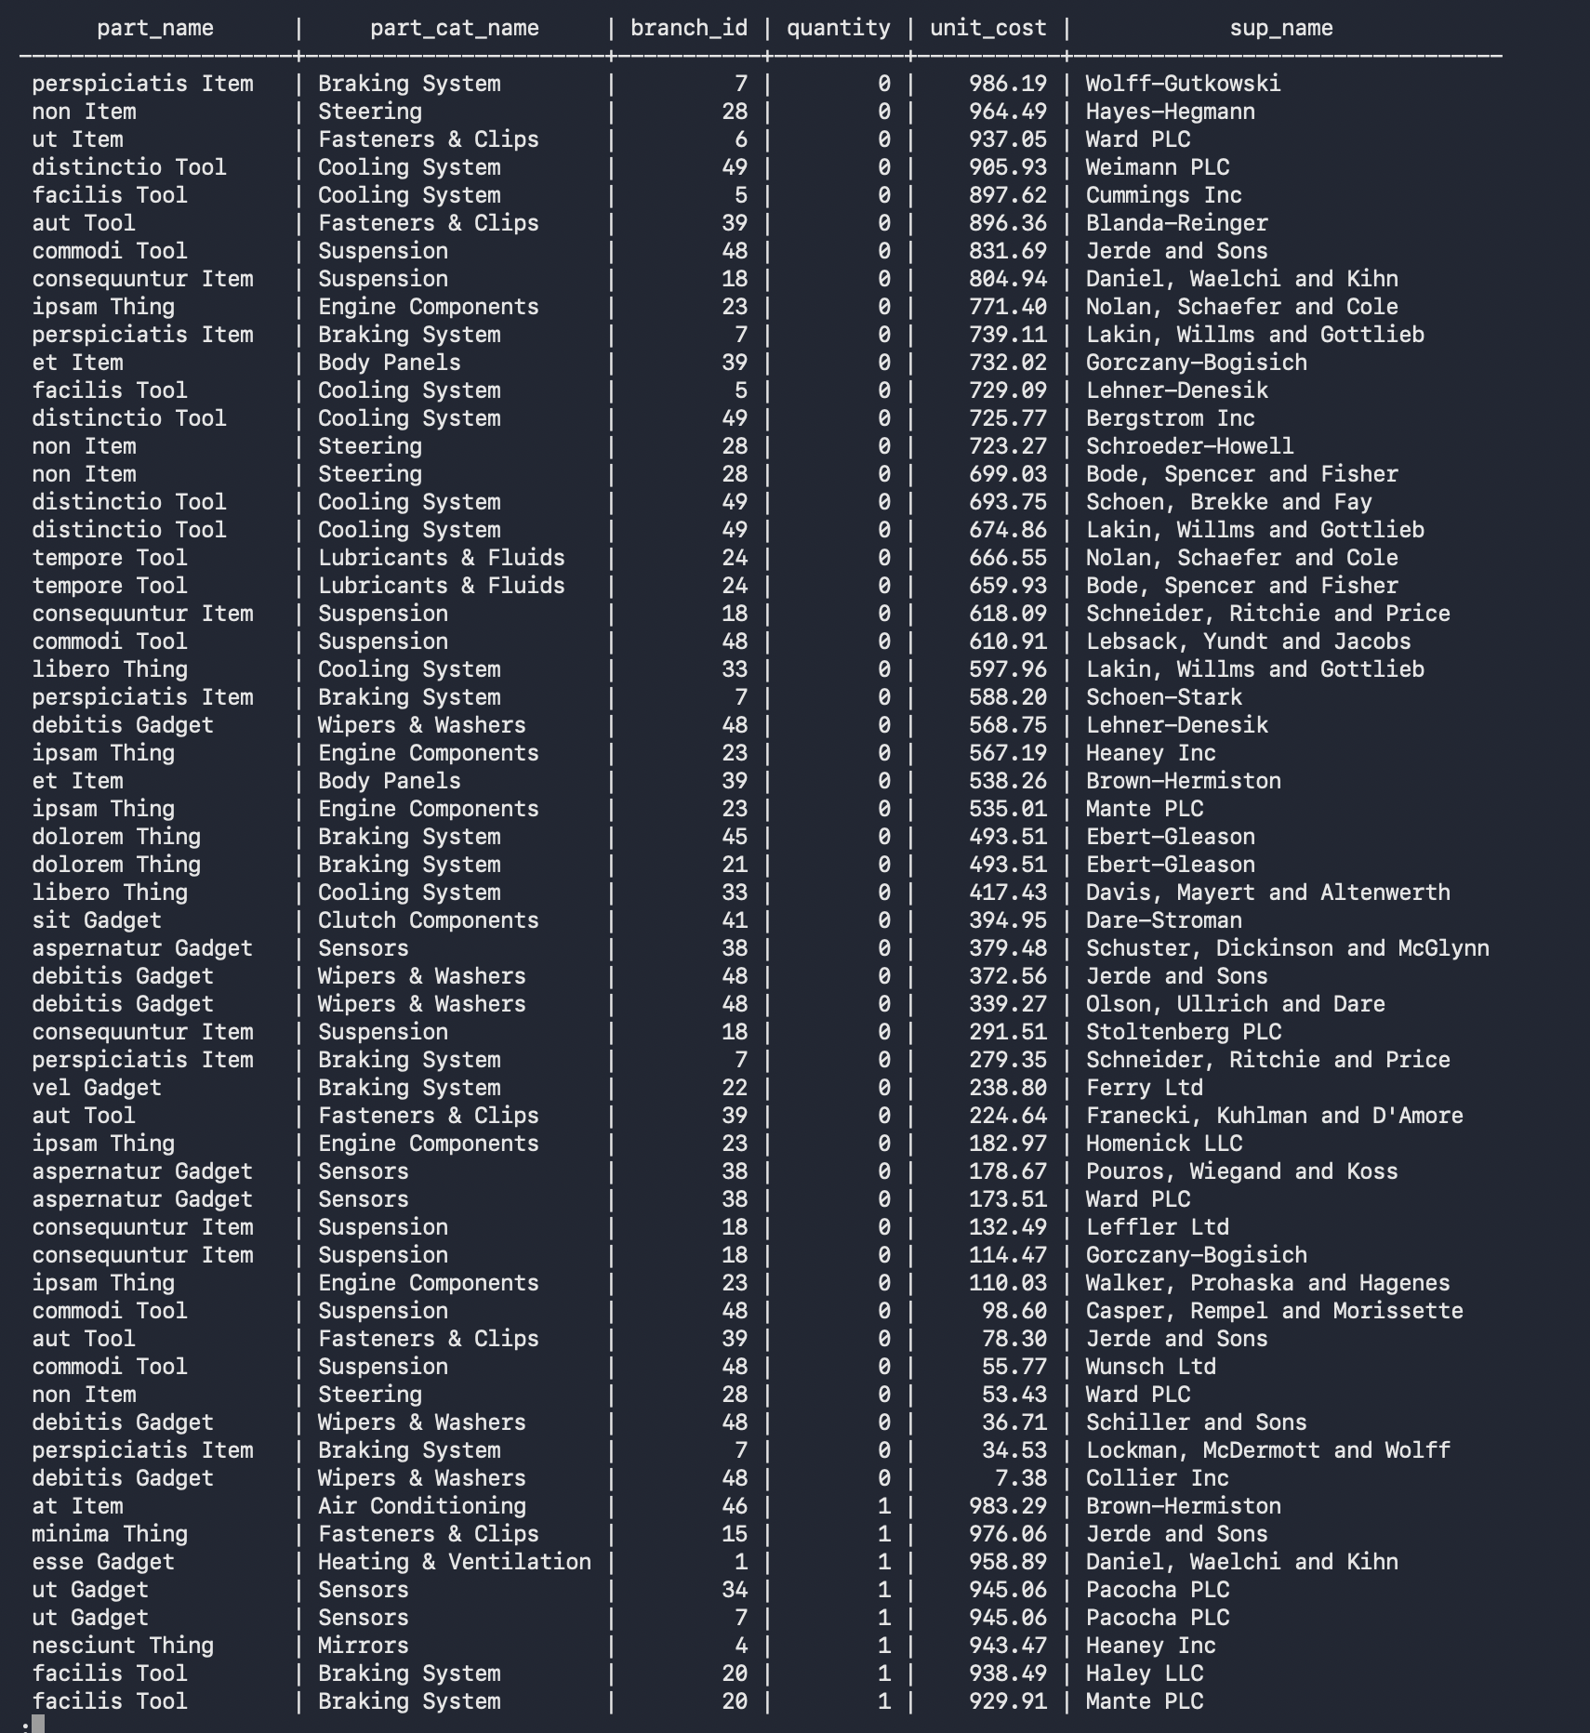

- This is an additional query on top of 5, to demonstrate what queries a data analyst could do with the views they have access to. It is a simple query for demonstrating purposes. It shows each part alongside with the lowest unit cost, the supplier’s name, and whether that supplier is still supplying or not. This can be useful to find out the supplier’s for each part with the lowest unit cost, and order from those. Some results:
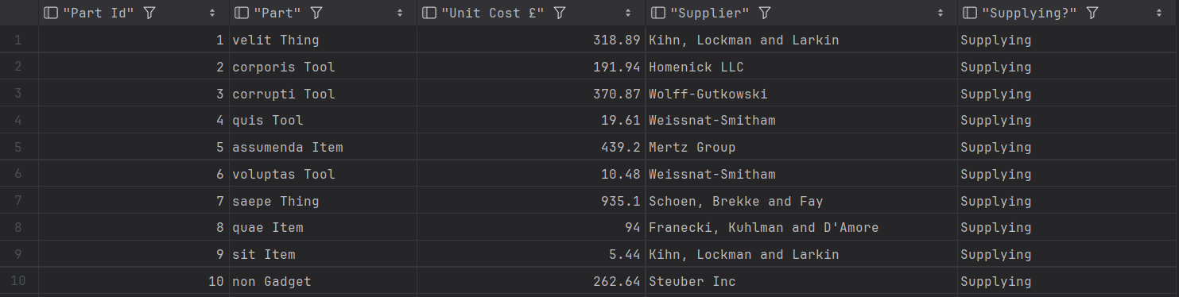
- This is also a simple demonstrating query as a data analyst. It shows total bookings, the number of bookings with feedback, and the ratio between them.

- Optimisation

Triggers & functions
We have implemented multiple functions and triggers, which ensures smoother operation, as it automates some tasks, for example calculating invoice amount or adjusting stock levels automatically, which ensures data integrity. The triggers we implemented:
- Check same branch manager
When inserting a new record into branch_managers table, the trigger checks if there is already an existing active branch manager for the given branch, preventing duplicate entry for the same person.
- Check stock level before inserting a part usage record
Before inserting into part_usage , the trigger checks if there is enough available part quantity in the branch where the job is being done.
- Check stock level before insert a part transfer record
Before inserting into part_transfers , the trigger checks if the requested part exists, and if so, there is enough quantity at the source branch to transfer from.
- Check if manager approved the part transfer
Before inserting or updating in the part_transfers table, the trigger checks if the approved_by and the requested_by are different staff, and also if the approved_by is a manager at the destination branch.
- Update stock level after a part transfer is completed
If the status of a part transfer is set to COMPLETED , the stock level will be decreased at the source branch, and the stock will be updated or a new record inserted (if no part exist yet at the destination branch) to the destination branch parts.
- Prevent paid invoice deletion
Before deletion on invoices if the status is ‘PAID’, it cannot be deleted.
- Update invoice status after installment update
After update on installments, if all the installments of an invoice is set to paid, then the invoice status becomes paid. If one of them is OVERDUE, then the invoice becomes overdue.
- Check bay status
Before inserting to jobs , if the selected bay is occupied, it raises an exception, if available, it will mark it as occupied.
- Calculate invoice amount
When an invoice is inserted, the invoice total, discount, and invoice final (total – discount) are calculated via a trigger. It collects all service prices, all discounts (service discounts and/or membership discounts), and calculates the correct values. This auto calculation allows better data integrity and accuracy, as workers/technicians don’t need to manually calculate.
- Deduct parts
After inserting into part_usage, the used quantity will be deducted from the branch.

Views
To reduce the amount of joins for some common operations, and provide easier data readibility, we have created some materialised and normal views. Some views are created for security purposes. They are mentioned under the security section, not here. Views that are not updated frequently are stored as materialized views, where views that updates data frequently, are just regular views. (less stress on the database, as since materialized views need to be refreshed on data change)
- staff_role_detailed materialized view
It joins the staff, staff_roles, and roles table. It displays the staff id, code, their full name, the role id and role name. It provides quick access when it comes viewing what staff holds what role.
- branch_manager_details materialized view
It joins staff, branches, and branch_managers tables to show details about the ACTIVE managers at all branches. It provides staff code, staff full name, branch code and branch name, as well as since when they are managers.
- branch_part_detailed view
It shows details about current branch stocks, displaying part name, branch code, and quantity. Provides a quick way to inspect current stocks, without performing the joins manually, as it already joins the tables.
- next_week_bookings view
Shows the bookings with vehicle registration booked for the next 7 days (always for the next 7 days based on the date it is ran)
- branch_low_stock view
Shows the branch detail, and part detail and quantity of those parts, that has stock <= 20
- invoices_with_installments view
Shows invoices that has installments
- active_customer_memberships view
Shows customers with active memberships, alongside with membership details
- customer_booking history materialized view
Shows total bookings of a customer, the date of first and last booking, and total vehicles they have
- upcoming_bay_inspections view
Shows bay inspections and bay info for upcoming inspections in the next 30 days (always current_date + 30 days)
The materialized views have corresponding triggers for auto refreshing, keeping data in sync with base tables.

Indexes
Most of the tables have indexes implemented (tables with 2-3 fields, obviously don’t). Indexes were not randomly created, but carefully thought from the business perspective that what are the fields in each tables that are frequently filtered or ordered by. For example, for bookings the common ones are by booking date and/or vehicle.
Using a transaction analysis matrix (please see at the end of document, as it is exported from a spreadsheet as pdf), we identified that the most frequently accessed tables are bookings, jobs, branch_parts, invoices. The reason behind, that when a booking is made, it contains multiple services, which are resolved by multiple staff, using multiple parts, therefore these data will be constantly updated, so proper indexing was crucial.
Indexes can be found after each table in the code.
Since our second query is the most complex one, we tested out performance using indexes and without indexes. Here is the result with indexes:
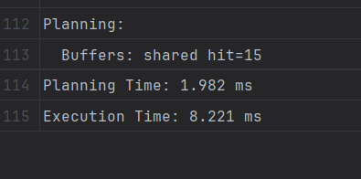
Without using indexes:
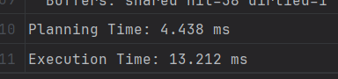
Using indexes on tables resulted in a 60% faster execution time.

- Professional, legal, and ethical issues

PROFESSIONAL ISSUES
- Database security and access control
  - Password management and secure authentication
  - Staff only see data relevant to their work
  - Regular security audits and vulnerability assessments
- Data integrity and quality
  - Use of triggers to maintain data consistency (stock levels, invoice calculations)
  - Regular database backups and Testing restore procedures
- Database performance
  - Capacity planning for database growth
  - Monitoring database performance and response times

LEGAL ISSUES
- GDPR and Data Protection
  - Right to access, Customers can request all their stored data
  - Right to erase, Ability to delete customer records while maintaining integrity
  - Data minimisation, Only storing neccessary fields, eg customer name, customer contact details.
  - Purpose limitation, Data collected for bookings should not be used for unauthorised purposes
  - Encryption for sensitive fields, Payment information should be encrypted
  - Audit logging, Tracking who accessed/modified customer data and when
- Compliance with industry regulations
  - MOT data must meet DVSA (driver and vehicle standards agency) requirements
  - Secure storage of legally required documentation
  - Database must support compliance reporting if requested by authoritites
- Database access logging
  - Required for legal compliance and investigations
  - Protection against unauthorised access or data breaches

ETHICAL ISSUES
- Privacy
  - Customers should only access their own records, not other customer data
- Transparent data usage
  - Customers should know how their data is stored and used
  - Clear purposes for data collection
- Database administrator ethics
  - DBA’s with superuser access must not abuse privileges
  - Not accesing customer/staff data for personal curiosity
  - Proper handling of sensitive information during troubleshooting
  - Whistleblower protection is database misuse is discovered
- Data quality ethics
  - Ensuring accurate MOT results as lives depend on vehicle safety
  - Not manipulating invoice or pricing data
  - Honest recording of part usage and inventory
  - Accurate staff cetitication records
- Insider threat prevention
  - Monitoring for staff abusing database access
  - Preventing data theft or selling customer information
  - Protecting against malicious deletion or modifications of records

- DDT
Group Number: [04]
Database Development Tracker

Date | Task Description | Member ID | Task Details | Time | Signature
09/10/2025 | Initial meetup | 2255832  2287200  2306492 | First meetup. Agreeing on when and how often we communicate and/or meet. Read through the coursework requirements, and make an initial plan. Create live documents where we collaborate. Created an initial conceptual design with basic entities and relationships between them. Created a github repo for coding. | 2H |   Robin
11/10/2025 | Started working on the ERD | 2255832  2287200  2306492 | I went to the library and reviewed the logic in miro and created multiple tables and formed the relationships between them. We used Miro. | 2H | 
16/10/2025 | Completed the ERD | 2255832  2287200  2306492 | Completed the ERD with all tables and relationships based on the conceptual design. | 2H |   Robin
18/10/2025 | Created 3 queries on logical level | 2255832 | I researched the business needs and decided on my 3 queries from this information gathered. No code at this point yet, just created them on a conceptual level, thinking about what could be useful for the business. | 3H | 
21/10/2025 | Started SQL implementation of create statements | 2255832 | I reviewed the ERD and started implementing all tables in sql (create statements only) | 2H | 
22/10/2025 | Started working on data dictionary | 2255832  2287200  2306492 | We had a meetup where we reviewed our ERD, and started thinking about indexes, constraints (checks), and started implementing the data dictionary. We split up the work to be more efficient. | 2H |   Robin
02/11/2025 | Data dictionary continue and small fixes | 2306492 | I continued the data dictionary, matching it to the ERD, and also made some overall changes to the structure, for example renaming columns, adding or removing columns. I also added a table for tracking booking packages. | 1.5H | 
07/11/2025 | Finishing create statements  Finishing table indexes | 2255832  2287200  2306492 | All the create statements were completed, including indexes, constraints, and throughlty tested if they work without error. | 2H |   Robin
9/11/2025 | Finished Data dictionary and Double checked that Data dictionary and database matches | 2287200 | Finished the rest of the data dictionary by adding the remaining tables and fixed any discrepancies between the two to make them match as well as changed some names between the two to make it match up. | 2H | Robin
13/11/2025 | Finished creating dummy data | 2306492 | Using Laravel faker, seeder + copilot for speeding up the process, I created dummy data for each table, that sort of represents a real company data with the amount and accuracy, so I tried to use the least amount of “lorem ipsum” - it is mainly used for remarks and comments as filler text. And yes, it actually took this amount of time. | 4H | 
17/11/2025 | Created additional 2 queries | 2306492 | Once the dummy data was available, I started thinking about additional queries that could be useful for business. I ended up deciding to do expiring MOTs, and branch performance. The queries had multiple iterations, especially the branch performance, as even though I had many data, it is spread across 50 branches over 2 years, so initially I wanted to do performance in the last 60 days, but then I changed it to the year of 2025 to have more data. | 2H | 
28/11/2025 | Adding views for optimisation and security | 2306492 | I added more views for both optimisation purposes (eliminate the need for multiple joins for frequent data access), and security purposes as well (hiding sensitive information in certain views) | 1H | 
28/11/2025 | Implementing my 3 queries on code level | 2255832 | Since I had the initial logical design for my queries, I wrote the code for them as we had the dummy data available. | 1.5H | 
30/11/2025 | Triggers and automation | 2255832  2287200  2306492 | For optimisation and data integrity purposes, we added triggers for certain tables, for example calculating invoice amounts, deducting and adjusting part numbers after a transfer or job done. | 3H |   Robin
02/12/2025 | Finished database security | 2306492 | Finished creating roles and privileges on code level. After that, I added the explanation in the document, with code and usage examples, and the reason why such roles were decided on. | 3H | 
02/12/2025 | Transaction analysis matrix | 2255832  2287200  2306492 | For all the queries (7) we have, and for some other heavy transactions we did transaction analysis matrix. Initially there were some doubts regarding the format (where to do it), but Excel was a good choice, and then exporting it as a PDF. | 1H |   Robin
03/12/2025 | Optimisation writing | 2255832  2287200  2306492 | Based on the optimisation techniques we implemented, we wrote some paragraphs and explanations what we implemented and why. | 1.5H |   Robin
04/12/2025 | Tidying ERD | 2255832  2306492 | The initial ERD was too messy and cluttered, and since the plan was to tidy it up once the majority of the coursework is done, the ERD now looks a lot better and easier to follow. It still contains some overlapping lines, but they cannot be eliminated and the relationships can be easily followed. | 1H | 
06/12/2025 | Some casual checks and prepare for finalisation | 2306492 | To ensure everything is included, and correct, did some checks on ERD, data dictionary. Also started merging the code together for some final testing. | 1H | 
07/12/2025 | Working on ethics | 2255832  2287200  2306492 |  | 2H |   Robin
08/12/2025 | Final meeting | 2255832  2287200  2306492 | We did a final meeting before the submission, to double triple or whatever check everything, like if we included all the sections and we did a final check if our ERD and data dictionary fully match. | 2H |   Robin

