

B.Sc. (Hons) in IT Specialization Interactive Media 2024
Year 04 – Semester 02
SE4031 – GAME DEVELOPMENT

Assignment 02

2D game - Crimson Jump

Submitted By:
Name | IT Number
Mahawegedara M K S P | IT22891372

Crimson Jump
Game Documentation

1. Game Overview
Crimson Jump is a 2D side-scrolling platformer where the player navigates through multiple levels filled with obstacles, enemies, and collectibles. The main objective is to survive, collect coins, and reach the final flag in each level. The game focuses on smooth and responsive movement using advanced mechanics like coyote time and jump buffering, making gameplay feel fluid and modern.
The player must manage health while avoiding hazards and enemies. Strategic use of jumping abilities and power-ups such as the Strawberry boost helps the player progress through increasingly challenging levels.

2. Gameplay Mechanics
• Movement: Player moves left and right with smooth directional control and sprite flipping.
• Jump System: Includes basic jump, double jump, coyote time, and jump buffering for better control.
• Health System: Player starts with 100 HP and loses health upon collisions with hazards or enemies.
• Power-Ups: Strawberry increases jump ability temporarily.
• Enemies: Patrol between points and damage the player on contact.
• Coins: Collectible items that increase the score.
• Level Progression: Player completes levels by reaching the flag.
• UI System: Displays health bar and coin count in real time.

3. Unique Features
The game includes advanced jumping mechanics such as coyote time and jump buffering, which significantly improve responsiveness. Additionally, temporary power-ups enhance gameplay dynamics, making the experience more engaging and skill-based.

4. Controls
Move: A / D or Arrow Keys
Jump: Space
Pause: Escape

5. Gameplay Screenshots
Screenshot 1:
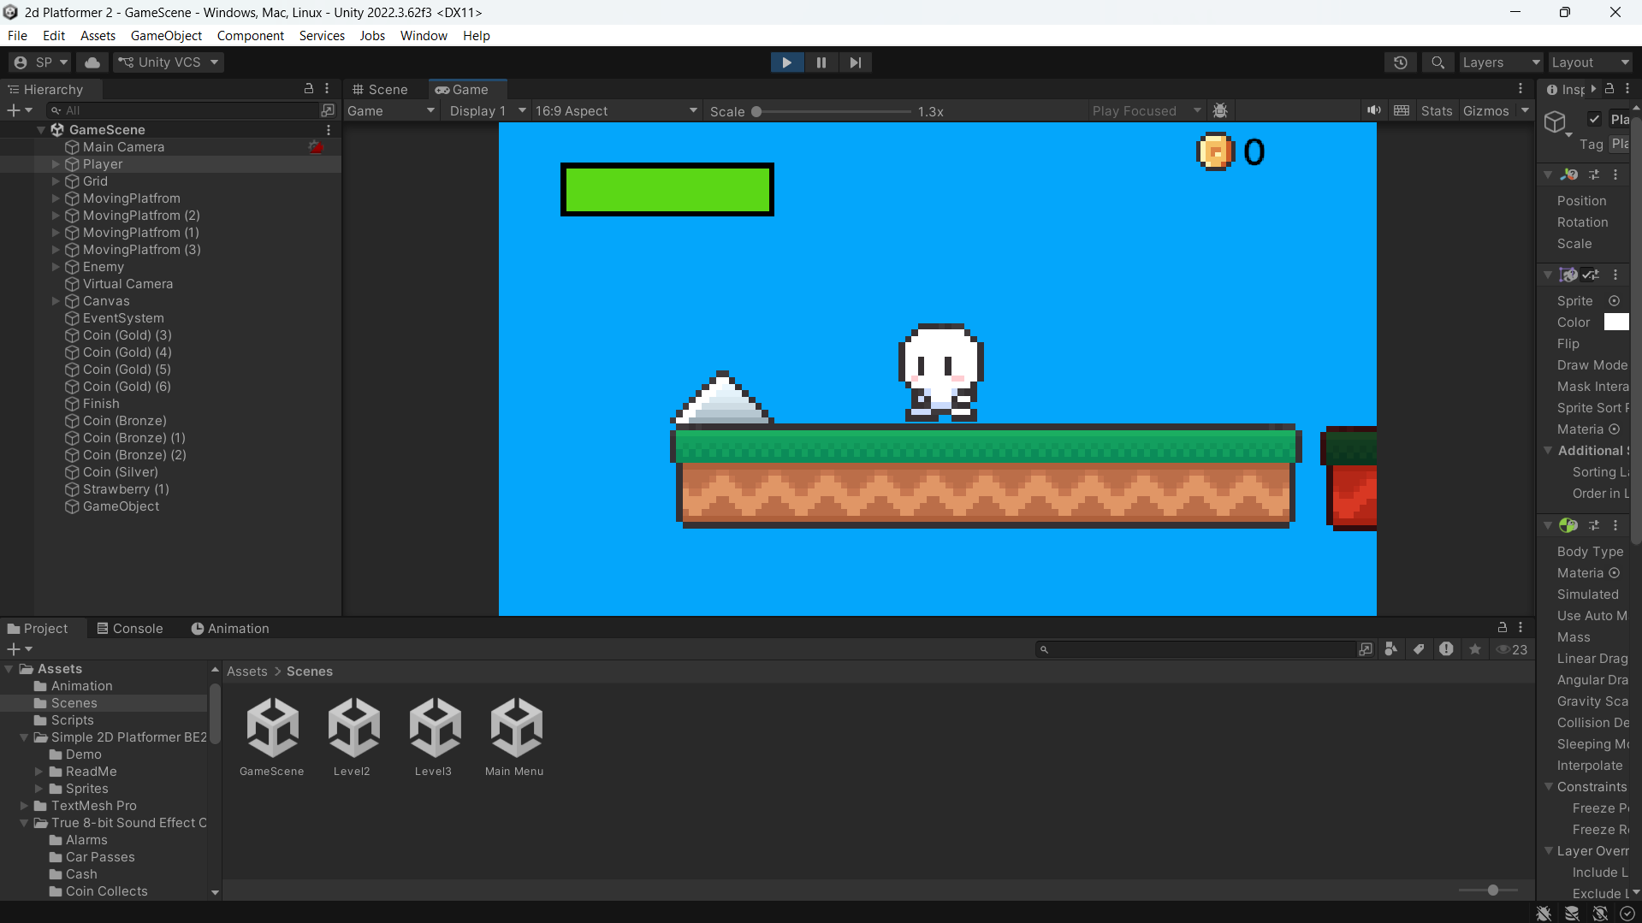

Screenshot 2:
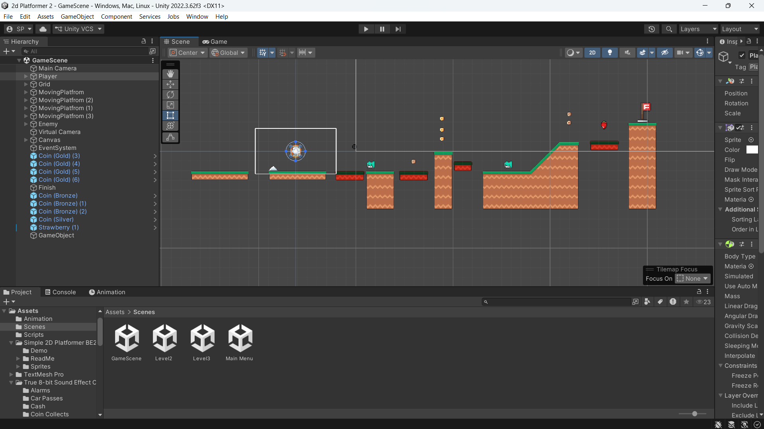

Screenshot 3:
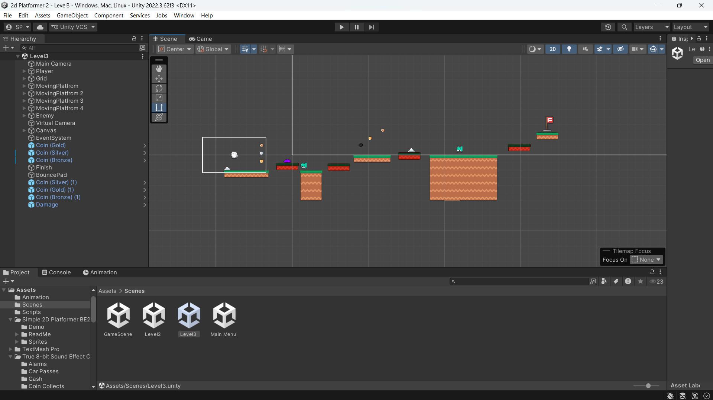

Screenshot 4:
