Castle of Shadows:
The Lost Key

Game Documentation

Student Name: Nisala Gunasekara
IT Number: (Add your IT number here)

Unity 2D Game Development Project

1. Summary of the Game Concept
Castle of Shadows: The Lost Key is a 2D action-platformer game developed using Unity. The game is set inside a dangerous medieval castle filled with enemies and deadly traps.
The player controls a brave prince whose mission is to find a hidden key within the castle. This key is essential to unlock the final gate and save the kingdom from invading enemies.
Throughout the game, the player must:
- Fight enemies such as skeleton warriors, knights, and monsters
- Avoid environmental hazards like fire traps
- Explore different sections of the castle
- Survive and reach the key to complete the level
The game focuses on combat, exploration, and survival mechanics.
2. Core Features Implementation
The game’s core features are implemented using C# scripts in Unity. Below are the main systems:
Player Movement System
- Implemented using Unity’s Rigidbody2D and Input System
- Player can move left and right using keyboard input (A/D keys)
- Jumping is handled using physics-based force
Combat System
- Mouse input is used to trigger sword attacks
- Attack animations are controlled using the Animator
- Damage is applied to enemies using collision detection (hitboxes)
Enemy
- Enemies (Skeletons, Knights, Monsters) :
  - Patrol movement
  - Detect player using distance checks
  - Attack when player is in range
- Scripts control enemy health and destruction on defeat
Trap System
- Fire traps are implemented using trigger colliders
- When the player touches the trap, damage is applied
- Some traps are timed using coroutines
Key Collection System
- The key object uses a trigger collider
- When collected:
  - Player inventory is updated
  - UI or game state changes to allow level completion
Game State Management
- Win condition: Player collects the key
- Lose condition: Player health reaches zero
- Scene transitions handled via Unity Scene Manager

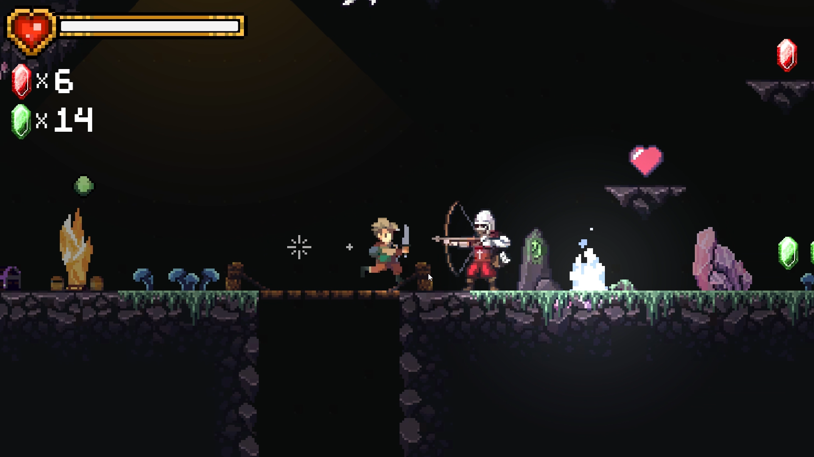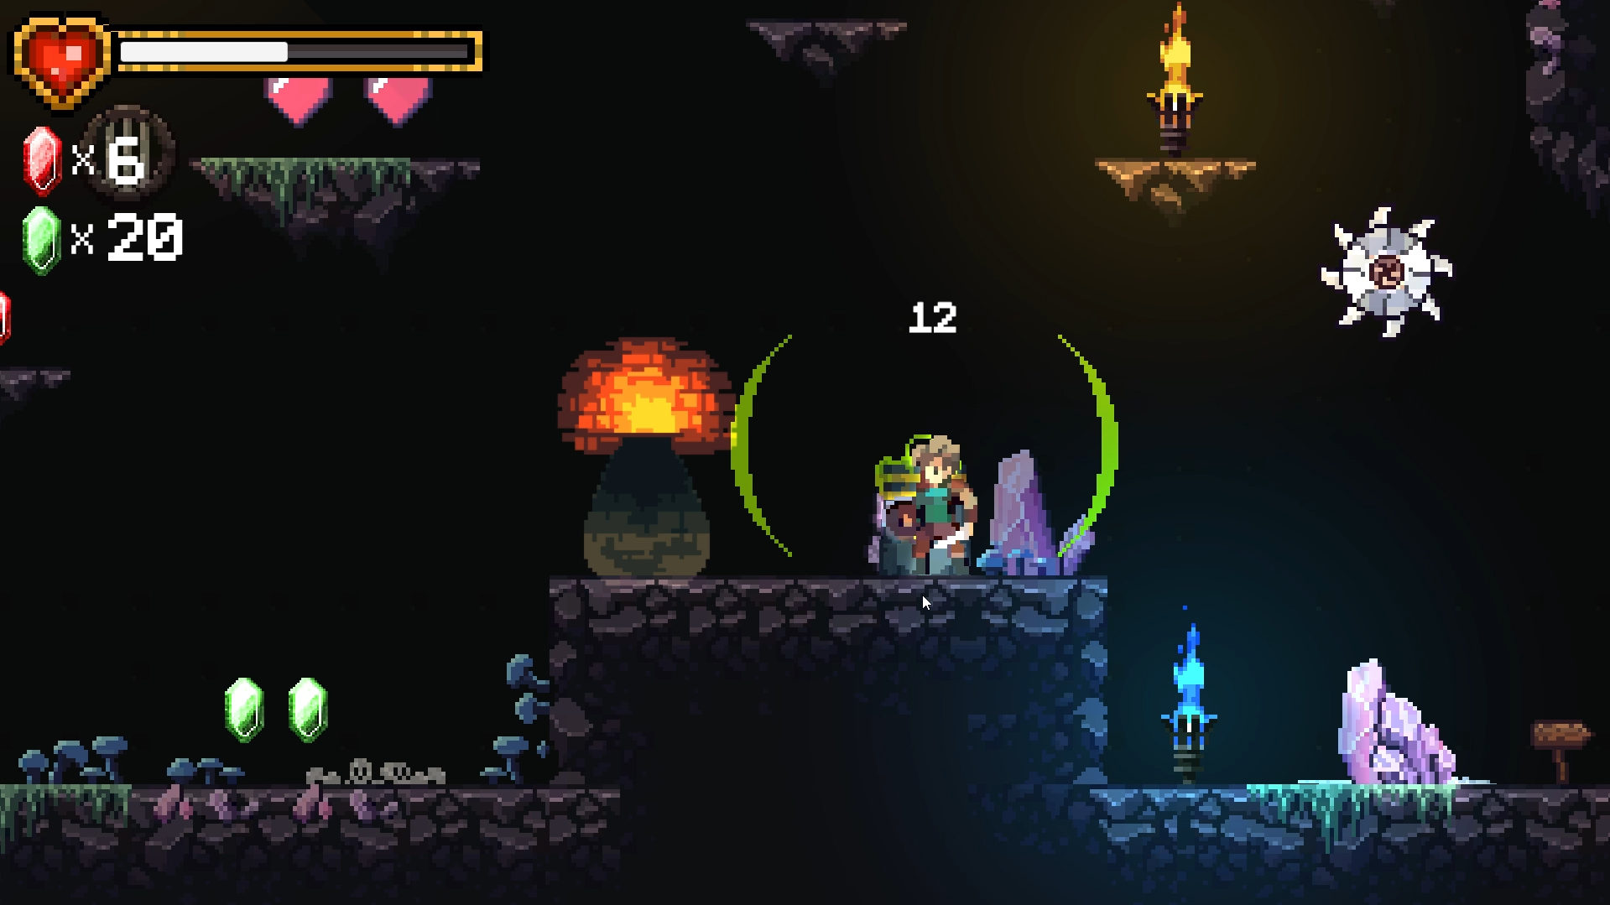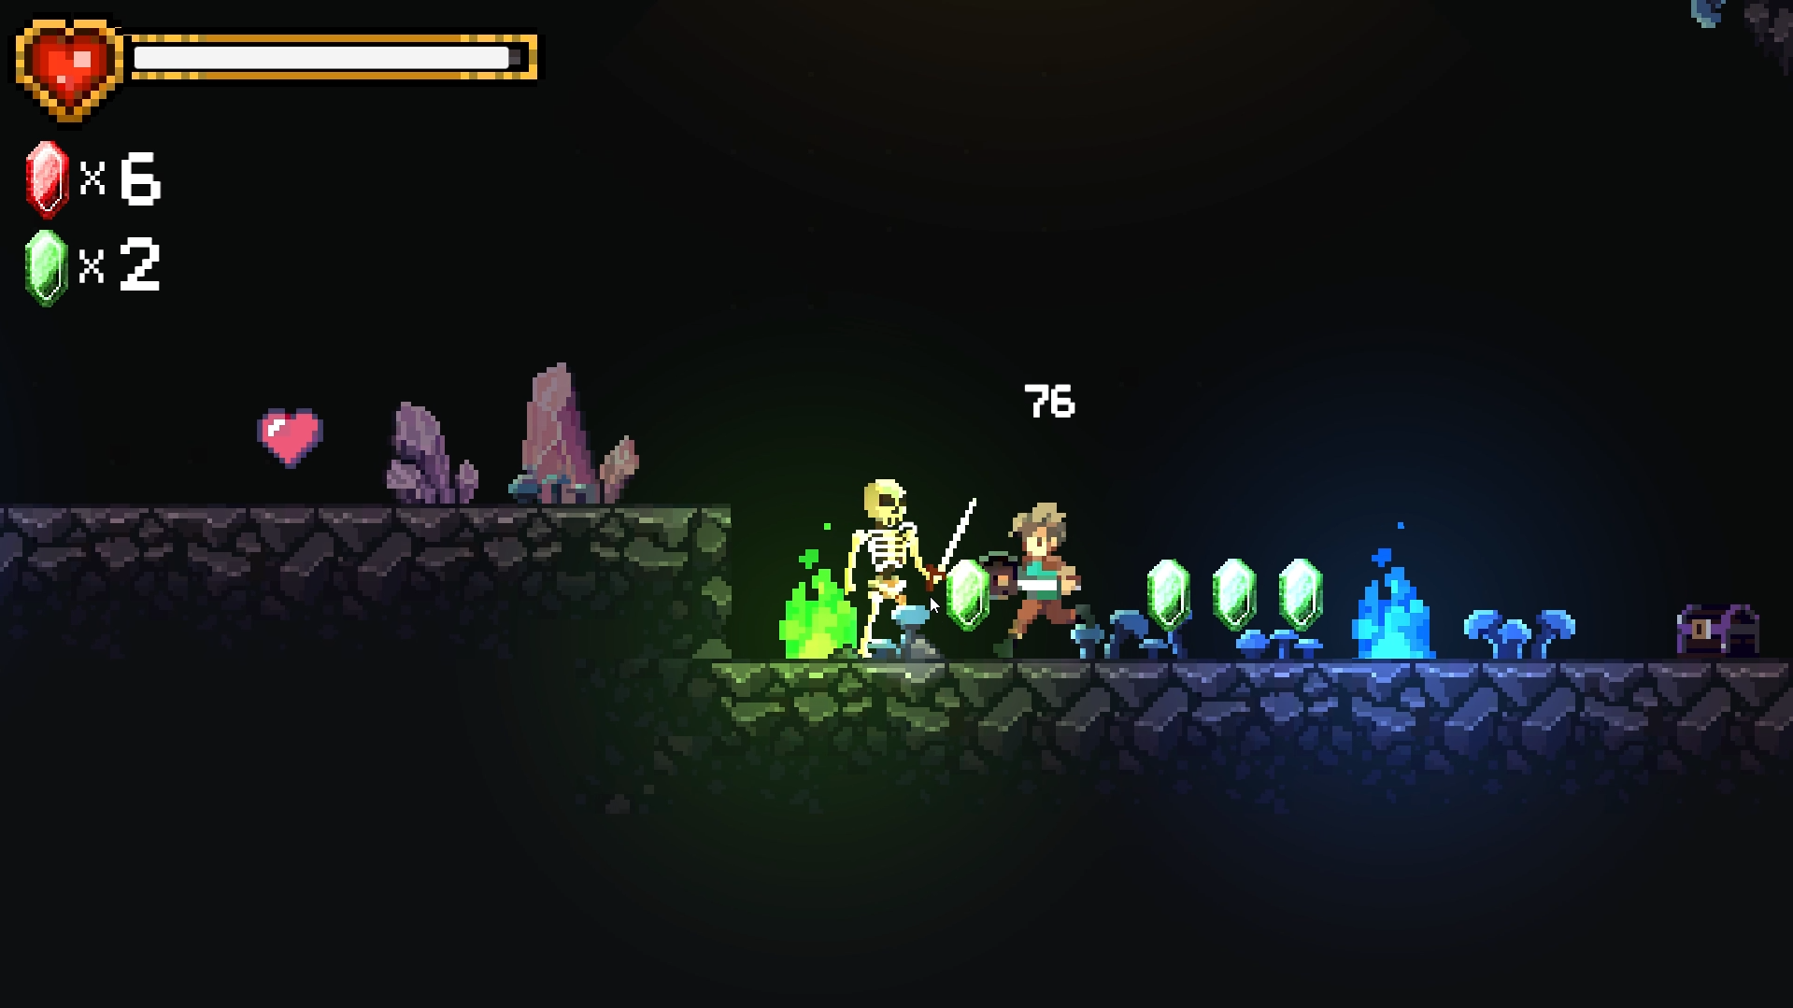

4. Control Guide
Move Left | A
Move Right | D
Jump | W
Crouch | S
Attack | Mouse Click

5. Creative Feature
One of the main creative features of this game is the castle trap system combined with combat gameplay.
- The player must fight enemies while avoiding traps at the same time
- Fire traps create dynamic challenges and timing-based gameplay
- Enemy variety (skeletons, knights, monsters) adds difficulty and diversity
- The castle environment creates an immersive medieval atmosphere
This combination makes the gameplay more strategic rather than just fighting.

6. Credits
Game Engine: Unity (2D)
Programming Language: C#
Assets:
- Some character sprites and environment assets were obtained from Patreon
- Additional free assets may include:
  - Unity Asset Store resources
Tools:
- Unity Editor
- Visual Studio (for scripting)

7. Gameplay Video Link
https://drive.google.com/drive/folders/16rsz2ocapNV3_ZIGlb6VD0L2mYrk2kvt?dmr=1&ec=wgc-drive-%5Bmodule%5D-goto

8. Build and Source Code
https://drive.google.com/drive/folders/16rsz2ocapNV3_ZIGlb6VD0L2mYrk2kvt?dmr=1&ec=wgc-drive-%5Bmodule%5D-goto

