Bundle and Data Instructions

Hardware Requirements
16GiB of RAM and a dual processor is required.

Software Requirements
3D Slicer, version 4.10.2 or newer. Available at https://download.slicer.org/
(Release, 4.10.2, and 4.11.20200930 tested, we cannot guarantee other versions will function.)

Comprehensive slicer installation, Getting Started Documentations including platform specific instruction can be found here: https://slicer.readthedocs.io/en/latest/user_guide/getting_started.html

3D Slicer is a free open source software platform for medical image informatics, image processing, and three-dimensional visualization.
The ndLibrarySupport code is part of this bundle, and is also published on the web on github. If you have git installed you can update the bundle copy with normal git commands. ** Highly recommend tagging your version first.

Mac OS security “unidentified developer”
Once Slicer is downloaded, move it to the Applications folder and double click to open. When started the first-time Mac OS may display a warning that it cannot be opened because it cannot be verified. Click Cancel and right click on the Slicer icon and select “Open” again. Click “Open” or “Open Anyway” to bypass this error. If there are additional issues, visit https://support.apple.com/en-my/guide/mac-help/mh40616/mac or https://support.apple.com/en-us/HT202491 for further instructions.

Data and Viewer Code Setup

- Download 3D Slicer
- (optional) Move the bundle folder
- Open bundle folder
- Generate the bundle shortcut by running MacSetup or WindowsSetup
(Linux setup is currently manual, add option to Slicer start --python-script "bundle_folder/ndLibrarySupport/Testing/DistStart.py". Don’t forget to change bundle_folder appropriately.)
Mac setup requires Slicer in Applications, if Slicer is installed somewhere else it will need to be set up manually (or have the setup script edited).
Windows users are asked for the location of Slicer. To get Slicer installation path, right click on the Slicer shortcut and select “Open File Location”. Hold the shift key and right click on the Slicer application, select “Copy As Path”. When setup prompts for the path to Slicer.exe, provide the path.

Again, for Mac OS users: When the Slicer is started the first-time Mac OS may display an unidentified developer warning. Follow above instructions used to bypass verification warning or visit https://support.apple.com/en-my/guide/mac-help/mh40616/mac or https://support.apple.com/en-us/HT202491 to resolve.

Windows users: When the application is started for the first time, it may display a message that the script is “unsafe”. (optional) Open the script and read through it. Select run anyway.

Once setup starts, a script window should pop up. When the installation is complete, it will alert you to it is safe to close the script window. The script window must be allowed to run until it states Setup complete. If there are any problems in setup, please check the Hints, Limitations and Known issues section below for a solution.

Once setup is complete, a shortcut will appear in the bundle folder. StartSlicer shortcuts are created in the root of the data path, next to the setup scripts. You can move the shortcuts after creation. (Shortcut file names follow a formula of StartSlicer_with_{LIBNAME}_v{DATAVERSION}.)

Double click to start viewer. There can be a delay.

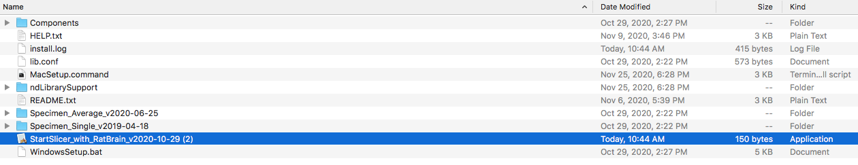

Limitations and Additional Resources
If 3D slicer is currently open when starting the shortcut, it may not launch properly. Should the package menu prompt fail to display, close 3D Slicer and try again.

The setup scripts do not work if there are spaces or special characters in the path.

You CANNOT move the data folder after setup. If you do, delete the shortcut, and re-run setup.

For limited help refer to Hints, Limitations and Known issues section below. Please note: Support is only available from the full slicer documentation.

For full documentation on 3D Slicer, visit https://www.slicer.org/wiki/Documentation/4.10
(Not all modules are installed by default; the extension manager can add additional modules)

Viewer Walkthrough
The ndLibraryViewer is a tool written in python to run in 3D Slicer for viewing slices of 3D volumes in 2D planes. It makes use of its imaging capabilities to allow for easy visual inspection of and comparison between two different volume contrasts for a given data group. Users are also able to interactively review these files, changing angles, zooming in and out, etc. Users can also view the labels outlining each region of the brain, which can be toggled on and off accordingly. Loading additional volume files into the ndLibraryViewer is also possible through normal slicer layouts, or one additional customized view.

Once the shortcut file is launched you should see a screen similar to the below.

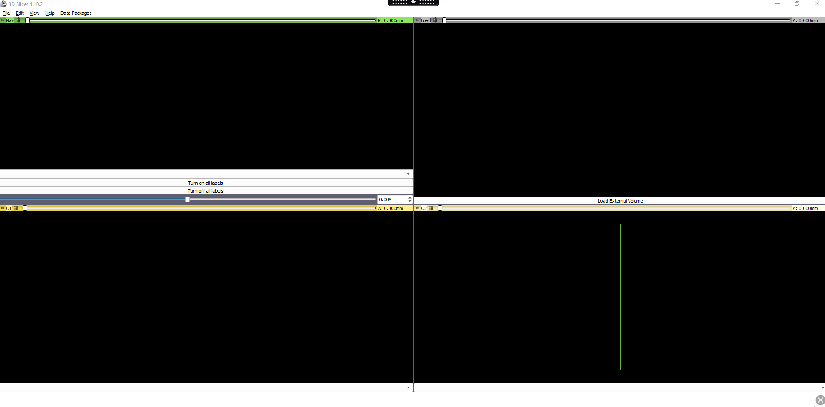
Initial set up of the ndLibraryViewer

At the top of the 3D Slicer window, there is a “Data Packages” menu that lists the available ndLibraries to choose from. Choose one of these package options to view the image volumes.

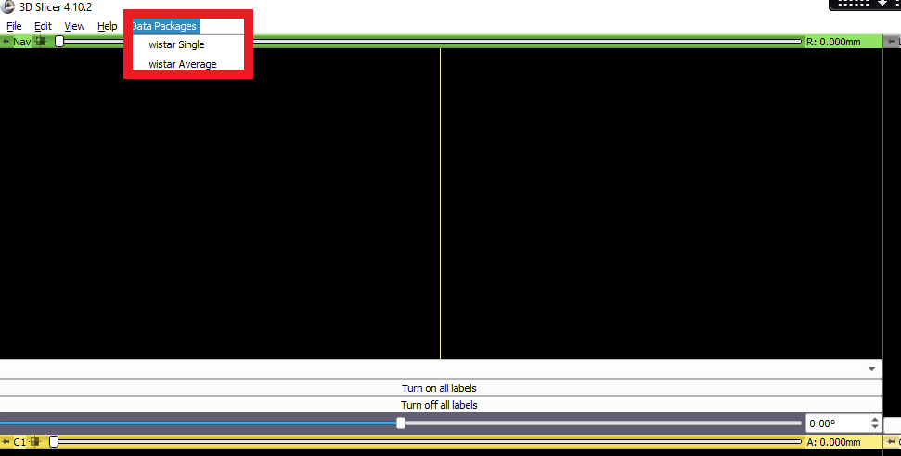
Data Package menu shown in the red rectangle

The dropdown menus at the bottom of the “Nav”, “C1”, and “C2” view panes will automatically populate. After selecting an image volume from one of these, it will be loaded into Slicer and displayed. If another package is selected on the Data Packages menu, the view drop downs will automatically update, only displaying files for that option.

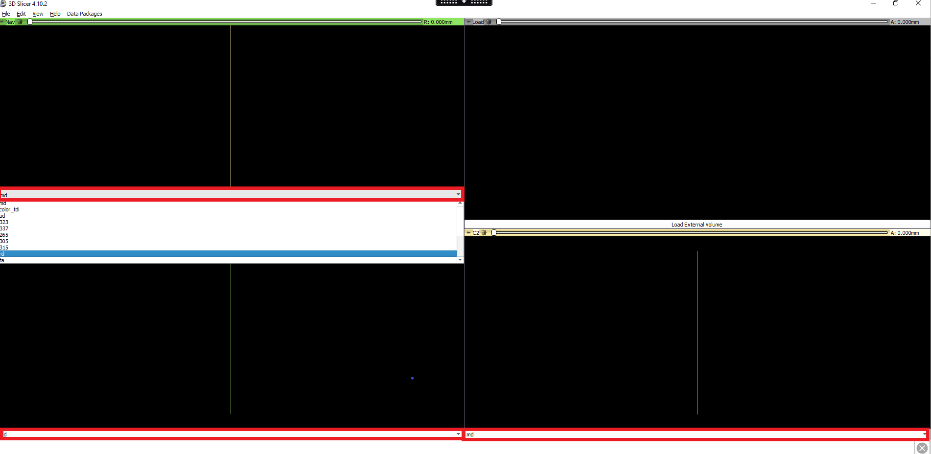
Locations of the dropdown menus are highlighted in red rectangles. Clicking on one of them opens a list of available files to view.

The default planes the selected volume files will be seen in are Sagittal plane in the “Nav” view, Coronal plane for the “C1” and “C2” windows. Notice a slider in the “Nav” window that says 0.00° next to it. This controls the angle extracted from the volume displayed in “C1” and “C2” from -200° to 200°. If one is to look at a brain in the Sagittal plane from the left, the angle indicates the number of degrees the volumes have rotated in the clockwise direction.

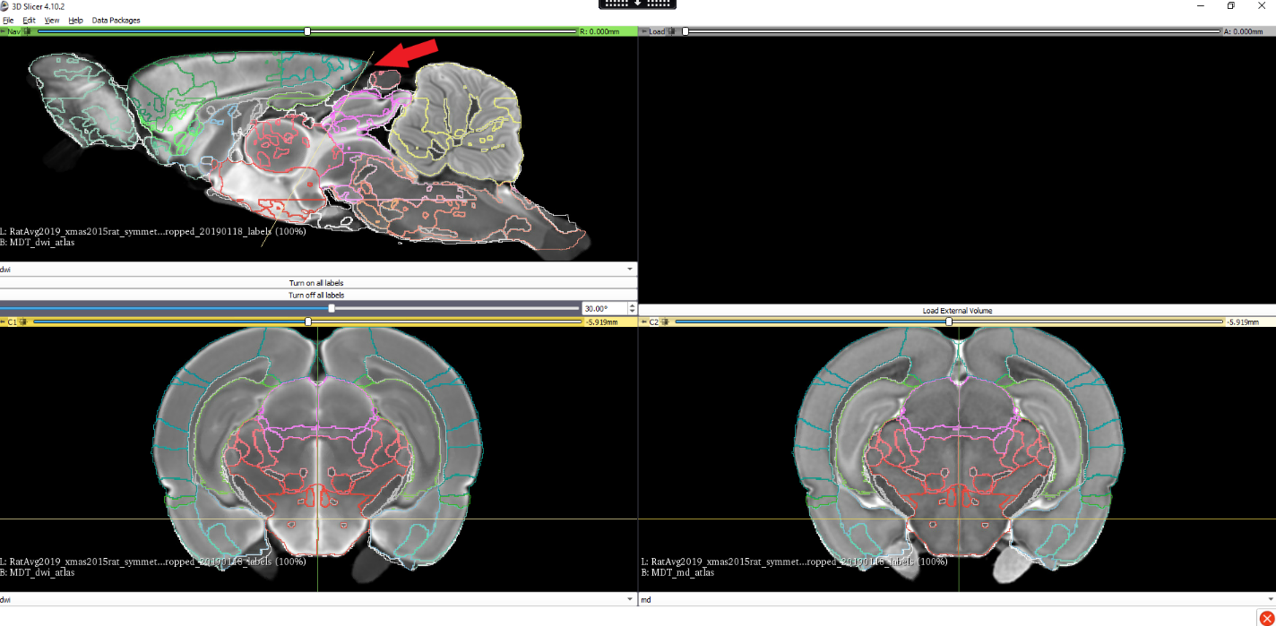
Example screen of ndLibraryViewer after selecting the files from the menu. The volumes in the C1 and C2 windows have been rotated 30° clockwise.

As can be seen above, the volumes have been loaded into the ndLibraryViewer, along with the associated labels. Click on a region of the brain inside the slice view, and the label for the region that was clicked will toggle on or off. You can toggle all “on” and “off” however these operations are slow to complete. The buttons, “Turn on all labels” and “Turn off all labels” are located at the bottom of the “Nav” window.

There are also green and yellow lines present in each window. These lines indicate the planes that are seen in other windows with respect to the current plane of that window. For example, the red arrow in the above figure points to the yellow intersection lines at which the volumes in the “C1” and “C2” slice through the plane shown in the “Nav” window. Like the angle slider shows, the intersection lines indicate a 30° rotation clockwise with respect to the plane seen in the “Nav” window.

It is also possible to manipulate the labels being displayed using the Colors Module of 3D Slicer. To do this Click the “View” menu and enable the Module panel. You may also need to enable the Module Selector. To do this:

- Click View menu
- Toolbars
- Module selection
- The Module toolbar should appear in the top left corner of the screen
- Click on the dropdown menu, scroll down to Informatics and select “Colors” to view default module location.
- A table should appear under the “Color Table Display” heading where you will be able to double click to toggle labels on and off.

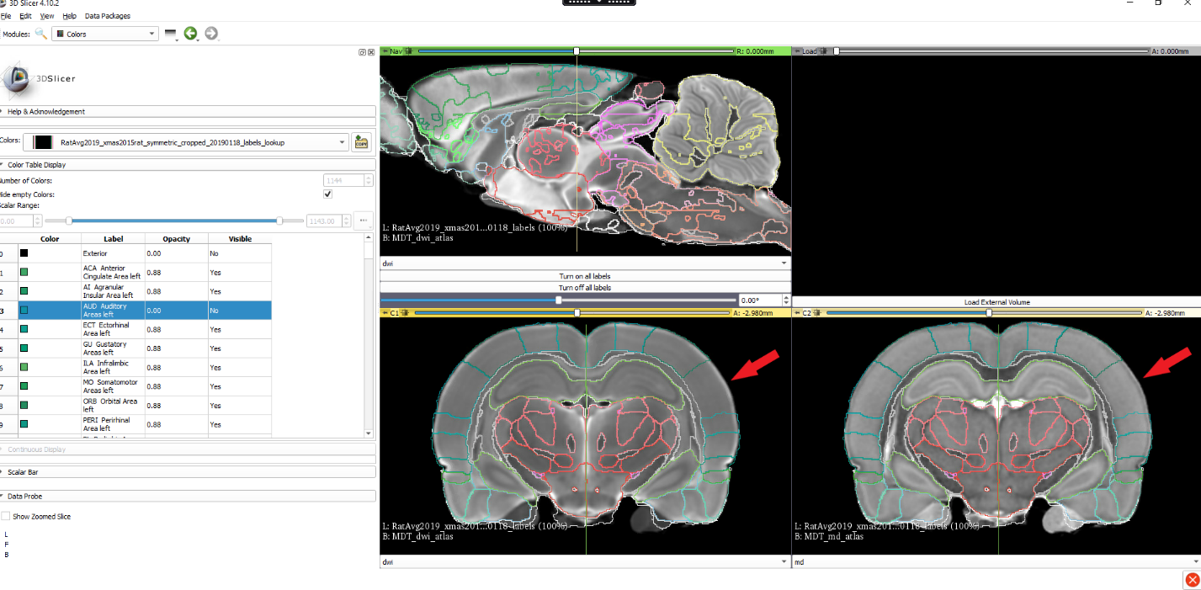
Double clicking the row for region #3 in the table, highlighted above, hides that label in the slice views. Red arrows point to where region #3 should be. Notice the label outline for that region is no longer visible.

Customized view layouts are in use to attach data volume drop down menus.

Some layouts have a "load" panel option for data which is not part of the bundle. This allows arbitrary data to integrate with the simplified interface.

Only a limited selection of data files has been tested and is confirmed to work well in this "load" panel. 2D images of nrrd/nhdr, png, tiff, nifti, or jpeg files are known to work however, 3D slicer supports a wide range of images, and data formats which may also work.

You can switch between the default 3D slicer layouts or customizations using the View menu and selecting Layouts.

The custom views are designated with a Green Arrow.

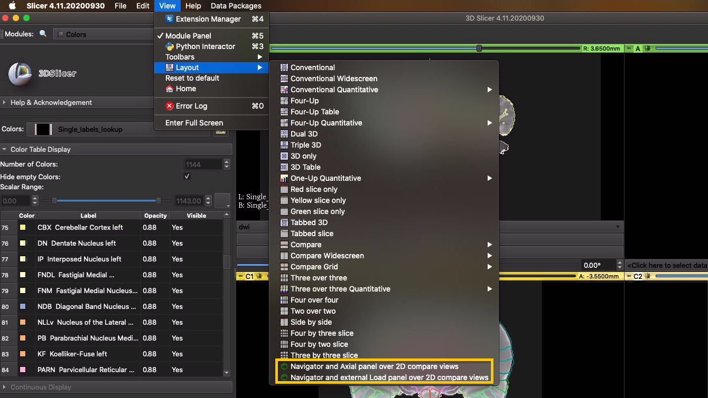
Customized views option

The top right window is reserved for outside files users want to load into Slicer. After clicking the “Load External Volume” button, a small window will pop up allowing users to choose the files they want added, much like the Slicer’s default Add Data button. However, the added data will only show up in the top right window.

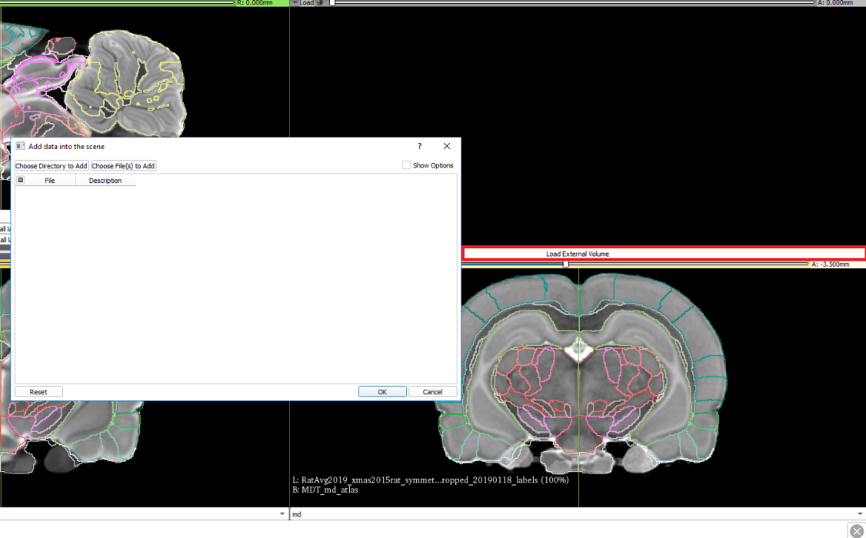
Pressing the “Load External Volume” (highlighted in the red rectangle) brings up a file dialog for adding data into the scene.

Hints, Limitations and Known issues
Please note: Support is only available from the full slicer documentation.

For full documentation on Slicer, visit https://www.slicer.org/wiki/Documentation/4.10
(Not all modules are installed by default; the extension manager can add additional modules)

First load of data can be slow (may take several minutes to load the first data volume), Windows and Mac OS have been reported offering to close the program for you.

Data is loaded on demand, and kept in memory once loaded. The first time an image is selected from the drop down menus they will be loaded.

Slicer convention places object left on image right.

Enabling/Disabling all labels is slow (may take 10s of seconds).

Initial contrast setting is often poor. To adjust, click and drag with the mouse to change contrast/brightness. In new versions of 3D Slicer you may need to change the mouse interaction mode.

When switching layouts in newer versions of 3D Slicer, or on loading data without using the ndLibraryViewer drop down menus, the mouse interaction mode may be reset to manipulation only mode instead of contrast/brightness. The mouse interaction toolbar needs to be enabled from the view menu to switch it back.

The ndLibraryViewer hides all toolbars when it initializes. The full 3D Slicer functionality may be accessed through the view menu. To enable, click the “View” menu, hover over “Toolbars” and Select the toolbar you want to view. This is also true of the Module Panel (another option in the View menu).

Hold the shift key on your keyboard and experiment with your mouse.

For PC users,
- left-click-and-hold with movement in the x-axis enables adjustments of image contrast
- left-click-and-hold with movement in the y-axis enables adjustments of image brightness
- rotating the scroll wheel scrolls through the loaded data volume in-plane
- right-click-and-hold with movement in the y-axis enables adjustments of image magnification

For Mac users with trackpad or magic mouse,
- click-and-hold with movement in the x-axis enables adjustments of image contrast
- click-and-hold with movement in the y-axis enables adjustments of image brightness
- right-click-and-hold with movement in the y-axis enables adjustments of image magnification
- shift+click-and-hold enables x-y translation of data volume

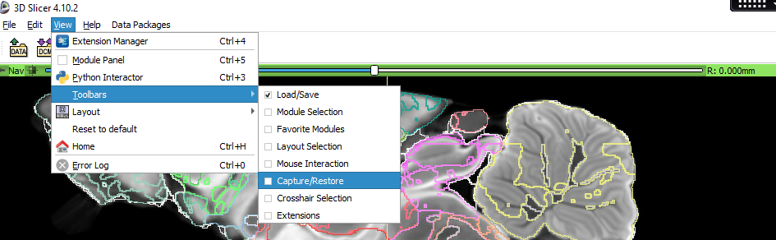

Interactive labels: The ndLibraryViewer only affects the labels loaded for the currently selected data package. This means that switching to another data package may or may not bring back labels for certain regions. One way to easily tell what region of the brain you are looking at is found at the bottom of the Slicer window. It will tell you what label and region your mouse is currently hovering over in the slice view.

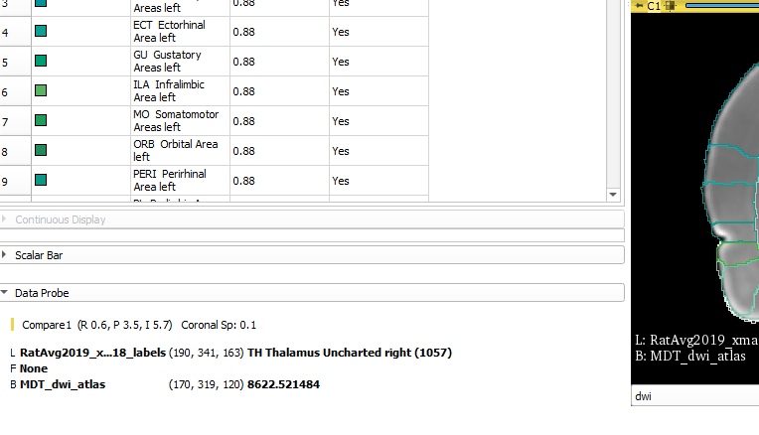

The setup scripts don't work if there are spaces or special characters in the path. On Macs, if you extract the bundle twice you'll have both. To resolve: delete previous copies of the zip file, and the extracted directories. Rename the latest zip file, and directory (removing spaces or parenthesis or any other non-alphanumeric characters). Run MacSetup again.

Mac security settings may prevent 3D Slicer from launching the first time. We only recommend adjusting security settings if you know what you’re doing. Downloading an earlier release of 3D Slicer may work. Our code is known to work on version 4.10 and newer. It may work on older versions as well. If you want to patch the security problem and understand the implications, you may use the following terminal command (ensure you're using the proper slicer path if it is not the default):
sudo xattr -dr com.apple.quarantine /Applications/Slicer.app

The ndLibrarySupport can be updated. If you have git installed you can update the copy of code in your bundle with normal git commands. It is highly recommend that you first tag your version.

