# Design

# To give an authentic and realistic impression of a lamp store, it was important to us that the website applies familiar design principles. Due to this we decided to design a bright user interface that invites the user to discover the website. Clear shapes and colors should give the user a feeling of trust. The colors petrol and purple should capture the LED charm of a smart lamp and at the same time look timeless and modern. The CSS basis was created with Bootstrap. This allows us to create an interface as simple and familiar as possible.

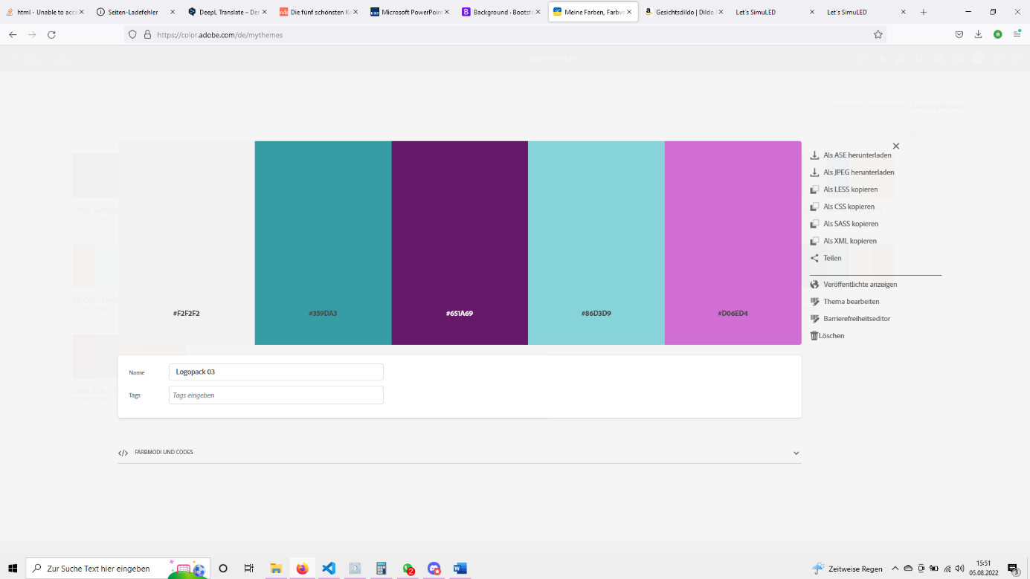

## Applications of the different colors

The white/cream tone was used by us to make light areas stand out from the white background. This color is used for example in the navbar or the shopping cart.

The petrol tone is our main highlight color. Similar to a blue or green hue, the petrol tone inspires confidence and positivity. Unlike blue and green, petrol is not yet overused. That's why it looks fresh and unspent to the observing eye. Almost all UI elements use this color.

In contrast, the purple hue is meant to function as a warning signal. For example, the logout button uses this color.

Both petrol and purple are used in two different intensity levels. The darker shade is used when something should be particularly legible or should have a clear distinction from the background. Whereas the light tone is used when the element should appear particularly discreet and friendly.