

Network Programming (IE2102)
2nd Year, 2nd Semester

Assignment

Design and Implementation of a Secure Multiprocessor TCP Server

Submitted to
Sri Lanka Institute of Information Technology

IT24101551
Kuyilini. T

In partial fulfillment of the requirements for the
Bachelor of Science Special Honors Degree in Information Technology

11/04/2026

Declaration
I certify that this report does not incorporate without acknowledgement, any material previously submitted for a degree or diploma in any university, and to the best of my knowledge and belief it does not contain any material previously published or written by another person, except where due reference is made in text.

Table of Contents

1. Introduction 5
2. System Design 5
3. Custom Protocol Design(A1) 6
4. Multiprocessing Implementation(A2) 7
5. Authentication System(A3) 7
6. Security Features(A4) 7
Username Validation 8
Rate Limiting 8
Brute-force Protection 8
Payload Validation 8
7. Logging System(A5) 9
8. Testing & Results 9
1. Server Running 9
2. Register 10
3. Login Success 10
4. Login Failure 11
5. Account Lock 11
6. Multiprocessing 12
7. Log File 12
8. Hostname Configuration 13
9. Network Configuration 13
10. Port Verification 14
11. Zombie Process Check 14
12. Multiple Message Handling 15
13. Project Files 15
9. Challenges Faced 15
10. Conclusion 16
11. References 16
12. Appendix 17
Appendix A - Server Code 17
Appendix B – Client Code 20
Appendix C - Project Files 20

Table of Figures

Figure 8.1: Server Running 10
Figure 8.2: Register Command 10
Figure 8.3: Login Success 11
Figure 8.4: Login Failure 11
Figure 8.5: Account Lock 12
Figure 8.6: Multiprocessing 12
Figure 8.7: Log File 13
Figure 8.8: Hostname Configuration 13
Figure 8.9: Network Configuration 14
Figure 8.10: Server Port Verification 14
Figure 8.11: Zombie Process Check 14
Figure 8.12: Multiple messages handled correctly by the server. 15
Figure 8.13: Project File 15

Introduction

This assignment is centered on the design and development of a secure TCP client-server system. The server is implemented using the C programming language, while the client is implemented using the Python programming language. The system allows for communication between multiple clients and a server using socket programming.
The server is implemented in a way that it can handle multiple clients using multiprocessing with the help of the fork() system call. In addition, the system provides authentication for users through user registration, login, and logout mechanisms. The system also provides security mechanisms for users to communicate safely using input validation, rate limiting, and bruteforce protection. The system also provides a logging mechanism for recording interactions between the client and server.

System Design

The system consists of two main parts: the server side and the client side. The server side is responsible for handling connections, requests from clients, and sending the responses accordingly. The client side is used for sending commands to the server and displaying the responses sent by the server.
- A server implemented in C
- A client implemented in Python

The server communicates with clients using TCP sockets. It listens on port 50551 and accepts multiple client connections concurrently using multiprocessing.
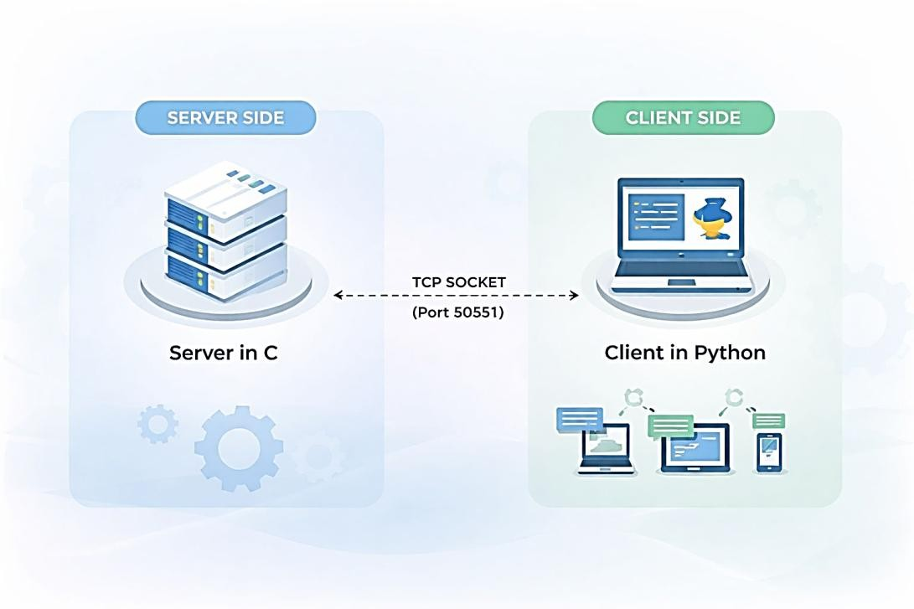

Custom Protocol Design(A1)

This protocol ensures reliable communication between the client and server. The use of the LEN field helps the server correctly identify message boundaries, even when partial data is received. It also prevents malformed or incomplete messages from being processed.
A custom communication protocol is implemented to facilitate the structured communication between the client and the server. Each message from the client starts with a size indicator followed by the message payload.

Client request format:
LEN:<length>
<payload>

Example:
LEN:20
LOGIN user1 123

The server processes the payload and returns a structured response. Responses are categorized as either successful or error messages.

Successful responses follow the format:
OK 200 SID:1015 <message>
Error responses follow the format:
ERR 400 SID:1015 <message>

This structured format ensures proper communication and error handling.

Multiprocessing Implementation(A2)

The server uses fork() to create a new process for each client connection. This allows multiple clients to communicate with the server at the same time.
if (fork() == 0) { close(server_fd); handle_client(client_socket, client_addr); exit(0);
}
Explanation:
Each client connection is handled by a separate child process, allowing concurrent communication.

Authentication System(A3)

Passwords are stored using a hashing technique to improve security. Instead of storing plain text passwords, the system converts them into hashed values. Although a simple hashing method is used, stronger techniques such as salted hashing (e.g., SHA-256 with salt) can further improve security. Session tokens expire after a period of inactivity (e.g., 5 minutes) to improve security.
The system supports user authentication through:
- REGISTER – creates a new user
- LOGIN – verifies credentials
- LOGOUT – ends session

Passwords are stored using a simple hashing technique. hash_password(pass,hashed);

A session token is generated upon successful login: generate_token(session_token);

Security Features(A4)

The system includes:
- Username validation
- Rate limiting
- Brute-force protection
- Payload size checking
These features help prevent misuse and improve security.

Username Validation

This prevents attackers from injecting malicious characters and ensures only valid usernames are accepted.

if (!isalnum(user[i])) { sprintf(response, "ERR 400 SID:1015 Invalid username\n"); }

Prevents invalid input.

Rate Limiting

This limits the number of requests per second, preventing denial-of-service attacks and server overload.
if (request_count > 5) { sprintf(response, "ERR 429 SID:1015 Too many requests\n");
}
Limits excessive requests.

Brute-force Protection

This blocks users after multiple failed login attempts, protecting accounts from password guessing attacks.
if (login_attempts >= 3) { sprintf(response, "ERR 403 SID:1015 Account locked\n"); }
Prevents repeated login attempts.

Payload Validation

This ensures that excessively large data is rejected to prevent buffer overflow attacks.
if (bytes > 4096) { sprintf(response, "ERR 413 SID:1015 Payload too large\n");
}
Restricts large data inputs.

Logging System(A5)

All client activities are recorded in a log file. Each entry includes timestamp, IP address, command, and result. fprintf(fp, "%s | %s:%d | PID:%d | USER:%s | CMD:%s |RESULT:%s\n", ...);
The log file used is:
server_IT24101551.log

Testing & Results

The system was tested for registration, login success, login failure, and account locking. Multiprocessing and logging were also verified successfully.

Server Running
Server running successfully and accepting client connections on port 50551.

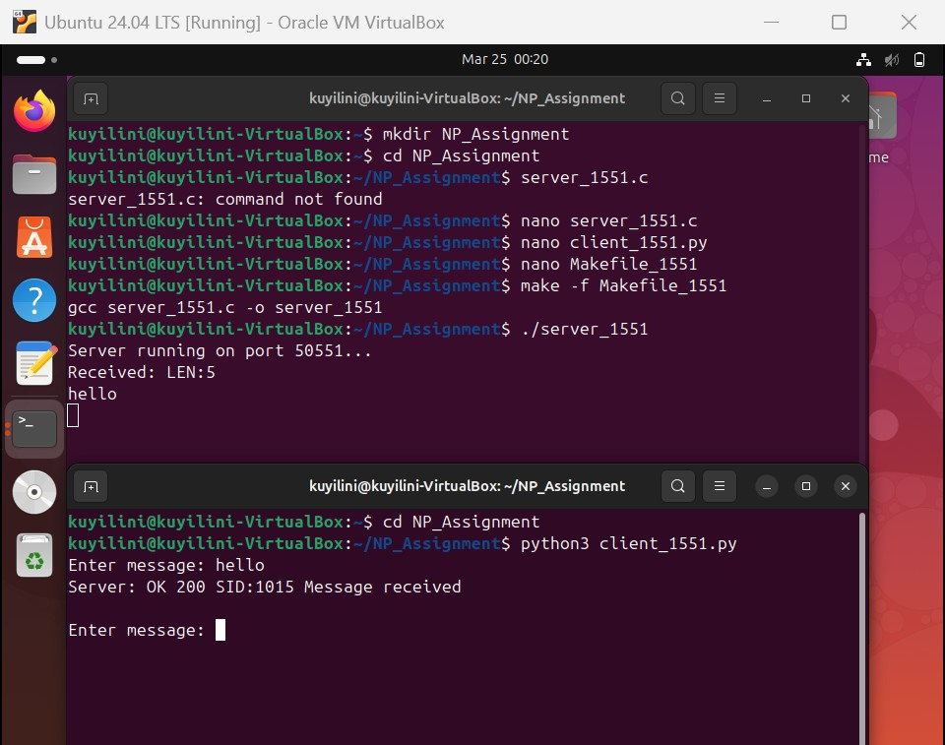
Figure 8.1: Server Running

Register
The REGISTER command successfully creates a new user account in the system.

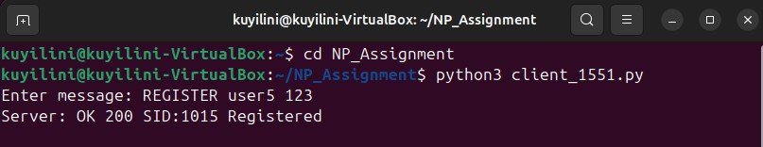
Figure 8.2: Register Command

Login Success
The LOGIN command validates the user credentials and generates a session token.

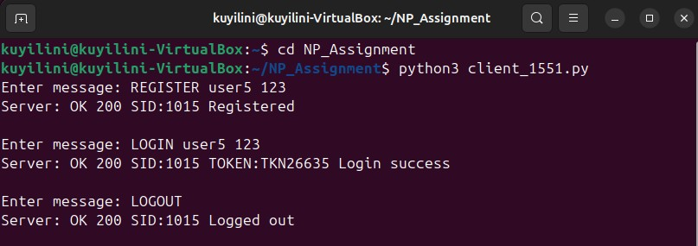
Figure 8.3: Login Success

Login Failure
Invalid login attempts are correctly rejected by the server.

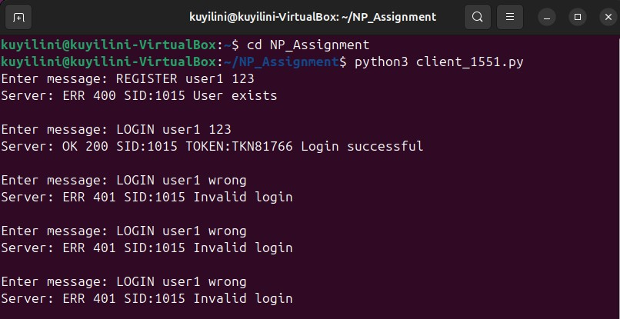
Figure 8.4: Login Failure

Account Lock
After multiple failed login attempts, the account is locked for security purposes.

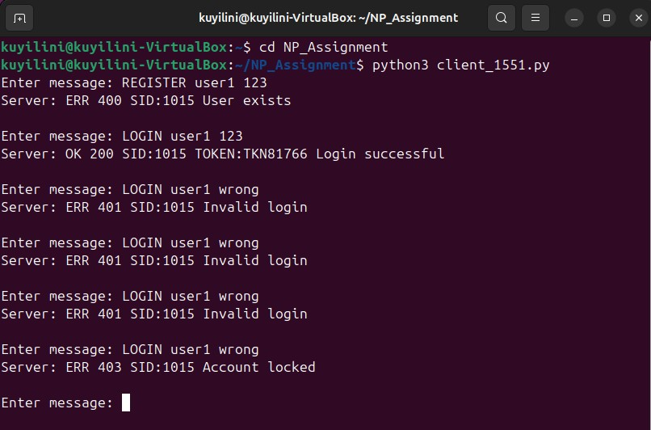
Figure 8.5: Account Lock

Multiprocessing
Multiple server processes are created using fork() to handle different client connections.

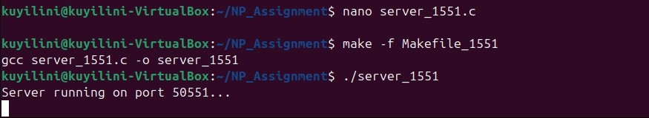
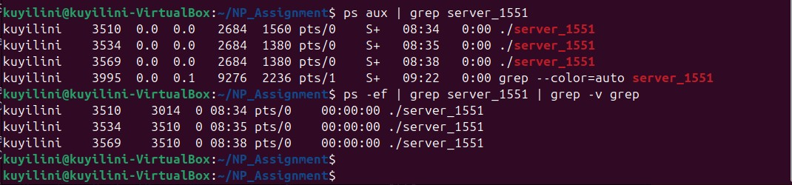
Figure 8.6: Multiprocessing

Log File
The log file records all client activities including commands and results.

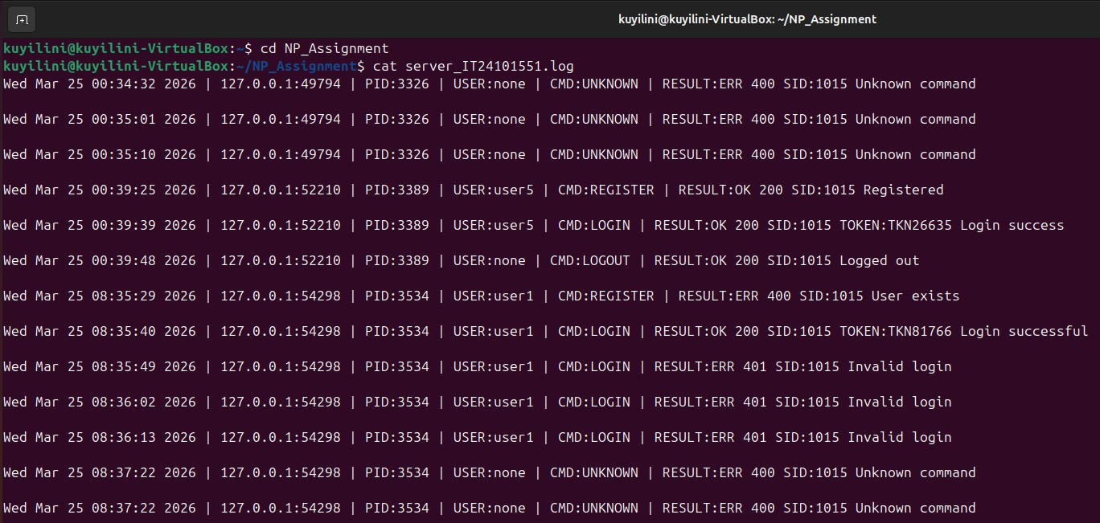

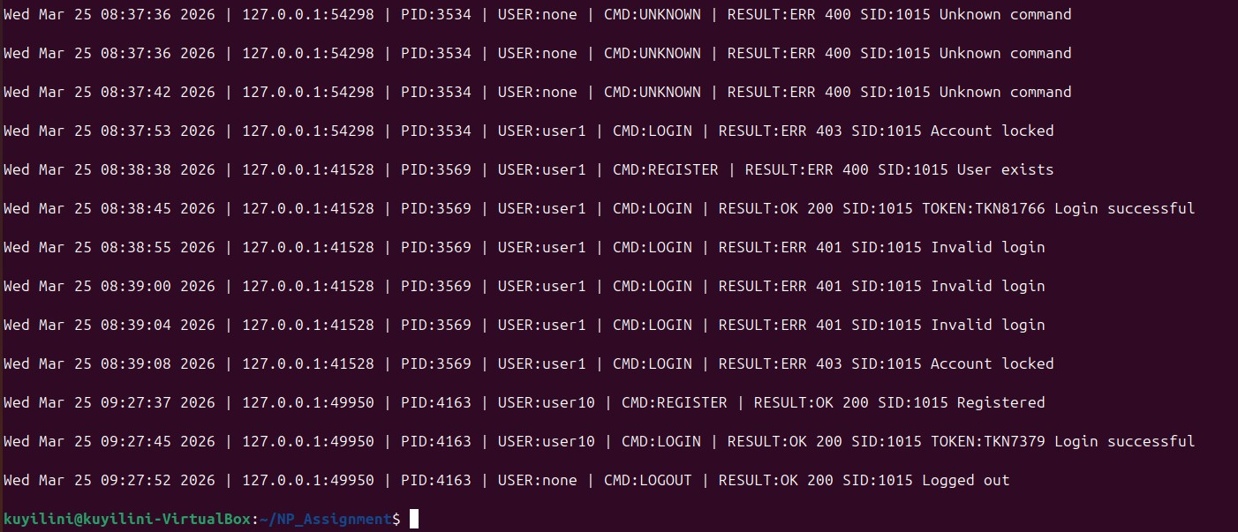
Figure 8.7: Log File

Hostname Configuration
The hostname command shows the identity of the server machine.

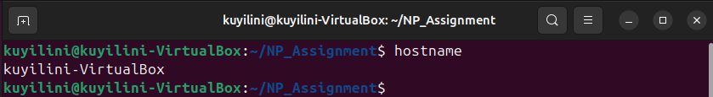
Figure 8.8: Hostname Configuration

Network Configuration
The network configuration displays the IP address used for communication.

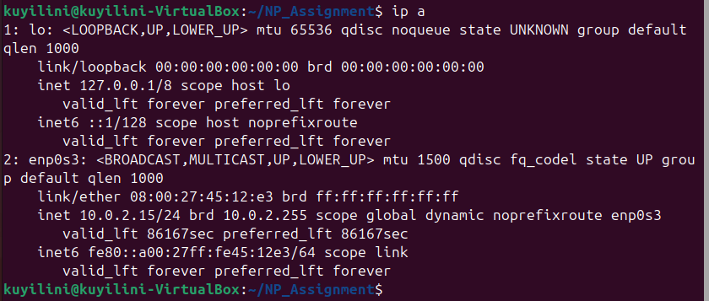
Figure 8.9: Network Configuration

Port Verification
The server is actively listening on port 50551 as shown in the output.

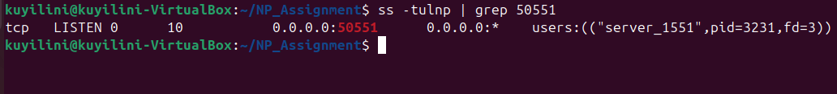
Figure 8.10: Server Port Verification

Zombie Process Check
No zombie processes are present, confirming proper process management.

Figure 8.11: Zombie Process Check

Multiple Message Handling
The server correctly handles multiple client requests sent continuously without mixing responses or crashing. The following figure demonstrates multiple commands processed successfully in sequence.

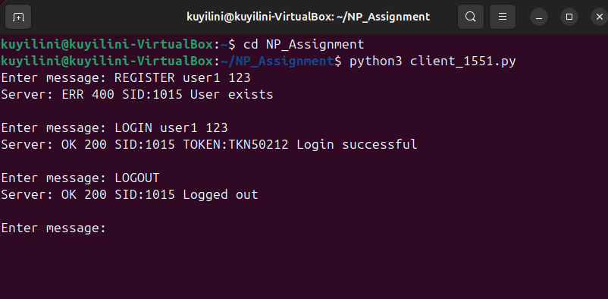
Figure 8.12: Multiple messages handled correctly by the server.

Project Files

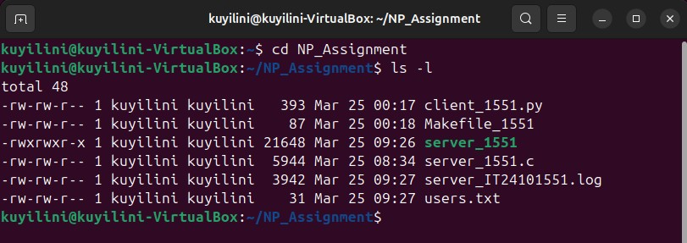
Figure 8.13: Project File

Challenges Faced

During the development of the system, a number of challenges were encountered. One of the main challenges was the parsing of the custom protocol format. This challenge was averted by effectively handling string operations.
Another challenge was the handling of multiple processes. During the development of the system, a number of zombie processes were encountered. This challenge was averted by effectively utilizing the waitpid() function.
Designing security features such as rate limiting and brute-force protection was a challenge. This challenge was averted by effectively handling the security features so that they operate effectively without interfering with the normal functioning of the system.

Conclusion

In conclusion, the assignment has successfully demonstrated the implementation of a secure and efficient client-server system using TCP. This client-server system supports multiple clients using multiprocessing and also ensures security by authenticating and implementing different security options. Future improvements include implementing stronger password hashing techniques and session timeout mechanisms.
The addition of a logging system makes the program even easier to use and maintain. It is evident that this project has given a good insight into socket programming, process management, and basic security options.

References

- Beej’s Guide to Network Programming
- RFC 793 – Transmission Control Protocol
- Linux Manual Pages

Appendix

Appendix A - Server Code

#include <stdio.h>
#include <stdlib.h>
#include <string.h>
#include <unistd.h>
#include <arpa/inet.h>
#include <sys/wait.h>
#include <time.h>

#define PORT 50551
#define BUFFER_SIZE 4096

char logged_user[100] = ""; char session_token[100] = "";

// Security globals int request_count = 0; time_t last_time = 0; int login_attempts = 0;

// Simple hashing void hash_password(char *input, char *output) {
int i; for (i = 0; input[i]; i++) { output[i] = input[i] + 3;
} output[i] = '\0';
}

// Generate token void generate_token(char *token) { sprintf(token, "TKN%d", rand() % 100000);
}

// Logging
void write_log(char *ip, int port, char *user, char *command, char *result) {
FILE *fp = fopen("server_IT24101551.log", "a");

time_t now = time(NULL); char *time_str = ctime(&now); time_str[strlen(time_str)-1] = '\0';

fprintf(fp, "%s | %s:%d | PID:%d | USER:%s | CMD:%s | RESULT:%s\n", time_str, ip, port, getpid(), user, command, result);

fclose(fp);
}

// Register user void register_user(char *user, char *pass, char *response) {

// Username validation for (int i = 0; user[i]; i++) { if (!((user[i] >= 'a' && user[i] <= 'z') || (user[i] >= 'A' && user[i] <= 'Z') || (user[i] >= '0' && user[i] <= '9'))) { sprintf(response, "ERR 400 SID:1015 Invalid username\n"); return;
}
}

FILE *fp = fopen("users.txt", "a+"); char line[200], u[100], p[100];

while (fgets(line, sizeof(line), fp)) { sscanf(line, "%s %s", u, p); if (strcmp(u, user) == 0) { sprintf(response, "ERR 400 SID:1015 User exists\n"); fclose(fp); return;
}
}

char hashed[100]; hash_password(pass, hashed); fprintf(fp, "%s %s\n", user, hashed); fclose(fp);

sprintf(response, "OK 200 SID:1015 Registered\n");
}

// Login user void login_user(char *user, char *pass, char *response) {

// Brute force protection if (login_attempts >= 3) { sprintf(response, "ERR 403 SID:1015 Account locked\n"); return;
}

FILE *fp = fopen("users.txt", "r"); char line[200], u[100], p[100];

char hashed[100]; hash_password(pass, hashed);

while (fgets(line, sizeof(line), fp)) { sscanf(line, "%s %s", u, p); if (strcmp(u, user) == 0 && strcmp(p, hashed) == 0) { strcpy(logged_user, user); generate_token(session_token); login_attempts = 0;

sprintf(response, "OK 200 SID:1015 TOKEN:%s Login successful\n", session_token); fclose(fp); return;
}
}

fclose(fp); login_attempts++; sprintf(response, "ERR 401 SID:1015 Invalid login\n");
}

// Handle client
void handle_client(int client_socket, struct sockaddr_in client_addr) { char buffer[BUFFER_SIZE];
int bytes;

char client_ip[INET_ADDRSTRLEN]; inet_ntop(AF_INET, &client_addr.sin_addr, client_ip, INET_ADDRSTRLEN); int client_port = ntohs(client_addr.sin_port);

while ((bytes = recv(client_socket, buffer, sizeof(buffer)-1, 0)) > 0) { buffer[bytes] = '\0';

char command[20] = "", user[100] = "", pass[100] = ""; char response[BUFFER_SIZE];

// Payload size check if (bytes > 4096) { sprintf(response, "ERR 413 SID:1015 Payload too large\n"); send(client_socket, response, strlen(response), 0); continue;
}

// Rate limiting time_t now = time(NULL); if (now == last_time) { request_count++; } else { request_count = 1; last_time = now;
}

if (request_count > 5) { sprintf(response, "ERR 429 SID:1015 Too many requests\n"); send(client_socket, response, strlen(response), 0); continue;
}

// Correct parsing char *payload = strchr(buffer, '\n'); if (payload != NULL) { payload++; sscanf(payload, "%s %s %s", command, user, pass);
} else {
strcpy(command, "UNKNOWN");
}

if (strcmp(command, "REGISTER") == 0) { register_user(user, pass, response); write_log(client_ip, client_port, user, "REGISTER", response);
}
else if (strcmp(command, "LOGIN") == 0) { login_user(user, pass, response); write_log(client_ip, client_port, user, "LOGIN", response);
}
else if (strcmp(command, "LOGOUT") == 0) { strcpy(logged_user, ""); strcpy(session_token, ""); sprintf(response, "OK 200 SID:1015 Logged out\n"); write_log(client_ip, client_port, "none", "LOGOUT", response);
} else {
sprintf(response, "ERR 400 SID:1015 Unknown command\n"); write_log(client_ip, client_port, "none", "UNKNOWN", response);
}

send(client_socket, response, strlen(response), 0);
}

close(client_socket);
}

// Main server int main() { int server_fd, client_socket; struct sockaddr_in address, client_addr; socklen_t client_len = sizeof(client_addr);

srand(time(0));

server_fd = socket(AF_INET, SOCK_STREAM, 0);

address.sin_family = AF_INET; address.sin_addr.s_addr = INADDR_ANY; address.sin_port = htons(PORT);

bind(server_fd, (struct sockaddr *)&address, sizeof(address)); listen(server_fd, 10);

printf("Server running on port %d...\n", PORT);

while (1) {
client_socket = accept(server_fd, (struct sockaddr *)&client_addr, &client_len);

if (fork() == 0) { close(server_fd); handle_client(client_socket, client_addr); exit(0); } else { close(client_socket);
}

while (waitpid(-1, NULL, WNOHANG) > 0);
}

return 0;
}

Appendix B – Client Code

import socket

HOST = "127.0.0.1"
PORT = 50551

client = socket.socket(socket.AF_INET, socket.SOCK_STREAM) client.connect((HOST, PORT))

while True:
msg = input("Enter message: ")

if msg.lower() == "exit":
break

payload = f"LEN:{len(msg)}\n{msg}" client.send(payload.encode())

response = client.recv(4096).decode() print("Server:", response)

client.close()

Appendix C - Project Files

File Name Description
server_1551.c | Server source code
client_1551.py | Client program
Makefile_1551 | Build file
server_IT24101551.log | Log file
users.txt | User database

