Internship on Title

SUMMER INTERNSHIP REPORT
Submitted by [Student Name] [Enrolment number]

In fulfilment for the award of the degree of DIPLOMA ENGINEERING
In

Information Technology Gyanmanjari Institute of Technology, Bhavnagar



Gyanmanjari Innovative University, Bhavnagar
April 2026

GYANMANJARI INNOVATIVE UNIVERSITY
Bhavnagar



GYANMANJARI INSITUTE OF TECHNOLOGY
BHAVNAGAR

A Project report On
[Project name]
Under Subject Of
Internship – DETXX16252 Diploma Semester – VI (Information Technology)

Submitted By

Sr. no | Student Name | Enrolment number
1 | Student name | 2012XXXXXXXX

[Concern faculty] (Faculty Guide)

Prof. Dhaval R Chandarana (Head of Department)

Academic Year 2025-2026


GYANMANJARI INSTITUTE OF TECHNOLOGY BHAVNAGAR

DEPARTMENT OF INFORMATION TECHNOLOGY ENGINEERING
CERTIFICATE
This is to certify that the basic process and framework has been satisfactorily carried out by [student name] [enrolnment number]
Under my guidance in the fulfillment of the course [PROJECT] during the academic year 2025-2026.

Date of submission:

Faculty In-Charge Internal Examiner External Examine

i


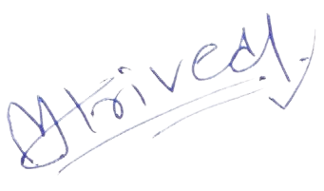
Internship Completion Letter
ii
During his internship, Japan worked on the project NER App – Equipment Rental App. His contributions and dedication to the project were commendable. Throughout his internship, Rudra demonstrated diligence, hard work, and a strong sense of curiosity. he actively engaged in various processes, showing a keen interest in learning and problem-solving.
During Internship, Rudra worked on “Microsoft Power App Trainee”. His performance exceeded expectations and was able to complete the project successfully.

We wish him all the best for his future career.

Yours Faithfully,

Global Tec Solution.

Site: https://globaltecsolution.com/ Mail: mihirtrivedi@globaltecsolution Phone No.+91 7600044534
Date: 30th May, 2024

Internship Completion Letter
Dear Sir/Ma’am,

This is to certify that Japan Mavani, a student of Gyanmanjari Institute of Technology, has successfully completed his internship in the field of Microsoft Power Apps Development from 16th January 2024 to 30th April 2024 (a total of 15 weeks) under the guidance of Mihir Trivedi.

Declaration



I hereby declare that the Internship report submitted along with the Intern entitled Internship on [Project Title/ Techstack] submitted in partial fulfilment for the degree of Diploma Engineering in Information Technology to Gyanmanjari Innovative University, bhavnagar, is Bonafide record pf original project work carried out by me at [company name]. under supervision of [Industry Expert/Industry mentor] and that no part of this report has been directly copied from any student’s report or taken from any other source, without providing due reference.

Name of Student Sign of Student
[Name of Stduent]

Name Of Student: | [Student Name]
Enrollment No.: | [Enrolment number]
Contact No.: | [Student number]
Email Id: | [Email Address]
College Name/Code: | Gyanmanjari Institute of Technology [129]
Branch/Sem.: | Information Technology / 6th
Student’s sign:

I have taken efforts in this project. However, it would not have been possible without the kind of support and help of many individuals and organizations. I would like to extend my sincere thanks to all of them.

I am highly indebted to [Faculty guide] and Prof. Dhaval R Chandarana for their guidance and constant supervision as well as for providing necessary information regarding the project & also for their support in completing the project. I would like to express my special gratitude and thanks to faculties for giving me such attention and time.

My thanks and appreciations also go to my colleague in developing the project and people who have willingly helped me out with their abilities.

Every project big or small is successful largely due to the effort of a number of wonderful people who have always given their valuable advice or lent a helping hand.

I sincerely appreciate the inspiration; support and guidance of all those people who have been instrumental in making this project a success. I would also like to thank all the faculty members of
I.T. department for their critical advice and guidance without which this project would not have been possible.

Last but not the least I place a deep sense of gratitude to my family members and my friends who have been a constant source of inspiration during the preparation of this project work.

Thank you.

Abstract

Need to Add Abstract of your project. Sample abstract is provided.

Timesheet cg revolutionizes time management within organizations, offering a streamlined solution for tracking and managing employee hours efficiently. With a focus on optimizing workflow and enhancing productivity, Timesheet cg delivers more than just a standard timesheet system—it's a pivotal tool for modern business operations.

Founded by a team of dedicated professionals with a keen understanding of workplace dynamics and technological innovation, Timesheet cg is committed to improving the precision and ease of timesheet management. From automated time tracking to insightful analytics, the platform is designed to empower both employees and managers.

Key features include real-time tracking, allowing users to accurately log hours worked and managers to approve or query entries seamlessly. Additionally, the system offers comprehensive reporting tools, enabling organizations to monitor labor costs and productivity trends effectively.

Whether you're aiming to refine payroll processes or enhance project management, Timesheet cg is your essential tool for achieving greater efficiency and compliance in the workplace. Adopt Timesheet cg today and transform your organization's approach to timesheet management.

INDEX

Sr. No. Content Name Page No.

- Introduction 1
  - Project Summary 2
  - Project details 2
  - Project Specification 3
  - Literature Review 3
  - Technology 4
- Project Management 5
  - Feasibility Study 6
    - Technical Feasibility 6
    - Time Schedule Feasibility 7
    - Operational Feasibility 7
    - Implementation Feasibility 7
  - Project Planning 7
    - Project Development Approach and Justification 7
    - Milestone & Deliverables 9
    - Roles & Responsibilities 9
    - Group Dependencies 10
  - Project Scheduling 10
  - Risk Management 10
    - Risk Identification 10
    - Risk Analysis 11
    - Risk Planning 11
- System Requirement Study 12
  - Study of Current System 13
  - Problems and Weakness of Current System 13
  - User Characteristics 13
  - Hardware and Software Requirements 13
  - Constraints 14
    - User Interface 14
    - Communications Interface 14
    - Hardware Interface 14
    - Criticality of the application 14
    - Safety and Security Consideration 14
  - Assumption and Dependencies 14
    - Assumptions 14
    - Dependencies 14
- Requirements of Proposed System 15
  - Main Module of the System 16
  - Module Descriptions 16
- System Design 17
  - Architecture Design 18
    - E-R Diagram 18
    - Use Case Diagram 19
    - Class Diagram 20
    - Activity Diagram 21
    - DFD Diagram 23
  - Data Dictionary 25
- Snapshots 28
  - Admin View 29
  - Client View 34
  - Other Functionality 36
- Implementation 37
  - Implementation Environment 38
  - Program Specification 38
  - Security Features 38
  - Coding Standard 39
- Testing 40
  - Testing Plan 41
    - Design Testing 41
    - Implementation Testing 41
    - Product Testing 41
  - Testing Stretegy 41
  - Testing Methods 43
    - Unit Testing 43
    - Integration Testing 43
    - Validation Testing 43
    - Storage Testing 43
  - Test Case 44
- Limitation And Future Enhancement 46
  - Limitation 47
  - Future Enhancement 47
- Conclusion And Discussion 48
  - Project Liabilities 49
  - Problem Encountered And Possible Solution 49
  - Summary of project work 49
  - References 50
  - Work Experience 50

Figure No. | Figure Name | Page No.
1 | Iterative Waterfall Model | 8
2 | E-R Diagram | 18
3 | Use Case Diagram | 19
4 | Class Diagram | 20
5 | Activity Diagram | 21
 | 5.1 User’s AD* | 21
 | 5.2 Web Admin AD* | 22
6 | DFD Diagram | 23
7 | Data Dictionary | 25
8 | Snapshots | 28
 | 6.1 Admin view | 29
 | 6.2 Client’s view | 34
 | 6.3 Other Functionality | 36

AD* : Activity Diagram

Table No. | Table Name | Page No.
1 | Schedule | 10
2 | TCT* Login Issue | 44
3 | TCT* Dashboard Issue | 44
4 | TCT* Match Timer Issue | 45
5 | TCT* Match Sharing Issue | 45

TCT* : Test Case Table

CHAPTER 1
INTRODUCTION

Project Summary

Project details

Project Specification

Literature Review

Technology

Chapter 1: Introduction

Project Summary:
"Time Sheet CG" is an efficient time management application meticulously designed to serve the needs of businesses and their employees. Emphasizing productivity and accuracy, this app facilitates the meticulous recording of work hours for each task or project. Crafted by professionals with expertise in workplace efficiency and software solutions, the application strives to streamline time tracking processes and enhance time accountability. Its standout features include hourly task updates, enabling employees to log their activities in real-time, and detailed time allocation records to monitor the distribution of effort across various assignments. With its intuitive design and robust functionalities, Time Sheet CG is set to become a vital asset for businesses wishing to optimize their workforce's time utilization.

Project Details:
"Time Sheet CG" is an innovative time management application tailored for professionals across various industries. Developed by a team of IT experts and business efficiency advocates, it offers live tracking of work hours and comprehensive task management for diverse professional activities. The app delivers insightful analysis of time spent and personalized reports to enhance employee productivity. With an emphasis on ease of use and streamlined functionality, Time Sheet CG is the ideal solution for individuals seeking to optimize their workday, improve task accountability, and foster collaborative time management among team members.

The technical architecture of Time Sheet CG is composed of several essential components:

    - Frontend Development: Time Sheet CG presents a user-centric interface designed for ease of navigation and efficient task recording. It moves beyond basic time-tracking by offering hourly updates, detailed task descriptions, and customized reporting tools.

    - Backend Infrastructure: Time Sheet CG runs on a dedicated server, which underpins the backend structure. This foundation is responsible for the secure storage of time data, processing of user inputs, and maintenance of the application's operational logic.
    - API Integration: The backend is equipped with APIs that facilitate various features within the app, such as real-time task updates, data synchronization, and analytic computations. These APIs enable fluid interaction between the app and other systems, ensuring data consistency and reliability.

By integrating sophisticated frontend functionalities with a strong backend system and consistent API interactions, Time Sheet CG stands out as a comprehensive tool designed to meet the time-tracking demands of a modern workforce.

Project Specification:
Time Sheet CG" is envisioned as a premier mobile application for efficient time management, specifically crafted for businesses and their employees. The application's primary goal is to facilitate meticulous tracking and analysis of work hours per task, thereby optimizing productivity and offering in-depth insights into time allocation.

Literature Name: Time Sheet CG: Streamlining Workforce Efficiency

Abstract:

Time Sheet CG presents an innovative approach to tracking professional time expenditure across various industries. It integrates a web-based interface that allows employees to promptly record their working hours on different projects via any internet-connected computer terminal. This system ensures accurate and streamlined time logging, promoting efficient workforce management and detailed reporting for both individuals and teams.

Description:

Time Sheet CG transforms workforce time management by offering a platform where employees can easily record and monitor time spent on tasks. Through a well-designed interface and organized data structuring, the web pages are engineered to facilitate a seamless experience for users. The system prioritizes consistent presentation of time logs, allowing for transparent access to time-related data for all parties involved.

Conclusion:
Time Sheet CG is crafted to overcome the inefficiencies found in conventional time-tracking methods by providing an accessible, centralized solution for global workforces. It fosters a direct connection between time spent on tasks and overall productivity. Consequently, this mitigates the need for physical time tracking methods, cutting down on administrative efforts and costs. Time Sheet CG paves the way for heightened operational efficiency, enabling real-time insights and fostering a culture of accountability and time ownership within organization.

Technology:
- Platform: Microsoft PowerApps
- Client OS: Cross-platform compatibility (Windows 10, macOS, Android, iOS)
- Client Authoring: PowerApps Canvas with support for rich UI elements and customizations using formulas similar to Excel
- Code Behind: Utilizing Microsoft’s Power Fx, a low-code programming language for expressing logic across the Power Platform
- Data Service: Microsoft Dataverse, providing a scalable and secure data platform with rich data types and business logic
- Integration: Azure services for advanced functionalities, including Azure Functions for serverless computing and Azure Logic Apps for workflow automation
- Version & Source Control: Integration with GitHub for version control and source code management
- Backend Tools: Utilization of Azure SQL Database for robust and scalable relational database service

CHAPTER 2

Project Management

Feasibility Study

  - Project Planning

  - Project Scheduling
  - Risk Management

Chapter 2: Project Management

Feasibility Study

- The feasibility study for the Time Sheet CG application underscores a significant advancement in workplace efficiency tools. This project, uniquely designed for time management within businesses, combines a user-friendly interface with the powerful capabilities of Microsoft PowerApps, Dataverse, and Power Automate.
- In summary, Time Sheet CG exhibits considerable promise in enhancing time management and productivity for businesses and their employees. Careful strategic planning, alongside effective training and support mechanisms will be crucial in overcoming the market's existing solutions. The feasibility study confirms the project's potential for success, emphasizing the importance of objective analysis in establishing the credibility and viability of the application.

Technical Feasibility
      - At this stage, we evaluate if the Time Sheet CG application is technically feasible, focusing on the integration and functionality within the Microsoft Power Platform ecosystem.
      - The technical feasibility assessment centers on understanding the capabilities of Microsoft PowerApps, Dataverse, and Power Automate, ensuring they align with the application's requirements. This involves evaluating the platform's ability to support a user-friendly interface, robust data management, and automated workflows.
Front-end selection:

      - The application leverages PowerApps for its graphical user interface, prioritizing ease of use and accessibility.
      - Designed for flexibility, it allows for seamless updates and integration with other Microsoft services.
      - PowerApps supports direct connections to Dataverse, enabling a robust backend without traditional server dependencies.
Back-end selection

      - Dataverse offers support for multiple users, ensuring efficient and secure data handling.
      - It provides efficient data storage and retrieval, crucial for the application's real-time tracking features.
      - The integration between PowerApps and Dataverse ensures compatibility and simplifies implementation, meeting the project's technical requirements.

Time Schedule Feasibility

      - Time schedule feasibility assesses the realism of the allocated timeframe for project completion. It underscores the importance of finishing projects promptly to prevent failure due to prolonged development times. This aspect ensures projects are completed before the technology or need for the project becomes outdated or redundant.

Operational Feasibility
      - The Operational feasibility evaluates how effectively the proposed system addresses identified problems and leverages opportunities outlined during the scope definition. It also considers whether the system meets the requirements specified in the requirements analysis phase. The "Time Sheet CG" app is designed to encompass all necessary features, fulfilling the requirements identified during the analysis phase, thus confirming its operational feasibility.

Implementation Feasibility
      - The clarity and stability of project planning and requirements eliminate any ambiguity, indicating that the "Time Sheet CG" project is practical and ready for implementation. Our thorough planning and defined requirements affirm the project's feasibility for development.

Project planning
Project planning is a part of project management. Every new project requires understanding of the science behind the project, the techniques involved and the elements to be handled to give the result. Hence, the initial period was spent in surfing a number of sites. We need to do domain study for better understanding of the project and preparing project synopsis.

Project development approach and justification
      - Addressing real-world problems in an industry context requires adopting a development strategy that integrates process, methods, and tools across various project phases. This approach, often referred to as a process model or software engineering model, is crucial for structuring the development process of "Time Sheet CG." Our chosen methodology is designed to ensure the project's success by aligning with industry best practices and the specific requirements of our project.

The choice of a process model is influenced by the project's nature, the tools and methods to be utilized, and the required deliverables and controls. For "Time Sheet CG," the iterative waterfall model has been selected due to its alignment with our project's characteristics.

ITERATIVE WATERFALL MODEL
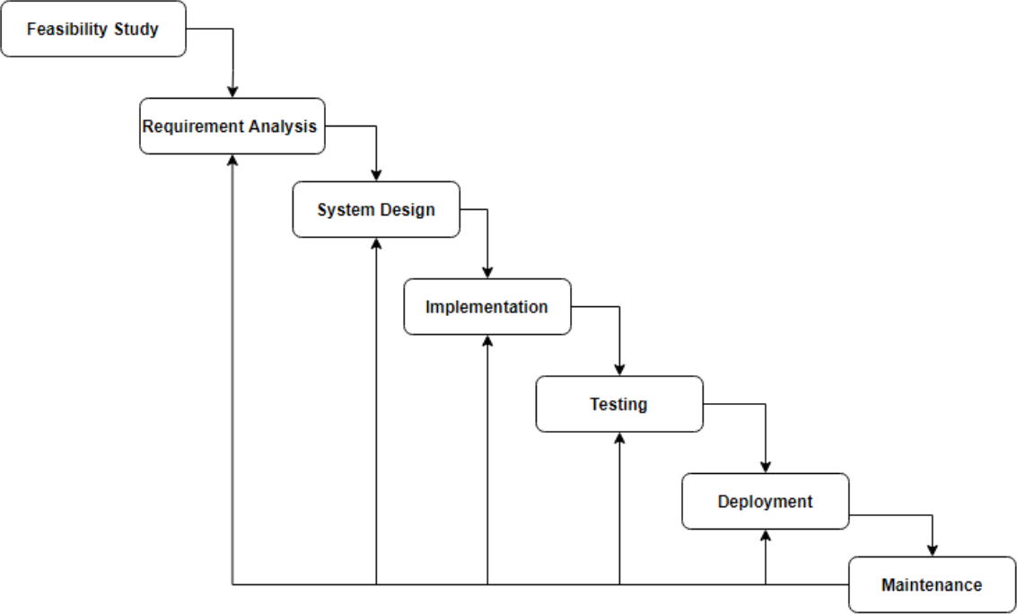

[Figure 1: Iterative Waterfall Model]
Explanation:
      - The iterative waterfall model is extensively adopted in software development.
      - It emphasizes early error detection, ideally during the phase where it occurs, through a concept known as phase containment of errors
      - This model facilitates feedback from each phase to the preceding ones, allowing for timely corrections of errors.
      - The model's feedback paths enable prompt error correction, essential for our project's clear and well-defined requirements.
      - Its simplicity ensures ease of understanding and implementation, fitting for our project's scope and team capabilities.
      - Feedback paths allow programmers to rewrite or change the code of some phase, and they are reflected at later phase. How it is suitable for our system?
      - As this project’s Requirement is well specified and clear so it is suitable for it.

      - It divides complex tasks to smaller subtasks, so it is suitable for

Milestone and Deliverables

      - Defined during project planning, milestones serve as critical checkpoints to gauge progress. They help in identifying vital project activities, setting targets, and marking significant phases such as the start or end of key tasks.
      - These are tangible or intangible outputs of the project, measurable and verifiable, that must be completed and delivered under the project's agreement terms.
      - First Milestone: Conduct an analysis of the application and the technology utilized. Submit industry-defined problems to both the college and university.
      - Second Milestone: Complete technology analysis, establish the software design approach, select the development model, and define basic functionalities required for further development and analysis.
      - Third Milestone: Decide on the project approach and design; outline the modules and their respective responsibilities. Database design is also concluded in this phase.
      - Fourth Milestone: With the database design finalized, estimate the time required for coding and developing the modules.
      - Fifth Milestone: Execute the coding phase for the application.
      - Sixth Milestone: Perform application testing to ensure functionality and reliability.

Roles & Responsibilities

      - Roles: These represent the positions or functions that team members fulfill within the project. Roles define the scope of work and expectations for each team member.
      - Responsibilities: These are the specific tasks or duties tied to each role. Responsibilities outline what each team member is expected to accomplish or manage, ensuring accountability for their part in the project.
      - Throughout all stages of the project, guidance and oversight will be provided by our internal guide, Prof. Vishakha Savani. This ensures that the project aligns with academic standards and objectives, while also benefiting from professional expertise and direction.

Group Dependencies
      - Group Dependency Dynamics: This project will encounter various types of dependencies among groups, pivotal for seamless coordination and progress.
      - Systematic Progression : Developers and designers are tasked to follow a meticulously structured plan, ensuring that all tasks progress in a coherent and interconnected manner.
      - Sequential Workflows: The workflow is designed to unfold in a sequential pattern, with each phase dependent on the completion of its predecessor to maintain a fluid project trajectory.

Project Scheduling

Task | Expected Days
Analysis | 30 days
Design | 30 days
Coding | 180 days
Testing | 20 days
[Table 2.1: schedule]

Risk Management

- Proactive Approach: Risk management is integral to the project lifecycle, aiming to identify, assess, and respond to potential risks in order to safeguard the project's objectives.
- Preventative Strategy: It's a forward-looking process, essential for preempting risks before they evolve into tangible issues, thereby ensuring project resilience.
- A risk is anything that could potentially impact your project’s timeline, performance, or budget. Risks are potentialities, and in a project management context, if they become realities, they then become classified as “issues” that must be addressed.
- So, risk management is the process of identifying, categorizing, prioritizing, and planning for risks before they become issues.

Risk Identification
      - Early Detection: Focuses on the early and ongoing detection of potential threats that could negatively impact the project's ability to meet its performance or outcome goals.determines which risks might affect the project and documents their characteristics.

      - Source Identification: Risks are identified through a thorough review of previous project documentation and insights from similar projects, with an eye on both internal and external origins.

Risk Analysis
      - Risk Evaluation: Involves a detailed assessment of identified risks, categorizing them based on their potential impact on the project.
      - It maps the risk and makes an estimate of impact of the risk on the project.

      - It has two approaches: first qualitative and second quantitative.
      - Qualitative Analysis: Assesses the probability and impact of risks through a descriptive lens, aiming to prioritize risks based on severity.
      - Quantitative Analysis: Translates risk impacts into numerical data, providing a basis for estimating potential cost and time overruns.

Risk Planning
      - Mitigation Strategies: Outlines specific actions and plans to address identified risks, employing tactics such as avoidance, mitigation, transfer, or acceptance.
      - We can handle risk by four ways: avoid, resolved, Transfer, and assigned.
      - Early Planning: Stresses the importance of integrating risk management from the project's inception and maintaining vigilance through its conclusion, ensuring a proactive stance on potential challenges.

CHAPTER 3

System Requirement Study

Study of Current System

Problems and Weakness of Current System

User Characteristics

Hardware and Software Requirements

Constraints

  - Assumption and Dependencies

Chapter 3: System Requirement Study

Study of Current System
The analysis of the existing system and comparable platforms revealed a clear understanding of the current functionalities and the workflow processes involved in development. This investigation highlighted several areas for potential enhancements or modifications to improve efficiency and utility in the system's usage.

Problems and Weakness of Current System
- Manual work.
- Managing large data.

User Characteristics
Understanding the characteristics of the users is crucial for the project's success. This analysis helps in tailoring the system to meet the specific needs of its primary users - individuals and organizations. By continuously monitoring project alignment with user needs, the development can remain user-centric. Mainly two typeof user comes into picture:
- Users
- Organizations
In this application the users are users and organization. Users log into to find their product expo where organizations use to show their product to global users and other organizations.

Hardware and Software Requirements
- Hardware Requirement
  - Development Side: Minimum required, Pentium IV processor (2 GHZ or higher is recommended), RAM with minimum 512 Mb, Disk space: 1 GB, Mouse and keyboard are needed as input and a monitor.
  - Deployment Side: Most compatible Domain which is provided us at least 1gb virtual storage and give support of
- Software Requirement
  - Development side: PowerApps, Power Automate, Dataverse, Dynamic 365, Azure Blob
  - Deployment side: Domain

Constraints

User Interface
Description: The project emphasizes providing an interactive user interface (UI) tailored for both Android and iOS users to enhance usability and user experience. Communication Interface. The project utilizes email notifications and social media advertising as primary channels to inform and remind users about product events, ensuring engagement and participation.

Hardware Interface
The project's success hinges on the availability of adequate hardware resources for implementing and testing within a high-performance environment. This includes the necessity for smart Android devices or computers that meet the specified hardware and software criteria.

Criticality of the project
Internet Connectivity: The application's functionality is significantly impacted by slow internet connections, emphasizing the need for robust internet service. Additionally, it requires specific hardware capabilities to ensure smooth operation of the software application.

Safety and Security Consideration
Access Control: System access is rigorously controlled through unique usernames and passwords assigned to each user. This measure safeguards product data and other sensitive information from unauthorized access.

Assumptions & Dependencies

Assumptions
      - A user of an application may have knowledge of operating any supported device.

Dependencies
      - Device dependency
      - Operating system dependencies
      - Internet availability

CHAPTER 4

Requirements of Proposed System

Main Module of the System

Module Descriptions

Chapter 4: Requirement of Proposed System

Main Module of the System

The overarching goal is to create a robust and user-friendly system that enables users to attend product exhibitions from any location worldwide. Simultaneously, it allows organizations or individuals to showcase their products to a global audience efficiently, with minimal human intervention, cost, and maximum global reach.
As of our project plan, we divide into three modules:
    - User interface
    - Admin
    - Sub-Admin

Module Description

Admin:
The admin module serves as the central authority, granting exhibitors the permission to showcase their products or prototypes. It oversees all exhibition activities, ensuring compliance and managing user and exhibitor access.

Sub Admin:
Sub-admins assist in the management of exhibitions under the guidance of the Admin. They facilitate real-time presentations and the distribution of invitations to users, ensuring a seamless and interactive exhibition experience.

User interface:
This module is designed for users to navigate and interact with the virtual exhibition space. It offers access to real-time information, enabling users to engage directly with exhibitors and explore products in detail.

CHAPTER 5

System Design

Architecture Design

  - Data Dictionary

Chapter 5: System Design

System Architecture Design

E-R Diagram
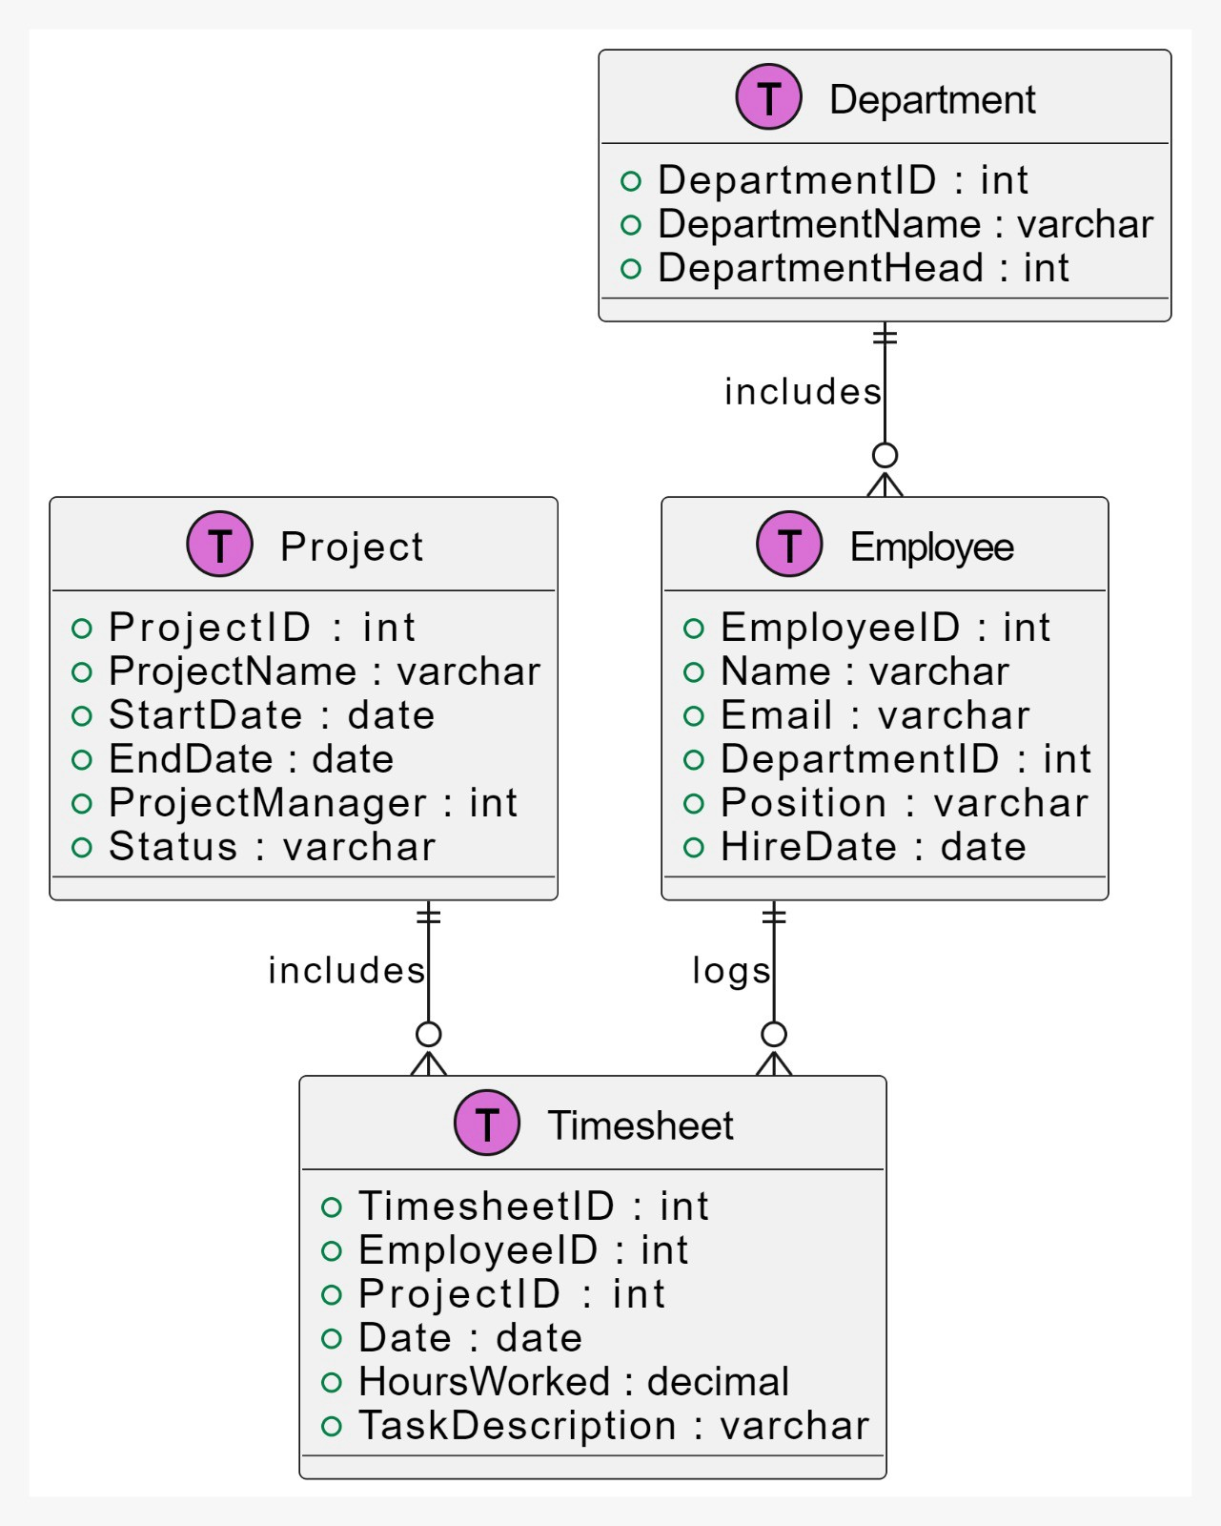

[Figure 2: E-R Diagram]

Use Case Diagram

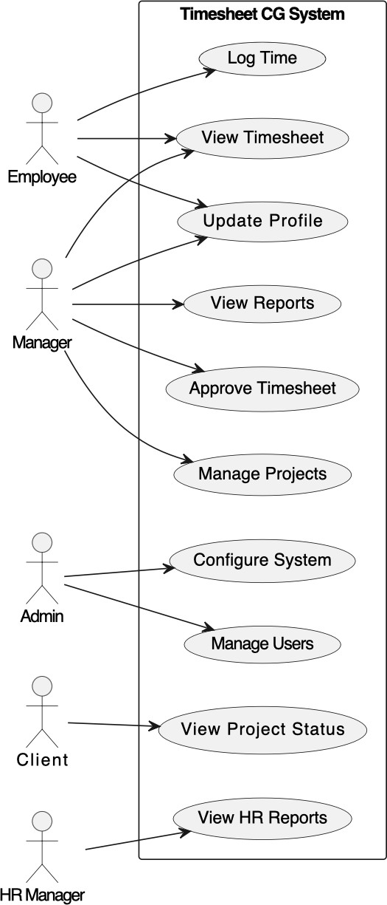

[Figure 3: Use Case Diagram]

Class Diagram
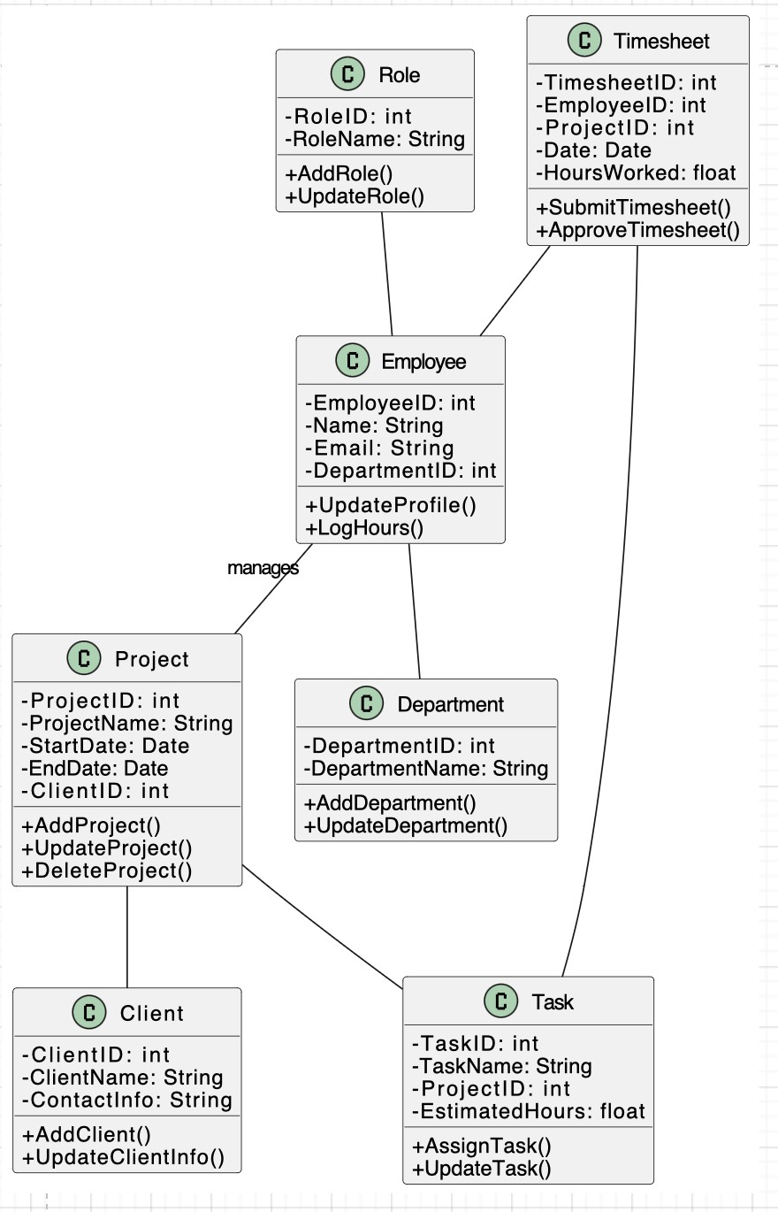
[Figure 4: Class Diagram]

Activity Diagram
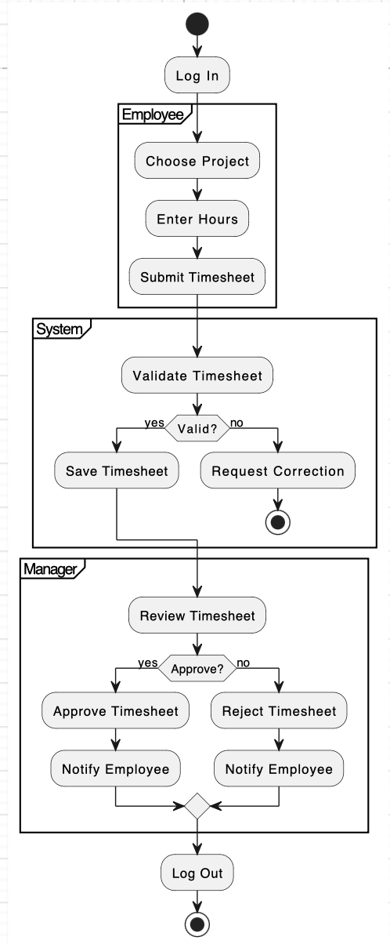

[Figure 5.1: User’s Activity Diagram]

    - Web Admin Activity Diagram

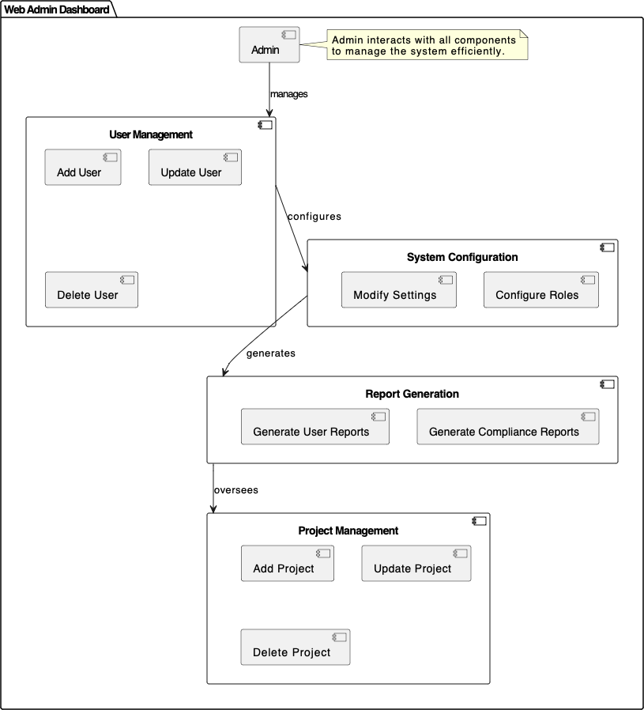

[Figure 5.2: Web Admin Activity Diagram

Data Flow Diagram
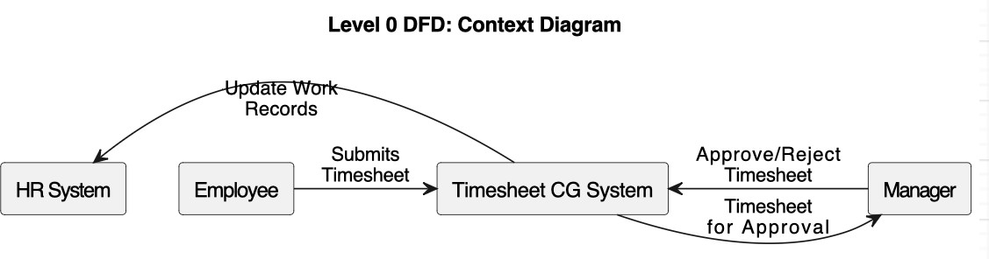
[Zero level data flow diagram]

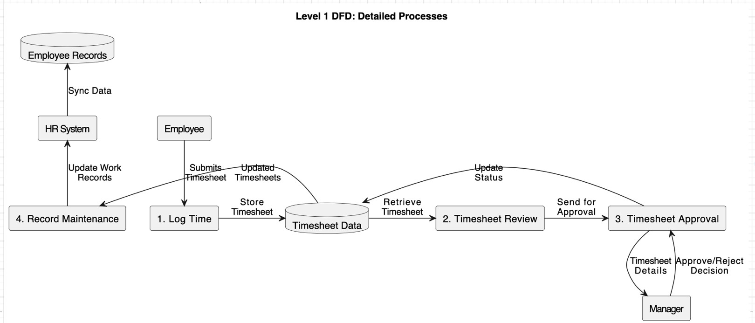
[First level data flow diagram]

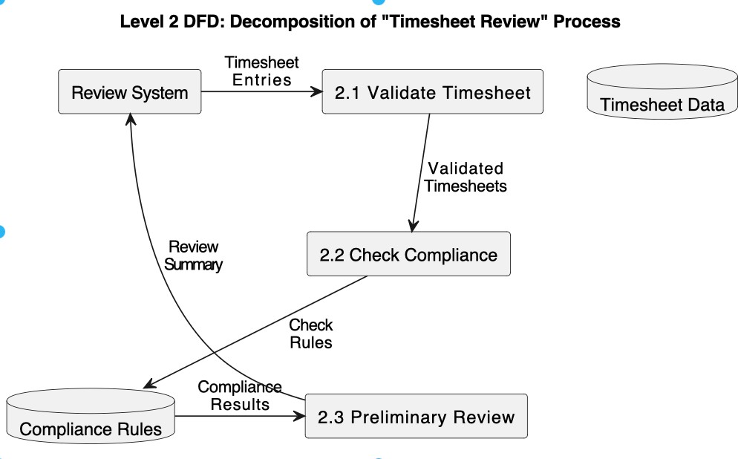

[Second level data flow diagram]

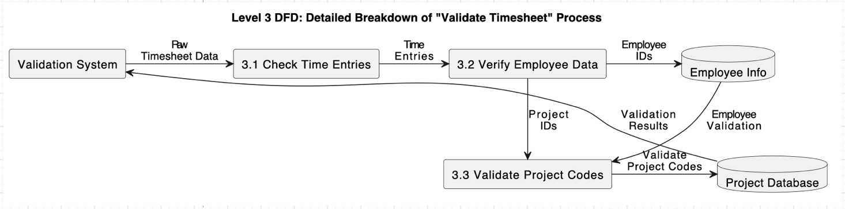

[Third level data flow diagram] [Figure 6: Data FlowDiagram]

Data Dictionary
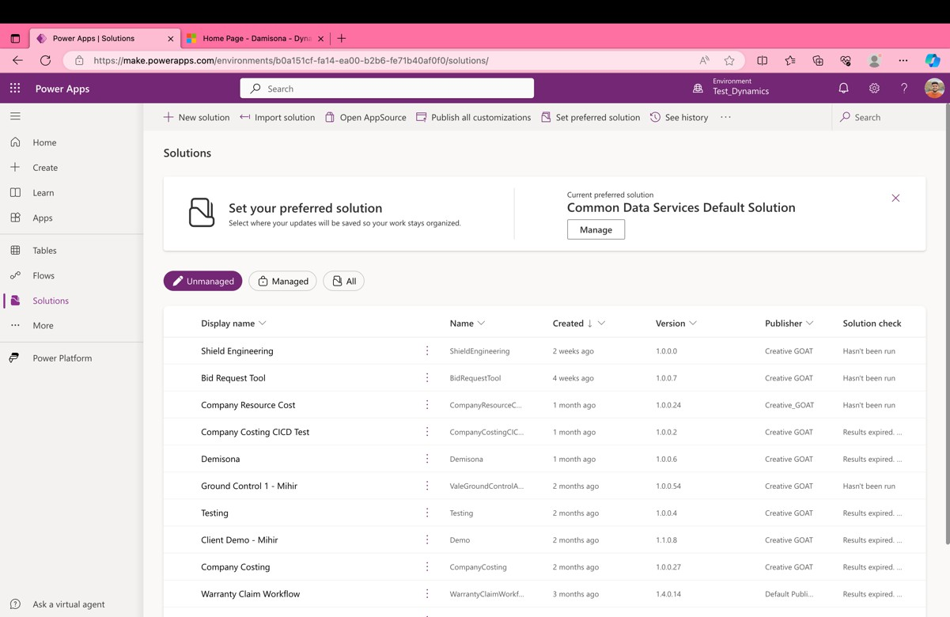

Weekly Timesheet CG [Table 5.2.1]
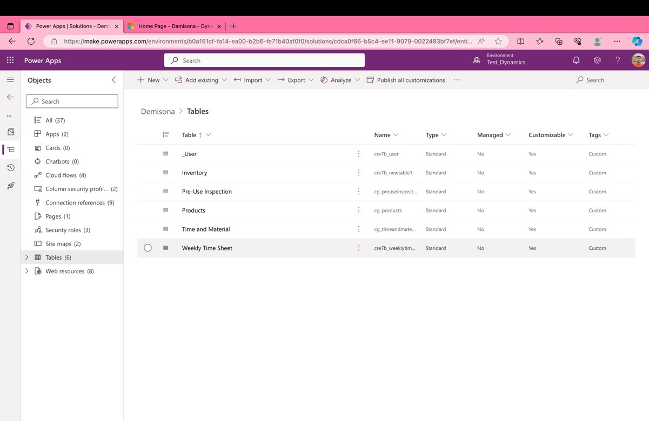
Weekly Timesheet CG [Table 5.2.2]

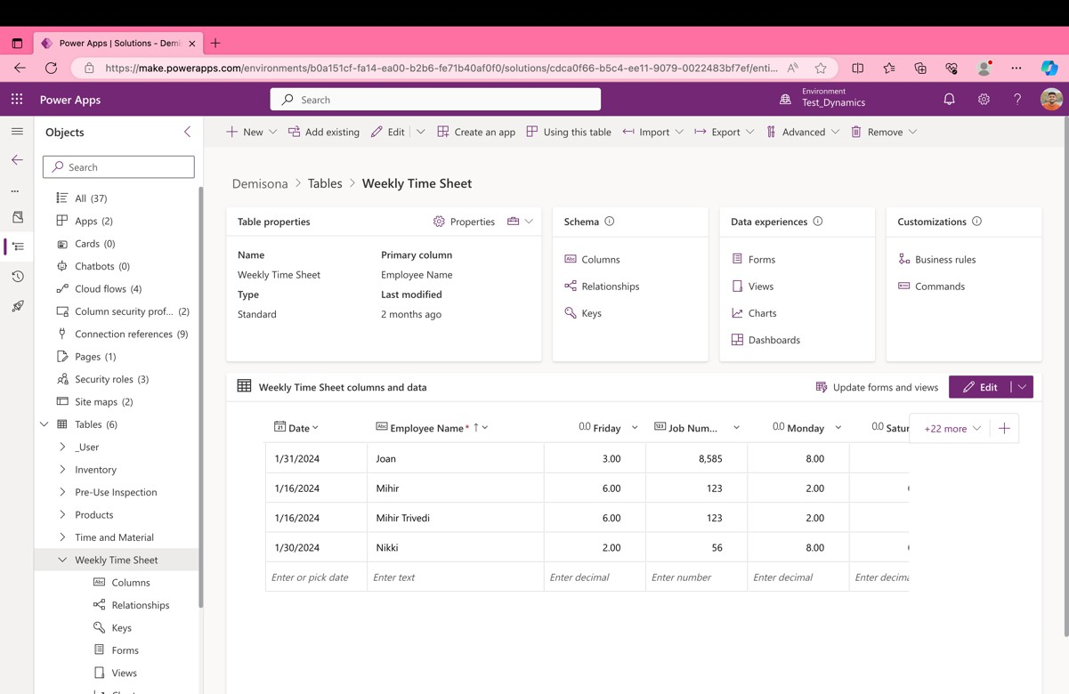
Weekly Timesheet CG [Table 5.2.1]
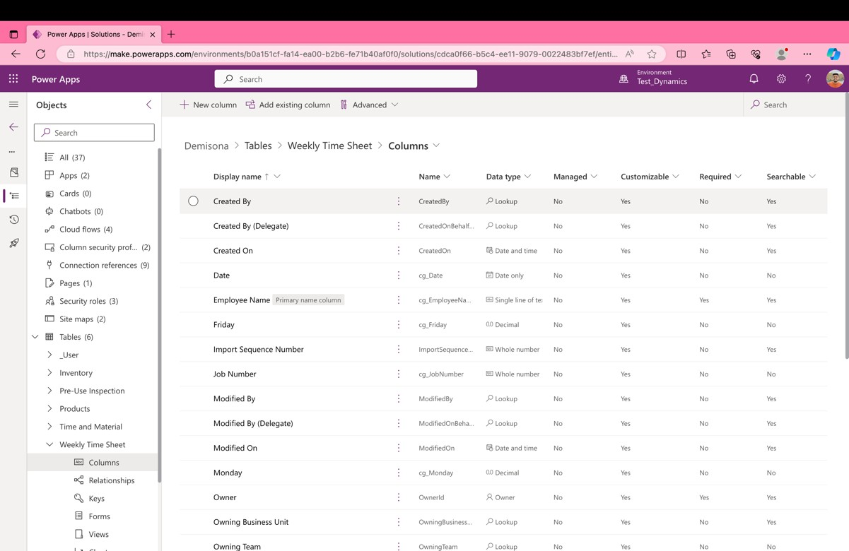
Weekly Timesheet CG [Table 5.2.1]

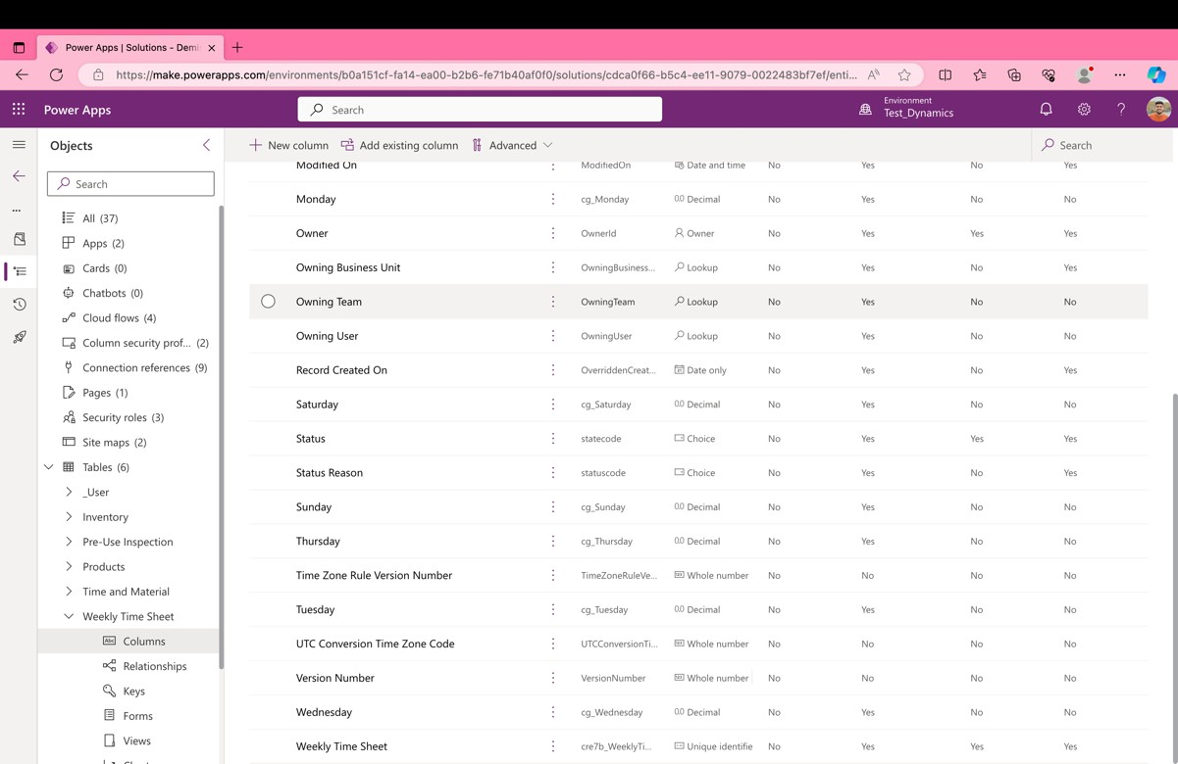

Weekly Timesheet CG [Table 5.2.1]

CHAPTER 6

SnapShots

Admin View

Client’s View
  - Other Functionality

Chapter 6: Snapshots

Admin View

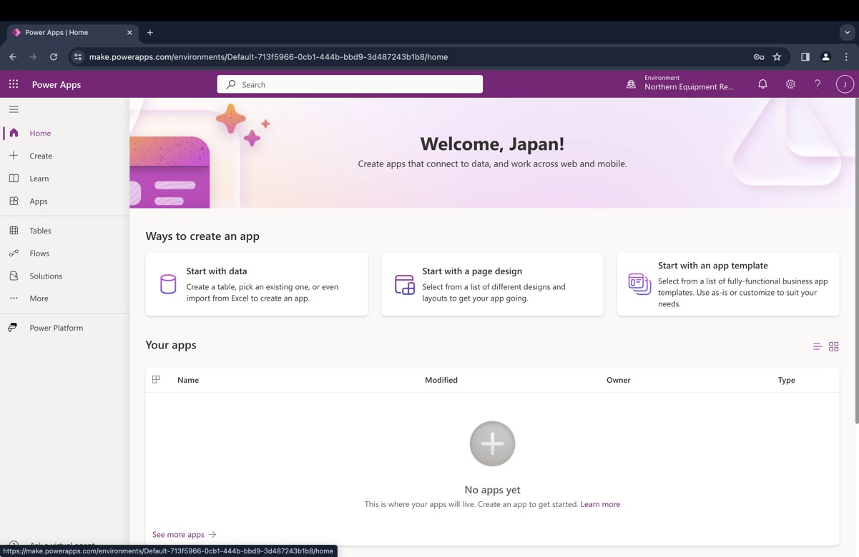
Weekly Timesheet CG [Table 5.2.1]
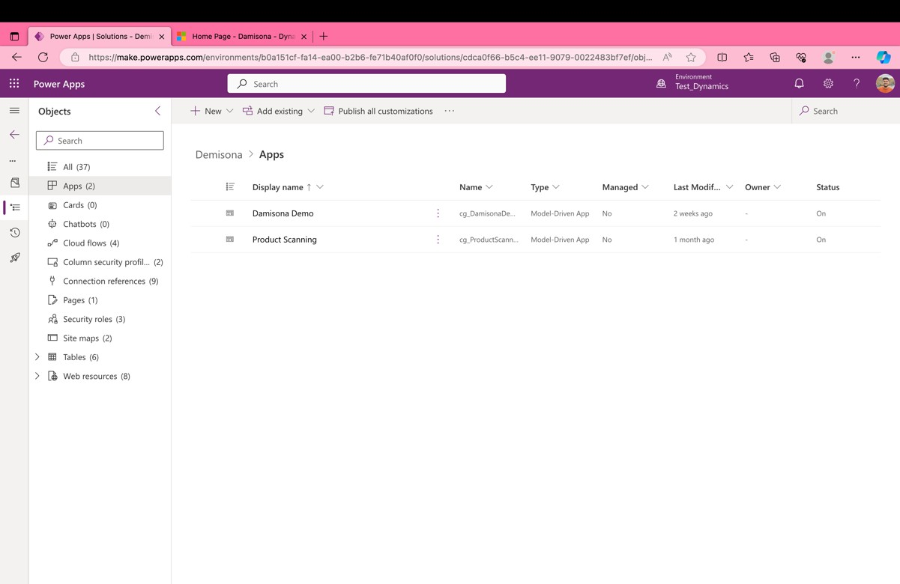
Weekly Timesheet CG [Table 5.2.1]

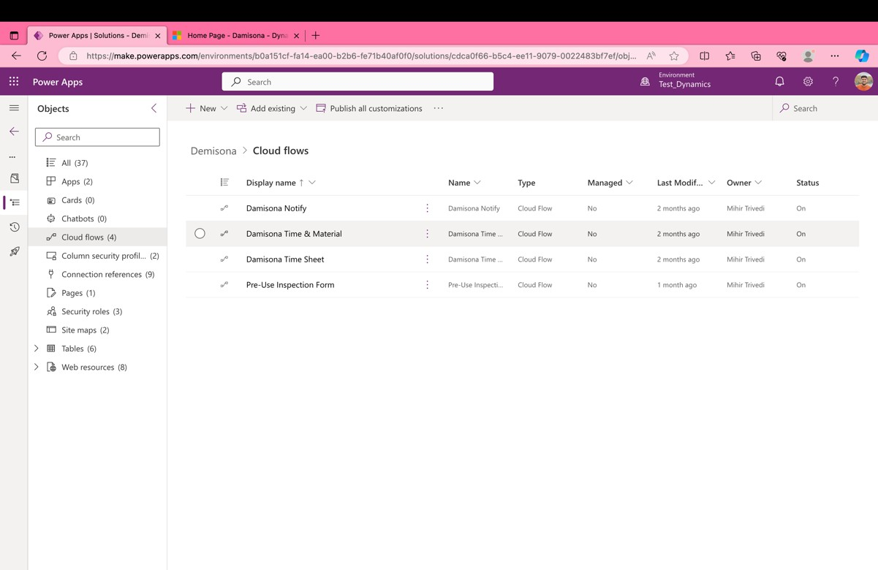
Weekly Timesheet CG [Table 5.2.1]

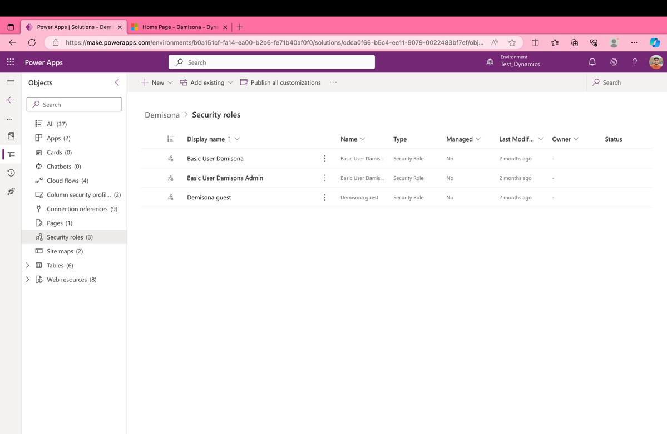
Weekly Timesheet CG [Table 5.2.1]

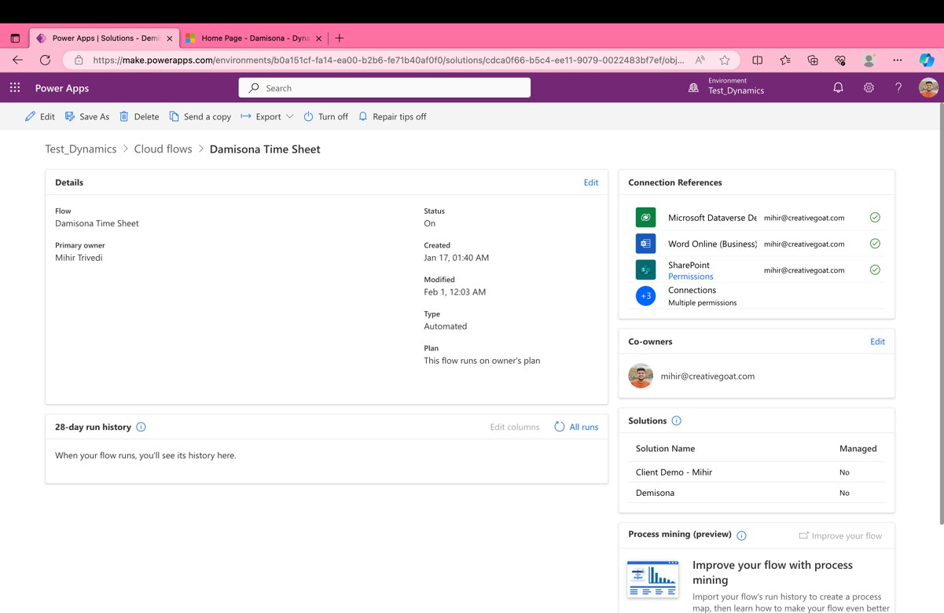
Weekly Timesheet CG [Table 5.2.1]
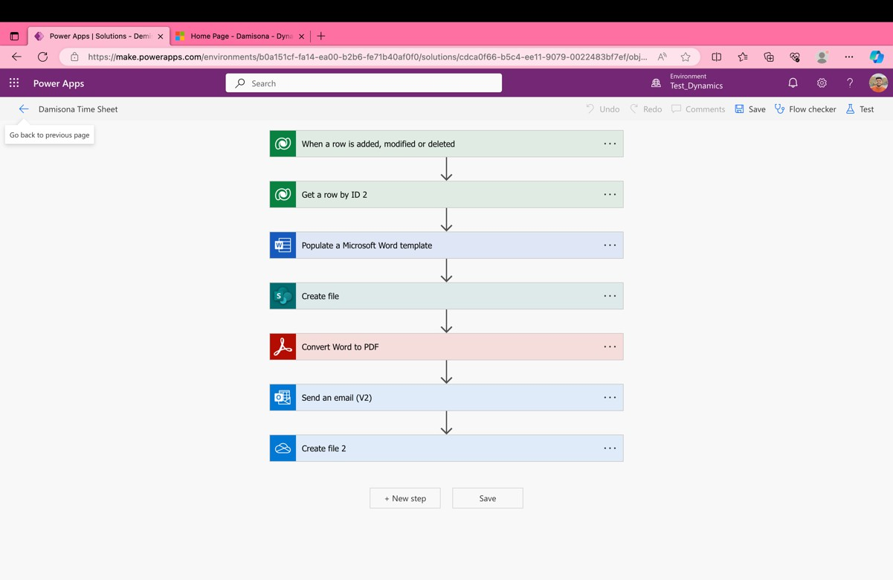
Weekly Timesheet CG [Table 5.2.1]

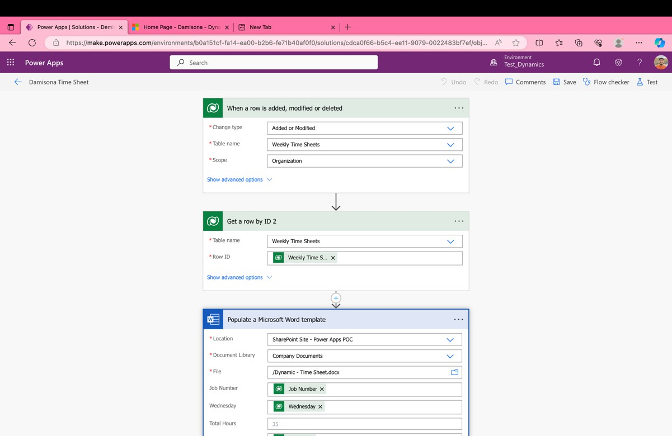
Weekly Timesheet CG [Table 5.2.1]
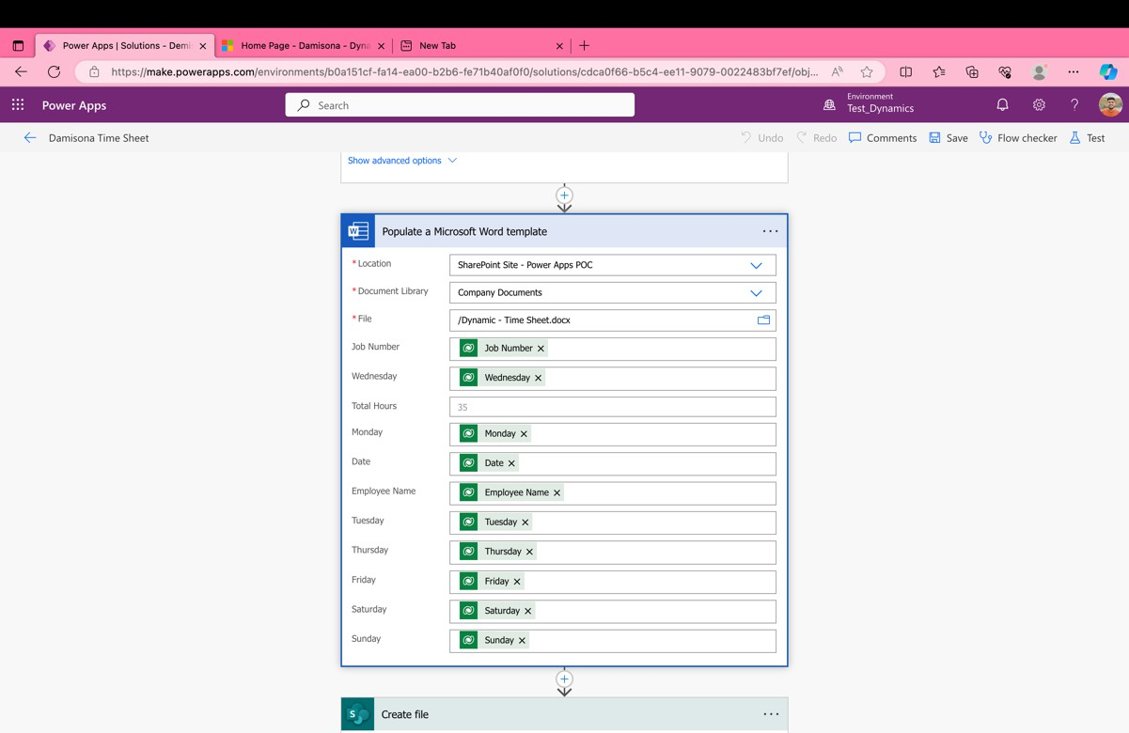
Weekly Timesheet CG [Table 5.2.1]

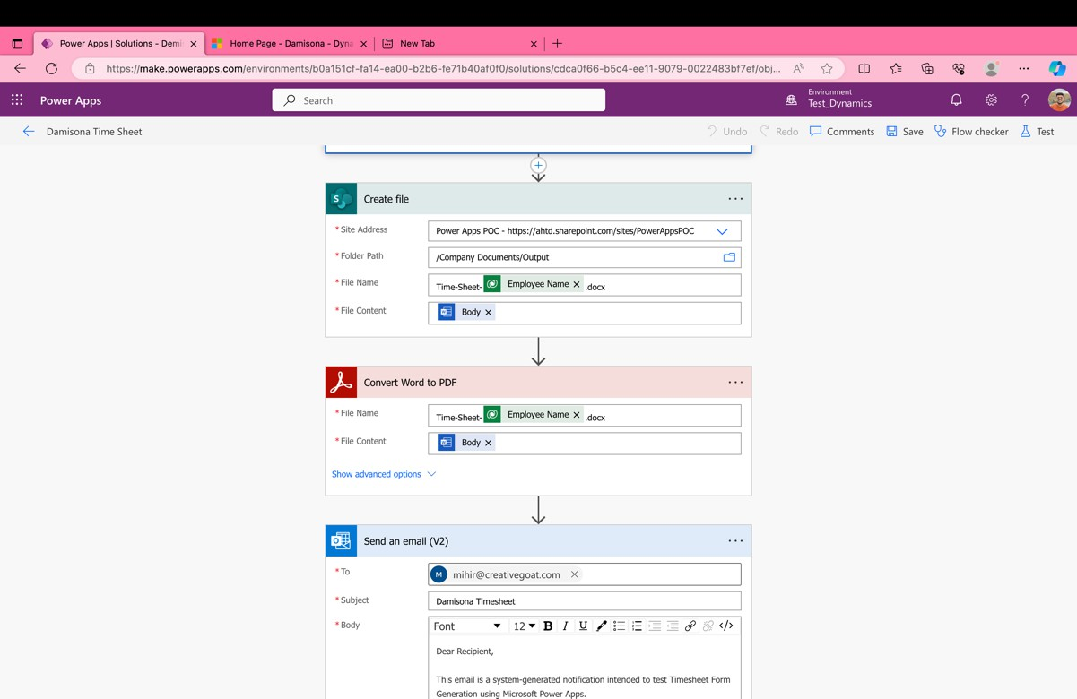
Weekly Timesheet CG [Table 5.2.1]

Client-View

Weekly Timesheet CG [Table 5.2.1]

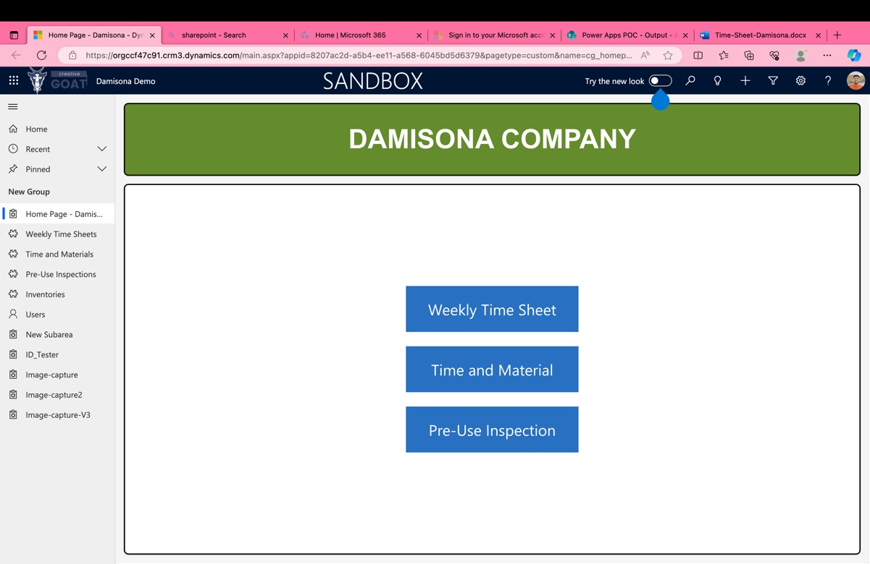
Weekly Timesheet CG [Table 5.2.1]

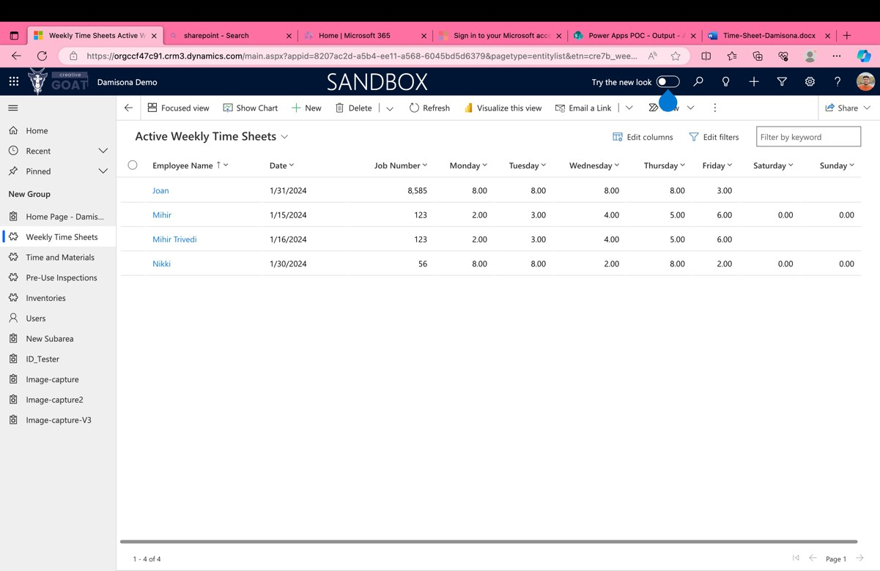
Weekly Timesheet CG [Table 5.2.1]
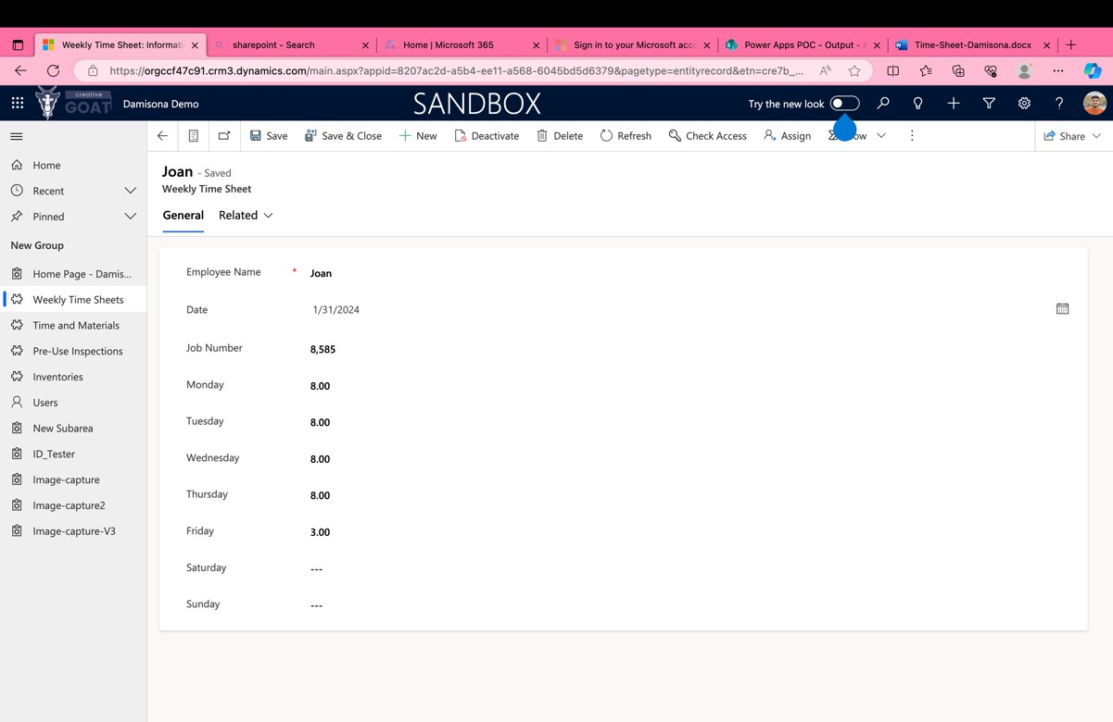
Weekly Timesheet CG [Table 5.2.1]

Other Functionality
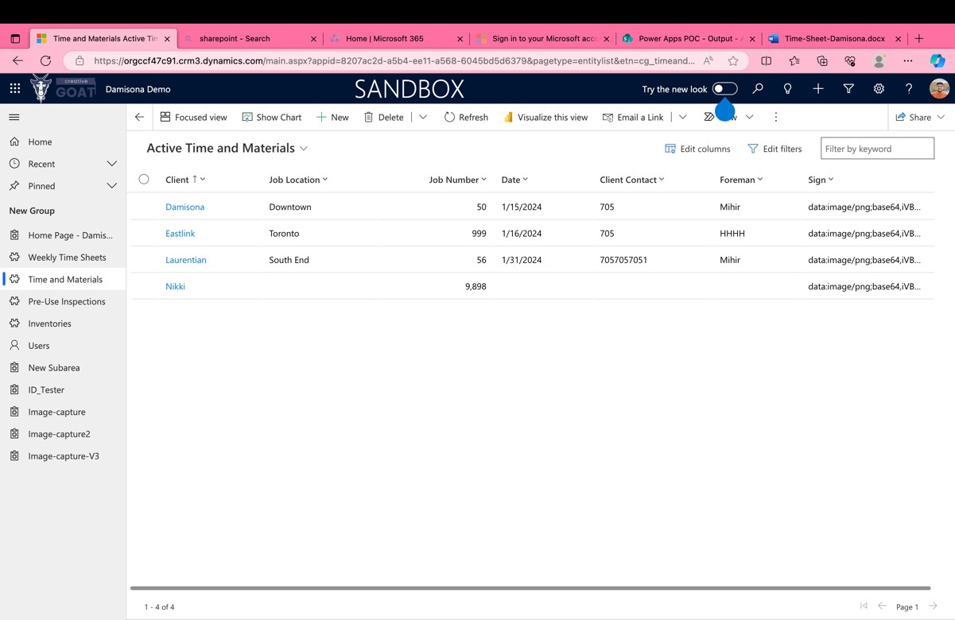
Weekly Timesheet CG [Table 5.2.1]

CHAPTER 7

IMPLEMENTATION

IMPLEMENTATION ENVIRONMENT

  - PROGRAM/MODULE SPECIFICATION

SECURITY FEATURES

  - CODING STANDARDS

CHAPTER 7: IMPLEMENTATION

Implementation Environment:

For our project, we configured our development environment as follows:
    - Web Server:
We employed Apache Server for its widespread usage and availability as a free resource. While PHP is versatile across various web servers, Apache was selected for its compatibility and reliability.

    - Database:
Dataverse for our database needs. Dataverse offers a robust and flexible environment, seamlessly integrating with PowerApps and Power Automate, providing a unified and efficient database solution that enhances our application's capabilities beyond traditional database systems like MySQL.

    - PHP Parser:
Chrome is our go-to browser for executing PHP scripts and delivering HTML output to users. For debugging purposes, we also use Microsoft Edge to ensure cross-browser compatibility and performance optimization.

Program/module specification:
Three main modules are dealing with the application:
- Admin
- Sub Admin
- Users

This central module oversees product and product information management. Admins hold the reins to customer connections and product presentations, ensuring smooth operation and quality service.

Supporting the Admin, the Sub Admin module manages project data and resolves issues. With comprehensive control over project details and connections, Sub Admins ensure seamless administration and operational efficiency.

Users are the heart of the platform, ranging from end customers to exhibitors. Before subscription, they are considered potential customers. The website’s front page showcases live exhibitions, inviting user engagement and participation.

Security features:

Since our project saves data online, some customers or users might be worried about security. However, security is a top priority for online. In addition, the online connection makes it easy to be participating event, link up with organizations. We create OTP based registration for security purposes. Also, we maintain strong folder structure.

Coding standards:

To ensure our development process is efficient, maintainable, and accessible, especially for new team members, we've adopted several coding standards supported by automated tools for checking and fixing code. These standards facilitate smoother onboarding, enhance code readability, and allow our team to concentrate on more critical aspects of development and review.

- Null Safety and Container Wrapping Implementing null safety is mandatory, alongside careful container wrapping, to maintain UI integrity and prevent disruptions.

- Commenting: We adhere to a consistent commenting approach, using // for single-line comments and /* */ for multi-line comments, especially within Js development. This practice is crucial for code maintainability and knowledge transfer within the team.

- Line Length & Indentation: Our code lines are kept within 75-85 characters to ensure readability. Indentation follows the standard practice of using 4 spaces instead of tabs, aligning with the conventions used across many programming languages.
- Structuring the control flow statements: Control flow statements like if, for, while, and switch are structured with a single space between the keyword and the opening parenthesis, differentiating them from function calls and enhancing code clarity.there must be one space between the keyword and the opening parenthesis.

- Function Calls: When invoking a function, we ensure there is no space between the function name and the opening parenthesis, maintaining consistency and readability.

Above mentioned all Coding standard followed in our project Time sheet CG.

CHAPTER 8

TESTING

TESTING PLAN

  - TESTING STRATEGY

  - TESTING METHODS

  - TEST CASES

CHAPTER 8: TESTING

In this chapter is aimed to provide a brief account of testing the software.There are two principal motives of testing the software:

- To rectify the error in execution
- To check the viability of software

The testing ensures that the software is according to the required specification standards and performs the task meant for it. The testing is done by our team members that act as novice users and test the project with all possible way to find the bugs and error as well as check validation.

Testing plan:
Testing is carried out at the following three stages:
- Design
- Implementation
- Coding

Design Testing:

This Testing apply after designing stage to verify product design.At this stage we test ourproject’s all designing schema like class diagram, E-R diagram and UI/UX design also.

Implementation Testing:
This testing is not a proper structural testing but every time check the program after writing some code of particular function, programmer check their code by testing some edgecase to check reliability of code. This testing perform during implementation of project.

Product Testing:
Product testing is last stage of testing, Here We tested our project’s end to end customer Satisfaction. In this testing we use black box and white box testing techniques to check technical and practical View of project.

Testing strategy:

A technique for programming testing coordinates programming experiment structure strategy into an all-around arranged arrangement of steps that outcome in the effective development of the product. The system gives the guide that depicts the means to be led as a piece of testing.

- We have tried our entire project utilizing bottom up testing technique.
- Bottom up testing includes incorporating and testing the modules to the lower levels in the chain of importance, and afterward stirring up progression of modules until the last module is tried.
- Bottom up testing procedure demonstrates how genuine testing is to be finished with the entire project yet it doesn't demonstrate any insight concerning every module testing.
- For every module testing, we have chosen to test each lower level module with white box testing system.
- When all modules are tried effectively then I will move to one stage up and proceed with white box testing technique.

When all modules will be tested successfully then I will integrate those modules and tryto test the integrated system using black box testing strategy.

Why Black Box Testing in my Project?

In our project whatever we have implemented was going to be tested by Bhavin (our team member)knowing bit of code, so there was a black box testing involve directly.

Why White Box Testing in my Project?

During the project we were making the website, we knew how it should proceed internally; all the team members done the white box testing for individual portion of project.

Why interface Testing in our Project?

In this testing mainly focused on Interface view. In this testing we tests some basic GUI functionality, some of tested functionality is:

- Testing the Screen Control for its position And Side.
- The Position and Related Marks for All Control were checked
- Validations for all input were done.
- Whether the system prompts the user with appropriate message as and when invalid information is entered.
- All required fields aren’t left blank.

Testing methods:

Unit Testing:

The unit testing is intended for testing the littlest unit of programming. There are two methodologies to be specific: bottom-up and top-down. In bottom up methodology the last module is tried and after that moving towards the principal module while top down methodology switches the activity. In present work we select the first.

Integration Testing:

The integration testing is intended to test every one of the modules at the same time since it is conceivable that every one of the modules may work accurately when tried separately. However, they may not work by and large and may prompt unforeseen results.

Validation Testing:

Validation can be defined in many ways but a simple definition is what a validation succeeds when software functions in a manner that can be reasonably accepted by the user.

Storage Testing:

The database of the system has to be stored on the hard disk. So, the storage capacity of the hard disk should be enough to store all the data required for the efficient runningof the system.

Test cases:

TEST CASE ID: TC_Login_01 | NAME: User Login Flow
TESTING STRATEGY | Validation and Response Message Testing
PURPOSE | For better User experience
INPUT: | email, password
TEST DATA: | email, password
EXPECTED O/P: | To verify validation and response messages for all scenarios.
UNBEHAVIOURABLE O/P: | N.A.
STEPS:
- Enter a valid email and password, then observe.
- Enter an invalid email and password, then observe.
[Table 8.4.1.1: Test case table Login]

TEST CASE ID: TC_Dashboard_02 | NAME: User’s dashboard timer getting stuck
TESTING STRATEGY | All the match must be shown and live match timer must be running
PURPOSE | For beeter understanding of user
INPUT: | Create match
TEST DATA: | Live Match list of the particular user
EXPECTED O/P: | If a match is ongoing, the match timer should run in real-time, and all ongoing  matches of the particular user should be displayed.
UNBEHAVIOURABLE O/P: | If a match is ongoing, the match timer should run in real-time, but the timer appears to be sticking.
STEPS:
- Create a match of any sport
- Pause match or Select Play Later.
- Observe the bug
[Table 8.4.1.2: Test case table Dashboard]

TEST CASE ID: TC_MatchTimer_03 | NAME: Match Timer running faster
TESTING STRATEGY | Game timer and Set timer issue
PURPOSE | Timer should work properly.
INPUT: | Set the Match and Set Timing
TEST DATA: | Match and Set Timing
EXPECTED O/P: | Timer should work properly.
UNBEHAVIOURABLE O/P: | The timer runs faster when fast scoring occurs.
STEPS:
Create a match and Start scoring fast and Observe the bug
[Table 8.4.1.3: Test case table Match Timer]

TEST CASE ID: TC_MatchSharing_04 | NAME: Match Shiring with QR or Deep Linking
TESTING STRATEGY | Match Sharing Issue
PURPOSE | Users can share the current match with their friends via QR code or a match sharing link.
INPUT: | -
TEST DATA: | -
EXPECTED O/P: | Match can be share via both way
UNBEHAVIOURABLE O/P: | N.A.
STEPS:
Create a match and share it with others to view the live scoring of the current match.c
[Table 8.4.1.4: Test case table Match Sharing]

CHAPTER 9

LIMITATION AND FUTUREENHANCEMENT

LIMITATION

FUTURE ENHANCEMENT

Gyanmanjari Institute of Technology Gyanmanjari Innovative University

CHAPTER 9: LIMITATION AND FUTURE ENHANCEMENT

Limitation:
    - Physical Interaction: - The nature of racquet sports, involving tactile feedback from holding the racquet and the ball's impact, is difficult to simulate in a virtual setting. This limitation could detract from the immersive experience we aim to provide.

    - Real-Time Communication: Our platform currently supports match creation and scoring but lacks comprehensive real-time communication tools for players to coordinate or discuss strategies effectively.

    - Device Dependency: The reliance on smartphones or tablets for accessing and interacting with the app may exclude individuals without these devices or those who prefer different platforms.

    - Technical Constraints: Issues such as unstable internet connections, device compatibility, or software glitches could negatively affect app performance and user satisfaction during critical gameplay.

Future enhancement:
    - Tournament Feature: Introducing a feature to organize and participate in tournaments through the app could significantly enhance its competitive appeal and encourage greater user involvement.
    - Multiple Time sheet CG By expanding the range of racquet sports available on the app, we can appeal to a wider audience and offer more varied and engaging gameplay experience

CHAPTER 10

CONCLUSION AND DISCUSSION

  - PROJECT VIABILITIES

  - PROBLEM ENCOUNTERED AND POSSIBLE SOLUTIONS

SUMMARY OF PROJECT WORK

REFERENCES

WORK EXPERIENCE

CHAPTER 10: CONCLUSION AND DISCUSSION

Project viability:
    - Market Demand:
There's a significant demand for efficient, user-friendly time tracking solutions among businesses and their employees, indicating strong market potential for Time Sheet CG.
    - Unique Offering:

Time Sheet CG differentiates itself with features like real-time activity logging and detailed time allocation records, providing a distinct advantage over competing solutions.

    - Scalability:

The application's architecture is designed for scalability, allowing for the introduction of new features such as advanced analytics and integrations with other business tools.
    - Monetization Opportunities:

Time Sheet CG has various monetization paths, including subscription models, premium feature offerings, and integration with enterprise systems, offering sustainable revenue streams.

Problem encountered and possible solutions:

Problem Enhancing user engagement and ensuring accurate time entry can be challenging. Solution: Improving the application's user interface to make time entry more intuitive and less time-consuming.

Summary of project work:
- Conceptualization: Time Sheet CG was envisioned as a solution to streamline time tracking, improve productivity, and facilitate better project management for businesses and their employees.
- Development: The project leverages a robust tech stack including PowerApps, Power Automate, and Dataverse for backend services, ensuring a flexible and powerful application framework.
- Testing: - The application underwent thorough testing, ensuring its reliability, user-friendly interface, and efficiency in managing and logging time.
- Enhancements Plans to expand the application's capabilities, including advanced reporting features and deeper integrations with business systems, are set to further enhance its value proposition.

- Overall, Time Sheet CG represents an innovative approach to time management, addressing key industry needs with its unique features and scalable design, promising ongoing improvements and expansions.

References

Websites:

- Official PowerApps Documentation (https://learn.microsoft.com/en-us/power-apps/)
- PowerApps Community Forums (https://powerusers.microsoft.com/t5/Power-Apps-Community/ct-p/PowerApps1)
- Power Automate Documentation (https://learn.microsoft.com/en-us/power-automate)
- Dio Package for HTTP Requests (https://learn.microsoft.com/en-us/power-automate/getting-started)
- Azure Library (https://learn.microsoft.com/en-us/azure/?product=popular)
- Official Dataverse Documentation (https://learn.microsoft.com/en-us/power-apps/maker/data-platform/)
- Stack Overflow for Troubleshooting (https://stackoverflow.com/)
- Medium Articles and Tutorials (https://medium.com/tag/powerapps)

These references provide comprehensive resources for PowerApps development, API calling, Block pattern implementation, and troubleshooting common issues.

WORK EXPERIENCE:

The journey of developing "Time Sheet CG" within the Microsoft Power Platform environment provided our team with invaluable experience in leveraging cloud-based services for business application development. Under the leadership of our project manager and through the support of Microsoft's extensive documentation and community resources, we navigated the complexities of app development from concept to deployment.

This project allowed us to deeply engage with PowerApps for creating intuitive user interfaces, Power Automate for streamlining business processes and workflows, and Dataverse for managing data securely and efficiently. Our experience highlighted the Power Platform's capability to rapidly develop and deploy business applications that can scale according to organizational needs.

Through "Time Sheet CG," we've not only enhanced our technical skills in working with Microsoft's Power Platform but also learned critical lessons in teamwork, project management, and the agile development process. This endeavor has significantly contributed to our growth as developers and professionals in the field of technology, readying us for future challenges and opportunities in app develop.

