Dean Sheldon

Assignment 1

Server Building

**Assignment:**

You have accepted the post of systems administrator for Acme corporation. Congratulations on your new job!

*Your first task:*

We need two Linux systems. One for home and one in class. The one built in the lab will be done on a virtual machine, either on one of the given servers, or on your own machine. The home server can be done on a Raspberry Pi, a persistent boot USB or on a second virtual machine on your laptop.

You will need to use 2 different Linux Distros, one for each setup.  One must be CentOS, the other can be another server distro of your choice such as Ubuntu Server, Debian, OpenSUSE or Fedora.

The initial configuration may include a GUI but most of the work will be done through the command line and remote access using ssh.

Turn in 2 screenshots, one for each distro, showing that you were able to successfully get it up and running.  Also turn in a short executive summary of your process.  No more then a page total.

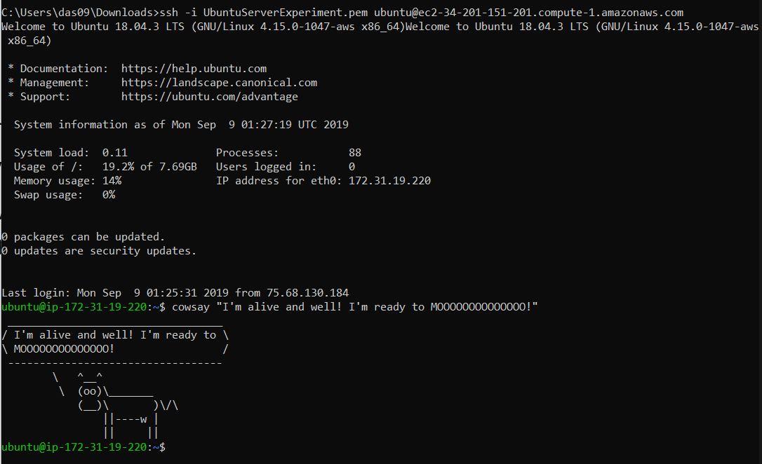**Plan – Build Two Servers:**

*Server One:*

Format Cloud primary.

Operating System: Ubuntu Server 18.04.3

Since it is hands down the most common server, I have decided to dive deeper into it’s architecture for this class. It will be built in the cloud so it is accessible by anything.

*Server Two:*

Format: Virtual machine experimental.

Operating System: CentOS.

This server will be used in class and for homeworks and will not be used for any major networking/publicly accessible projects.

