Dean Sheldon

Assignment 1

Server Creation Documentation

**Assignment:**

**Objective – Build Two Servers:**

**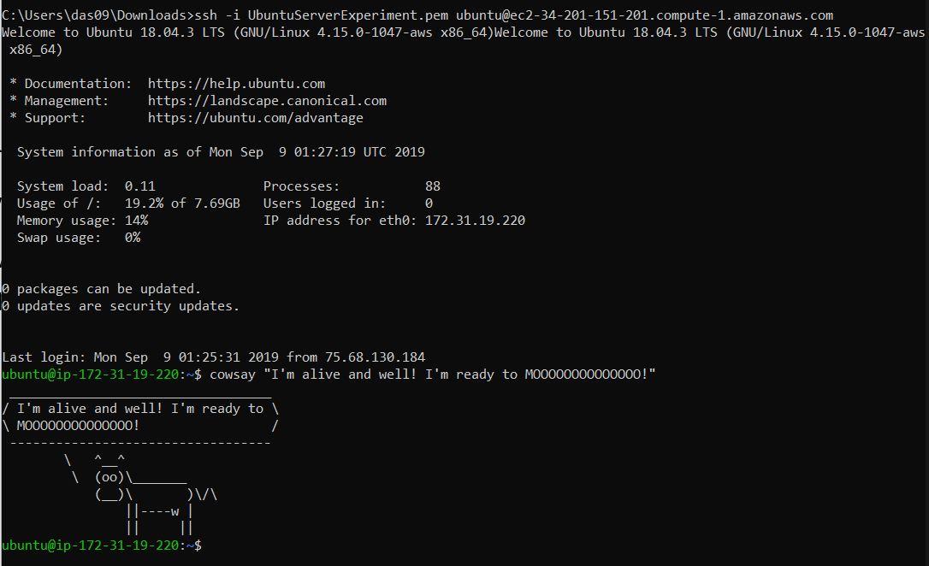***Server One:*

Format Cloud primary.

Operating System: Ubuntu Server 18.04.3

Since it is hands down the most common server, I have decided to dive deeper into it’s architecture for this class. It will be built in the cloud so it is accessible by anything.

Creation Guide:

In order to build a server in the cloud, you need to follow a lot of prerequisites:

1. Create an AWS Account:

<https://aws.amazon.com/premiumsupport/knowledge-center/create-and-activate-aws-account/>

1. Setup an IAM profile that will be used as your primary access account. This security measure is used to keep your Root account safe. Make sure the password to this account is hidden and safe. <https://docs.aws.amazon.com/IAM/latest/UserGuide/id_users_create.html#targetText=To%20create%20one%20or%20more,name%20for%20the%20new%20user.>

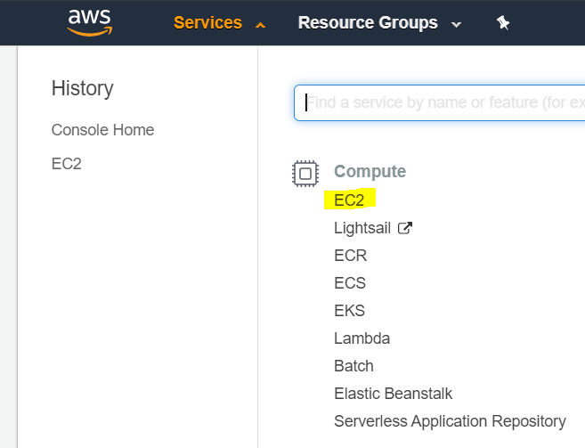The next step is creating an EC2 Instance. To do this, go to Services>EC2:

In the EC2 main menu, click “# Running Instances.” This will bring you to the EC2 Instance Menus.

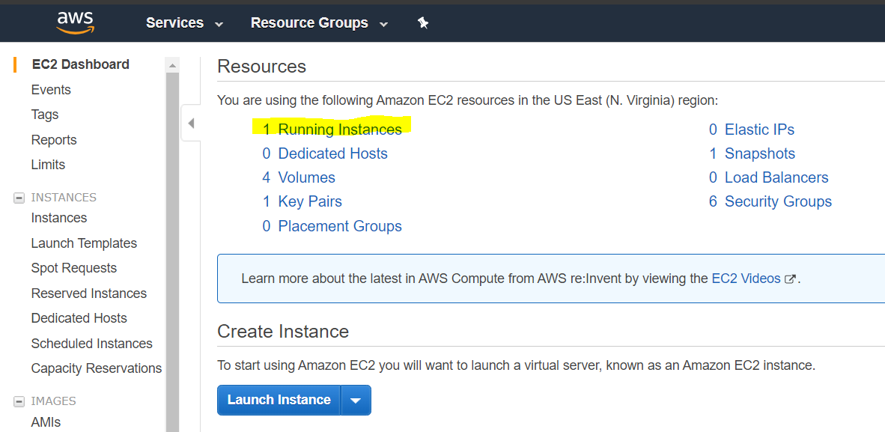

Now we are ready to create our first instance. To begin, press Launch Instance:

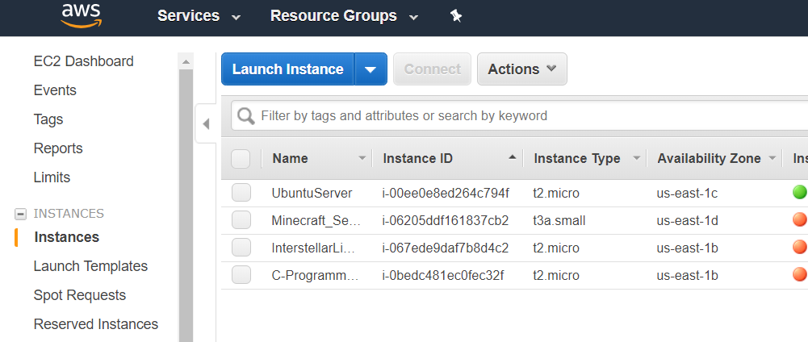

In the next menu, choose the Amazon Machine Image of your choice. In this case we need to search Ubuntu. Find the version that you wish to use, then press “Select.”

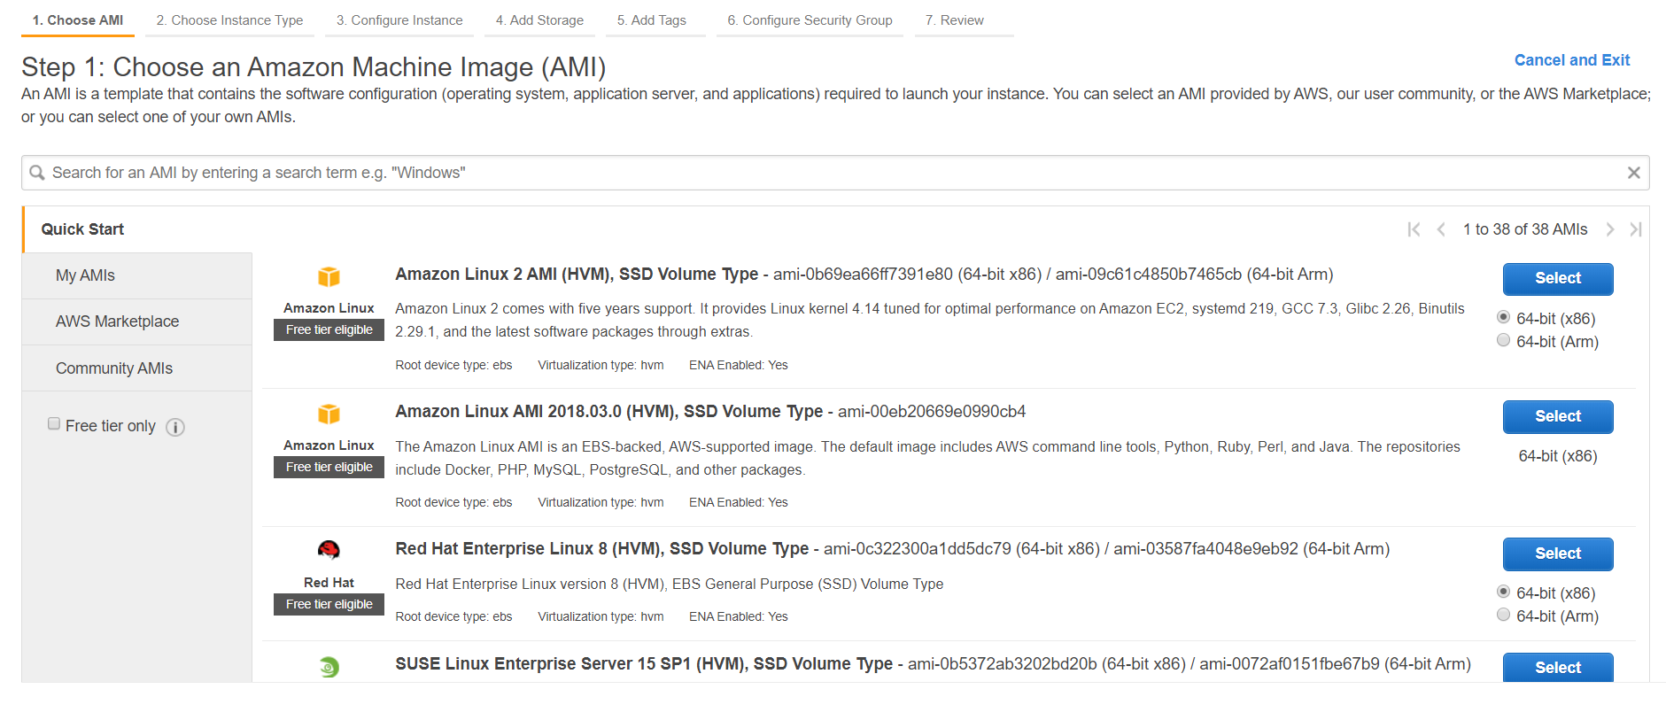

Next you need to choose the level of instance you want. In this case all we need is the t2.micro. Leave it selected, then go down to the bottom and Review and Launch. The instance will start out with 8 gb of space which is more than enough for our needs – if you want to increase it later, that is easy. If you wish to go through the rest of the windows, see further documentation.

On the Review Screen, press Launch, and the Instance will be added to your account and initiate. The Ubuntu Server has been created and is ready to go.

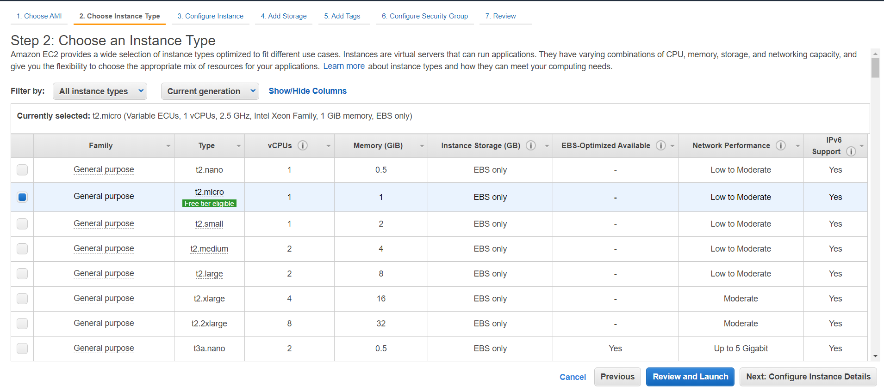

*Server Two:*

Format: Virtual machine experimental.

Operating System: CentOS.

The Platform that this machine runs on is Hyper-V due to it’s integration into the Windows OS. It does not cost anything beyond Windows Pro, and it’s “simple” in the sense of access and setting up.

First, go to the link below to download CentOS.

<http://isoredirect.centos.org/centos/7/isos/x86_64/CentOS-7-x86_64-DVD-1810.iso>

Choose any of the links below to get the image.

Next Open Hyper-V

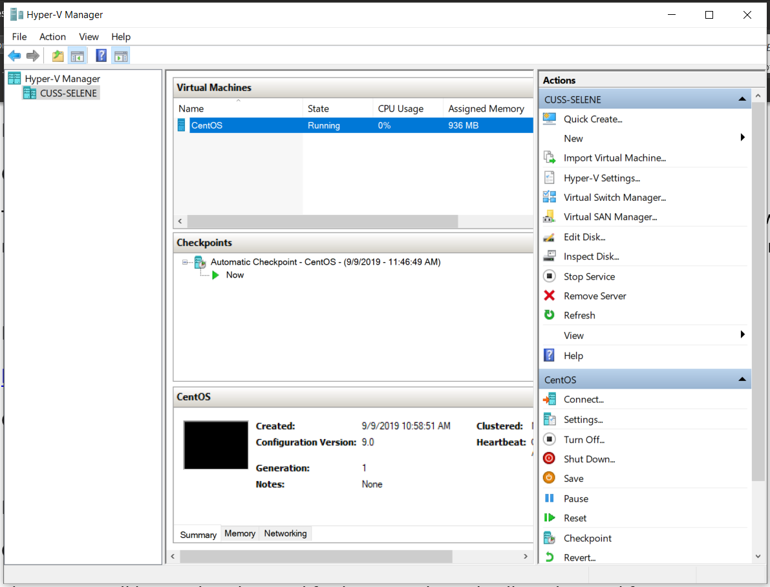

Choose your machine, then choose “New > Virtual Machine” from the right-hand column.

When “New Virtual Machine Wizard” opens, click “Next,” then enter the name of the VM you are creating. If you wish, change the directory in which the VM will be stored.

Press “Next” with Generation 1

Press “Next” with Memory if you are happy with that much memory. Since this is Linux, unless you need more WAM for Minecraft, one Gig should be enough.

On the dropdown, choose Default switch, but later you will need to update this with your active wireless adapter. Please see the link ahead for further instruction. <https://www.altaro.com/hyper-v/work-hyper-v-virtual-network-adapters/>

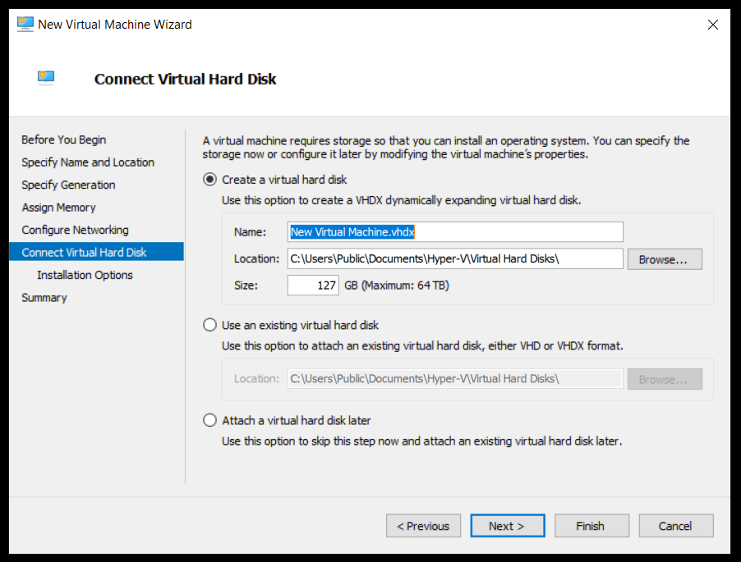

Finally Change the name of the VM, make sure the location is where you want it, then make sure the size of the drive is what you want it to be. Like the previous machine, a minimum of 8 gigs is needed, but you can add more if you wish.

Press “Finish” to complete the VM creation, then press “Connect” and “Start” to connect to your new Virtual Machine.

