GeoSwipe: A Privacy-Preserving, Gesture-Controlled Web Platform for Interactive Earth and Indian Heritage Learning
Kushal Soni  Dept. of Computer Engineering  K. J. Somaiya Institute of Technology  Mumbai, India  kushal.soni@somaiya.edu | Kartik Verma  Dept. of Computer Engineering  K. J. Somaiya Institute of Technology  Mumbai, India  kartik.verma@somaiya.edu | Bhavana Suthar  Dept. of Computer Engineering  K. J. Somaiya Institute of Technology  Mumbai, India  bhavana.suthar@somaiya.edu | Shreeya Sati  Dept. of Computer Engineering  K. J. Somaiya Institute of Technology  Mumbai, India  shreeya.sati@somaiya.edu | Prof. Pradnya Patil  Dept. of Computer Engineering  K. J. Somaiya Institute of Technology  Mumbai, India  pradnya08@somaiya.edu

Abstract—Geography and cultural heritage are still taught largely through static text, images and flat maps. We present GeoSwipe, a browser-based learning platform that unifies a WebGL 3D globe, an interactive map of 126 Indian heritage sites, narrated storybooks, country, flag and heritage quizzes with real-time two-player rooms, a large-language-model (LLM) assistant, an AI trip planner, route-safety scoring and touch-free hand-gesture control. Gestures are recognised entirely in the browser from MediaPipe hand landmarks with a rule-based nine-gesture classifier and a five-frame stabiliser, so no video frame leaves the device. A Node.js back end keeps all API keys server-side and uses a two-tier shared cache with request de-duplication and API-key pooling so that third-party usage scales with the number of sites rather than users. On the production deployment, cache hits were 20× to 4,363× faster than upstream calls, a representative news sequence needed 5 instead of about 32 NewsAPI calls, and warm API medians were 351–2,233 ms from a client in Mumbai. In a synthetic benchmark of 18,000 poses per noise level, per-frame gesture accuracy stayed at or above 99.06% up to a landmark noise of σ = 0.01, and the stabiliser emitted no wrong gesture in any tested condition. Moving recognition into the browser removed about 3.2 GB of upstream traffic per user-hour.
Index Terms—cultural heritage education, 3D geovisualization, WebGL, hand-gesture recognition, MediaPipe, game-based learning, large language models, real-time multiplayer.
I. Introduction
Geography and heritage are domains in which where something is matters as much as what it is. Educational games are associated with better learning outcomes, motivation and engagement [1], provided their mechanics are aligned with learning goals [2]. 3D virtual environments and reconstructions are effective contexts for heritage learning [3], [4], interaction quality is central to heritage applications [5], [6], and virtual globes and WebGL make large geospatial scenes available in a browser [7], [8]. Vision-based hand gestures offer natural, touch-free manipulation [9], [10], and on-device models such as MediaPipe Hands now track 21 hand landmarks in real time on commodity hardware [11], [12]. LLMs and chatbots enable open-ended questioning [13], [14], context-aware itinerary recommendation links learning to travel [15], and multiplayer serious games add a social dimension [16].
These capabilities are, however, studied in isolation. A learner who wants to explore Indian heritage in its geographic context must combine a textbook, a map, a weather or news site, a quiz app and a travel portal, none of which share context. For a student team there are also two practical obstacles: free tiers of third-party APIs are small (e.g., 100 NewsAPI requests per day), so naïve per-view calls fail after a few visitors; and server-side gesture recognition requires streaming webcam video, which is both a privacy risk and a hosting cost.
This paper presents GeoSwipe, a deployed platform that addresses these gaps. Our contributions are: (i) an integrated workflow that links a 3D globe, a heritage map, storybooks, quizzes, multiplayer rooms, an LLM assistant, trip planning and safety navigation around a shared site context; (ii) a privacy-preserving in-browser gesture pipeline with a stabiliser whose latency we derive analytically; (iii) a quota-aware back end (two-tier cache, de-duplication, key pooling) that makes free-tier operation feasible; and (iv) a quantitative evaluation of the production system and of gesture robustness.
II. Related Work
Game-based and heritage learning. Reviews report positive associations between educational games and learning outcomes [1] but stress that engagement yields learning only when mechanics serve the objectives [2]. Heritage studies show the value of 3D environments [3] and site reconstructions such as Delphi [4], and frameworks couple interaction with 3D visualization [6]; most target one site or XR hardware [5].
Geovisualization and gestures. Globe-based 3D GIS places heritage at true coordinates [7], and WebGL renders massive geodata in browsers [8], but these systems target GIS experts. Classical vision-based gesture interfaces [9], [10] faced lighting and background sensitivity; MediaPipe [11], [12] provides robust landmarks on-device, leaving gesture semantics to the application.
AI, tourism and multiplayer. LLM and chatbot reviews identify question answering and learner support as key uses, together with accuracy concerns and weak evaluation [13], [14]. Semantic itinerary recommendation [15] and multiplayer serious games [16] address travel planning and social learning, respectively. To our knowledge, none of these works combines all capabilities in a single browser workflow.
III. Design Goals and Requirements
We derived five design goals from the gaps above, and each one constrained a concrete engineering decision.
• G1 Integration. All activities must share the selected site, so that the map, storybook, quiz, assistant, trip planner and safety navigator open on the same monument without re-entry.
• G2 Zero installation. The platform must run in a current desktop browser with WebGL and an optional ordinary webcam; every gesture must have a mouse or touch equivalent.
• G3 Privacy. Webcam frames must never leave the device, and no account or personal data may be required.
• G4 Free-tier sustainability. Third-party usage must not grow with the number of users, and no API key may reach the browser.
• G5 Robust interaction. Noisy per-frame gesture classifications must not trigger unintended actions, and a held gesture must not repeat a click.
Functionally, the system provides 18 client routes: a landing page with a gesture guide; Explore mode with country quiz and flag game; a heritage map with a monument sidebar (information, access routes, visitor details, images, 360° views, 3D models, weather and news); storybooks; single-player and two-player quizzes; an LLM assistant; a trip planner; and safety navigation. The content covers 126 sites in eight categories across 22 states and union territories (Fig. 1), of which 36 are UNESCO World Heritage entries.
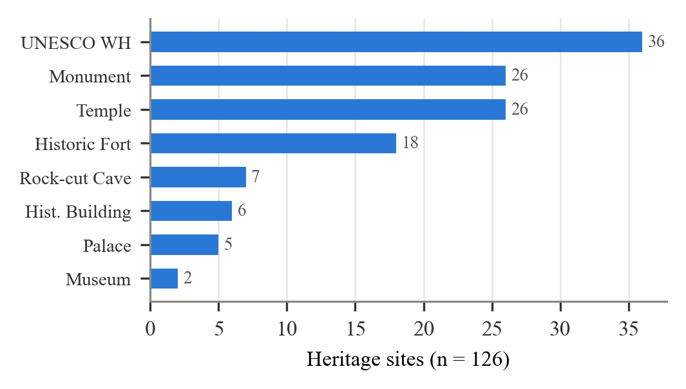
Fig. 1. Heritage sites by category in the GeoSwipe database.
IV. System Architecture
GeoSwipe follows a three-tier architecture (Fig. 3). The presentation tier is a React 19 single-page application (SPA) built with Vite and served from Cloudflare Pages; it contains the Three.js globe, a MapLibre GL heritage map, games, a page-flip storybook reader, the trip planner, safety navigator, chatbot widget and the gesture subsystem. Every route is lazily loaded. The application tier is an Express 5 server with Socket.IO on a free Render instance (Singapore); it applies security headers, a CORS allow-list and per-route rate limits, serves heritage, quiz, flag and safety routes, proxies every keyed API (Groq, MapTiler, OpenWeatherMap, NewsAPI, Unsplash) and manages multiplayer rooms. The data tier is MongoDB Atlas (M0), holding 126 heritage sites (2dsphere index), 780 quiz questions (13 monuments × 20 easy/medium/hard) and cached API payloads.
A typical interaction illustrates how the tiers cooperate (Fig. 2). When a learner selects a monument, the client requests the site document (looked up with an escaped, anchored regular expression to prevent NoSQL injection) and then its weather. The server consults the cache; only on a miss does it call the provider with a pooled key, persisting the result so that every later visitor to that site is served locally. The same pattern serves news, map styles, safe places and images.
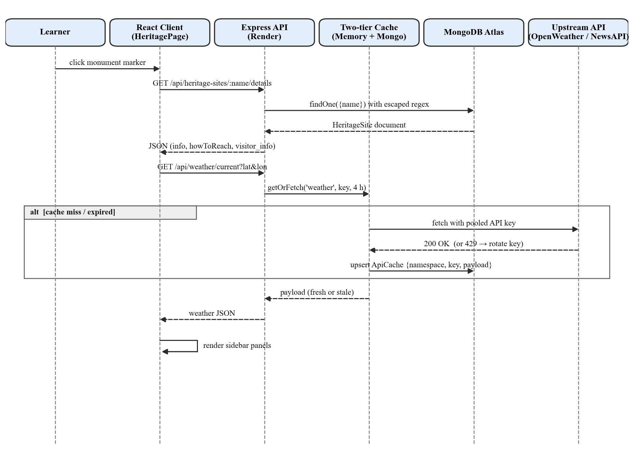
Fig. 2. Sequence of a monument selection: details from MongoDB, weather through the two-tier cache.
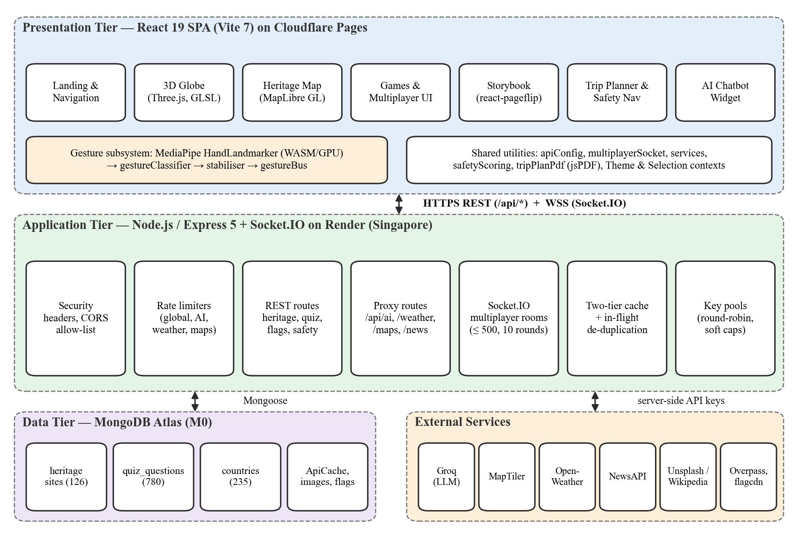
Fig. 3. Three-tier architecture of GeoSwipe. API keys exist only in the application tier.
V. Methodology
A. In-Browser Gesture Recognition
The webcam stream (≤ 30 FPS) is processed by MediaPipe’s HandLandmarker [11] in VIDEO mode on the GPU delegate (one hand, detection confidence 0.7). The WASM runtime and the 7.8 MB model are self-hosted and loaded only when a gesture screen opens. Landmarks p_{i} = (x_{i}, y_{i}) are mirrored (x′ = 1 − x) and classified with the 2D distance d(p_{i}, p_{j}). A finger with tip t and PIP joint p is open iff y_{t} < y_{p}; the thumb is extended iff
d(p₄, p₂) > 0.07 ∧ d(p₄, p₀) > 0.12 | (1)
With δ = d(p₄, p₈) and τ = d(p₄, p₀), the rules in Table I are evaluated in order. cursor_move drives an on-screen cursor from the middle fingertip, click activates the control under the cursor, and the rotate, thumbs and zoom/pinch gestures rotate (±0.01875 or ±0.0125 rad) and zoom (×0.9875 or ×1.0125) the globe.
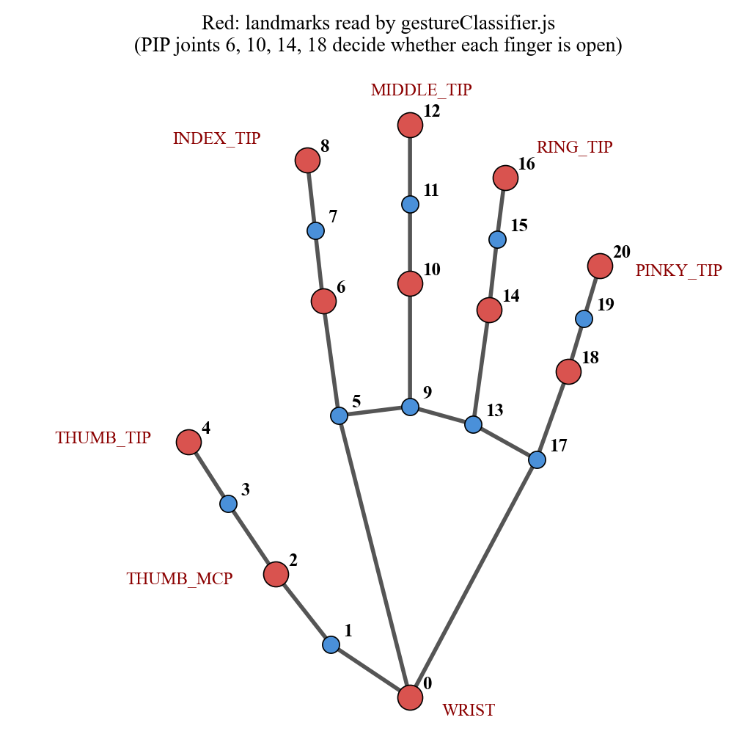
Fig. 4. MediaPipe hand landmarks; red points are read by the classifier.
TABLE I
GESTURE CLASSIFICATION RULES (FIRST MATCH WINS)
Gesture | Condition
click (“OK”) | δ < 0.05 ∧ middle, ring, pinky open
thumbs_up / down | thumb ext. ∧ fingers closed ∧ y₄ ≶ y₀ ∓ 0.08
pinch | δ < 0.04 ∧ middle, ring, pinky closed
zoom (“L”) | thumb ext. ∧ only index open ∧ δ > 0.13
index_point | only index open ∧ ¬thumb ext. ∧ τ < 0.10
cursor_move | all four fingers open ∧ τ ≥ 0.08
rotate_left / right | index, middle open; x₈ < x₀ → left, else right

Stabiliser. A pose is emitted only after N = 5 identical consecutive classifications; frames closer than Δ = 50 ms are skipped; a click is emitted at most once per C = 1 s. For a camera period T, the minimum latency from the onset of a steady pose to its emission is
L_{min} = (N − 1) · ⌈Δ / T⌉ · T | (2)
which is 267 ms at 30 FPS (effective inference rate 15 FPS). Events are distributed through a scoped in-page bus whose per-consumer scopes prevent one component’s unsubscription from detaching another’s handlers.
Fig. 5 gives the stabiliser as a state machine. Classification noise therefore manifests only as a longer stay in the Accumulating state, never as a premature transition to Stable, which is the property we test empirically in Section VII.
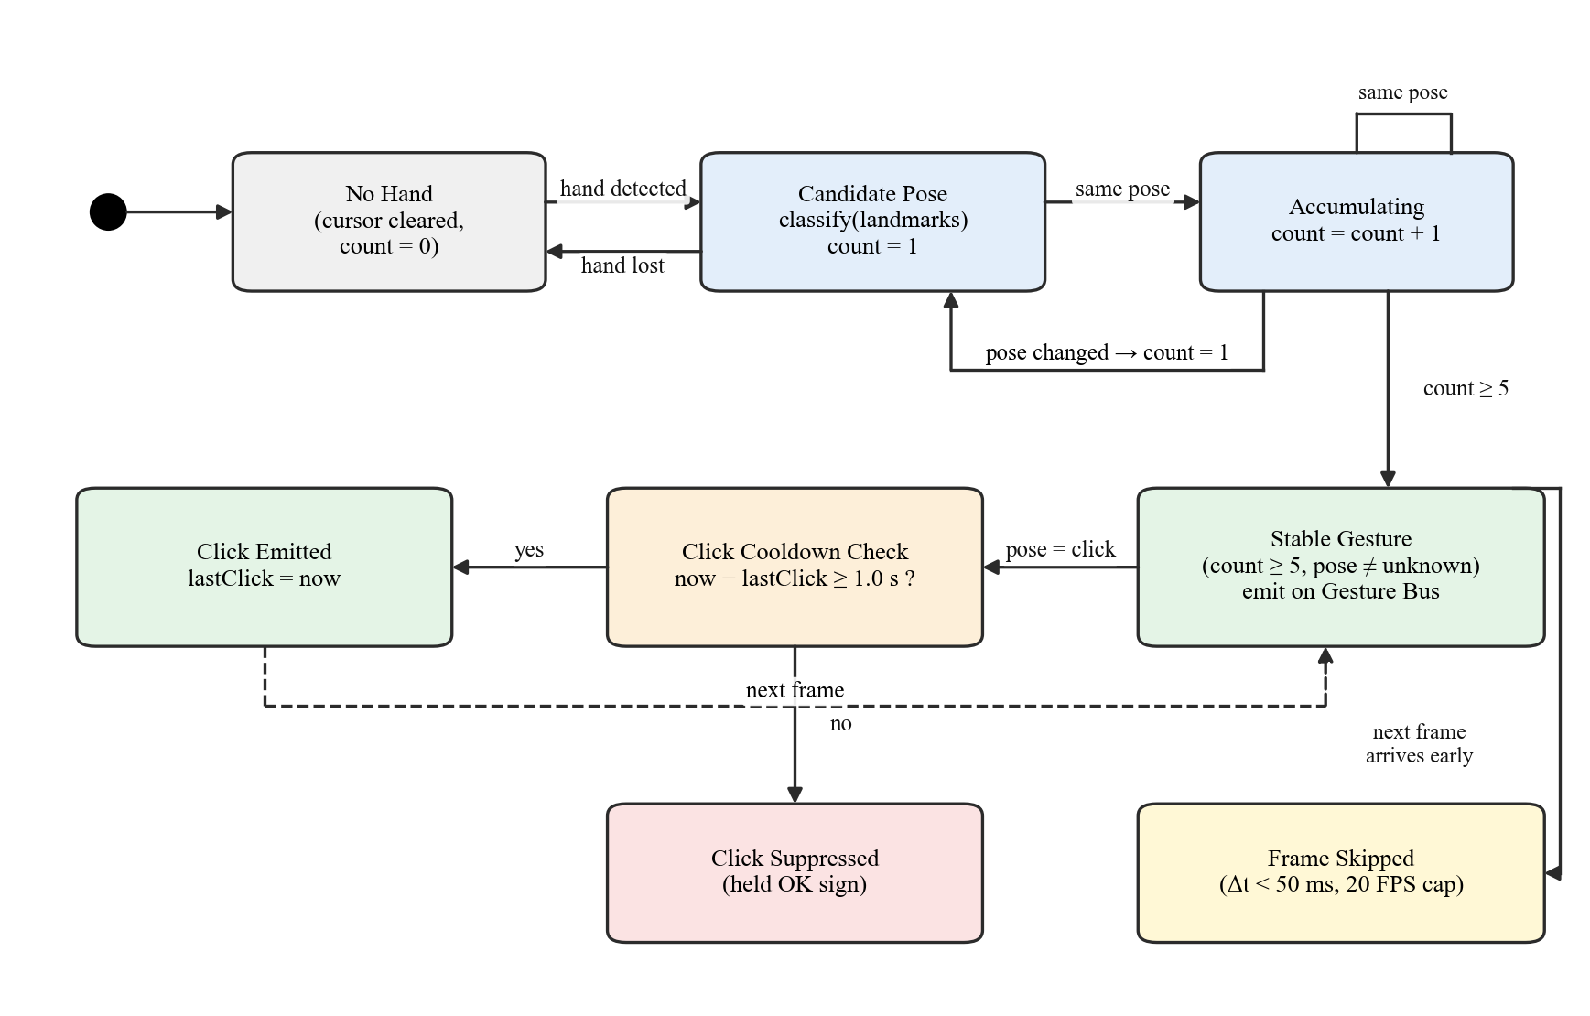
Fig. 5. State machine of the gesture stabiliser (5-frame threshold, 1 s click cooldown, 20 FPS cap).
B. Quota-Aware Data Proxy
Weather, news, map styles and safe places are requested for a fixed set of places, so their results are cached per place and shared by all users. getOrFetch(ns, key, ttl, fn) checks an in-memory map, then a MongoDB collection; on a miss it collapses concurrent requests for the same key into one upstream call, stores the result in both tiers, and on failure serves the expired entry (stale-on-failure). Empty results are cached too. With S places and freshness θ hours, daily upstream calls are bounded independently of users by
calls/day ≤ S · ⌈24 / θ⌉ | (3)
e.g., 126 · 6 = 756 weather calls per day (θ = 4 h) against a 1,000-call free limit. Each service also accepts a pool of keys used round-robin; a key is retired for the UTC day on HTTP 429/401/403 or when it reaches a soft cap below the provider limit (90/100 for NewsAPI, 900/1,000 for OpenWeatherMap). News is fetched in four cached tiers — monument, city, state, country — so tiers are shared by all monuments in a place.
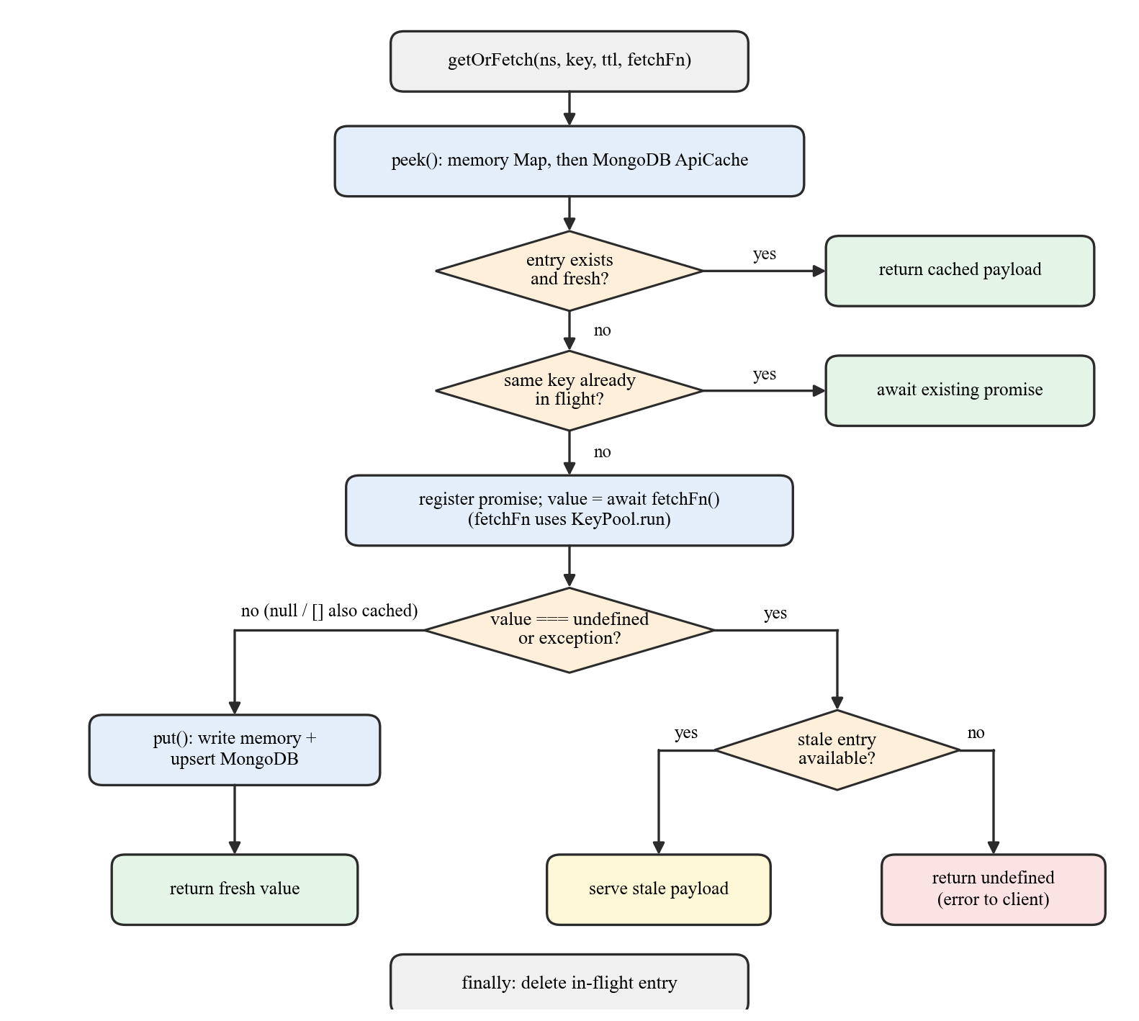
Fig. 6. The getOrFetch algorithm: fresh hit, in-flight de-duplication, fetch-and-store, stale-on-failure.
C. Safety Scoring, Multiplayer and AI
Routes are ranked by a transparent score. Up to 12 route points are sampled and the mean haversine distance [18] to the nearest hospital, police or fire station (Overpass, 3 km) gives coverage C = clamp(1 − d̄/5000, 0, 1); rule-based weather risk W and alert risk A lie in [0, 1]:
S = 55·C + 25·(1 − W) + 20·(1 − A) | (4)
The final ranking adds duration and distance terms (0.7·S + 20·D_{min}/D + 10·L_{min}/L). Multiplayer games run over WebSocket [17] with the server as the single source of truth: six-character room codes from a 32-symbol alphabet (32⁶ ≈ 1.07 × 10⁹), two players, ten rounds, server-side scoring, at most 500 rooms and 30 room actions per 10 s per socket. All LLM calls pass through one route that accepts only a profile name (heritage, safety, tripPlanner); model, temperature and token limits are fixed server-side, the heritage prompt is grounded with site names from the database, and the trip planner returns schema-constrained JSON (day-wise schedule, INR costs, booking links) that is rendered and exportable to PDF.
VI. Implementation
Fig. 7 shows four modules of the deployed system (geoswipe.pages.dev). The client has 21,040 lines of JavaScript/JSX and the server 4,734; storybooks exist for six monuments with five narrated chapters each. Security measures include server-side keys with log redaction, CSP and related headers, HSTS, regex escaping against NoSQL injection, and a CORS wildcard verified against 15 adversarial origins.
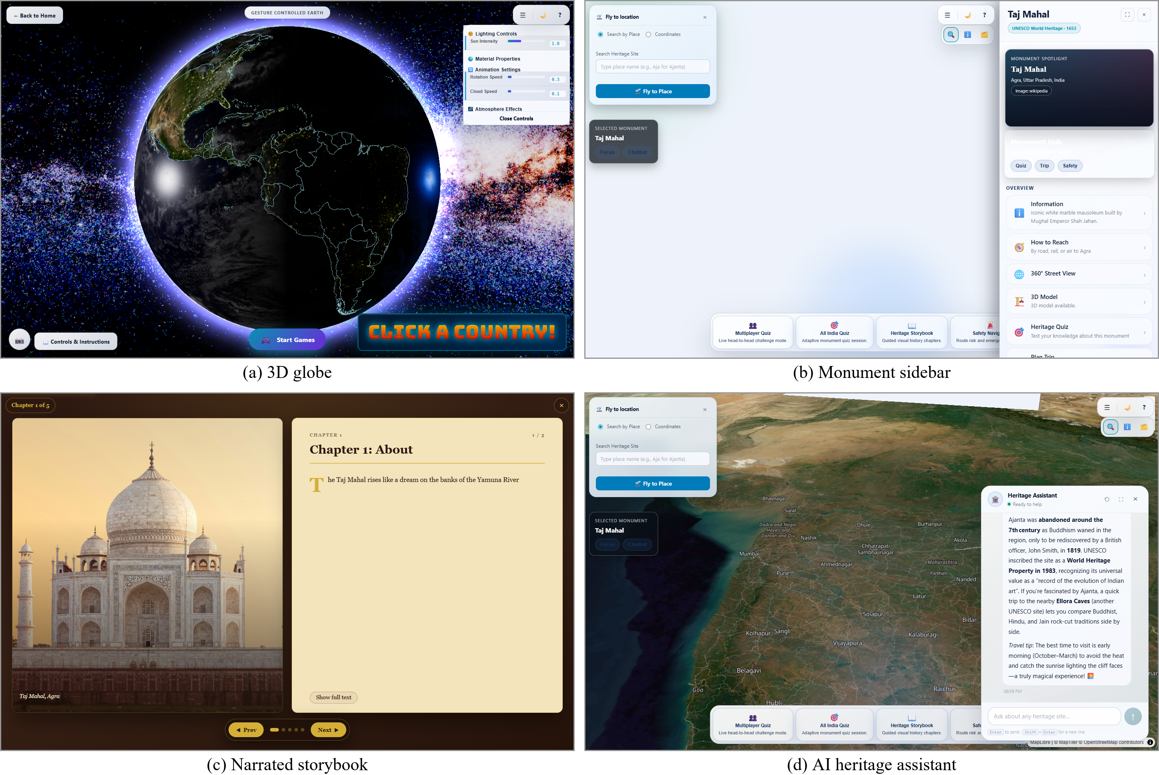
Fig. 7. Production screenshots: (a) Explore globe; (b) monument sidebar; (c) storybook spread; (d) assistant answering a live question.
VII. Results
A. Setup
Server-cache figures were measured by the team on 12 Sept. 2026; end-to-end figures were measured on 30 Sept. 2026 against production from a laptop (Core i5-13450HX, 16 GB) on residential broadband in Mumbai, 10 requests per endpoint. The gesture benchmark runs the unmodified classifier in Node.js 22 on synthetic poses; it involves no human participants.
B. Cache and Quota
Warm cache responses took 2–6 ms, 20×–4,363× faster than cold ones (Fig. 8); the Overpass safe-places query dropped from 8,726 ms to 2 ms. For three Maharashtra monuments plus one repeat view, the tiered news cache used 5 NewsAPI calls versus an estimated 32 previously, and the repeat view returned in 18 ms.
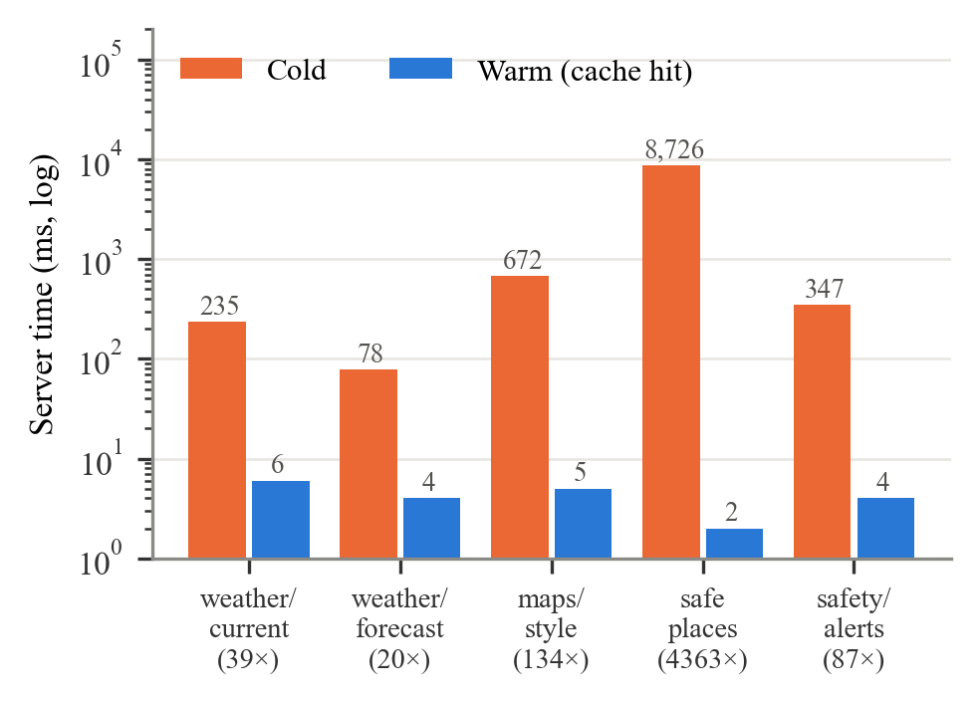
Fig. 8. Cold vs. warm server response time of cached endpoints (log scale; speed-up in parentheses).
C. End-to-End Latency and Health
All 120 requests to 12 production endpoints returned HTTP 200 (Fig. 9). Cached endpoints had warm medians of 351–648 ms, close to the 383 ms /health baseline, so the network dominates; the full catalogue endpoint (272 KB) was slowest at 2,233 ms. An idle free instance needed 23.1 s to wake. The diagnostics endpoint reported 9 of 10 integrations healthy, all required ones included; only the optional Wikipedia image fallback was rate-limited.
TABLE II
END-TO-END LATENCY OF PRODUCTION ENDPOINTS (N = 10)
Endpoint | First (ms) | Median | P95
/health | 831 | 383 | 907
weather/current | 889 | 351 | 391
maps/style/:name | 1,639 | 371 | 819
random-flag-country | 1,019 | 386 | 722
weather/forecast | 1,049 | 480 | 2,097
country-question | 948 | 539 | 973
heritage-sites/:name/details | 704 | 566 | 674
quiz/available-monuments | 646 | 573 | 774
news/:siteName | 1,808 | 648 | 1,186
quiz/all-india | 800 | 802 | 1,416
heritage-sites/geojson | 1,683 | 1,401 | 1,604
heritage-sites (full) | 2,113 | 2,233 | 2,921

The first request to each cached endpoint was 2–5× slower than its median, consistent with a cache miss followed by hits. P95 spikes (e.g., 2.1 s for the forecast) are typical of a shared free instance and residential network and do not appear in the medians.
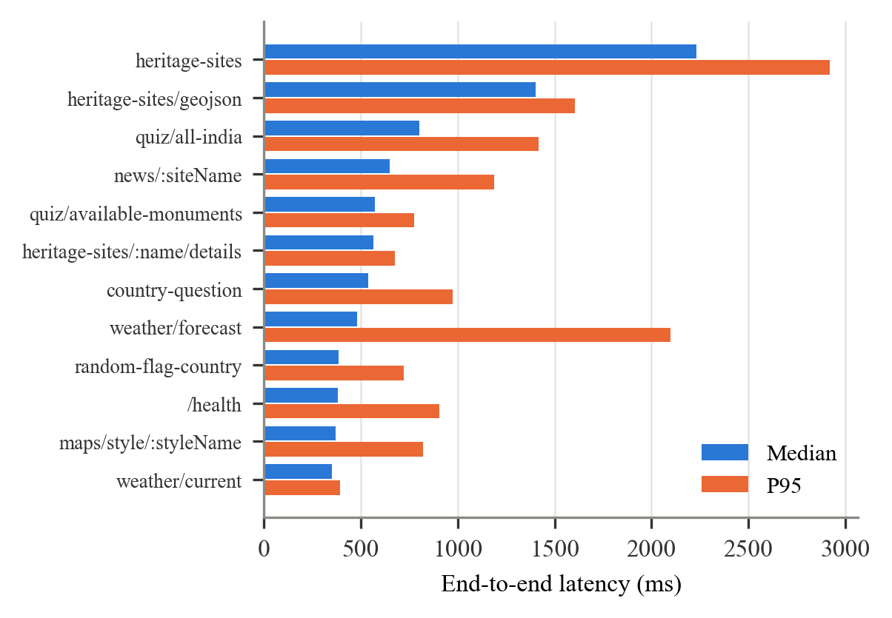
Fig. 9. Median and 95th-percentile end-to-end latency of production endpoints.
D. Gesture Robustness
For each of the nine gestures we built a canonical 21-landmark template (each correctly classified at zero noise), added i.i.d. Gaussian noise of standard deviation σ to every coordinate, and classified 2,000 poses per gesture and level (fixed seed). Accuracy was 100% up to σ = 0.005 and ≥ 99.06% up to σ = 0.01 (≈ 6 px on a 640-px frame), then fell to 57.75% at σ = 0.03 (Fig. 10). Pinch is the most sensitive gesture because its 0.04 threshold is the tightest; at σ = 0.01 most errors fall into the inert unknown class. Scaling templates by 0.5–1.6× (hand distance) kept overall accuracy within 99.38–100%.
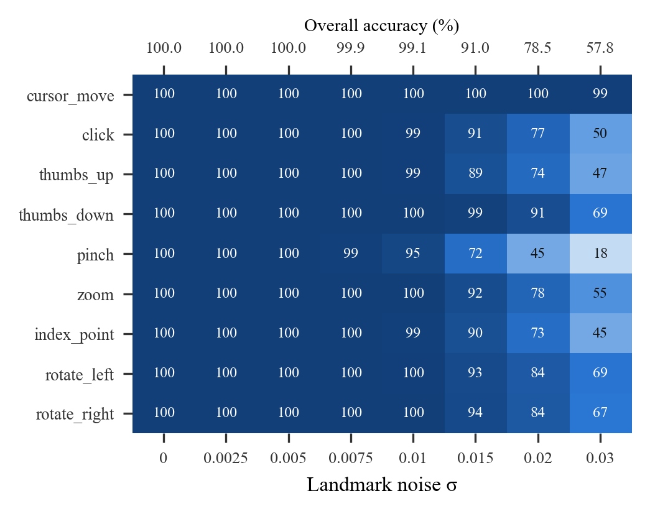
Fig. 10. Per-gesture accuracy (%) vs. landmark noise σ; top axis gives overall accuracy.
We then simulated a user holding a gesture for 3 s before a 30 FPS camera (300 runs per condition). Although up to 53.8% of raw frames were misclassified, no wrong gesture was emitted in any condition (Fig. 11, Table III); noise turns into delay, not wrong actions. Noise-free latency matched the analytic 267 ms (200 ms at 60 FPS); holding the “OK” sign for 5 s produced 5 clicks instead of 72 without the cooldown. One classification costs 0.145 µs (≈ 6.9 × 10⁶ poses/s), negligible next to landmark inference.
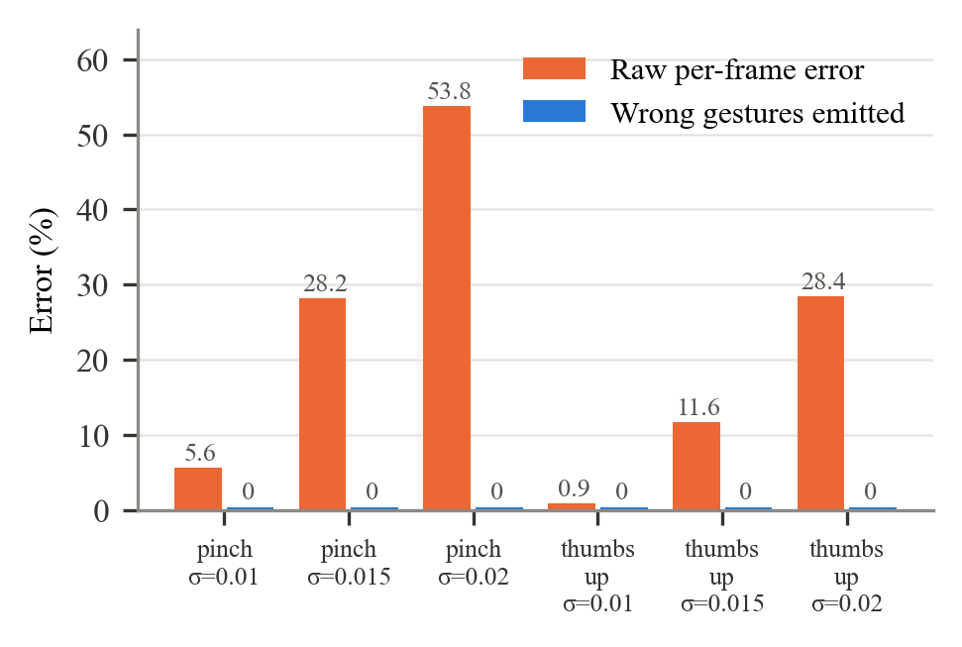
Fig. 11. Raw per-frame error vs. wrong gestures emitted after stabilization (simulated, 300 runs × 3 s).
TABLE III
STABILISER LATENCY UNDER NOISE (30 FPS)
Gesture @ σ | Raw err. (%) | Median (ms) | P95 (ms)
pinch @ 0.010 | 5.56 | 267 | 600
pinch @ 0.015 | 28.20 | 667 | 2,133
pinch @ 0.020 | 53.81 | 1,400 | 2,667
thumbs_up @ 0.015 | 11.63 | 267 | 867
thumbs_up @ 0.020 | 28.45 | 733 | 2,333

E. Network Cost and Bundle Size
The earlier server-side pipeline streamed ≈ 30 KB JPEG frames at up to 30 FPS (≈ 900 KB/s, 3.2 GB per user-hour) and exceeded the 512 MB free instance. In-browser inference needs a one-time ≈ 10 MB download (model 7,819,105 B), breaking even after ≈ 11 s of use. The production build has 38 assets (3.24 MiB; 0.90 MiB gzip), but the landing page needs only three (318 KiB; 95 KiB gzip); MapLibre (918 KiB) and Three.js (474 KiB) load only on their pages.
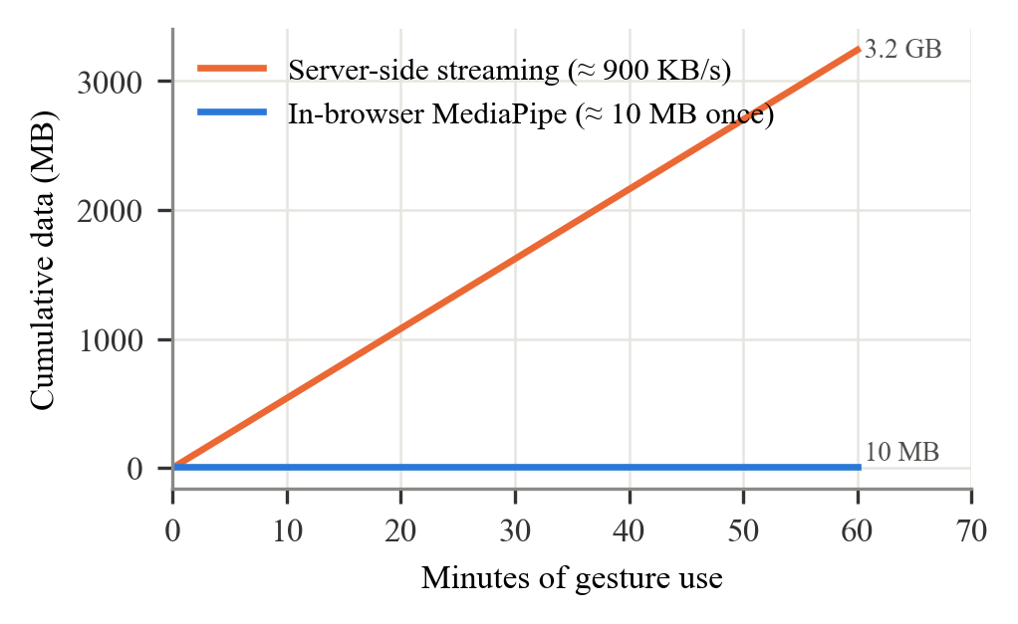
Fig. 12. Cumulative network data for gesture recognition: frame streaming vs. in-browser inference.
Table IV summarizes the measurable effect of the redesign relative to our earlier prototype, which compiled keys into the bundle, called providers on every view and recognized gestures on the server.
TABLE IV
EARLIER PROTOTYPE VS. FINAL GEOSWIPE
Measure | Earlier | Final
API keys in browser bundle | 3 services | none
NewsAPI calls, 4-view sequence | ≈ 32 | 5
Safe-places response (cached) | 8,726 ms | 2 ms
Gesture traffic per user-hour | ≈ 3.2 GB | ≈ 10 MB once
Gesture compute | server | browser
Production health | deploy failed | 9/10 OK

VIII. Comparison and Discussion
Table V compares capabilities with representative systems; GeoSwipe’s contribution is integration rather than fidelity in any single dimension. It does not match the realism of a dedicated reconstruction [4] or XR immersion [5], but it covers 126 sites, needs no installation, keeps video on-device and runs at zero hosting cost.
Two design choices proved decisive. First, caching per place rather than per request converted the scarcest resource — free API quota — from a per-user into a per-site budget, which is what allows a student project to remain online for any number of visitors. Second, the stabiliser shifts the cost of recognition errors from correctness to latency; for an educational interface, a delayed action is far less disruptive than a wrong one, and the analytic latency bound makes the trade-off explicit for designers who wish to tune N and Δ.
TABLE V
CAPABILITY COMPARISON (✓ = STATED IN THE WORK)
System | 3D | Herit. | Games | Gest. | AI | Trip | Multi
Liritzis [4] | ✓ | ✓ | – | – | – | – | –
Scianna [7] | ✓ | ✓ | – | – | – | – | –
Kölsch [10] | – | – | – | ✓ | – | – | –
Fogli [15] | – | – | – | – | – | ✓ | –
Wendel [16] | – | – | ✓ | – | – | – | ✓
GeoSwipe | ✓ | ✓ | ✓ | ✓ | ✓ | ✓ | ✓

Limitations. The gesture benchmark uses idealized templates and independent Gaussian noise; real hands, lighting and MediaPipe’s correlated errors are not modeled, so a study with participants and real webcams is required. Latencies depend on the client network and the free hosting tier. Keyword news search can return off-topic articles. Learning gains and usability have not yet been measured.
IX. Conclusion and Future Work
GeoSwipe shows that an integrated, privacy-preserving geographic and heritage learning platform is feasible on free infrastructure. In-browser gesture recognition with a five-frame stabiliser eliminated video upload and produced no wrong actions in simulation, and a quota-aware proxy made third-party usage scale with sites rather than users. Future work includes a controlled study using the System Usability Scale [19], [20] and pre/post knowledge tests, real-world gesture validation with hand-size-normalized thresholds, a progressive web app for mobile and offline use, storybooks and quizzes for all sites, and classroom-scale multiplayer.
X. References
[1] Z. Yu, M. Gao, and L. Wang, “The effect of educational games on learning outcomes, student motivation, engagement and satisfaction,” J. Educ. Comput. Res., vol. 59, no. 3, pp. 522–546, 2021.
[2] A. I. Abdul Jabbar and P. Felicia, “Gameplay engagement and learning in game-based learning: A systematic review,” Rev. Educ. Res., vol. 85, no. 4, pp. 740–779, 2015.
[3] M. Mortara and C. E. Catalano, “3D virtual environments as effective learning contexts for cultural heritage,” Italian J. Educ. Technol., 2018.
[4] I. Liritzis, P. Volonakis, and S. Vosinakis, “3D reconstruction of cultural heritage sites as an educational approach: The Sanctuary of Delphi,” Appl. Sci., vol. 11, no. 8, Art. no. 3635, 2021.
[5] V. Okanovic et al., “Interaction in eXtended Reality applications for cultural heritage,” Appl. Sci., vol. 12, no. 3, Art. no. 1241, 2022.
[6] A. Belhi et al., “An integrated framework for the interaction and 3D visualization of cultural heritage,” Multimedia Tools Appl., vol. 83, no. 15, 2024.
[7] A. Scianna and M. La Guardia, “Globe based 3D GIS solutions for virtual heritage,” Int. Arch. Photogramm. Remote Sens. Spatial Inf. Sci., vol. XLII-4/W10, pp. 171–177, 2018.
[8] R. Wüest, H. Eugster, S. Nebiker, and M. Christen, “Processing and rendering massive 3D geospatial environments using WebGL — The examples of OpenWebGlobe and SmartMobileMapping,” in Proc. Graphical Web, 2012.
[9] X. Zabulis, H. Baltzakis, and A. A. Argyros, “Vision-based hand gesture recognition for human–computer interaction,” in The Universal Access Handbook, C. Stephanidis, Ed. CRC Press, 2009.
[10] M. Kölsch and M. Turk, “Vision-based hand gesture interfaces for wearable computing and virtual environments,” 2004.
[11] F. Zhang et al., “MediaPipe Hands: On-device real-time hand tracking,” arXiv:2006.10214, 2020.
[12] C. Lugaresi et al., “MediaPipe: A framework for building perception pipelines,” arXiv:1906.08172, 2019.
[13] B. Dong, J. Bai, T. Xu, and Y. Zhou, “Large language models in education: A systematic review,” in Proc. 6th Int. Conf. Comput. Sci. Technol. Educ. (CSTE), 2024.
[14] H.-A. Bekkar and Y. Chtouki, “Chatbots in education: A systematic literature review,” in Proc. 10th Int. Conf. Smart Comput. Commun. (ICSCC), 2024, pp. 637–644.
[15] A. Fogli and G. Sansonetti, “Exploiting semantics for context-aware itinerary recommendation,” Pers. Ubiquitous Comput., vol. 23, no. 6, 2019.
[16] V. Wendel, F. Hertin, S. Göbel, and R. Steinmetz, “Collaborative learning by means of multiplayer serious games,” in Advances in Web-Based Learning — ICWL 2010, 2010.
[17] I. Fette and A. Melnikov, “The WebSocket protocol,” IETF RFC 6455, Dec. 2011.
[18] R. W. Sinnott, “Virtues of the haversine,” Sky and Telescope, vol. 68, no. 2, p. 159, 1984.
[19] J. Brooke, “SUS: A ‘quick and dirty’ usability scale,” in Usability Evaluation in Industry, P. W. Jordan et al., Eds. London, U.K.: Taylor & Francis, 1996, pp. 189–194.
[20] K. Orfanou, N. Tselios, and C. Katsanos, “Perceived usability evaluation of learning management systems: Empirical evaluation of the System Usability Scale,” Int. Rev. Res. Open Distrib. Learn., vol. 16, no. 2, pp. 227–246, 2015.

