GeoSwipe – Interactive Earth Exploration using Hand Gestures

Kushal Soni
Department of Computer Engineering, K. J. Somaiya Institute of Technology, Mumbai, India
kushal.soni@somaiya.edu

Shreeya Sati
Department of Computer Engineering, K. J. Somaiya Institute of Technology, Mumbai, India
shreeya.sati@somaiya.edu

Kartik Verma
Department of Computer Engineering, K. J. Somaiya Institute of Technology, Mumbai, India

kartik.verma@somaiya.edu

Bhavana Suthar
Department of Computer Engineering, K. J. Somaiya Institute of Technology, Mumbai, India
bhavana.suthar@somaiya.edu

Prof. Pradnya Patil
Department of Computer Engineering, K.J. Somaiya Institute of Technology,
Mumbai ,India
pradnya08@somaiya.edu

Abstract— Cultural heritage and geographical knowledge are often presented through static texts, images, and maps, limiting opportunities for active exploration and interaction. This paper presents GeoSwipe, an interactive educational platform that integrates geographical exploration, cultural-heritage learning, game-based learning, gesture-based interaction, artificial intelligence, contextual services, and real-time multiplayer functionality within a unified environment. The platform employs an interactive three-dimensional globe for geographical exploration and connects heritage locations with descriptive information, multimedia resources, maps, and contextual services. Vision-based hand gesture recognition using OpenCV and MediaPipe provides touchless interaction, while quiz and flag-based games support interactive learning. An AI-powered heritage assistant enables users to obtain contextual information through natural-language interaction, and supporting services provide weather, news, trip-planning, and safety-related information. The platform further incorporates Socket.IO-based multiplayer functionality for synchronized educational gameplay. The implemented prototype integrates React, Three.js/WebGL, Node.js/Express, MongoDB, computer-vision processing, and external services into a single system. The results demonstrate the technical and functional feasibility of the proposed platform and its ability to combine multiple interaction and learning mechanisms. However, educational effectiveness, usability, and learning gains have not yet been empirically validated and remain subjects for future controlled evaluation.
Keywords— cultural heritage, geographical education, 3D geospatial visualization, game-based learning, gesture-based interaction, artificial intelligence, multiplayer learning, interactive education.

- Introduction
Cultural heritage and geographical knowledge include historical, architectural, cultural, and spatial information that is hard to explain through conventional written texts. Typically, learners come across heritage information in static forms as descriptive texts, as well as in images or maps, which limit their opportunities for active exploration. This challenge can be alleviated by digital technologies, which allow the creation of interactive spaces where learners can interact with heritage contents in their geographical context. The effectiveness of three-dimensional virtual environments in learning about cultural heritage has been studied, while 3D reconstruction can also be employed for more vivid representation of heritage sites in education [3], [4].
Educational games are another avenue for increasing the level of interactivity. Learning objectives can be integrated into activities involving interaction, decision-making, feedback and challenges, which will result in learner motivation, engagement, and effective educational process [1], [2]. Similarly, globe-based 3D GIS is looked at in terms of virtual heritage usage, while WebGL enables interactive visualization of three-dimensional geographical environments through web technologies [7], [8]. These approaches provide a foundation for connecting geographical exploration with educational heritage content.
The interaction is one more significant feature of such systems. Hand gesture recognition by means of vision has been studied as a natural mechanism of interaction between a human and a computer and applied in virtual environments [9], [10]. AI technologies have allowed the creation of conversational educational systems using language models and chat-bots [11], [12]. Moreover, context-aware trip recommendation can combine geographic exploration [13], and travel planning, while multi-user serious games enable both collaborative and competitive learning [14].
However, this technology has generally been studied in separate or partially integrated approaches. Previous studies highlight the importance of digital heritage visualization, educational games, gesture-based interaction, Conversational AI, intelligent tourism, and multiplayer learning but integrating them into one geographic and cultural heritage learning environment is still an open design issue. GeoSwipe solves this issue by integrating interactive 3D map features, cultural heritage, gesture-based interaction, educational games, AI assistance, and multiplayer functionality.
This research project aims to develop a substantial understanding of the integration and use of the technologies in interactive geography educational platform with an emphasis on GeoSwipe, which allows for exploratory activities. GeoSwipe can provide a comprehensive experience of geographical site exploration, heritage information retrieval, educational games, gestures use, access to AI-based information, etc. The following sections outline theoretical background, methodology proposed, implementation of the initiatives, and results obtained at the stage when the prototype was developed.
- Theoretical Background
A. Digital Cultural Heritage and Heritage Education
Cultural heritage education is about conveying knowledge of history, architecture, culture, and geography in such a way that students understand individual cultural heritage sites as well as the context in which they exist. Traditional educational materials typically offer only text, photos, and maps, which do not provide learners with many opportunities to discover heritage in action. Digital heritage sites, on the other hand, allow users to go beyond passive consumption of heritage knowledge. Three-dimensional virtual worlds are an example of how cultural heritage has created a learning environment with active exploration opportunities [3]. The 3D reconstruction of cultural heritage sites also offers detailed visualizations that can give extensive information on historical and cultural resources for educational purposes [4].
Digital cultural heritage is about interaction. Interaction is one of the main aspects of digital heritage, as users interact with the information rather than just passively observing it. There is a number of studies on interaction via extended reality applications [5]. It has been shown that interaction should be connected to 3D visualization in a conceptual model [6]. These ideas form the basis for GeoSwipe heritage educational model, where geographical exploration and cultural heritage are combined with interactive media.
B. Game-Based Learning and Serious Games
The concept of game-based learning entails the integration of educational goals into exercises in which participants engage, make choices, get responses, and work towards identified objectives. Educational games are capable of providing opportunities for learning while also contributing to the motivation, involvement, and satisfaction of the participants [1]. Nevertheless, it is important to underline that it is not enough just to introduce the game components; the link between game mechanics and educational goals also matters [2].
Serious games implement the idea of game-based learning to a full extent by having the game mechanisms put to use for purposes other than entertainment. By using interactive challenges learners can apply their knowledge multiple times while getting instant feedback. In geographical and cultural-heritage education, quiz games, location identification and flag recognition can serve as tools for transforming the theoretical knowledge into active practical actions.
GeoSwipe helps implement the solutions of this concept through its quiz-type and flag-based games. The games do not represent only entertainment but educational ones associated with geographical and cultural heritage knowledge.
C. 3D Geospatial Visualization and Virtual Globes
Geographical data possess a spatial component, which is why visualization is considered a key element of any type of system aiming to facilitate the processes of geographic exploration and exploration of heritage. Note that three-dimensional geographical environments provide opportunities for a user to analyze spatial relationships and work with geographical information from different angles. Note that globe-based three-dimensional GIS solutions have been described with reference to virtual heritage, which shows that geographical coordinates and heritage resources can be combined [7].
At the same time, the advent of web technologies made it possible to see such three-dimensional geographical environments in everyday web browsers, and WebGL technology is remarkable for its ability to present and work with rather large three-dimensional geographical environments within web technologies [8]. It stands to mention that these developments pave the way for the emergence of browser-based interactive geographical systems.
GeoSwipe is a clear example of such systems: the founders of this system have created an interactive three-dimensional globe, which is serving as the main geographical interface. The globe helps users to locate the places they want to visit while at the same time providing a connection between geographical navigation and heritage exploration. Thus, geographical visualization becomes an active part of the learning workflow rather than merely a background representation.

D. Gesture-Based Human-Computer Interaction
Human-computer interaction is the process whereby a user performs an activity that is captured by a computer system. An interesting branch of HCI that has been researched is that of using hand gestures, as a form of interaction, for instructing a computer to perform a certain task without the need for traditional input devices [9]. Gesture-based interface has also been looked at in relation to virtual environments whereby gesture movements produced by a person are used to control virtual objects and environments [10].
Since the use of gesture interaction in three-dimensional environments is appropriate as it makes it easier to perform actions such as rotation, selection, movement, and zooming by using physical movements. GeoSwipe is based on this concept and operates through a gesture-interaction using computer vision which allows the user to control a part of geographic environment with his gestures. This gesture interaction system therefore provides yet another means for interaction apart from the traditional ones.

E. AI-Assisted Learning and Conversational Systems
Artificial intelligence technology has been implemented in educational settings by integrating intelligent tutoring systems, chatbots, and applications based on natural language processing systems. Recent studies have examined the role of artificial intelligence in education using natural language processes for interaction, guidance, and customization of the educational process [11]. Another example of the implementation of this technology is educational chatbots, which provide the interface for students to have conversations in order to ask questions and receive the needed information during their learning process [12].
Conversational communication is especially useful in educational environments where information is available in abundance as learners can ask questions according to their interests instead of going through the whole system of learning materials. In particular, the GeoSwipe project utilized the available features of artificial intelligence technology by creating an assistant that will provide relevant information related to heritage studies. Thus, the AI component supplements the available visual and geographical information on the platform along with the ability to ask questions related to heritage topics.
F. Intelligent Tourism and Context-Aware Exploration
The exploration of digital heritage can also go beyond just the understanding of a specific location but also towards the planning of a physical exploration of that location. Contextual travel recommendation systems have already studied the applicability of semantic data in terms of user satisfaction, places of interest, distance or other context-related issues and implemented this knowledge into their recommendations [13].
GeoSwipe takes this idea further and turns heritage discovery into trip-planning. The user is able to move from learning about the specific heritage location to getting the contextual information for it and planning a trip which gives the user an opportunity to keep on discovering the location.
G. Multiplayer and Collaborative Game-Based Learning
Game-based learning is a method whereby students come together to learn from each other. The study of multiplayer serious games has made it possible to test the effectiveness of collaborative learning within the context of serious games where participants work at the same time in a single game space while being either competitive or cooperative [14]. This allows adding a social aspect to the learning process while keeping the properties of the educational games.
GeoSwipe demonstrates the above principle by offering its learners the real-time multiplayer option. The multiplayer quiz and flag game provide opportunities for playing in a group with other participants in a shared game environment. Therefore, GeoSwipe expands its approach to learning from a personalized one to the collaborative one.
- Proposed Methodoly
A. Proposed Development Methodology
The developers have implemented an iterative and incremental approach to create GeoSwipe. Unlike traditional software development, where a system is created in a single cycle, GeoSwipe was created using structured development cycles to produce more functional components step by step. First components were created and tested individually to establish interaction among them and, finally, enhance the software as a whole. This development approach was advantageous as there are multiple interrelated parts in the software such as geographical visualization, exploration of culture and history, gesture interaction, educational games, Artificial Intelligence, and multiple players' modes of using the application.
The development process can be organized into the following phases:
Requirement Analysis → Core Architecture → Interactive Globe → Heritage Integration → Educational Modules → AI and Supporting Services → Multiplayer Integration → System Integration and Refinement
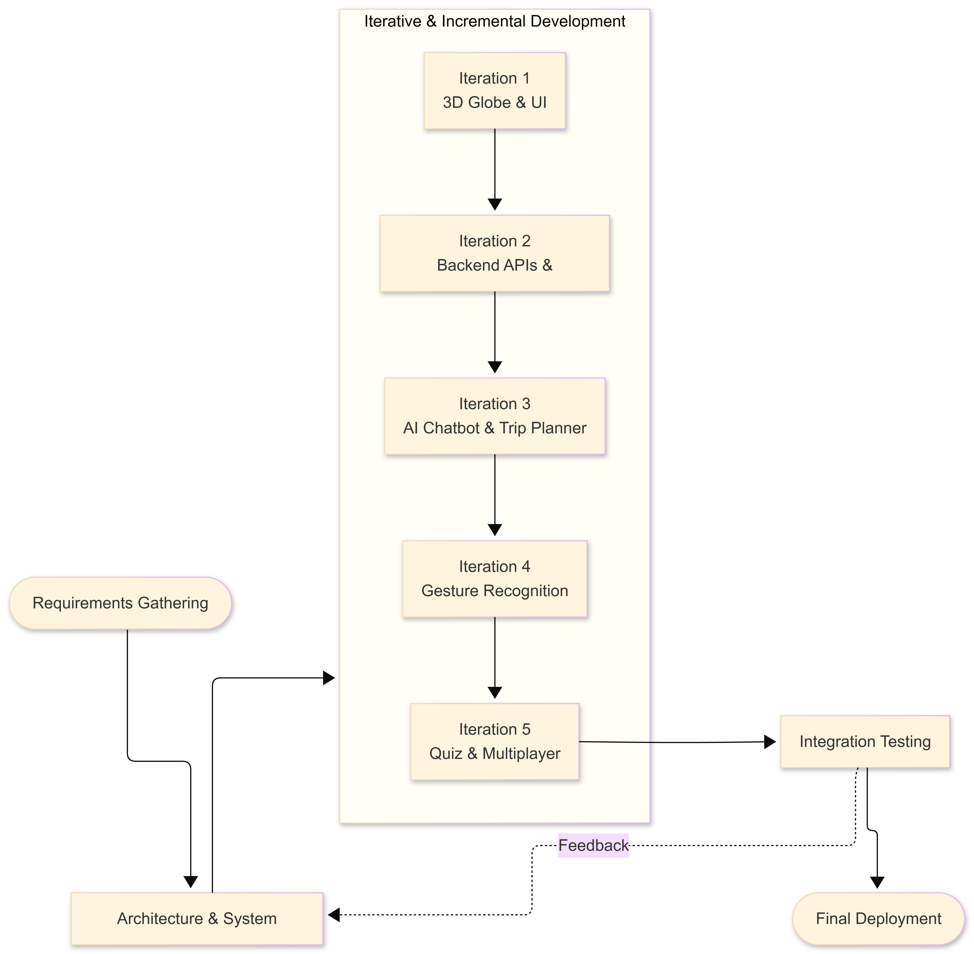
Fig. 1. GeoSwipe iterative and incremental development methodology.

Phase 1: Requirement Analysis
At the beginning of the project, its educational and functional needs were clarified. The project was designed to provide an interactive atmosphere for everyone to learn about the world and its cultural heritage. In this regard, requirements for the project were grouped into the following categories: geographic exploration, heritage information, interactive learning, natural interaction, contextual assistance, and multiplayer.
Phase 2: Core System Architecture
The architecture of the application was specified for independent modules to work together. In particular, the front end, back end, database, and third-party services were configured so that they could be integrated block by block.
Phase 3: Interactive Geographic Environment
As a main component of the platform, the three-dimensional globe was created as a geographic exploration interface. It provides a visual picture of the Earth to facilitate geographic explorations..
Phase 4: Heritage Exploration
Later on, the geographic layer was introduced into the cultural heritage system. This entailed the incorporation of heritage sites, their geographical coordinates, descriptive particulars, multimedia content, and interactive exploration sections that made it possible for the users to switch from geographical discovery to cultural heritage learning.
Phase 5: Educational Interaction
The game-based learning features were gradually incorporated into the system. Quiz and flag games were developed in the system to facilitate interactive application of geographical and cultural knowledge.
Phase 6: AI and Supporting Services
Once primary exploration and educational functionalities were ready, other contextual services were added, such as an AI-based heritage assistant, providing additional information without changing the existing exploration process.
Phase 7: Multiplayer Integration
Multiplayer capability was created as an additional interaction layer of educational gameplay. Enablement of the real-time communication and synchronized states from the games enables the players to participate in common games based on quiz and flag activities.
Phase 8: System Integration and Refinement
This last step was aimed at bringing all modules together into a unified platform that encompassed and coordinated all functions. Different elements of the system such as the globe, the heritage system, games, AI services, and multiplayer sections were tested and improved. An iterative development process helped solve potential problems that appeared during the integration stage before moving to the next stage of improvement.
The resulting methodology can therefore be viewed as a continuous cycle:
Develop → Integrate → Test → Refine → Extend
rather than a strictly linear development process. This allowed GeoSwipe to evolve from its core geographic interface into a broader interactive learning platform while maintaining the relationship between its individual components.
B. Research Queries
Based on the objectives and development of GeoSwipe, the study is guided by the following research queries:
Q1: How can an interactive 3D geospatial environment be integrated with cultural-heritage resources for exploratory learning purposes?
Q2: How can game-based learning and gestures be integrated with the geographic cultural-heritage platform for the purpose of user interaction enhancement?
Q3: How can AI-powered chat functionality and contextual tourism functionalities complement geographical and heritage exploration in one system?
Q4 How can the multiplayer function be utilized to enable users learn about heritage in an interactive competition format?
These questions dictate the course of implementation and discussion of GeoSwipe. The methodology is focused on stepwise integration of system components and the implementation section provides details regarding technical realization of system elements and their connections.
- IMPLEMENTATION
A. Ideation Phase
GeoSwipe started off with the goal of creating an engaging platform linking geographical exploration to education in cultural heritage. The particular concept was an interactive 3D globe that users could spin and learn where to look for information about heritage places. After going through several development iterations, this original idea evolved into something more complicated with the usage of educational games, gesture recognition, artificial intelligence, trip planning, safety features, and multiplayer gaming.The platform was therefore designed around a central exploration workflow:
Geographical Discovery → Heritage Exploration → Interactive Learning → Contextual Assistance → Extended Exploration
This workflow provided the basis for integrating the individual modules while maintaining a common user experience.
B. Phase of Conceptualizing Ideas
GeoSwipe's conceptual design broke it down into layers that would serve a specific function. The presentation layer is where interactive globe, maps, heritage interfaces, games, and its user interfaces are offered to users. The application layer is where you will find the management of heritage exploration, game logic, AI interaction, trip planning, and multiplayer options. The integration and data layer connects the system to MongoDB and other data and weather services.
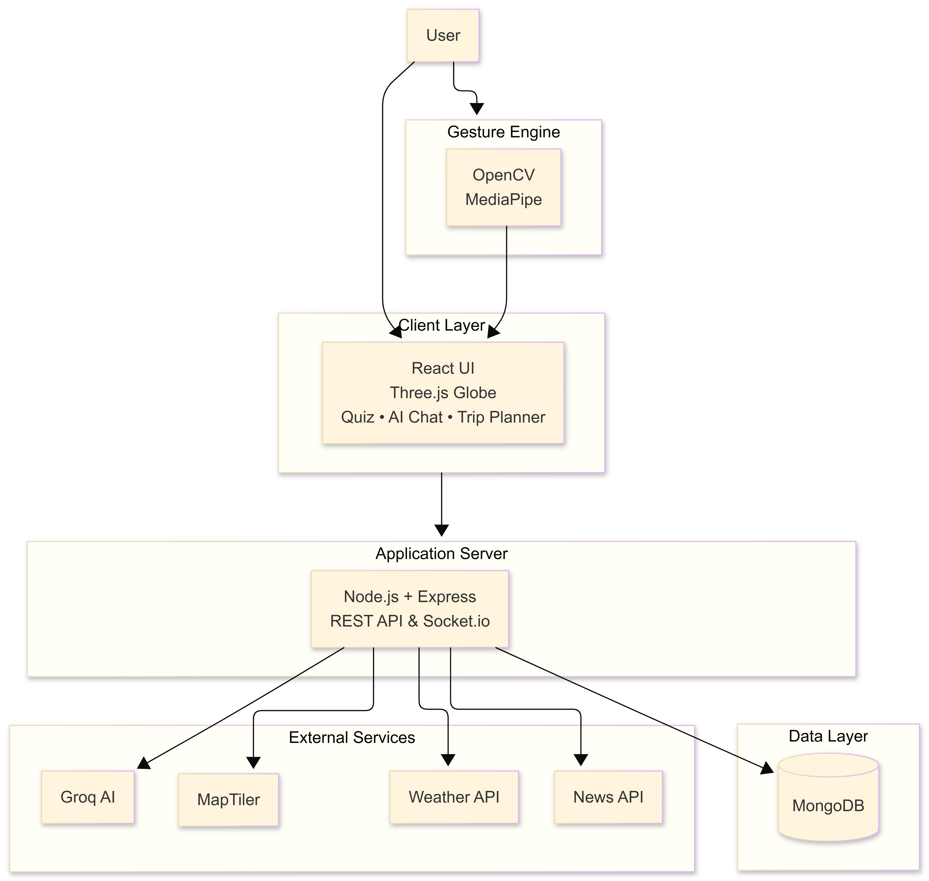
Fig. 2. Conceptual architecture of the GeoSwipe platform.
The architecture was developed in segments with individual pieces developed and tested on their own up until they were part of the whole product.
C. Prototyping Stage
The first prototype was meant to give users an interactive geographical setting or interface, and Three.js and WebGL were used to develop the interactive three-dimensional globe. The geographical components (countries) of the globe were slowly added.
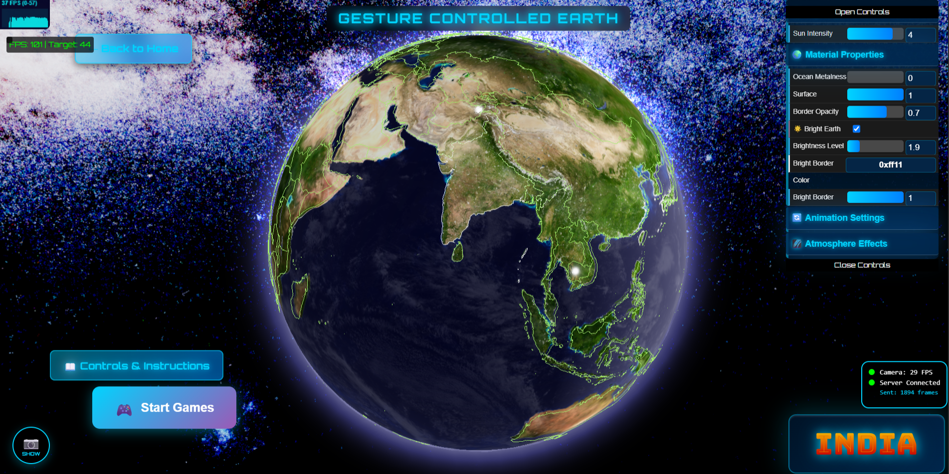
Fig. 3. Interactive three-dimensional globe interface of GeoSwipe.
The globe is meant to serve as an interactive tool instead of a static visualization tool.With the Earth to explore and interact with geographic areas, this interactive globe allows you to do just that. Besides, the interface allows for integrating the chosen location into the heritage study process. In addition, a distinct camera-related interaction system was created in order to provide interaction through gestures.
D. Gesture-Based Interaction
A separate computer-vision interaction pipeline was developed to support touchless interaction with the platform. The gesture subsystem uses OpenCV and MediaPipe for camera-based hand tracking and gesture recognition. Recognized gestures are converted into interaction events and communicated to the application through the real-time communication layer.The interaction pipeline can be represented as:
Camera Input → Hand Detection → Landmark Extraction → Gesture Classification → Socket Communication → React Interface
There is a specific mapping of input gestures on visual action resulting in cursor manipulation, picking an object, zooming, and spinning the globe. Since the automation of the process is needed to avoid incorrect actions related to unplanned actions caused by minor movement variations.
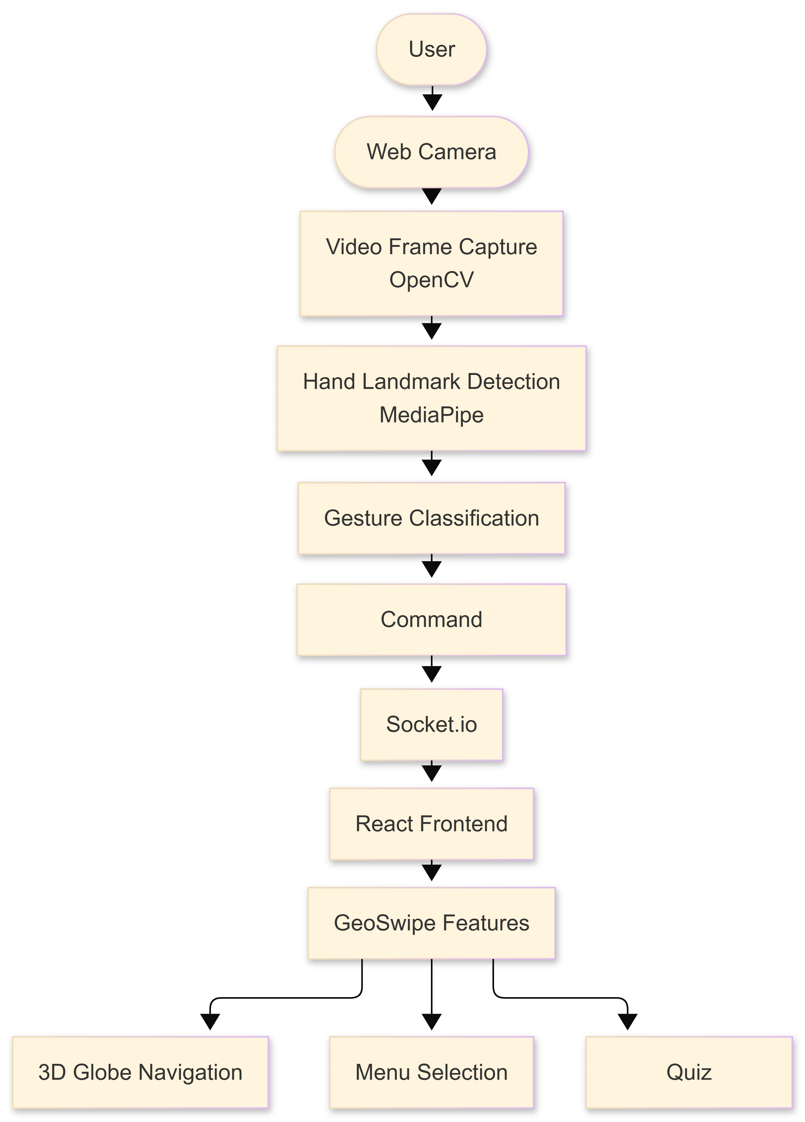
Fig. 4. Gesture recognition and interaction pipeline.
This technology allows the separation of the computer vision technology and the interface created using React technology meaning that the interaction technology and the web program work independently.
E. Heritage Exploration Module
The module of heritage forms a connection between geographical locations and cultural heritage data. MongoDB is used to store all the heritage sites which include their coordinates and descriptions. The information about the sites allows associating heritage sites with the locations on the map.
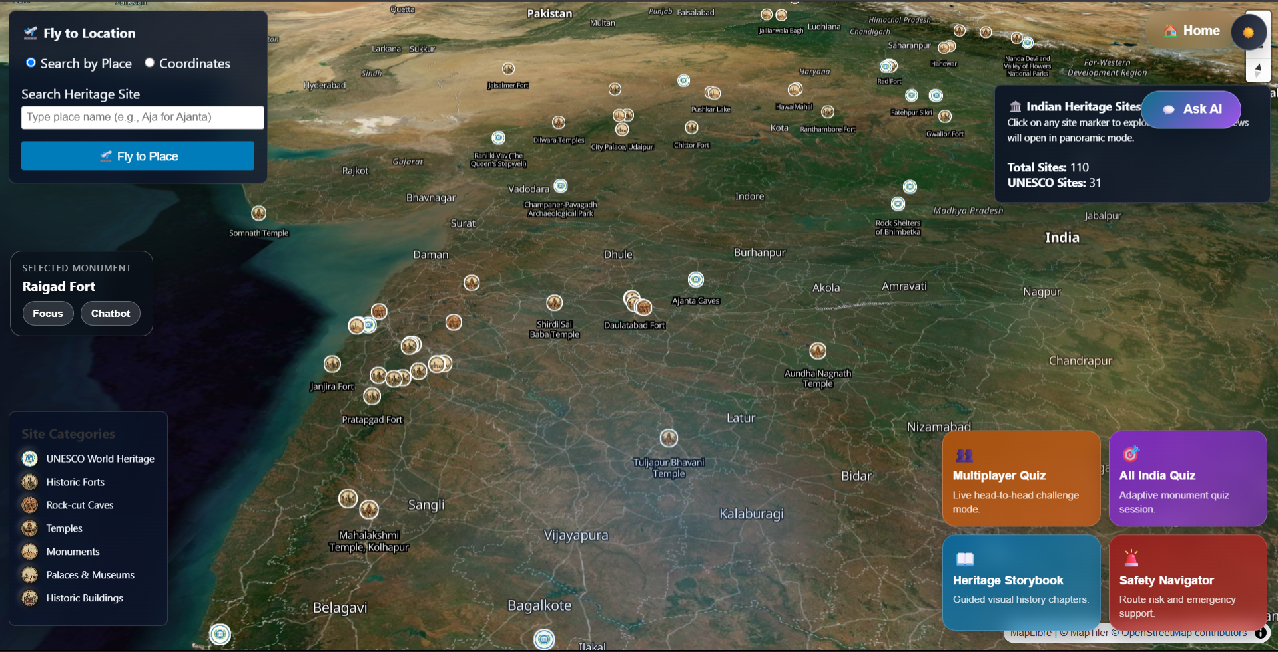
Fig. 5. GeoSwipe heritage exploration interface.
After the user has chosen the site he/she can observe its background information, multimedia resources, maps, and possibilities for further exploration. The service can provide other data as well: for instance, weather information and recent news about the placed selected by the user.
The heritage workflow therefore extends beyond displaying a location:
Location Selection → Heritage Information → Multimedia Exploration → Contextual Services
This allows the geographic interface to function as an entry point into a broader heritage-learning experience.
F. Educational Game Modules
The educational part of GeoSwipe consists of interactive quiz and flag games. This module enables users to convert the cultural and geographical knowledge into short interactive games that help people test their proficiency.
The quiz module consists of questions and answers of the quiz type, while the flag game requires the participants to find the correct country according to its flag.
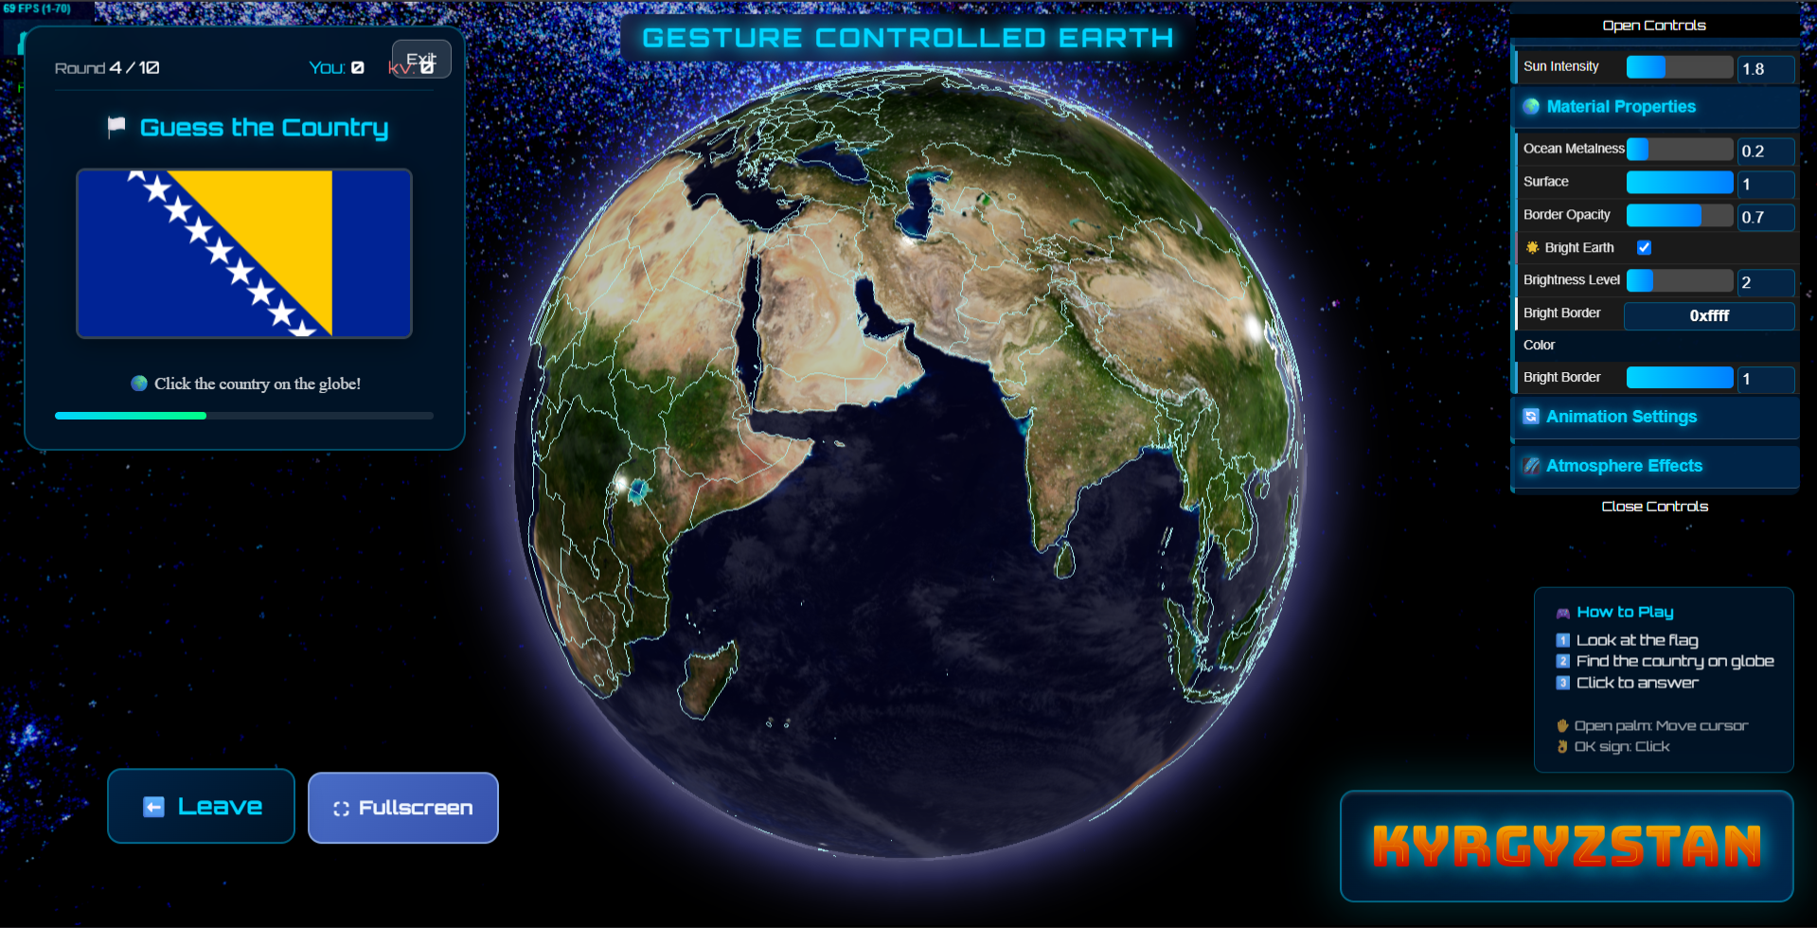
Fig. 6. GeoSwipe educational game interface.
According to its premise, the implementation states that the game mechanics should work towards the educational goal instead of existing as a completely separate component of entertainment.

G. AI-Assisted Heritage Interaction
The solution offers a chatbot that is based on artificial intelligence for giving heritage information by way of natural word communication. The chatbot receives information about the user’s request and any other context-related data, then formulates an answer with the help of an integrated language-modeling service.
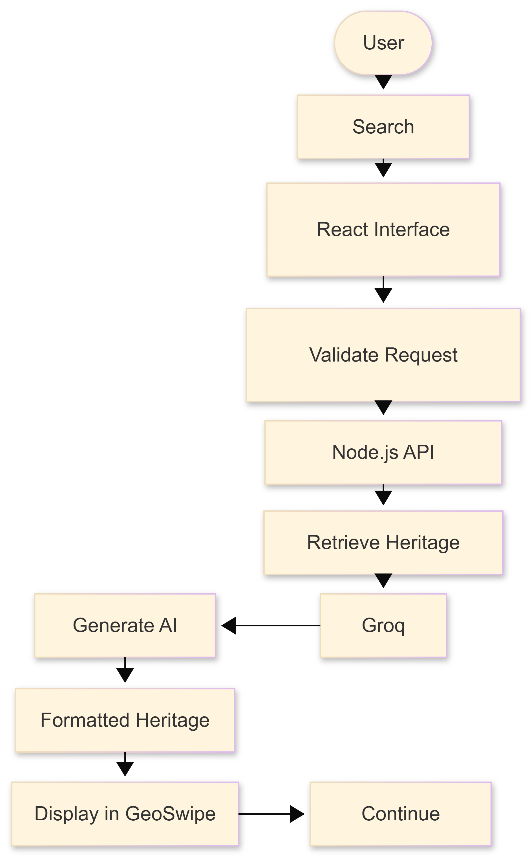
Fig. 7. AI-assisted heritage interaction workflow.
This creates an extra channel of information by means of which the users have access to the heritage information, being able to ask questions regarding the selected heritage location and receive informative explanations without leaving the platform.
The overall interaction can be represented as:
Selected Heritage Context + User Query → AI Processing → Contextual Response
As it follows, the AI system is able to supplement the organized heritage information provided by the platform.
H. Trip Planning and Supporting Services
GeoSwipe enables its users to broaden the subject of historic exploration by using additional contextual services. In particular, the users are allowed to plan their trip by means of an appropriate service. The supporting services provide data related to weather, news, maps, and other appropriate location-based services.
The platform is equipped with all required functionalities connected to the security issues.
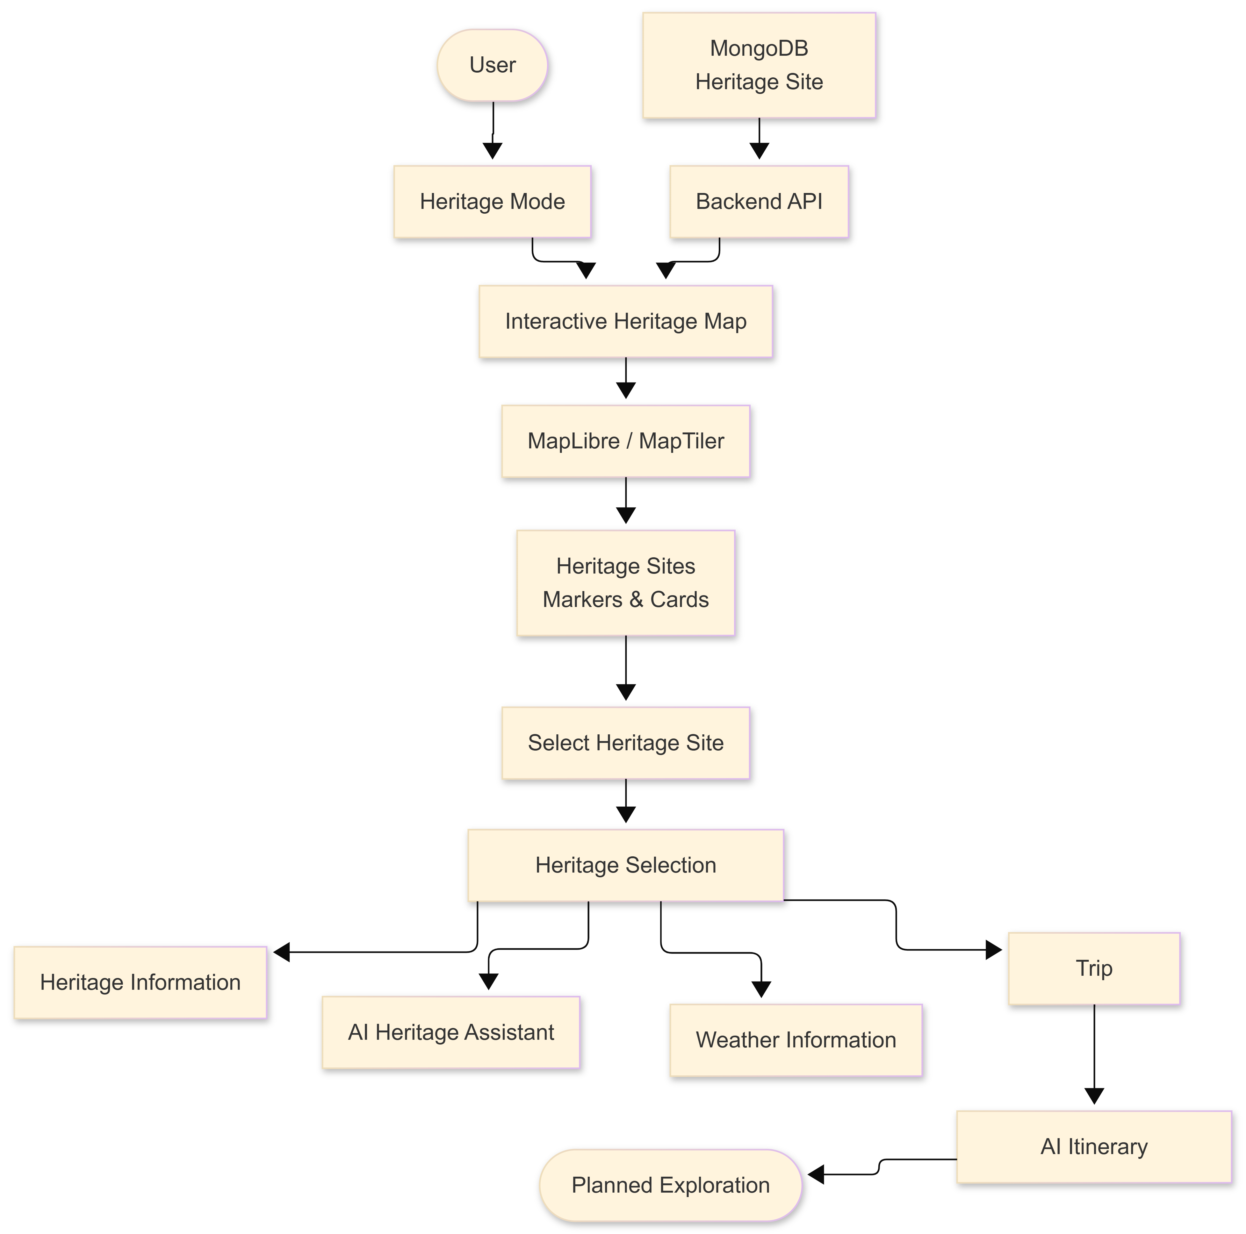
Fig. 8. Heritage exploration and contextual trip-planning workflow.
These services extend the platform's workflow from educational discovery toward practical geographic exploration:
Discover → Learn → Explore → Plan
I. Real-Time Multiplayer System
The multiplayer component brings the concept of shared gaming into the realm of education. GeoSwipe employs the Socket.IO technology to enable the real-time communication between participating clients and back end systems.
The game rooms contain the information about players, mode of the game, rounds, questions and answers, and the game progress.
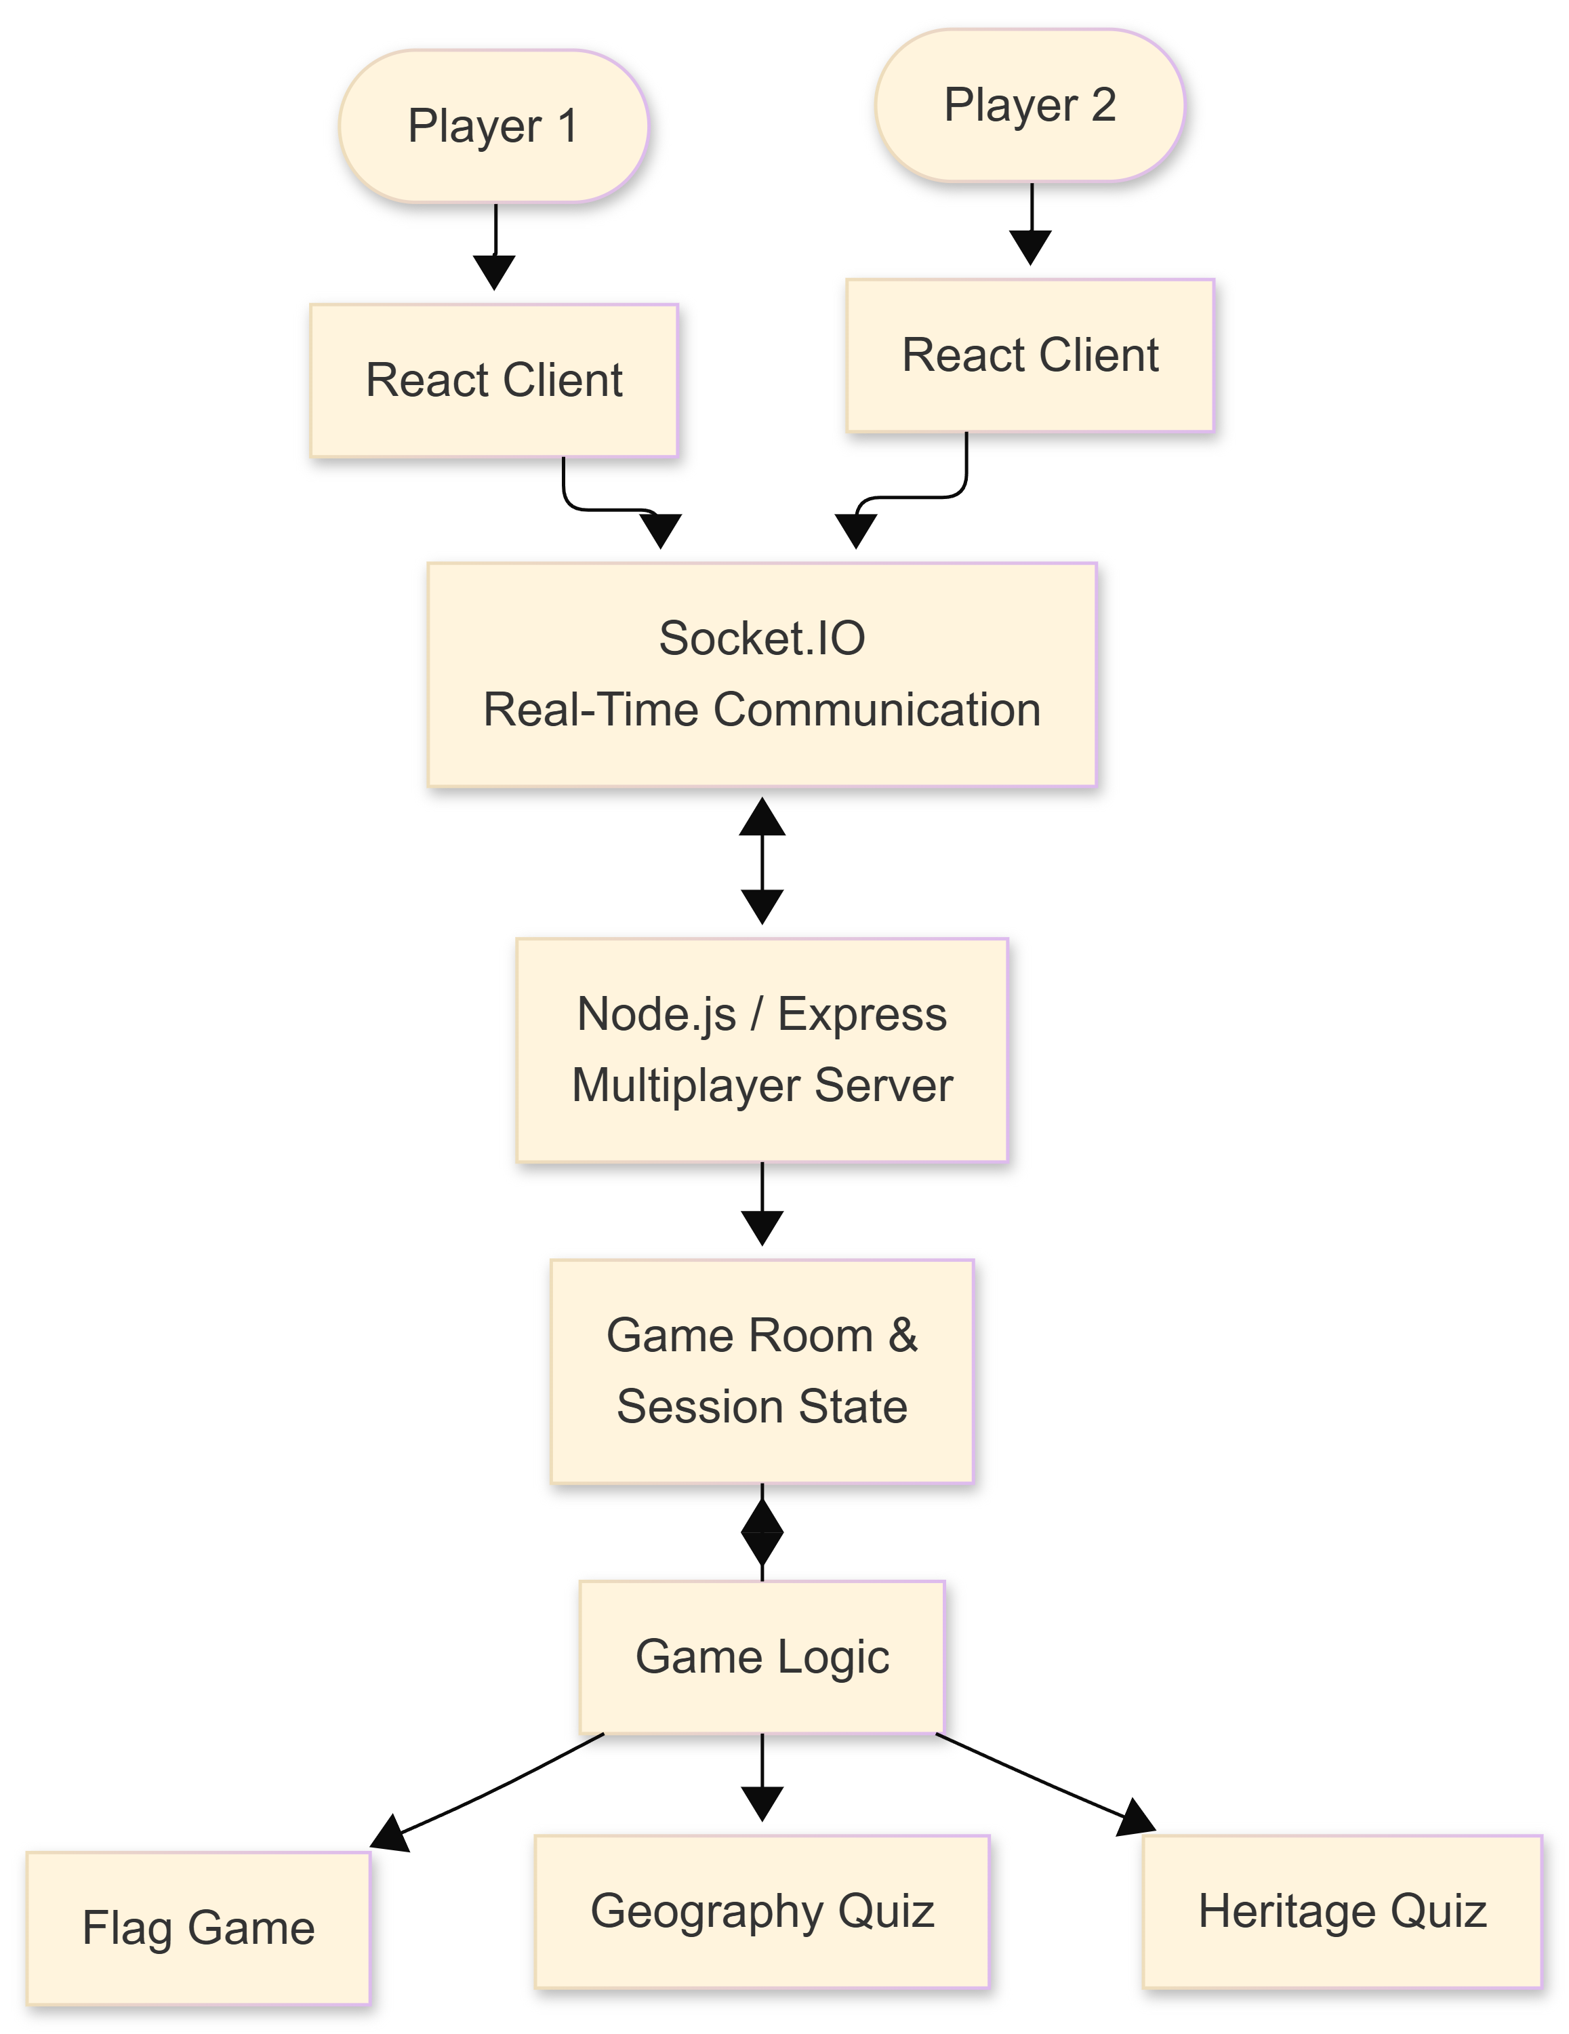
Fig. 9. GeoSwipe real-time multiplayer architecture.
The multiplayer workflow can be summarized as:
Player Connection → Room Creation/Joining → Game Initialization → Synchronized Questions → Answer Submission → Score/State Update → Game Completion
This infrastructure makes it possible to expand the quiz and flag-based activities from individual learning tasks to real-time experiences involving competition.
J. Database and System Integration
MongoDB serves as a key database for structured data of the platform, including the heritage resources and academic content. Node.js/Express is an essential part of the back end system that serves as a mediator between the front end and the database.
K. Integrated GeoSwipe Workflow
The full implementation enables the modules to function in a single user workflow. The user can sit in the comfort of his/her home and start with exploring a particular part of the world, initiate an exploration of the given location, learn about its culture, take part in online games, collect valuable information with the help of AI technologies and go on with trip planning and multiplayer tasks.
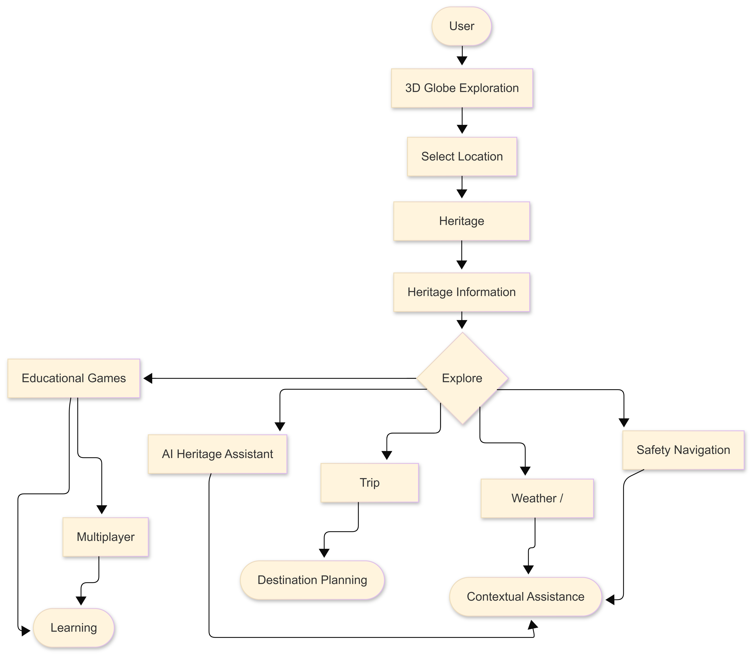
Fig. 10. Integrated GeoSwipe system workflow.
From the way development has taken place, it can be said that GeoSwipe now combines many individual applications and functions as one unified platform. During development, each of its components was designed in isolation but it has now been unified into a system ready for the use of shared data coming on-line from one source.

- Result and Discussion
The prototype has been assessed as regards its functions, capability to provide interactivity, educational capabilities, and different supporting services. It is clear that the final system will represent an interactive 3D globe with cultural-heritage capabilities, map-based visualizations, gesture-based interaction, quizzes and flag games, real-time multiplayer functionality, AI-powered heritage assistance, trip-planning functionality, and contextual services all being integrated into a single complex.
The findings show that the platform facilitates a continuous process of exploration and education that starts with the geographical discovery and goes all the way to heritage exploration and interactive educational activities. Users can rotate the 3D globe, find the information about heritage sites, use gesture-based controls to communicate with the environment, and take quizzes. The presence of the AI heritage assistant adds another interactive component to the platform through the conversational channel for collecting information, while travel-planning, weather, news, and safety services shift the platform from the heritage learning to practical exploration of destinations. The platform also includes multiplayer capabilities, allowing the organization of selected educational activities through real-time interaction among users.
The integration of technological layers needed for the platform is another result. The React user interface, Three.js/WebGL graphics rendering, Node.js application server, the MongoDB storage of data, computer-vision-based gesture control, and Socket.IO-based communication function together as one. This integrated system shows that it is possible to combine aspects of geographical information systems, game learning, natural interaction, conversational AI, and multiplayer features in one educational software application. The idea is in line with the findings of earlier studies which support the idea of interactive cultural heritage environment [3]-[8], game learning [1], [2], gesture interaction [9], [10], educational AI [11], [12], multiplayer serious games [14].
As a whole, what has been achieved shows that the GeoSwipe prototype is both technically and functionally viable in terms of the major components introduced in the study framework. However, it should be noted that these findings do not confirm the validity of the learning process, engagement, or usability. The present study does not involve an empirical approach with participating subjects. Thus, the statements about learning effectiveness cannot be proved completely. In the future, it will be necessary to carry out comparative and empirical research to assess the effectiveness of GeoSwipe using different methods including tools like SUS [15].
- Conclusion and Future Works
The GeoSwipe develops integrated geographic and cultural heritage learning systems by combining such elements of education as interactive 3D visualization, digital heritage exploration, games-based learning, gesture-based interaction, artificial intelligence, journey planning, and real-time multiplayer gameplay in one platform. The prototype illustrates how the mentioned parts can be linked with the help of a general exploration process so that users are able to find out their locations, get heritage information, participate in learning activities, and receive help in finding the necessary context in this way.
The development shows that this idea is feasible in terms of the technical aspects and functioning. The inclusion of the 3D globe, heritage materials, educational games, gesture interaction, AI assistant, contextual services and multiplayer system gives plenty of forms of interactions in one learning environment to use.
In the future, efforts will involve conducting controlled user studies to collect quantitative information regarding the utilization, use, and efficiency of GeoSwipe. The evaluation will involve the application of standardized usability measures such as System Usability Scale [15] along with a learning assessment to collect the data needed to assess the users' learning experience. The continuation of work may lead to possible implementation of multiplayer systems, enhanced user-centered approach through AI technology in traveling and educational purposes, extension of the heritage database, etc.
In conclusion, GeoSwipe can be regarded as the first step towards the future educational platform which will include such features as education based on game elements, culture exploration, and new-age interaction technologies.
VII . References

[1] Z. Yu, M. Gao, and L. Wang, “The Effect of Educational Games on Learning Outcomes, Student Motivation, Engagement and Satisfaction,” J. Educ. Comput. Res., vol. 59, no. 3, pp. 522–546, 2021.
[2] A. I. Abdul Jabbar and P. Felicia, “Gameplay Engagement and Learning in Game-Based Learning: A Systematic Review,” Rev. Educ. Res., vol. 85, no. 4, pp. 740–779, 2015.
[3] M. Mortara and C. E. Catalano, “3D Virtual Environments as Effective Learning Contexts for Cultural Heritage,” Italian J. Educ. Technol., 2018.
[4] I. Liritzis, P. Volonakis, and S. Vosinakis, “3D Reconstruction of Cultural Heritage Sites as an Educational Approach: The Sanctuary of Delphi,” Appl. Sci., vol. 11, no. 8, Art. no. 3635, 2021.
[5] V. Okanovic, I. Ivkovic-Kihic, D. Boskovic, B. Mijatovic, I. Prazina, E. Skaljo, and S. Rizvic, “Interaction in eXtended Reality Applications for Cultural Heritage,” Appl. Sci., vol. 12, no. 3, Art. no. 1241, 2022.
[6] A. Belhi, H. O. Ahmed, T. Alfaqheri, A. Bouras, A. H. Sadka, and S. Foufou, “An Integrated Framework for the Interaction and 3D Visualization of Cultural Heritage,” Multimedia Tools Appl., vol. 83, no. 15, 2024.
[7] A. Scianna and M. La Guardia, “Globe Based 3D GIS Solutions for Virtual Heritage,” Int. Arch. Photogramm., Remote Sens. Spatial Inf. Sci., vol. XLII-4/W10, pp. 171–177, 2018.
[8] R. Wüest, H. Eugster, S. Nebiker, and M. Christen, “Processing and Rendering Massive 3D Geospatial Environments Using WebGL—The Examples of OpenWebGlobe and SmartMobileMapping,” in Proc. Graphical Web, 2012.
[9] X. Zabulis, H. Baltzakis, and A. A. Argyros, “Vision-Based Hand Gesture Recognition for Human-Computer Interaction,” 2009.
[10] M. Kölsch and M. Turk, “Vision-Based Hand Gesture Interfaces for Wearable Computing and Virtual Environments,” 2004.
[11] B. Dong, J. Bai, T. Xu, and Y. Zhou, “Large Language Models in Education: A Systematic Review,” in Proc. 2024 6th Int. Conf. Comput. Sci. Technol. Educ. (CSTE), 2024.
[12] H.-A. Bekkar and Y. Chtouki, “Chatbots in Education: A Systematic Literature Review,” in Proc. 2024 10th Int. Conf. Smart Comput. Commun. (ICSCC), pp. 637–644, 2024.
[13] A. Fogli and G. Sansonetti, “Exploiting Semantics for Context-Aware Itinerary Recommendation,” Pers. Ubiquitous Comput., vol. 23, no. 6, 2019.
[14] V. Wendel, F. Hertin, S. Göbel, and R. Steinmetz, “Collaborative Learning by Means of Multiplayer Serious Games,” in Proc. 9th Int. Conf. Web-Based Learning (ICWL 2010), Advances in Web-Based Learning, 2010.
[15] K. Orfanou, N. Tselios, and C. Katsanos, “Perceived Usability Evaluation of Learning Management Systems: Empirical Evaluation of the System Usability Scale,” Int. Rev. Res. Open Distrib. Learn., vol. 16, no. 2, pp. 227–246, 2015.

