 

**SkillVerse**

SY Mini Project Report

Submitted in partial fulfillment of the requirements of the Subject Project Based Learning: Mini Project Lab-I (Sem IV)

by

Dhir Thakar

Kanav Trivedi

Vidit Sanghani

Kartik Verma

Supervisor

Dr. Nilesh Yadav



Department of Computer Engineering K J Somaiya Institute of Technology Ayurvihar, Sion Mumbai-400022 2024-25

**CERTIFICATE**

This is to certify that the project entitled **“SkillVerse”** is bonafide work **Dhir Thakar**, **Kanav Trivedi**, **Vidit Sanghani**, **Kartik Verma** submitted as a SY Sem IV Mini project in the subject of Project Based Learning: Mini Project Lab-I, Computer Engineering for the academic year 2024-25.

**Dr. Nilesh Yadav**

Project Guide

Department of Computer Engineering

**Dr. Sarita Ambadekar Dr. Vivek Sunnapwar**

Dept. of Computer Engineering Principal, KJSIT Head of Department

Place : Sion, Mumbai 400022 Date :

# PROJECT APPROVAL FOR S. Y.

This project report entitled **“SkillVerse”**

Dhir Thakar– B/43 Kanav Trivedi–B/49 Vidit Sanghani-B/50 Kartik Verma– B/59

is an approved Second Year Mini Project Semester IV in Computer Engineering.

EXAMINER:

1.

External Examiner Name and Sign

2.

Internal Examiner Name and Sign

# DECLARATION

We declare that this written submission represents our ideas in our own words and where others' ideas or words have been included, we have adequately cited and referenced the original sources. We also declare that we have adhered to all principles of academic honesty and integrity and have not misrepresented or fabricated or falsified any idea/data/fact/source in our submission. We understand that any violation of the above will be cause for disciplinary action by the Institute and can also evoke penal action from the sources which have thus not been properly cited or from whom proper permission has not been taken when needed.

Dhir Thakar

Kanav Trivedi

Vidit Sanghani

Darshan Tank

Date :

# ACKNOWLEDGEMENT

Before presenting our SY mini project work entitled **“SkillVerse”**, we would like to convey our sincere thanks to the people who guided us throughout the course for this project work.

First, We would like to express our immense gratitude towards our **Project Guide Dr. Nilesh Yadav** for the constant encouragement, support, guidance, and mentoring at the ongoing stages of the project and report.

We would like to express our sincere thanks to our **H.O.D Dr. Sarita Ambadekar** for the encouragement, co-operation, and suggestions progressing stages of the report. We would like to express our sincere thanks to our beloved **Principal Dr. Vivek Sunnapwar** for providing various facilities to carry out this project.

Finally, we would like to thank all the teaching and non-teaching staff of the college, and our friends, for their moral support rendered during the course of the reported work, and for their direct and indirect involvement in the completion of our report work, which made our endeavor fruitful.

Place: Sion, Mumbai-400022 Date :

# ABSTRACT

Skill Verse is an intuitive and community-powered app designed to make skill-sharing accessible to everyone. It allows users from all backgrounds to create, publish, and share courses based on their unique skills and experiences. Whether it’s coding, cooking, music, design, or any other talent, Skill Verse provides a platform where knowledge can be structured into engaging lessons and shared with a global audience. With simple tools for video, text, and quiz integration, even first-time course creators can build rich, interactive learning experiences without the need for technical expertise.

The platform emphasizes peer-to-peer learning, offering features like ratings, reviews, and discussion forums to promote feedback, collaboration, and improvement. Learners can follow their interests at their own pace, while creators can grow their personal brand and potentially monetize their content. Skill Verse is designed to be inclusive and scalable, enabling micro-communities to form around shared interests and educational goals, while maintaining a broad, diverse catalog of user-generated courses.

By focusing on accessibility and user empowerment, Skill Verse fosters a culture where everyone can be both a teacher and a learner. The app bridges the gap between traditional learning platforms and real-world skills, making education more personal, flexible, and relevant to the needs of a fast-evolving world.

v

# CONTENTS

|  |  |  |  |
| --- | --- | --- | --- |
| Chapter No. | | TITLE | Page no. |
|  |  | LIST OF FIGURES | viii |
|  | | | |
| 1 |  | **INTRODUCTION** | 1 |
|  | 1.1 | Problem Definition | 1 |
|  | 1.2 | Aim and Objective | 1 |
|  | 1.3 | Organization of the Report | 2 |
| 2 |  | **REVIEW OF LITERATURE** | 4 |
|  | 2.1 | Literature Survey | 4 |
|  | 2.2 | Summarized Findings | 5 |
| 3 |  | **REQUIREMENT SPECIFICATION** | 7 |
|  | 3.1 | Introduction | 7 |
|  | 3.2 | Hardware requirements | 7 |
|  | 3.3 | Software requirements | 7 |
|  | 3.4 | Feasibility Study | 8 |
|  | 3.5 | Cost Estimation | 8 |
| 4 |  | **PROJECT ANALYSIS & DESIGN** | 9 |
|  | 4.1 | Introduction | 9 |
|  | 4.2 | Architecture of Project | 9 |
|  | 4.3 | Timeline Chart | 11 |
| 5 |  | **METHODOLOGY** | 12 |
|  | 5.1 | Introduction | 12 |

|  |  |  |  |
| --- | --- | --- | --- |
|  | 5.2 | Flow chart | 12 |
| 6 |  | **IMPLEMENTATION DETAILS & Results** | 14 |
|  | 6.1 | Introduction | 14 |
|  | 6.2 | System implementation (Screenshot with detail description) | 14 |
| 7 |  | **CONCLUSION & FUTURE SCOPE** | 20 |
|  |  | REFERENCES | 21 |
|  |  | PLAGIARISM REPORT | 22 |

vii

# LIST OF FIGURES

|  |  |  |
| --- | --- | --- |
| Figure No. | Title | Page No. |
| 4.1 | System architecture | 11 |
| 4.1 | Timeline Chart | 11 |
| 5.1 | Flow chart | 13 |
| 6.1 | Landing Page | 14 |
| 6.2 | Login Page | 15 |
| 6.3 | Register Page | 15 |
| 6.4 | Page to view tips | 16 |
| 6.5 | Page to view reports | 16 |
| 6.6 | User Profile Page | 17 |
| 6.7 | About Us Page | 17 |
| 6.8 | Contact Us Page | 18 |

**CHAPTER 1 INTRODUCTION**

## Problem Definition:

In today's rapidly evolving world, there is a growing need for continuous learning and skill development. Traditional education systems often fail to meet the diverse and specific needs of learners, while educators may struggle to find an efficient platform to create and share courses. The lack of flexibility, accessibility, and personalized learning experiences hampers individuals in acquiring new skills and knowledge. Additionally, the current platforms often lack a user-friendly interface for both course creators and learners, making it challenging to engage with educational content effectively

## Aim and Objective:

To create a user-friendly platform that empowers individuals to share their knowledge and skills by designing and publishing personalized online courses, fostering a global community of peer-to-peer learning and collaboration.

Objectives:

* **Create Courses:** Allow educators and industry professionals to easily design, manage, and share courses tailored to specific needs and audiences.
* **Apply for Courses:** Provide learners with an accessible, searchable catalog of courses across different fields and expertise levels, enabling them to apply for courses that best suit their learning goals.
* **Enhance Skill Development:** Bridge the gap between demand for skills and access to relevant educational content by offering a wide range of diverse courses
* **Certification and Achievements:** Offer certificates and badges upon course completion, motivating learners to achieve their educational goals and providing tangible proof of their skills.

## Organization of the Report:

* **Introduction**

This chapter introduces the concept of Skill Verse, highlighting the growing demand for peer-to-peer skill-sharing platforms. It also outlines the purpose and scope of the report.

* **Background and Problem Statement**

Discusses the challenges faced by individuals seeking practical, experience-based learning and the limitations of traditional platforms. It establishes the need for an accessible, user-driven solution.

* **Aim and Objectives**

States the primary aim of the project and breaks it down into specific, measurable objectives along with the expected outcomes of the platform.

* **Methodology**

Describes the approach taken to gather data and requirements, including user research through surveys or interviews. It also covers the design and development methodology used for creating the platform.

* **Platform Design and Features**

Focuses on the UI/UX strategy, highlighting features that facilitate course creation, sharing, and interaction. It also covers important aspects such as data security and user privacy.

* **Implementation Plan**

Outlines the development timeline, project phases, and resource allocation. Additionally, it discusses strategies for launching the platform and creating awareness among potential users

* **Evaluation and Monitoring**

Details the criteria and key performance indicators (KPIs) used to measure the platform’s success. It also explains the feedback and update mechanisms for continuous improvement.

* **Conclusion and Recommendations**

Summarizes the project’s core findings, expected social and educational impacts, and provides suggestions for future upgrades and expansion of *Skill Verse*.

# CHAPTER 2 REVIEW OF LITERATURE

## Literature Survey:

The development of Skill Verse, a peer-driven platform for sharing skills via online courses, draws inspiration and justification from various scholarly works and studies that examine collaborative learning, online platforms, and resource-sharing technologies. These studies collectively highlight the need for flexible, accessible, and user-centric educational platforms.

**Johnson, D.W., & Johnson, F.P. (2002)** in their work *Collaborative Learning in Higher Education* explored the impact of collaborative learning in academic settings. Through a qualitative approach involving surveys and case studies, the authors found that collaborative learning significantly enhances critical thinking, problem-solving, and interpersonal skills. Moreover, it contributes positively to academic achievement and social development. These findings are relevant to Skill Verse’s design, as the platform encourages knowledge-sharing in a collaborative environment, fostering peer engagement and mutual learning.

**S. M. R. S. (2013)**, in the study titled *A Study on Resource Sharing Systems in Cloud Computing*, analyzed the mechanisms of resource sharing in cloud-based systems. The research used literature review and case study methods to examine the advantages and challenges associated with cloud computing. The study concluded that while cloud-based systems provide scalability and flexibility, they still face hurdles in terms of security, data privacy, and efficient resource allocation. These insights directly inform the backend considerations of Skill Verse, especially in building a secure, scalable infrastructure that ensures data integrity and privacy for users sharing and accessing educational content.

**L. H. Luecht & J. M. Kim (2019)** conducted a study titled *Online Learning Platforms for Internships: A Survey* to evaluate the effectiveness of digital platforms in facilitating internship opportunities. Using surveys and feedback analysis from participants, the study found that online platforms are highly valuable but require significant improvements in areas such as interactivity, employer engagement, and real-world exposure. These findings reinforce the importance of designing Skill Verse with robust interactive features and real-world applicability of content to improve learner engagement and relevance.

Together, these studies underline the core requirements and benefits of an educational platform that is collaborative, scalable, secure, and practically valuable. They serve as the foundational literature that supports the rationale behind Skill Verse and guide its features, infrastructure, and user experience design.

|  |  |  |  |  |
| --- | --- | --- | --- | --- |
| Author(s) | Title | Objective/Research Questions | Methodology | Findings/Results |
| Johnson, D.W., & Johnson, F.P. (2002) | Collaborative Learning in Higher Education | To explore the impact of collaborative learning in higher education. | Qualitative analysis of various educational settings, surveys, and case studies. | Collaborative learning fosters critical thinking, problem-solving, and social skills. It also enhances academic achievement and interpersonal relationships. |
| S. M. R. S. (2013) | A Study on Resource Sharing Systems in Cloud Computing | To analyze resource sharing mechanisms in cloud computing systems. | Literature review and case studies of cloud-based resource sharing models. | Cloud computing enhances scalability and flexibility for resource management, but challenges remain in security, data privacy, and resource allocation efficiency. |
| L. H. Luecht & J. M. Kim (2019) | Online Learning Platforms for Internships: A Survey | To examine the effectiveness of online platforms for internship opportunities. | Survey of online learning platforms, data analysis from internship participation and feedback. | Online learning platforms are valuable for internship opportunities, but require improvements in interactivity, employer engagement, and practical exposure for students. |

## Summarized Findings:

Based on our review of the literature, it is evident that while many platforms exist for online learning and skill development, few manage to combine collaborative learning, secure resource sharing, and real-world applicability in a single, cohesive system. Research highlights the strengths of peer-to-peer learning, the flexibility of cloud-based platforms, and the potential of online internship systems—but also reveals gaps in interactivity, data protection, and practical engagement. Skill Verse emerges as a solution that addresses these shortcomings by integrating community-driven course creation, secure content hosting, and real-world relevance. It bridges the divide between traditional educational platforms and modern learning needs, fostering both accessibility and authenticity in skill-sharing.

Here is a **summary of the key findings** from the three studies reviewed in the table:

1. **Collaborative Learning in Higher Education (Johnson & Johnson, 2002)**
   * Collaborative learning significantly enhances critical thinking, problem-solving, and social skills.
   * It leads to better academic performance and strengthens interpersonal relationships among learners.
2. **Resource Sharing in Cloud Computing (S.M.R.S., 2013)**
   * Cloud computing improves scalability and flexibility in managing resources.
   * However, persistent challenges exist in areas like data privacy, security, and efficient resource allocation.
3. **Online Learning Platforms for Internships (Luecht & Kim, 2019)**
   * Online platforms offer meaningful internship opportunities but lack in areas such as interactivity, employer involvement, and real-world exposure.
   * There's a clear need for improvements in engagement and platform design to maximize student benefit.

# CHAPTER 3 REQUIREMENT SPECIFICATION

## Introduction:

The SkillVerse project requires a well-defined set of hardware and software components to meet the needs of the educational community effectively. Clearly defining these requirements ensures the project aligns with the community’s expectations, resulting in a valuable, sustainable platform. Essential hardware may include servers and reliable networking equipment to support high usage, while software requirements involve robust backend (Node.js, MongoDB) and frontend (HTML, CSS, JavaScript) frameworks. These components will enhance user experience and data management.

## Hardware Requirements:

1. Processor: Intel i5 and above (development).
2. RAM: 8GB minimum
3. Storage: SSD with a minimum of 256GB.
4. Internet Connection: For testing and live hosting.
5. Server: Cloud server (AWS, Heroku, or Vercel) for hosting.
6. Monitor: HD resolution for responsive UI testing.

## Software Requirements:

Key software components include:

1. Programming Language: Node.js with Express.js framework for building robust and scalable backend services.
2. Frontend : HTML, CSS and JavaScript for designing a responsive user interface.
3. Database: MongoDB Atlas for efficient data storage and retrieval.
4. Operating System: Compatible with Windows for deployment.

## Feasibility Study:

* + 1. Technical Feasibility:

The *Skill Verse* platform is technically feasible with the current state of web and mobile technologies. The system is designed to be developed using widely adopted and well-supported tools such as:

* **Frontend:** React (for web), React Native (for mobile apps) – ensuring cross-platform compatibility and responsive user interfaces.
* **Backend:** Node.js – Capable of handling scalable APIs and user data management.
* **Database:** MongoDB – offering efficient data storage for user profiles, course content, and usage analytics.
* **Cloud Services:** AWS, Azure, or Firebase – for hosting, storage, authentication, and deployment support.
  + 1. Operational Feasibility:

Operationally, Skill Verse is feasible and sustainable. The platform's user-centric design is built around intuitive navigation and accessibility, reducing the learning curve for first-time users. The model supports a wide range of contributors—experts, hobbyists, educators—allowing them to create, share, and monetize their courses, which promotes long-term engagement.

With thoughtful planning and a clear operational roadmap, Skill Verse is positioned to function smoothly post-deployment, ensuring value delivery for both learners and contributors.

* + 1. Economic Feasibility:

The Skill Verse platform is economically viable, with a balanced cost-to-value ratio and multiple opportunities for revenue generation. A preliminary cost analysis indicates that the project can be developed and maintained within a reasonable budget, especially by leveraging open-source technologies and cloud-based infrastructure.

## Cost Estimation:

Costs include server hosting fees, development resources, and potential future maintenance. Total estimated initial costs ranges, depending on specific service providers and cloud storage needs.

# CHAPTER 4 PROJECT ANALYSIS & DESIGN

## Introduction:

The project analysis and design phase focus on translating the gathered requirements into an organized framework that guides development. This involves creating a scalable system architecture and developing a timeline for project execution.

## Architecture of Project:

The *Skill Verse* web application adheres to a Three-Tier Architecture:

1. Presentation Layer: Developed with React.js for responsive UI, it contains independent interfaces for students and teachers.
2. Application Layer: Driven by Node.js , this layer encompasses business logic, advisor verification, report processing, and authentication.
3. Data Layer: Permanently stores user data, reports, advisor data, and verification status using MongoDB.

All the components communicate safely through APIs and are joined through RESTful routes. JWT authentication guarantees safe session management through all interfaces.

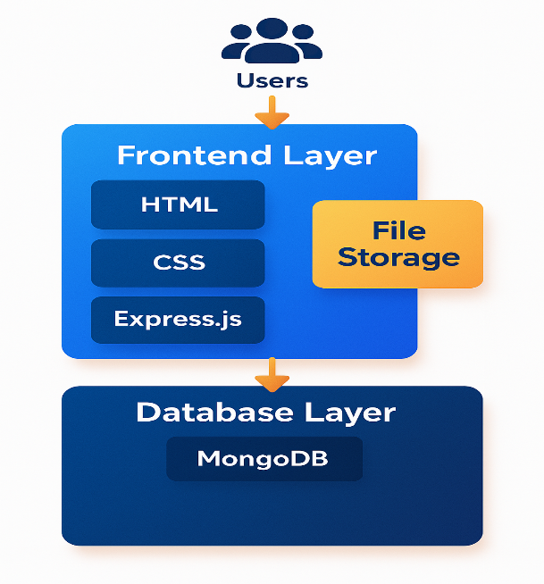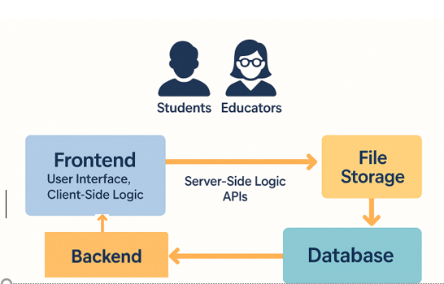

Fig 4.1 System architecture

## Timeline Chart:

The image is a Gantt chart outlining a 12-week project timeline. It displays phases like Planning, Front End, Backend, Testing, Bug Fixing, and Documentation, each scheduled across specific weeks.

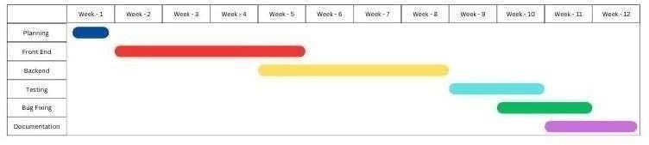

Fig 4.2 Timeline Chart

* 1. **Introduction:**

# CHAPTER 5 METHODOLOGY

The development of Skill Verse followed a user-centric and iterative methodology, combining surveys, interviews, and competitive analysis to identify gaps in existing skill-sharing platforms. Data gathered from users—such as students, professionals, and educators—helped define both functional and non-functional requirements, including ease of use, secure content sharing, and reliable instructor verification. Using agile principles, the project progressed through stages of wireframing, prototyping, and modular development, with continuous testing and refinement. Technologies like React, Node.js, and cloud services (e.g., Firebase or AWS) were chosen for their scalability and flexibility. Early user feedback was incorporated into each iteration to ensure the platform remained aligned with real-world needs and expectations.

## Flowchart:

Here's a step-by-step flow explanation based on the updated flowchart:

1. Start:

The system starts when a user logs into the application.

1. Login / Register:

The user is asked to either Login if he/she already has an account or Register if he/she is a new user and needs to register an account.

1. Authentication & Authorization:

Once login or registration is done, the system verifies: Authentication: Is the user identity confirmed (proper credentials)?

Authorization: What access level does the user possess? (Student or Teacher)

1. Role Determination (User is.):

The system identifies the user type:

* + Student
  + Teacher

1. Log Out:

Once tasks are done, the user may log out of the system.

1. End: The session is ended.

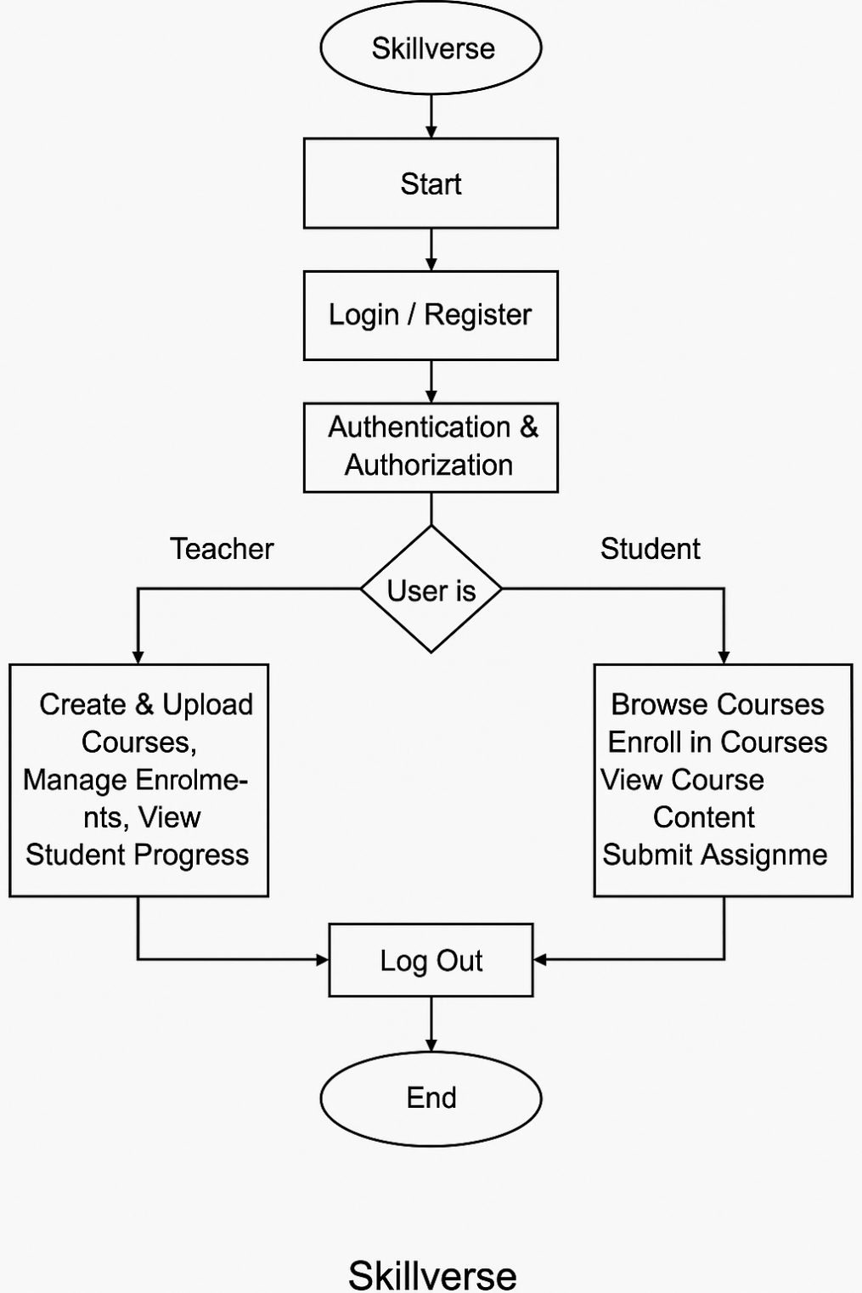

Fig 5.1 Flowchart

# CHAPTER 6 IMPLEMENTATION DETAILS & RESULTS

## Introduction

This section outlines the practical aspects of developing and deploying the Skillverse platform, including the technologies used, system architecture, and functional modules for both student and teacher users. It details the steps taken during the implementation phase, such as user interface design, backend integration, database management, and testing procedures. Additionally, it presents the outcomes of the development process, showcasing key functionalities, user interactions, and system performance. The results highlight the effectiveness of the platform in achieving its intended objectives, providing insights into user experience, system reliability, and overall functionality.

## System Implementation

This image shows a landing page for SkillVerse. The page has a simple and minimalistic design. It shows the available benefits and uses that our websites provides to everyone free of cost.

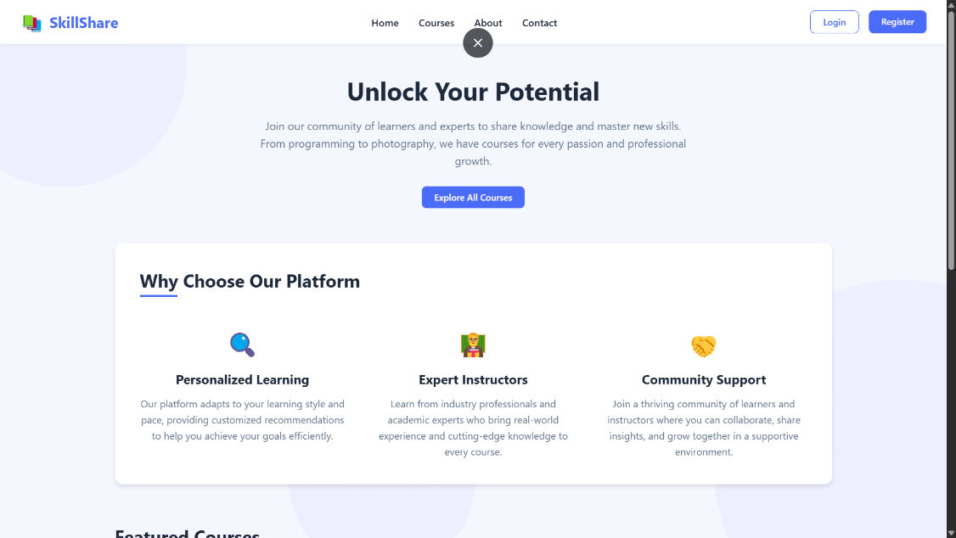

Fig 6.1 Landing page

The login page in the SkillVerse website is clean and very simple with fields for one to fill in their e-mail and password.



Fig 6.2 Login page

The Register Page enables new users to register by providing required information like full name, email address, and password. Registration is successful if it allows users to access the features of the platform based on their assigned role.

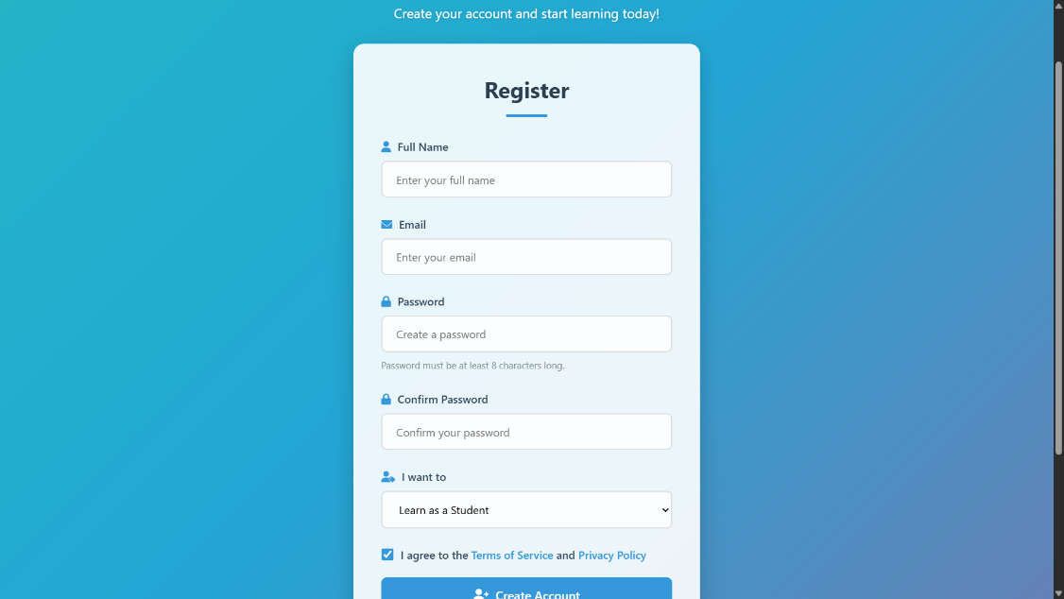

Fig 6.3 Register page

**Student:**

This page welcomes the user and displays their enrolled courses such as CSS, Python, and JavaScript. Each course card provides a brief overview and a "Continue Learning" button. Users can also click to find new courses or view all enrolled ones..

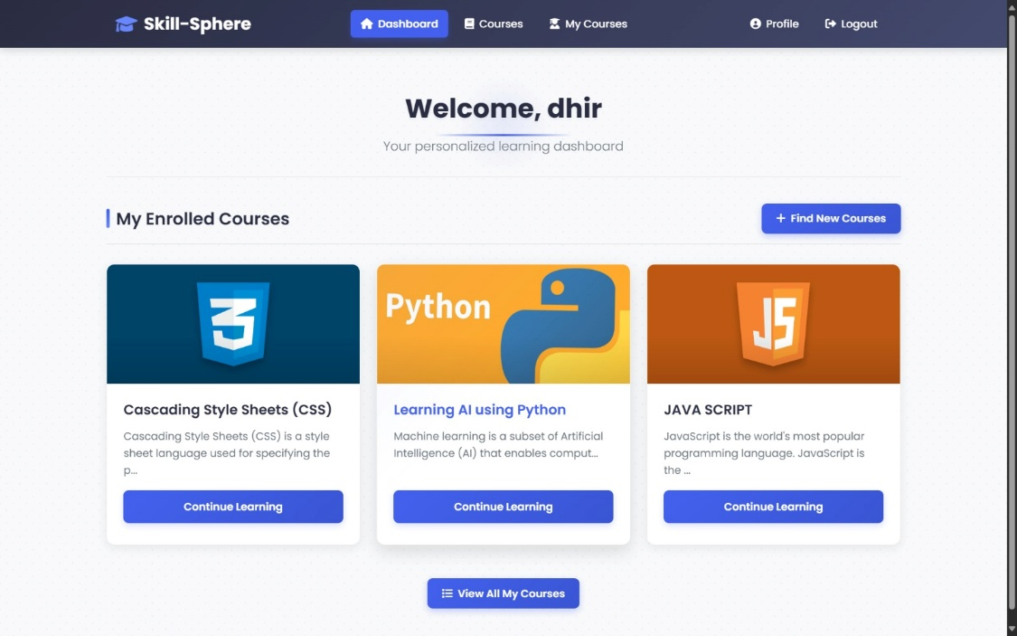

Fig 6.4 **Dashboard Page**

The Reports Page displays fraud and scam reports provided by users. Regular Users can view existing reports, but Admins may view, verify, and deal with these submissions to ensure platform security and integrity.

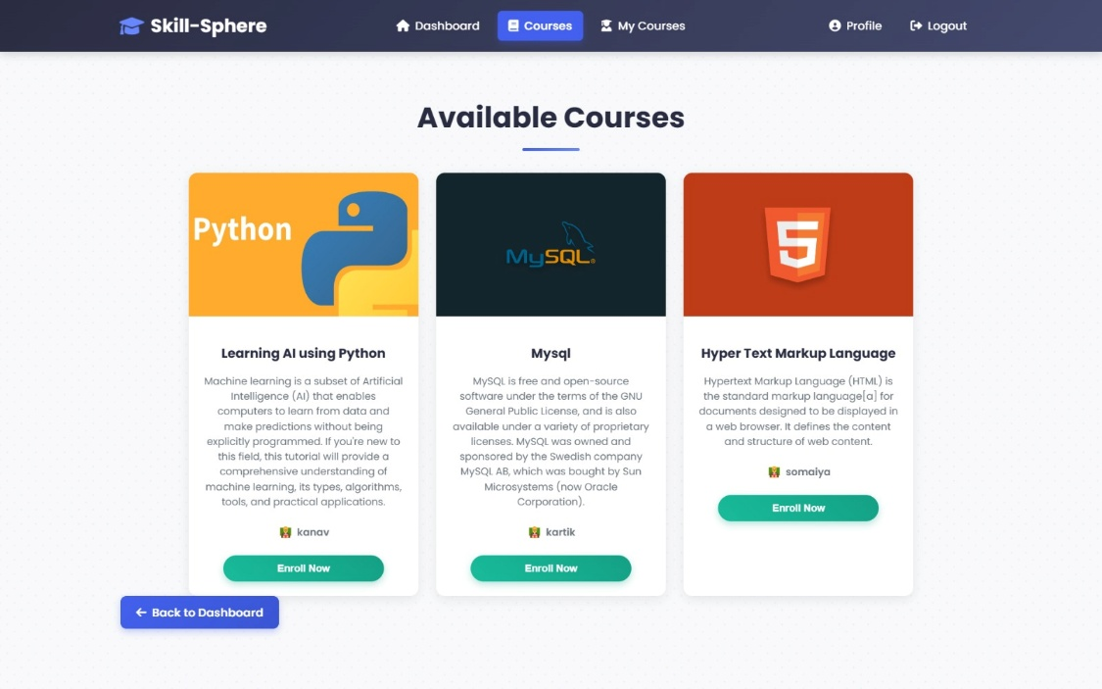

Fig 6.5 Available Courses Page

This section lists the courses the user is currently enrolled in, along with options to view the course or unenroll. Course details like title, description, and instructor are clearly presented. It helps users manage their ongoing learning efficiently.

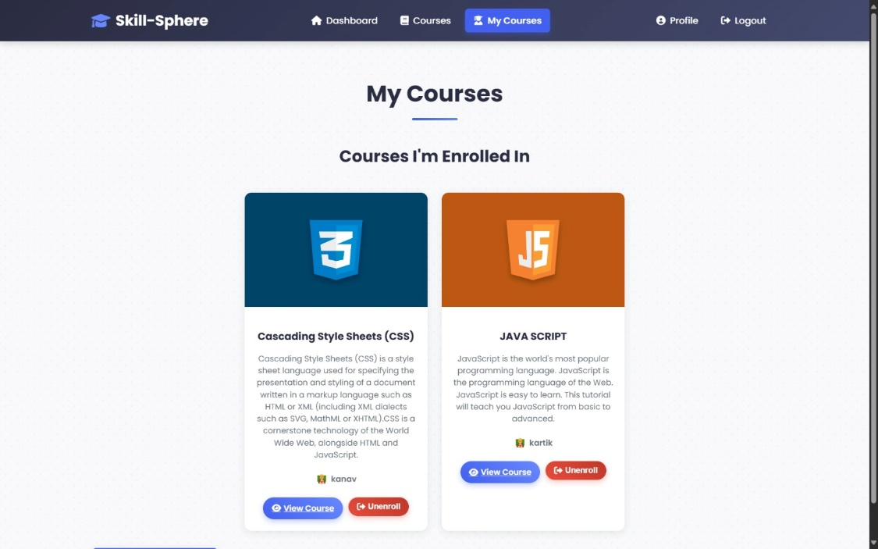

Fig.6.6 My Courses Page

The profile page displays the user's personal details including name, email, role, and enrolled courses. Users can edit their name and save changes easily. The design is simple, ensuring ease of use for profile management

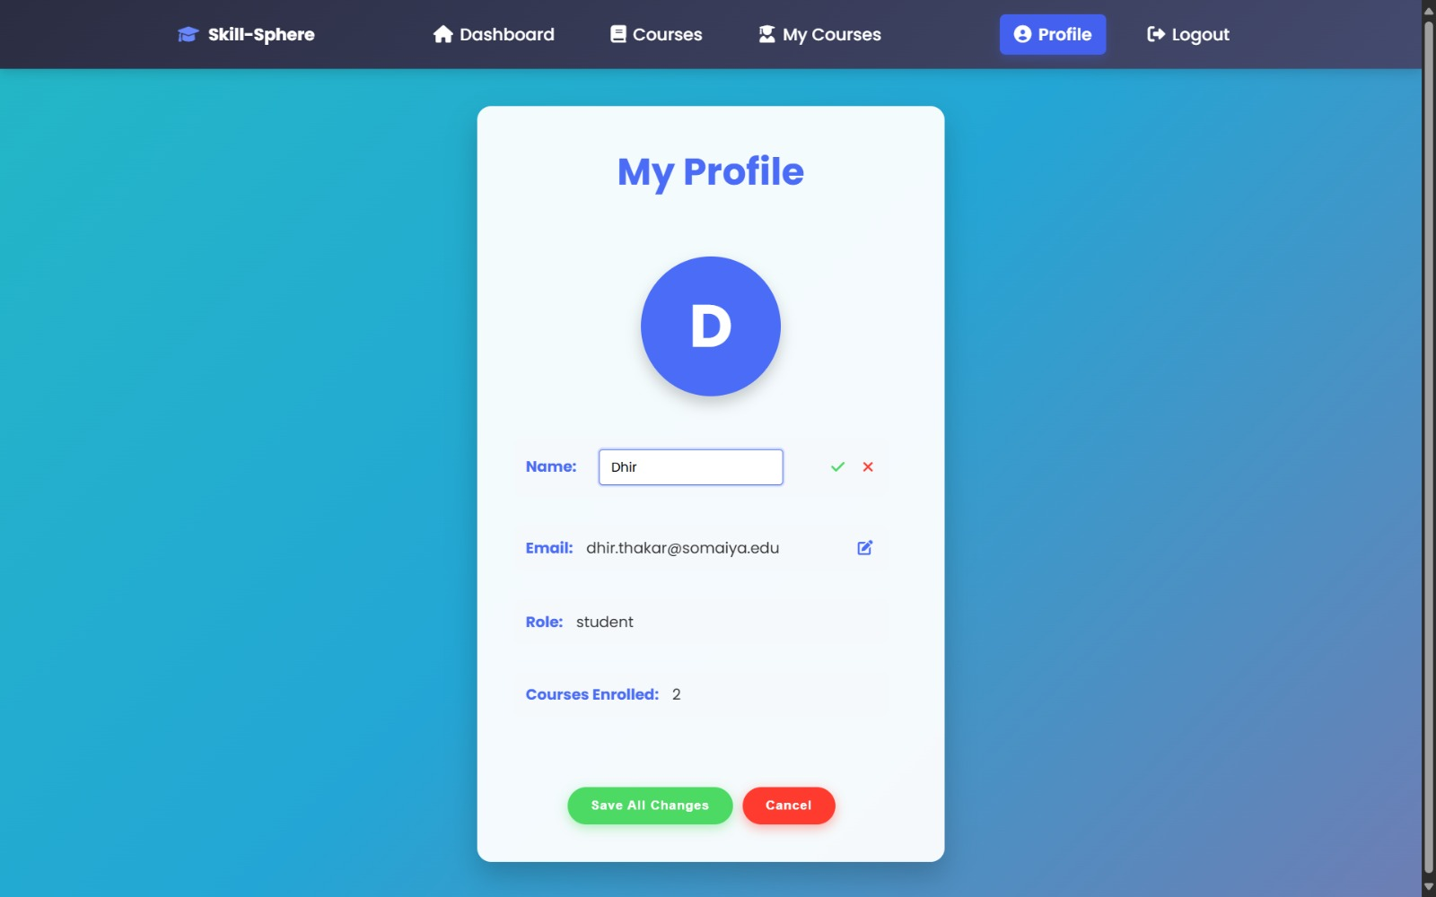

Fig 6.7 Profile Page

**Teacher:**

This is the instructor’s main dashboard showing a welcome message and a list of courses they are teaching. Each course card displays basic information like title, number of students, and materials, with options to manage or create new courses.

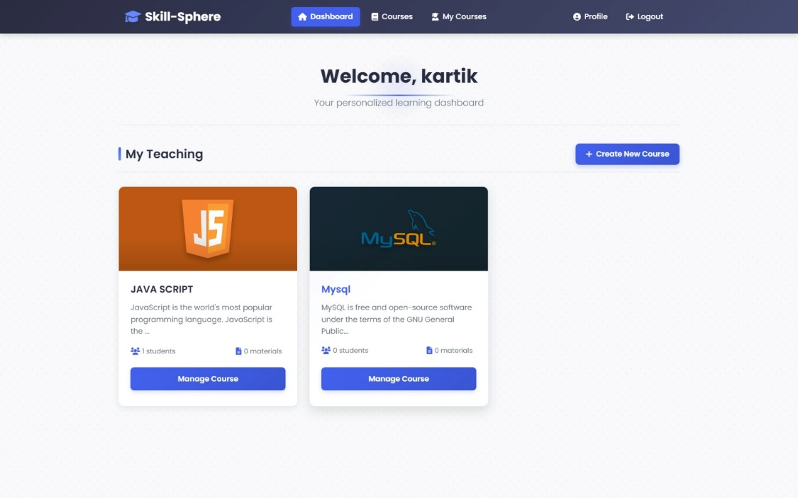

Fig 6.8 Dashboard Page

Displays all available courses on the platform, regardless of instructor. Each course shows a title, description, and the instructor's name, with a button to create new courses at the top.

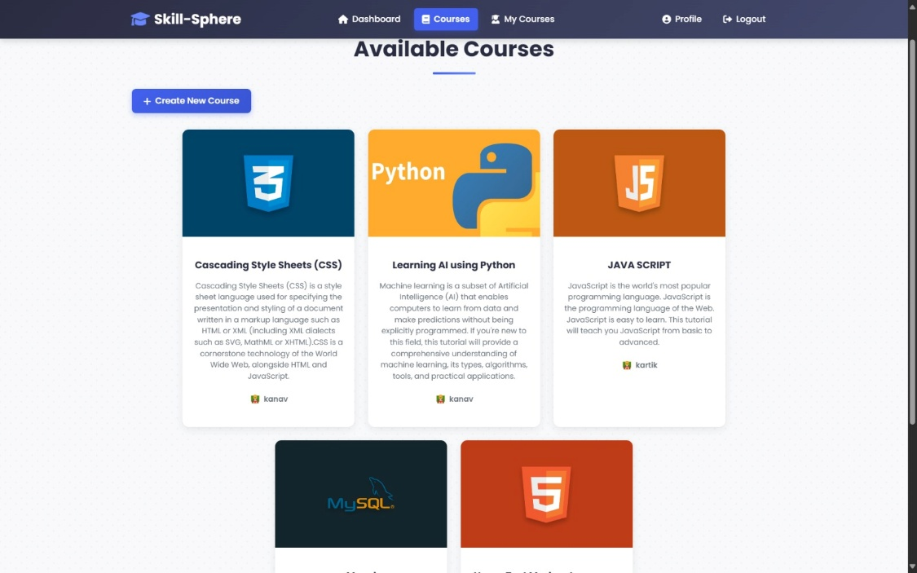

Fig 6.9 Available Courses Page

Shows details of a specific course (JavaScript in this case), including the description, and options to upload course materials and videos. There are also buttons to edit, delete, or go back.

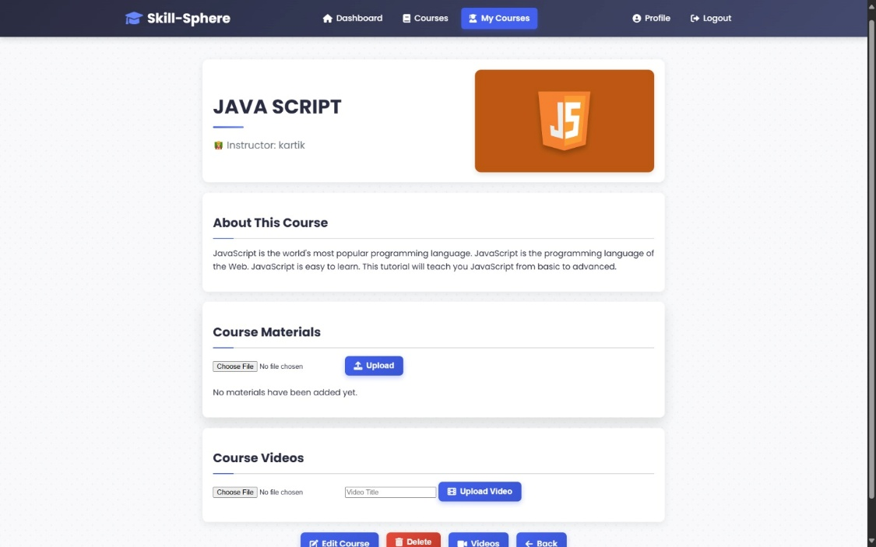

Fig 6.10 Course Management Page

Allows the instructor to update the course title, description, and thumbnail image. It provides a form layout with save (Update Course) and cancel options.

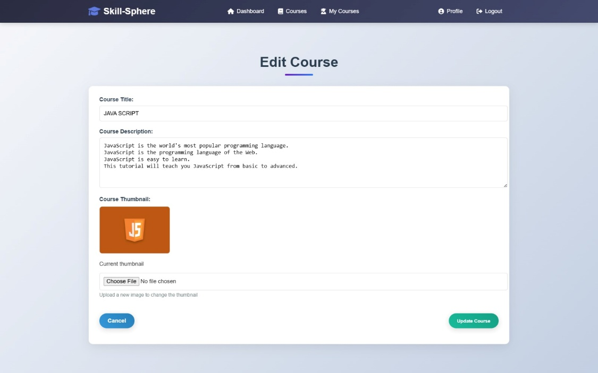

Fig 6.11 Edit Course Page

And many more features .

# CHAPTER 7 CONCLUSION & FUTURE SCOPE

## Conclusion:

Skillverse offers a robust and user-centric platform that effectively bridges the gap between learners and educators by enabling the seamless sharing of skills through structured online courses. It empowers teachers to create, manage, and deliver content while allowing students to explore, enroll in, and track their learning progress in a streamlined environment. The dual-role functionality not only supports a diverse range of educational interactions but also fosters a collaborative ecosystem that encourages continuous learning, skill enhancement, and knowledge exchange. With its intuitive interface and essential features, Skillverse stands out as a valuable tool for both personal and professional development.

## Future Scope:

Looking ahead, Skillverse holds significant potential for growth and innovation by integrating cutting-edge technologies and expanding its feature set. The inclusion of artificial intelligence could personalize learning paths, provide intelligent recommendations, and offer real-time performance analytics for both students and teachers. Future enhancements may also include virtual classrooms, community forums, certification pathways, gamified learning experiences, and multilingual support to cater to a global audience. Additionally, launching mobile applications and enabling offline access would further improve accessibility, making Skillverse a versatile and inclusive platform for learners and educators worldwide.

# References

* + 1. [1] D. W. Johnson and F. P. Johnson, Collaborative Learning in Higher Education, 2002.
    2. [2] S. M. R. S., A Study on Resource Sharing Systems in Cloud Computing, 2013.
    3. [3] L. H. Luecht and J. M. Kim, Online Learning Platforms for Internships: A Survey, 2019.
    4. MongoDB Atlas Documentation – https:/[/www.mongodb.com/cloud/atlas](http://www.mongodb.com/cloud/atlas)
    5. Brad Dayley and Brendan Dayley. Node.js, MongoDB and Angular Web Development. 2nd ed., Addison-Wesley, 20