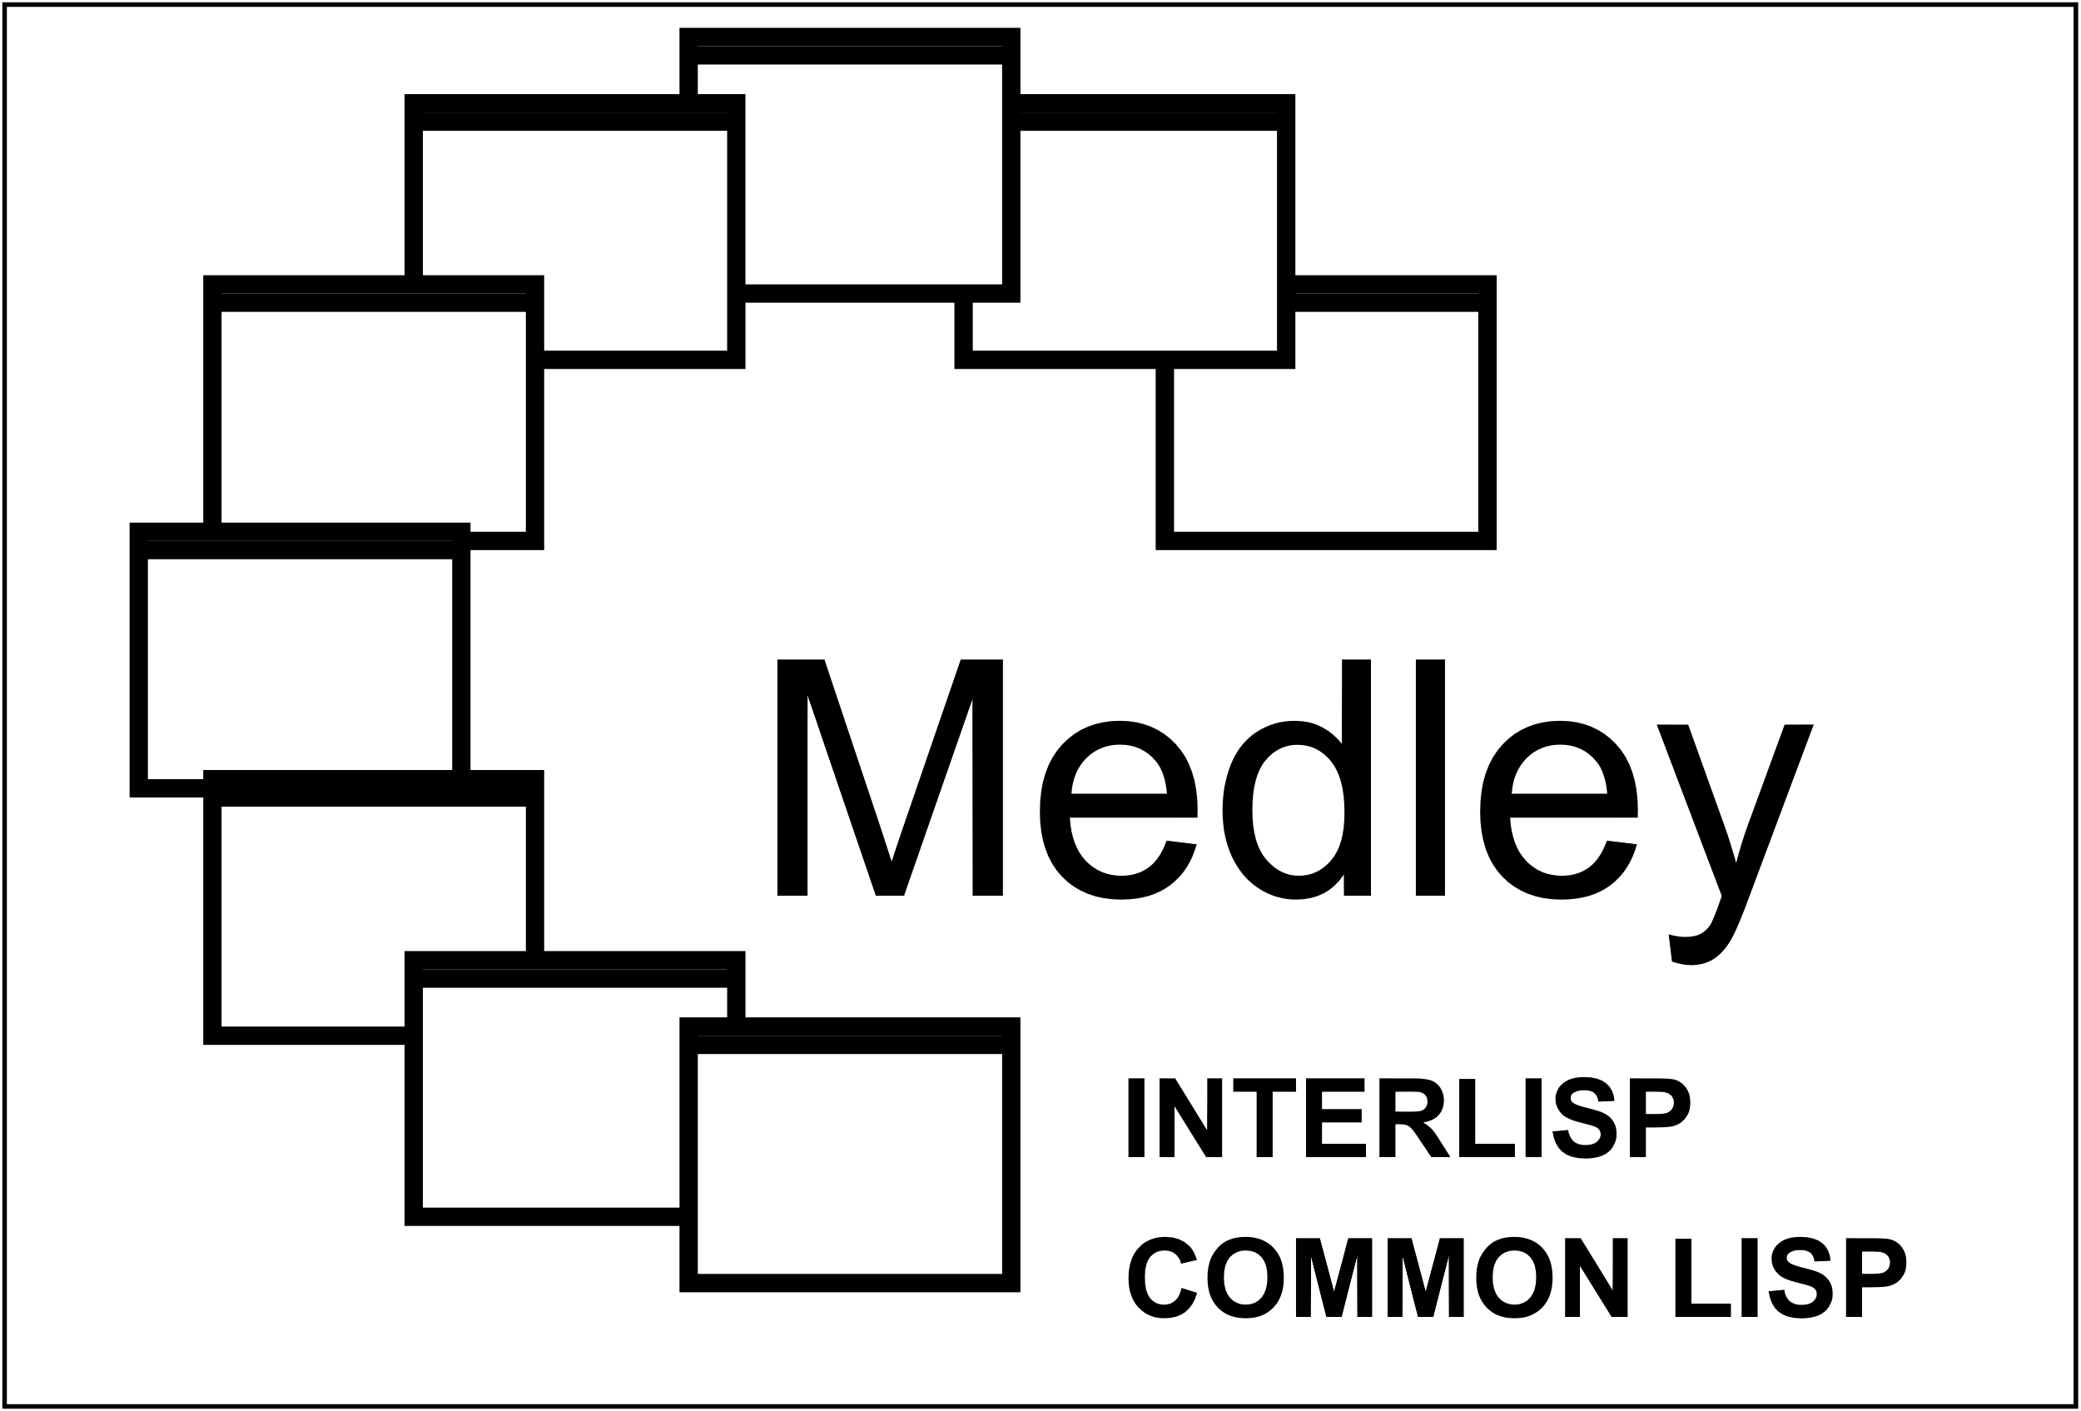
Medley Interlisp Demos
SEDIT
TEDIT
INSPHEX
KINETIC
HUNGARIAN RINGS
NOTECARDS

