CREDIT RISK & LOAN PORTFOLIO
ANALYTICS PIPELINE

An End-to-End Azure + Snowflake + dbt + Dagster + Streamlit Data Engineering Project
Finance | Credit Risk & Loan Portfolio Analytics

Prepared by
Fakiha Tabassum
Sravya Bachupally
Pavan Dasoju
August 2026

TABLE OF CONTENTS

No. | Section | Page
1. | Abstract | 3
2. | Problem Statement | 3
3. | Objective | 3
4. | Key Focus Areas | 4
5. | Software & Technical Specifications | 4
6. | Architecture | 5
7. | Flow Overview | 6
8. | Project Implementation Steps | 7
 | 8.1 Snowflake & Azure Environment Setup | 7
 | 8.2 Data Ingestion — Landing Zone | 7
 | 8.3 Bronze Layer — Snowflake Raw Ingestion | 8
 | 8.4 Silver Layer — Native dbt Transformation | 9
 | 8.5 Gold Layer — Dimensional Star Schema | 11
 | 8.6 Orchestration & Automation — Dagster | 13
 | 8.7 Visualization — Streamlit in Snowflake | 15
 | 8.8 Portfolio Assistant — Design Decision & Implementation | 15
9. | Testing & Validation | 16
10. | Audit Logging & Data Governance | 17
11. | Results | 17
12. | Future Scope | 18
13. | Conclusion | 18
14. | References | 18

1. Abstract
Lending institutions issue and manage large portfolios of consumer loans, and understanding risk at both the individual loan level and the aggregate portfolio level is critical to sound decision-making. This project builds a complete, production-style data engineering pipeline over the Lending Club loan origination dataset (2007–2018, 2.26 million records, 151 raw attributes) to segment borrowers by risk and analyze portfolio performance by vintage.
The pipeline ingests raw CSV data through Azure Blob Storage, loads it into a Bronze layer in Snowflake, and applies a medallion architecture (Bronze → Silver → Gold) using dbt running natively inside Snowflake. The Gold layer is modeled as a dimensional star schema with a central fact table and eight business-meaningful dimensions. The entire pipeline — from a new file landing in Blob storage through validated, tested Gold-layer tables — is orchestrated automatically using Dagster, with a sensor-based trigger and full audit logging at every layer. The final results are surfaced through an interactive Streamlit application, hosted natively in Snowflake, combining a multi-chart analytics dashboard with a guided Portfolio Assistant for ad-hoc, natural-language-style querying.
This document describes the problem, the architecture, the implementation steps, the testing and audit strategy, and the results of the project.

2. Problem Statement
Lenders need portfolio-level visibility into loan risk across vintage, grade, borrower profile, and geography rather than evaluating defaults individually. The raw Lending Club dataset contains 2.26 million rows, inconsistent data types, and sparse fields such as hardship, settlement, and joint-applicant information, making reliable analysis challenging. This project addresses these issues by building a governed, tested, and automated pipeline that transforms raw loan data into a clean, well-modeled analytics layer for dashboarding and natural-language querying.

3. Objective
Build an incremental, automated, and auditable data pipeline over Lending Club loan origination and repayment data that:
- Segments borrowers by risk using a well-designed dimensional model, not ad hoc queries.
- Analyzes portfolio performance by origination vintage (quarter/year).
- Demonstrates real-world incremental loading, not just a one-time bulk load.
- Is fully automated end-to-end: a new file landing in cloud storage should flow through to validated, dashboard-ready tables without manual intervention.
- Is auditable and testable at every layer, so that data quality can be proven, not assumed.
- Surfaces results through an interactive, natural-language-queryable interface.

4. Key Focus Areas
- Automated Data Pipeline: Using Dagster to orchestrate ingestion detection, Bronze loading, and dbt transformations end-to-end.
- Data Quality & Enrichment: Type standardization, validation flags, and derived business fields (risk segment, FICO average, credit history length) applied systematically in the Silver layer.
- Scalable Storage & Processing: Azure Blob Storage for staging, Snowflake for structured storage and native compute.
- Dimensional Modeling: A star schema in the Gold layer with one fact table and eight business-meaningful, multi-attribute dimensions.
- Native-Snowflake Execution: dbt transformations and the Streamlit application both run natively inside Snowflake — no separate hosting or local execution infrastructure required.
- Governance: A shared audit log capturing every load and transformation across all three medallion layers, plus schema and business-logic tests at each stage.
- Interactive Analytics & Guided Q&A: A Streamlit dashboard with adaptive, dimension-driven charts, plus a Portfolio Assistant that answers common risk and portfolio questions in plain language.

5. Software & Technical Specifications
- Programming Language: Python 3.x
- Orchestration: Dagster (sensor-based, event-driven)
- Cloud Storage: Azure Blob Storage
- Data Warehouse & Compute: Snowflake (native dbt Projects, native Streamlit)
- Transformation: dbt (dbt Projects on Snowflake — no local dbt install)
- Visualization: Streamlit in Snowflake, Altair (adaptive multi-chart dashboard)
- Additional Libraries: pandas, azure-storage-blob, snowflake-connector-python, faker (for simulated incremental test data)
- Version Control: Git

6. Architecture
The architecture follows a medallion (Bronze/Silver/Gold) pattern, with every transformation stage running natively inside Snowflake to minimize infrastructure overhead, and Dagster providing event-driven orchestration across the whole chain.
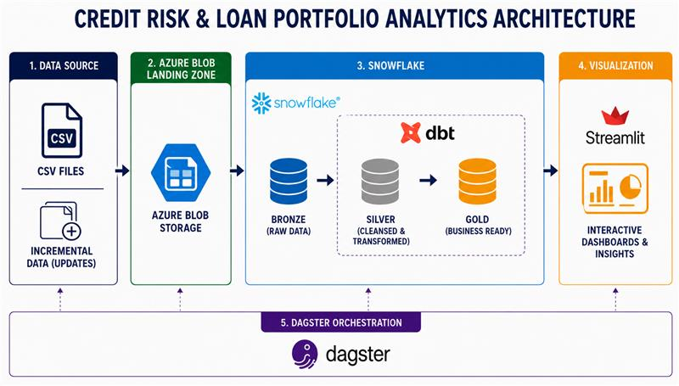

Figure 6.1 — End-to-end system architecture

7. Flow Overview
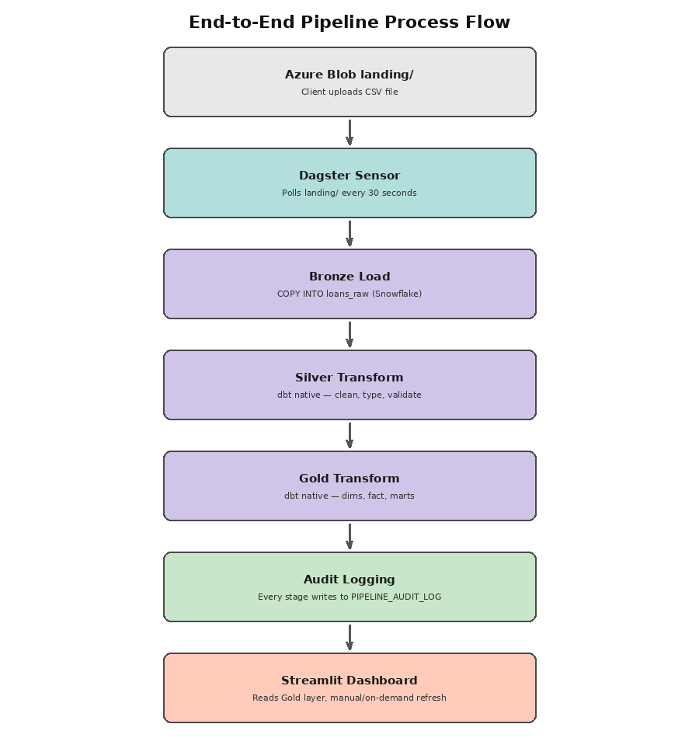
Figure 7.1 — Process flow from source file to dashboard
- A CSV file lands in the Azure Blob Storage landing/ container (from the client, or a simulated incremental generator).
- A Dagster sensor polls the container every 30 seconds and detects new, previously unseen files.
- The detected file triggers the Bronze load: a Snowflake COPY INTO statement loads the raw data as-is (all columns as VARCHAR) into the Bronze table, skipping any file already loaded.
- A native Snowflake dbt project rebuilds the Silver layer: cleaning, typing, validating, and enriching the data.
- The same dbt project rebuilds the Gold layer: eight dimension tables, one incremental fact table, and pre-aggregated summary marts.
- Every stage writes a row to a shared audit log table, independent of the BI layer.
- The Streamlit application, running natively in Snowflake, queries the Gold layer directly to render the dashboard and power the AI assistant.

8. Project Implementation Steps

8.1 Snowflake & Azure Environment Setup
- Created a Snowflake trial account on Microsoft Azure infrastructure, in the same region as the Azure resource group, to minimize latency and egress.
- Created an XSMALL warehouse with AUTO_SUSPEND = 60s and AUTO_RESUME = TRUE to minimize trial credit usage.
- Created three schemas mapping directly to the medallion layers: RAW (Bronze), SILVER, and GOLD.
- Created an Azure Storage Account and a Blob container (lendingclub-raw) with a landing/ prefix as the ingestion zone.
- Connected Snowflake to the Blob container via an external stage using a SAS token (a Storage Integration with a service principal is the production-grade alternative; SAS was chosen for faster setup on a trial account).
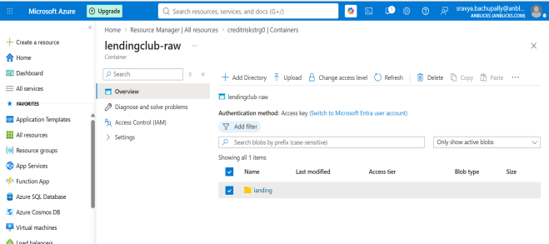 | 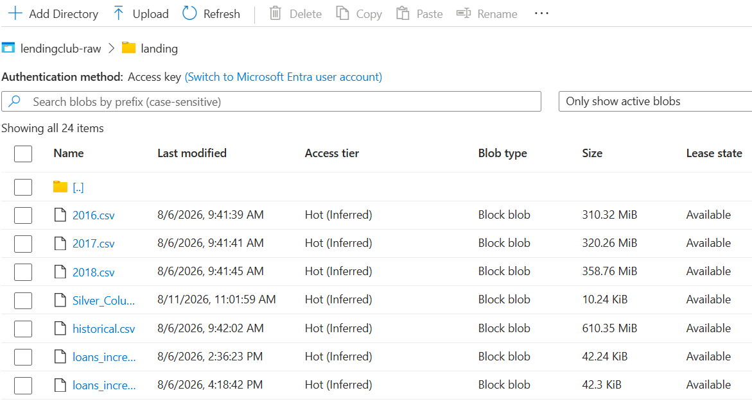

8.2 Data Ingestion — Landing Zone
The raw dataset (2,260,701 rows, 151 columns) is written to the Blob landing/ zone. Two ingestion paths were built:
- Bulk historical load: The full dataset, split by origination year into a historical bucket (2007–2015) and yearly incremental files (2016, 2017, 2018), uploaded once to simulate a realistic backfill.
- Simulated live ingestion: A Python script using the Faker library generates new synthetic loan records matching the exact source schema and uploads them directly to landing/ with a timestamped filename — this simulates a client dropping a genuinely new file, without needing to wait for real new data.
All uploads are logged (file name, byte size comparison between local and remote, duration, success/failure) to a local audit log and a JSON summary, and verified with an automated test script before being considered complete.

8.3 Bronze Layer — Snowflake Raw Ingestion
A single Bronze table (LOANS_RAW) holds all 151 source columns, every one typed as VARCHAR/STRING, plus two metadata columns: _SOURCE_FILE and _LOADED_AT. Loading everything as text at this layer is a deliberate medallion-architecture principle — Bronze should never fail or drop rows due to a type-casting problem; that responsibility belongs to Silver.
- A COPY INTO statement loads all files under landing/ into LOANS_RAW.
- Snowflake's COPY INTO automatically tracks which files have already been loaded and skips them on subsequent runs — this is what makes it safe to re-run on a schedule without creating duplicates.
- Every load is independently verifiable via Snowflake's native INFORMATION_SCHEMA.COPY_HISTORY, which records file name, row counts, and load status.
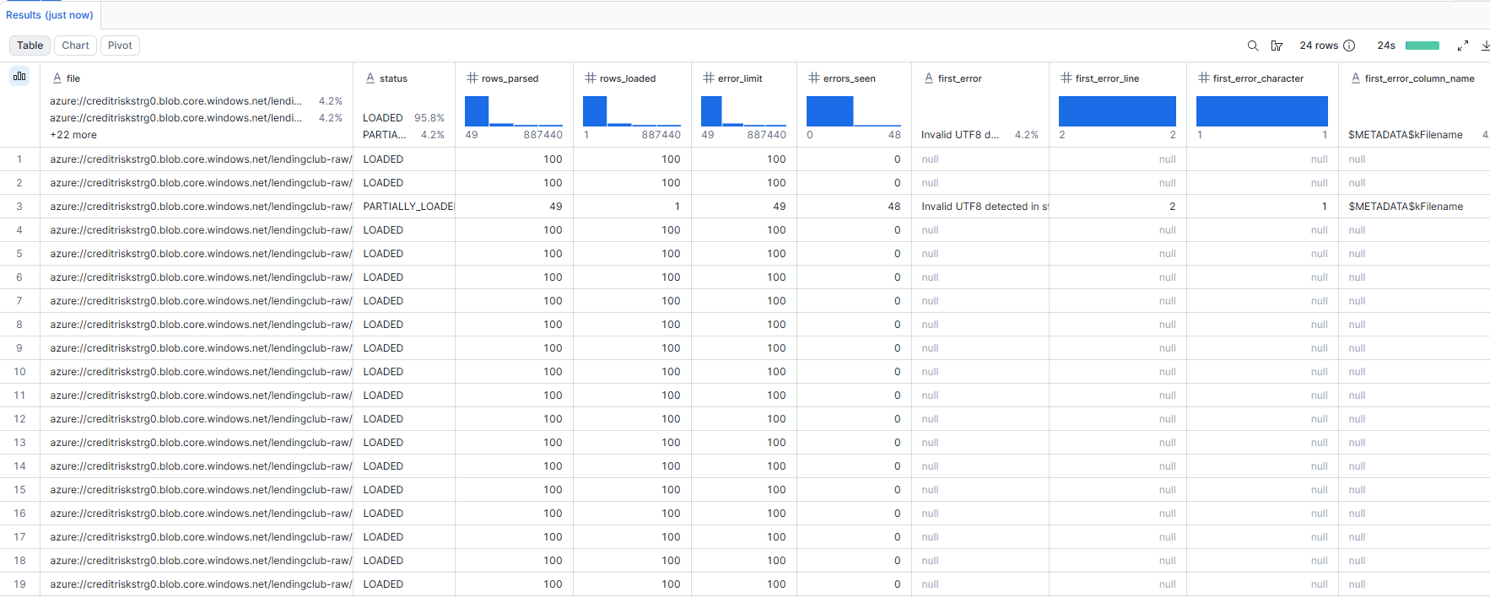

8.4 Silver Layer — Native dbt Transformation
The Silver layer is now built around a single shared model, int_loans_cleaned, organized as a long sequence of named CTEs (source_selected → deduped → numeric_standardized → date_standardized → text_standardized → zip_standardized → missing_handled → enriched → validated → quality_checked) so each transformation concept is independently identifiable and testable. Both stg_loans (rows that pass data quality) and stg_loans_rejected (rows that fail) select from this one model, so all cleaning and validation logic lives in exactly one place instead of being duplicated. This view is materialized via the folder-level config in dbt_project.yml, and the shared post-hook there fires log_layer_audit('SILVER', this) automatically — no per-model audit wiring needed.
48 of the 151 raw columns from the mentor's scoped list are carried through, plus one additional support column, earliest_cr_line, which is not on that list but is required to compute credit_history_years and to run the Credit History Validation check — both of which the mentor's own requirements call for. This is flagged explicitly here rather than left as a silent scope change.
Transformations applied, in order:
- Column selection, restricted to the mentor-scoped list plus earliest_cr_line, with a not-null filter on loan id.
- De-duplication using QUALIFY ROW_NUMBER() partitioned by loan id, keeping the most recently loaded record.
- Numeric standardization using TRY_TO_NUMBER on every measure column, stripping “%” from rate/utilization fields and “ months” from term, so a bad source value becomes null instead of failing the whole load.
- Date standardization via TRY_TO_DATE on issue_d and earliest_cr_line (“MON-YYYY” text into real DATE types).
- Text standardization on every categorical field (grade, sub-grade, home ownership, verification status, purpose, state, application type, hardship/debt-settlement flags) via consistent TRIM plus UPPER or INITCAP casing.
- Missing-value handling with business-appropriate defaults rather than silent nulls (emp_length → 'Unknown', dti/mort_acc/tot_coll_amt/delinq_amt/pub_rec_bankruptcies → 0).
- Derived / enrichment columns: fico_avg, credit_history_years, vintage_year and vintage_quarter, loan_age_months, is_default, risk_segment (Prime / Near-Prime / Subprime / Deep-Subprime), income_band, emp_length_bucket, us_region, purpose_category, int_rate_band, and revol_util_band.
- 14 explicit boolean validation checks — state, loan status, grade, FICO range, financials, loan amount, DTI, interest rate, revolving utilization, payment, credit history, revolving balance, credit accounts, and loan date — each computed as its own is_valid_* column.
- A single rolled-up is_dq_passed flag (all 14 checks ANDed together) plus a human-readable dq_fail_reasons array (via ARRAY_TO_STRING/ARRAY_CONSTRUCT_COMPACT) that names exactly which checks failed, so a quarantined row is debuggable without re-deriving the logic.
- Three composite dimension keys — borrower_key, credit_profile_key, and loan_terms_key — built by concatenating the relevant standardized fields, so the Gold layer can join to dimensions without repeating the bucketing logic.
- Audit columns (_source_file, _loaded_at, _silver_processed_at) carried through to the final SELECT for full lineage back to the Bronze load.
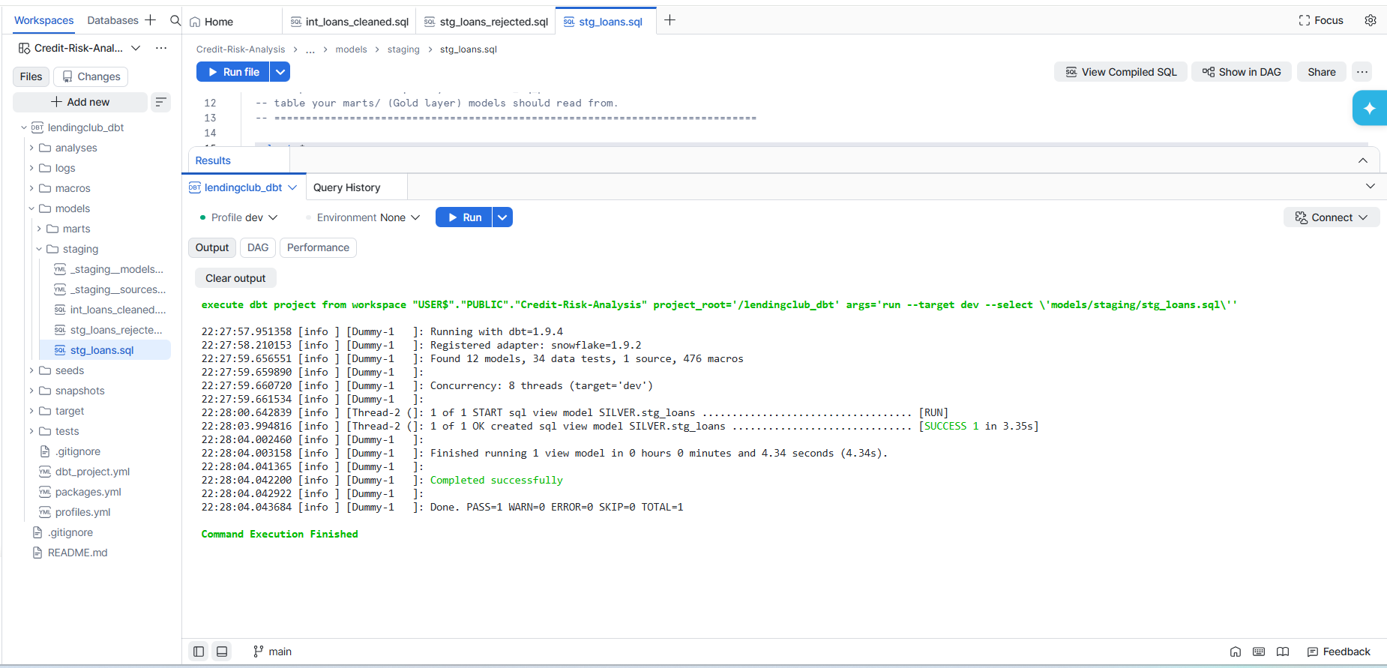

8.5 Gold Layer — Dimensional Star Schema
The Gold layer is modeled as a star schema: one incremental fact table (fct_loans) and eight dimension tables, each grouping related business attributes rather than a single column, so that each dimension answers a specific real analytical question. The dimension set was expanded from the original five to eight so that vintage cohorting, loan purpose, and loan outcome each get their own dedicated dimension instead of being folded into date, credit-profile, or status flags — separating "what was sold" (dim_loan_terms), "who bought it" (dim_borrower), "why they borrowed" (dim_purpose), "what happened" (dim_loan_status), and "when, and against what cohort" (dim_date / dim_vintage) is a deliberate Kimball-style design choice.
Dimension | Key Columns | Business Question It Answers
dim_date | calendar_year, month_name, year_quarter_label, season, half_year, months_since_issue | Enables seasonality, trend, and year-over-year comparison without runtime date math.
dim_borrower | income_band, emp_length_bucket, employment_stability_score, borrower_trust_level, housing_stability | Who tends to default — a socioeconomic segmentation of the borrower's overall profile.
dim_geography | us_region, market_size_tier, regulatory_environment, cost_of_living_tier, geographic_risk_zone | Regional risk varies by regulation, cost-of-living, and market maturity.
dim_purpose | purpose_category, borrower_intent, purpose_risk_expectation, portfolio_strategy_bucket, typical_loan_size | Stated loan purpose is one of the strongest behavioral predictors after FICO.
dim_loan_status | performance_category, delinquency_stage, loss_severity_bucket, ifrs9_stage, is_defaulted | The outcome dimension — models the full delinquency funnel, not just a binary default flag.
dim_credit_profile | grade, risk_segment, credit_tier, risk_return_profile, pricing_strategy, allocation_guidance | The heart of credit risk — grade, FICO, and risk segment together in one place.
dim_loan_terms | term_label, rate_environment, margin_tier, prepayment_expectation, duration_risk | The product dimension — separates what was sold from who bought it (a Kimball best practice).
dim_vintage | vintage_cohort_label, vintage_era, seasoning_bucket, months_on_book, economic_phase_at_origination | The gold standard in lending analytics — cohort-based vintage curves, tracked separately from calendar date.

fct_loans carries the measures (loan amount, outstanding principal, recoveries, default flag, etc.) and foreign keys into each dimension. Two pre-aggregated summary marts (mart_vintage_performance and mart_portfolio_kpis) are also materialized for the heaviest, most frequently-viewed dashboard views; all other cuts (default rate by grade, by state, by purpose, etc.) are computed live as queries/measures against the fact and dimension tables rather than pre-built as separate physical tables, avoiding table sprawl.
- fct_loans is built as a dbt incremental model (merge strategy on loan_id), so re-runs only process newly loaded rows rather than rebuilding the whole table.
- Only rows that passed all Silver-layer data quality checks (is_dq_passed = true) are propagated into the Gold layer.
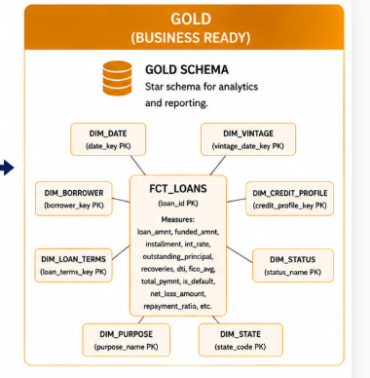

8.6 Orchestration & Automation — Dagster (Brief Overview)
Dagster orchestrates the pipeline from ingestion through Gold, using a sensor rather than a fixed schedule, so the pipeline reacts to new data rather than waiting for a scheduled run.
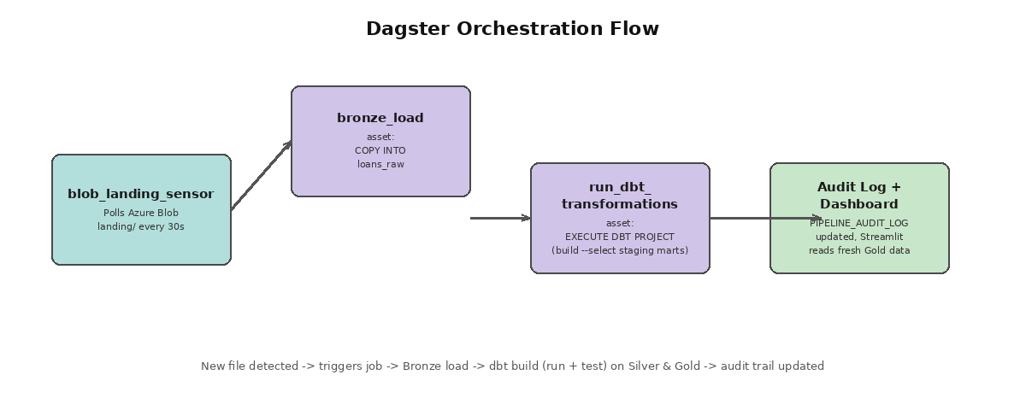
Figure 8.6.1 — Dagster orchestration flow
- blob_landing_sensor polls the Blob landing/ container every 30 seconds and compares the current file list against a persisted cursor of previously-seen files.
- When a new file is detected, it triggers the lending_club_pipeline job.
- bronze_load asset: executes the COPY INTO statement against Snowflake.
- run_dbt_transformations asset: triggers the deployed native Snowflake dbt project via EXECUTE DBT PROJECT … ARGS = 'build --select staging marts' — using dbt build (not just run) ensures schema and business-logic tests are enforced as part of every automated run, not only when triggered manually.
- All of Dagster's own run history, logs, and manual “Materialize All” trigger are visible in its local web UI, which also served as the live demo interface.
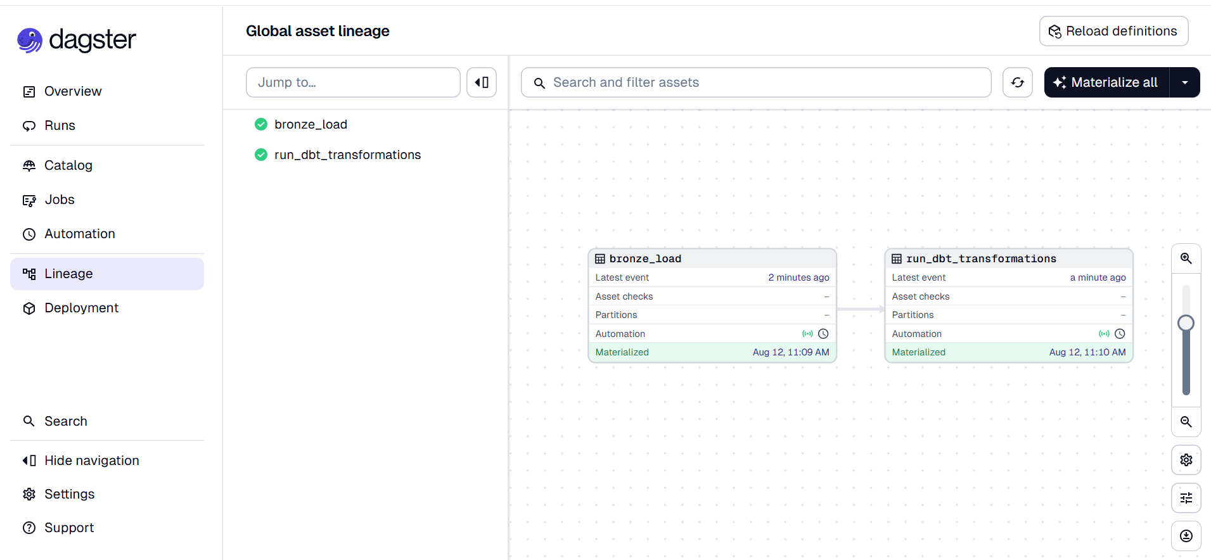

8.7 Visualization — Streamlit in Snowflake
Power BI was originally planned, but company sign-in restrictions made it unavailable. Streamlit in Snowflake (SiS) was chosen as the replacement — a native Snowflake capability requiring no separate hosting, credentials, or connection string, since the app runs directly on Snowflake compute with built-in access to the Gold schema. The app was rebuilt around a branded header and a persistent global filter panel so every chart on the page responds to the same selections, rather than each chart carrying its own local controls. All queries run live against LENDING_CLUB.GOLD with a 5-minute result cache; a "Last Refreshed" timestamp is shown in the header, and Refresh / Reset buttons let the latest pipeline output be pulled on demand or all filters cleared in one click during a live demo, rather than waiting out the cache window.
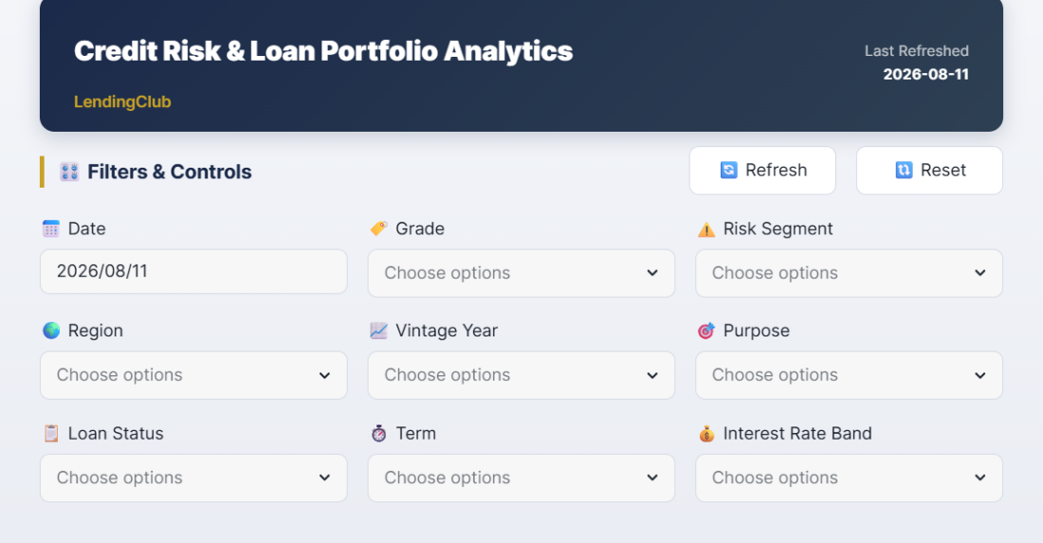
Figure 8.7.1 — Dashboard header and global Filters & Controls panel
Filters & Controls (new):
A single filter panel now sits below the header and drives every chart and KPI on the page. It exposes nine multi-select filters, laid out three per row: Date, Grade, Risk Segment, Region, Vintage Year, Purpose, Loan Status, Term, and Interest Rate Band. Each maps directly to a Gold-layer dimension attribute (grade and risk_segment from dim_credit_profile, region from dim_geography, vintage year from dim_date/dim_vintage, purpose from dim_purpose, loan status from dim_loan_status, term and interest rate band from dim_loan_terms), so adding a new filter is a matter of adding one multiselect bound to an existing dimension column rather than writing a new query. Because every chart reads from the same set of selected filter values, the dashboard behaves as one coherent, drillable view of the portfolio instead of a set of independent charts.
Dashboard contents (filtered by the panel above):
- A KPI banner: total loans, total funded amount, average interest rate, and overall default rate, recomputed live against whatever combination of filters is currently selected.
- Default Rate by Interest Rate Band — a combo bar/area chart testing whether the interest rate charged actually prices in the observed risk.
- Vintage Performance (2015–2018) — a combo chart of loan volume against default rate by origination quarter, joined from MART_VINTAGE_PERFORMANCE, DIM_DATE, and the new DIM_VINTAGE cohort attributes.
- Portfolio Risk Mix — a donut chart of loan count by risk segment, with the color domain built directly from the data returned rather than a hardcoded/guessed set of segment labels, so no slice is silently dropped if a label doesn't match expectations.
- Default Rate by FICO Band — the same combo-chart pattern applied to FICO score bands.
- Explore the Portfolio: a self-serve panel where the user picks any dimension (now including Purpose and Loan Status alongside Grade, Risk Segment, Region, and Vintage Year) and any metric (default rate, loan count, total funded, average interest rate); the chart type adapts automatically — a trend line for the time dimension, ranked horizontal bars for categories with many values, vertical bars otherwise.
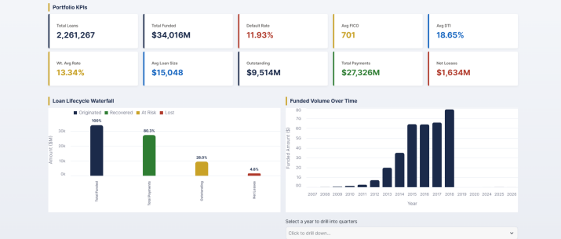 | 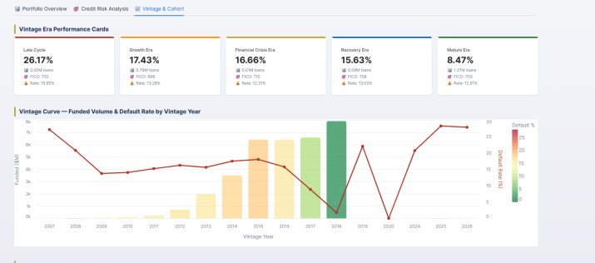

8.8 Portfolio Assistant — Design Decision & Implementation
The original design called for a Cortex-LLM-powered assistant (SNOWFLAKE.CORTEX.COMPLETE) that would translate free-text questions into SQL directly. During implementation this returned a hard error — “AI function COMPLETE is not available for trial accounts” — confirmed not to be a configuration issue: cross-region inference was already set to ANY_REGION, the active role held ACCOUNTADMIN, and the SNOWFLAKE.CORTEX_USER database role was explicitly granted. The restriction is a trial-account entitlement limit that cannot be worked around from within the account.
Rather than leave the feature out or silently misrepresent it, a rule-based Portfolio Assistant was built as an honest, fully-functional replacement:
- A simple text input plus “Ask” button lets the user type a question in plain English; an expandable panel lists example questions the assistant understands, so a user unfamiliar with the underlying schema still knows what they can ask.
- The typed question is matched against a bank of known question patterns using keyword checks (e.g. “grade” + “default”, “state” + “highest” + “default”), covering default rate by grade/region/state/FICO, vintage performance, portfolio totals, repayment rate, collection efficiency, recoveries, and risk segment mix.
- Each matched pattern runs a real, pre-written SQL query live against the Gold layer — there are no hardcoded or fabricated answers; every response reflects the current data, including any new data loaded since the last pipeline run.
- If no pattern matches, the assistant says so explicitly (“I don't have a matching query for that yet”) rather than guessing or returning an unrelated answer.
This is deliberately labeled a “Portfolio Assistant” rather than an “AI Assistant” in the interface and in this document, since no language model is involved in the current trial-account build. Enabling true Cortex-LLM-based natural language querying is listed under Future Scope.

9. Testing & Validation
Every layer of the medallion architecture has its own explicit tests, executed either automatically (as part of dbt build inside the Dagster-triggered run) or manually verified during development.
Layer | Test | Mechanism | Automated?
Local split | Row count reconciliation; output schema check; no duplicate ids | Custom Python assertions (test_split.py) | Manual trigger
Blob upload | Blob existence; byte-size match; all uploads succeeded | Custom Python assertions (test_landing.py) | Manual trigger
Bronze | Total row count; null id check; duplicate id check | SQL verification queries | Manual verification; load itself is automated
Bronze | Per-file load status and row counts | Snowflake native COPY_HISTORY | Automatic
Silver | not_null / unique on loan_id; accepted_values on grade and loan_status | dbt schema tests (YAML) | Automated via dbt build
Gold | not_null / unique on fact and dimension keys; accepted_values on is_default | dbt schema tests (YAML) | Automated via dbt build
Gold | Default rate must fall between 0 and 1 (catches bad joins / divide-by-zero) | Singular dbt test (assert_default_rate_between_0_and_1.sql) | Automated via dbt build

Data-quality validation (as distinct from schema testing) is also embedded directly in the Silver transformation itself: FICO range validation, loan status validation, state code validation, and financial sanity checks each produce a boolean flag, rolled up into a single is_dq_passed column that gates what reaches the Gold layer.

10. Audit Logging & Data Governance
A single shared table, LENDING_CLUB.AUDIT.PIPELINE_AUDIT_LOG, captures activity across all three medallion layers, so the full pipeline history can be queried from one place rather than piecing together logs from separate systems.
Column | Purpose
layer | BRONZE / SILVER / GOLD
table_name | Fully qualified table that was loaded or built
source_file | Source file name, where applicable (Bronze loads only)
rows_loaded | Row count at time of load/build
status | SUCCESS / PARTIAL / FAILED
started_at / completed_at | Timing for each load or build event

- Bronze loads insert a row via a direct SQL statement immediately following each COPY INTO.
- Every Silver and Gold dbt model automatically writes its own audit row via a reusable log_layer_audit() macro, configured as a post-hook at the model-group level in dbt_project.yml — meaning new models inherit audit logging automatically, with no per-model code required.

11. Results
- Ingested and processed 2,260,701 loan records across 151 raw source columns.
- Built a governed Silver layer of ~84 cleaned, typed, enriched, and DQ/audit columns from 49 scoped raw fields (the mentor's 48-column list plus earliest_cr_line).
- Designed and built an 8-dimension, 1-fact star schema Gold layer, plus 2 pre-aggregated summary marts.
- Automated the full pipeline end-to-end using a Dagster sensor, from a new file landing in Blob storage through tested Gold-layer tables, with zero manual steps in the automated path.
- Implemented layered testing (schema tests, business-logic tests, and row-count reconciliation) enforced automatically as part of every automated run.
- Implemented a unified, cross-layer audit trail covering Bronze, Silver, and Gold.
- Delivered an interactive Streamlit dashboard, running natively in Snowflake, with a live, self-serve exploration panel and a guided Portfolio Assistant for common risk questions.
- Diagnosed and honestly documented a trial-account platform limitation (Cortex LLM unavailability), and shipped a working, transparent alternative rather than leaving the feature broken or misrepresenting how it works.

12. Future Scope
- Event-driven ingestion: Replace the 30-second polling sensor with a true push-based trigger (e.g. Azure Event Grid) for near-instant pipeline activation.
- Predictive modeling: Train a machine learning model on the Gold layer to predict default probability at origination, rather than only reporting on historical outcomes.
- Automated dashboard refresh: Extend the Dagster pipeline to trigger dashboard cache refresh automatically after each Gold rebuild.
- True LLM-powered assistant: Enable Snowflake Cortex on a non-trial account to replace the rule-based pattern matching with genuine free-text-to-SQL generation, reusing the existing schema context and SQL-safety guardrails already written for that design.
- Expanded assistant scope: Move from single-turn Q&A to a multi-turn conversational agent capable of drafting portfolio summaries and flagging anomalies proactively, once LLM access is available.
- CI/CD for dbt: Add automated dbt test runs on every code change via a Git-integrated pipeline, rather than relying on manual runs during development.

13. Conclusion
This project demonstrates a governed, tested, and automated data pipeline that transforms raw, messy loan origination data into a trustworthy, well-modeled analytics layer. By running dbt and Streamlit natively inside Snowflake, and orchestrating the entire chain with an event-driven Dagster sensor, the solution avoids unnecessary infrastructure while still demonstrating the core disciplines of production data engineering: layered architecture, incremental processing, automated testing, and full audit traceability.
The dimensional model was deliberately designed around real business questions rather than around whichever columns happened to exist in the source data, and every architectural decision — from column scoping to dimension design to tool selection — was made explicitly and can be justified on its own merits, not simply because it was the default option.
Project Github Repository : https://github.com/Intern-407/Credit-Risk-Analysis

14. References
- Lending Club Loan Data (Kaggle) — https://www.kaggle.com/datasets/wordsforthewise/lending-club
- Snowflake Documentation — https://docs.snowflake.com
- dbt Documentation — https://docs.getdbt.com
- Dagster Documentation — https://docs.dagster.io
- Streamlit in Snowflake Documentation — https://docs.snowflake.com/en/developer-guide/streamlit/getting-started/overview
- Azure Blob Storage Documentation — https://learn.microsoft.com/en-us/azure/storage/blobs/

