**Table of Contents**

1. **Introduction3**
2. **State of Art4**
3. Context of Project5
4. Study of Existing5
5. Critical Review6
6. Proposed Solutions6
7. **Analysis Section4**
8. Functional Requirements5
9. Actors Identification6
10. Functional Specification **6**
11. NonFunctional Requirements5
12. **Conception Section4**
13. Use Case Diagram2
14. Sequence Diagram2
15. Class Diagram2
16. Activity Diagram2
17. **Implementation Section4**
18. Material Environment 2
19. Mock-Up 2
20. **Conclusion4**

**Table of Figures**

1. Figure1 : Screenshot of “LinkedIn” Web Application 6
2. Figure2 : Screenshot of “Fabskill” Web Application 6
3. Figure3 : 3
4. Figure4 : 2
5. Figure 5 : 5
6. Figure6 : 6

Introduction

An internship in a company is a crucial step in the training of students and young professionals. It allows them to put into practice the knowledge acquired in the classroom, discover how a company operates, gain work experience, and build a professional network.

However, communication between interns and their supervisors or colleagues can sometimes be challenging due to various factors such as distance, time constraints, or language barriers.

To overcome these challenges, a communication application can be developed to facilitate and enhance the interactions between interns and companies.

This report aims to present such an application and evaluate its effectiveness in improving the communication and collaboration between interns and companies.

**STATE OF ART**

1. **Context of Project**

As part of our fourth-year development project at the Private Higher School of Engineering and Technology “ESPRIT”, we are to develop a web application that integrates the different functionalities amongst them AI Systems that also respect the SSD with well adapted interfaces and new technologies.

1. **Study of Existing**

Web applications are in continuous development especially in the professional environment and more precisely in the search for jobs and internships. Indeed, several applications have opted to combine these two areas.

Among these applications we can mention:

* LinkedIn
* Fabskill

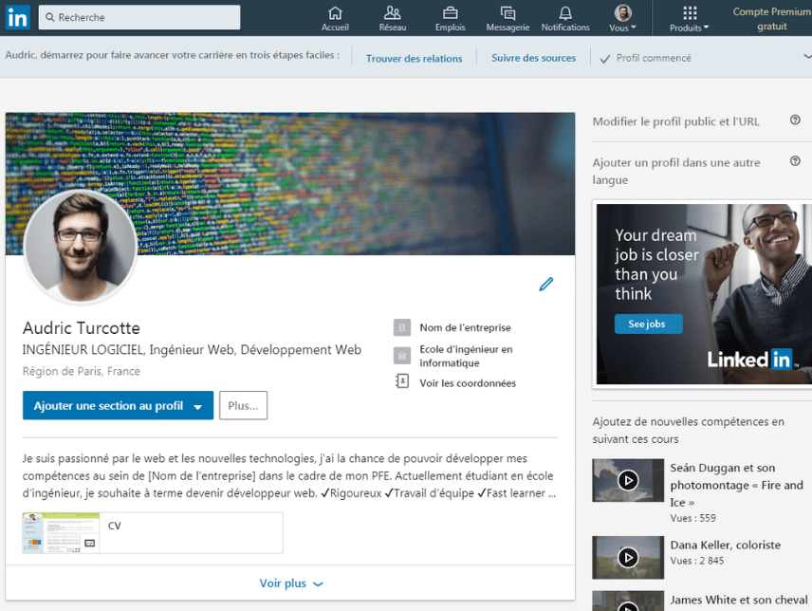

Figure 1: Screenshot of “Linkedin” Web Application

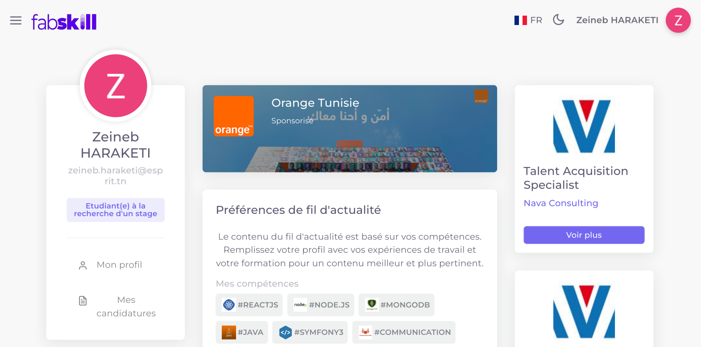

Figure 2: Screenshot of “Fabskill” Web Application

1. **Critical Review**

LinkedIn:

* Professional networking: it is a perfect platform for those seeking to expand their networking cercle.
* Internship opportunities: Employers can post an offer for internship, and job seekers can apply for those offers.
* Traditional CV Builder: it’s CV Builder print the information of a user as a pdf without any template.
* User-generated content quality: some users post valuable and informative content, others may post spammy or low-quality content that adds little value to the platform

Fabskill:

* Professional Video CV: Interns and job seekers can effectively build their resume through an AI Video Chat
* Offer Recommendation System: Interns and job seekers can search productively for offers as they were suggested based on their skills and location.
* Non-friendly User Experience: The User Interface is still lacking a few features
* Skill Lacking: A User can enter a maximum of three skills.

1. **Proposed Solutions**

* Provide a simple, easy to navigate UX solution.
* Give our users the ability to provide as much useful information about themselves as possible.
* Provide companies with the ability to conduct tests within our platform.
* Provide trainers with the ability to fully integrate their curriculum within our platform.
* Build a recommendation system to help interns and companies find their best match.

**ANALYSIS SECTION**

1. **Functional Requierements**
2. Actors Identification

An actor is simply a physical entity (person) or an abstract entity (software) capable of using the system to meet a well-defined need.

We can distinguish in our application, 3 main actors:

* Company
* User
* Super Admin

1. Functional Specifications

* Authentification: all users can authenticate according to their account type.
* Management of User Profile: All users must be able to customize their profile information and view other users' profiles.
* Management of Internship’s Offers: Companies must be able to create, update, and delete internship offers that are visible to all users.
* Management of Applications: Companies must be able to create, update, and delete internship offers that are visible to all users.
* Management of Training Offers: Trainers must be able to create, update, and delete training offers that are visible to all users.
* Management of Training Requests: : Interns must be able to apply for training offers and proceed with payment if their application is accepted
* Application Review: Companies and trainers must be able to review internship and training applications, and decide whether to decline, put on hold, or accept them.
* Tests and Video Interviews: Companies must be able to schedule tests and video interviews with interns.

1. **Non Functional Requierements**

non-functional requirements have a visible aspect for the user but are not directly related to the application's behaviour. They are the technical constraints of the application and the needs that distinguish it. The requirements that must be satisfied are:

* Scalability: The website must be able to handle a growing number of users and activities without sacrificing performance
* Security: The website must be secure, including measures to protect users' personal information and prevent unauthorized access to private messages and other data.
* Usability: The website must be user-friendly and intuitive, with clear navigation and easy-to-use features.
* Reliability: The website must be reliable, with minimal downtime or technical issues that could interfere with user activities
* Compatibility: The website must be compatible with a wide range of devices, browsers, and operating systems
* Accessibility: The website must be accessible to users with disabilities, including those who use assistive technologies like screen readers

**CONCEPTION SECTION**

**IMPLEMENTATION SECTION**

1. **Material Environnement**



MongoDB is a document-oriented database management system that can be distributed to any number of computers and does not require a predefined data schema.



React is a free JavaScript library developed by Facebook since 2013. The main goal of this library is to facilitate the creation of single-page web applications, via the creation of components that depend on a state and generate an HTML page at each state change.



Express.js is a framework for building web applications based on Node.js. It is in fact the standard framework for server development in Node.js.



Node.js is a free software platform in JavaScript, oriented towards highly concurrent event-driven network applications that must be able to scale. It uses the V8 virtual machine, the libuv library for its event loop, and implements the CommonJS specifications under the MIT license.

1. **Mock-UP**

Conclusion

Our communication application provides a simple and user-friendly platform for seamless interaction between interns and companies.

By enabling effective communication and collaboration, it has the potential to improve productivity, overcome common challenges, and provide invaluable work experience for students and young professionals.

As a web developer, I'm proud of the work we've done and am excited to see the positive impact our application can have on the internship experience.