|  |
| --- |
| DRAGON INC |
| Pilot App |
|  |
|  |
| 5/21/2025 |
|  |
|  |
|  |
|  |
|  |

Table of Index

Table of Index 1

1 Introduction 3

2 Tool & Technology used: 4

3 Steps Followed: 5

3.1 Initialize App: 5

4 References: 6

5 Document Revision History (Reverse Chronological Order) 7

Tables and Figures

Figure 1 Create new App example 5

Figure 2 Execution of an application 5

# Introduction

Pilot is your go-to app for staying on top of daily flying routines. Whether you're logging your pre-flight checks, tracking daily guidelines, or reporting issues you face in the air or on the ground, Pilot makes it simple and seamless. Designed with pilots in mind, it's your personal flight log, task tracker, and feedback channel—all in one place.

# Tool & Technology used:

1. In Frontend : React, React Native with Expo
2. In Backend : NodeJS, Express.js

# Steps Followed:

## Initialize App:

* To created a application using **npx create-expo-app@latest** command.
* After created use **npx expo start** command to execute the application.

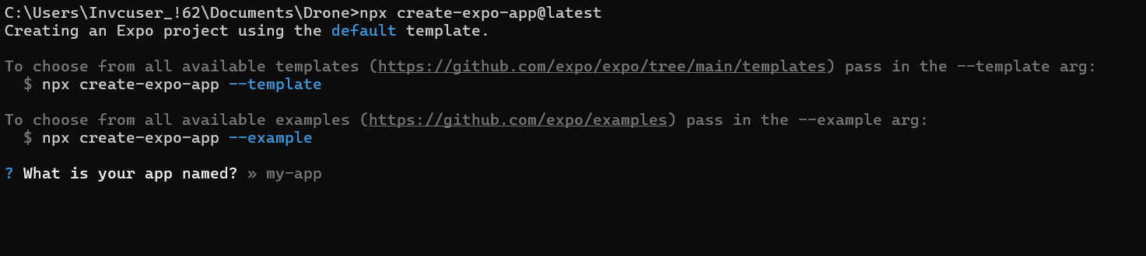

Figure Create new App example

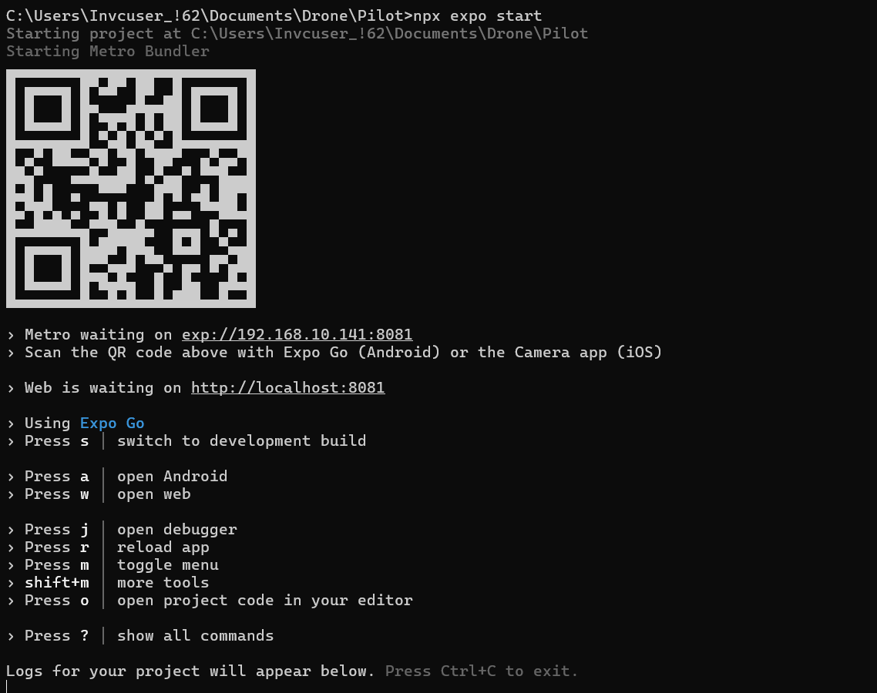

Figure Execution of an application

# References:

https://docs.expo.dev/tutorial/create-your-first-app/

# **Document Revision History (Reverse Chronological Order)**

|  |
| --- |
| Document Revision History |

|  |  |  |  |  |  |
| --- | --- | --- | --- | --- | --- |
| Date | Revision Number | Author Name | Reviewers | Sections Updated | Change Description |
| 21-05-2025 | - | Nandhakumar | - | Init updates | - |
|  |  |  |  |  |  |
|  |  |  |  |  |  |
|  |  |  |  |  |  |
|  |  |  |  |  |  |
|  |  |  |  |  |  |
|  |  |  |  |  |  |
|  |  |  |  |  |  |
|  |  |  |  |  |  |
|  |  |  |  |  |  |
|  |  |  |  |  |  |