Intern Rapport

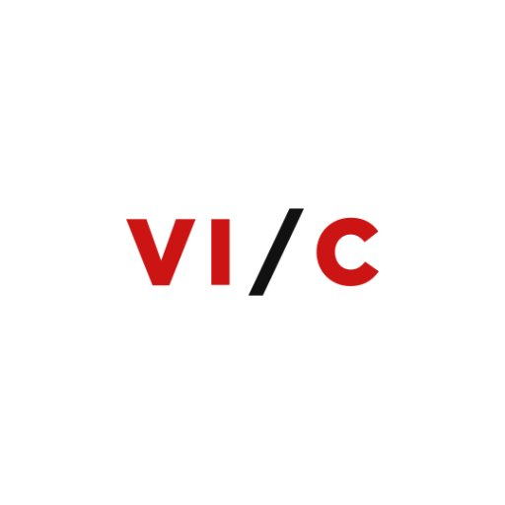

Name: Oscar Veldman  
Student number: 0879062  
Class: INF3C  
Module code: CMISTG01  
Company: VI Company

Table of Contents

Learning goals 3

Manage 3

Analyze 4

Advice 7

Design 8

Realize 10

Skills 12

Personal learning goals 16

Business orientation 17

Evidence (Dutch) 19

Bewijsstuk A – Userstories 19

Bewijsstuk B – De interviews 20

Onderwerpen 20

Vragen 20

Bewijsstuk C – Het programma foto’s 21

Bewijsstuk D – Usability test 22

Bewijsstuk E – Skills Bedrijfscultuur 23

# Learning goals

## Manage

**Learning goal 1**

**Situation**The assignment is exactly written in my intern plan. In this intern plan you can find the requirements, design, and description of the product. I have kept the most of the designs. Some points not, because there were come some information I didn’t know at that moment. At half my internship, there came with more features. The employees had new ideas that made the product better. The reason was that we must make a product for VI Company.

**Task**My tasks were:

* Programming within the guide lines
* Argue exceptions
* Correct any design if they are wrong

I want to achieve that I made a good product. That I can defend my product with arguments. I hope with the guidelines we made, that I can build a program with high qualities. I want to be sure to secure these qualities.

**Action**After I made the intern plan and let me approved by the intern teacher, I’m started to create the program. Because I made design and put it in the intern plan. So, I created the program how I planned it. The employees were positive about my product.

**Result**The result is that we have a good and working program. The employees can work with program now. My program is tested and has usability tests. I changed the exceptions and extra features in the design. Our working group gave us more ideas how I can improve my product. Because there was enough time to implant more features.

**Reflection**I made a product where I’m proud of. A couple of employees said they can work with the program and it make it easier for them. What did go well is that the greatest part of the program is the same as on the design scheme. The next I would think better about the technique what we want to use. Then we didn’t have to look some problems.

## Analyze

**Learning goal 2**You can analyze an assignment based on a research question. You use methods and technique that exists. Also, you can run a requirement analyze for a part of the software system with multiple stack holders. You must consider with the high-quality standards.

**Situation**In the first few weeks we did research to the needs of VI Company. They have running multiple software. Our assignment is to make one of the processes easier from the developers here. In this part of my internship I did interview multiple developers from this company. We interviewed frontend and backend developers. So, we can consider multiple sides of all the programs. These interviews are taken in the office. Also, we take a lot information from the internet to confirm what we thought we need.

**Task**My tasks were:

* Make the interview
* Give the interview
* Process the results to ideas

What we want to achieve is I want to know how the software works at VI Company. They expected to create a big and good assignment. The assignment need to make some processes easier for the employees. The approach of the assignment is to create a part software that automatic some processes. So, we needed to get some problems from the interviews and other research. We did research the projects of VI Company. We got the approve to look all the projects.

**Action**We took the assignment so big and open as possible. We had some subjects and ideas to start the interviews. For some people is difficulty to tell what is wrong or can be different. After each interview, I improved the interviews to get better answer from the developers. At first it was exciting to give an interview, but after a couple interview is slow away. After the last interview, I heard that there was a little structure, but not a lot. That feeling was not great.

**Result**The result is that we have a nice list of all the problems at VI. Now we can take the most interesting and learning subject to make an assignment. On our list came two subjects. The first one is translation of all products and the second one is the Identity Provider. My colleges reacted surprise for what we had on that list.

**Reflection**We got a great result from the interview and internet. So now we can create a new assignment for intern plan. The critical point is justified. We forgot to give a good explanation for some employees and why give this interview. I learning how to lead a discussion and consult what I can do for the assignment. Next time I must need more information how to give an interview. I need to inform myself from the internet and other people. Also, I want to clear the uncertainties as soon as possible newt time.

**Learning goal 3**You can create specification from the analyzing.

**Situation**From the interviews and projects from VI Company we got a lot information about processes. There is a lot background information here. After the interviews, we talked to college’s the get more information what exactly the problem is. Now we create a lot user stories. Our colleges checked the user stories and give us feedback. These user stories are on Team Foundation Server. So, that we can get user stories anywhere were we have connection to the local server.

**Task**My tasks were:

* Filter the information
* Create user stories
* Get and give advice

My part is that I was thinking about product. We needed to specify what the product needed to be. So, I created a good description and a good view of the product. The expectation was that we get a start to make the software. Of course, we can ask the questions in the future. I expected to create so good as possible product. So, I hope to impress the employees from the company.

**Action**I created the requirements with somebody else. These requirements are based on Scrum criteria. The user stories are also shared in tasks. After that, we discussed with other employees. These guys gave us improvements. So, we improved our requirements with the improvements. At that moment, I knew that we going to create a beautiful program. The intern teacher gave us the confirmation to start with the assignment.

**Result**The result was that we go a whole list with requirements with descriptions about the product. Everybody was positive about a preparation including the intern teacher. Now we can start with the design of the product.

**Reflection**It’s was going well, because we can start right now with the design and creating the product. Everything was obvious for everybody and in the rest of the time there was almost now unclear subjects. (We had a lot questions about the technique, but that is another story). What I learned is that is difficulty to write good user stories. So, it’s imported to check anyone his user stories. So, that you can learn from his mistakes and you can improve it. Next time I need more information for more idea’s. I need to learn to ask more questions. Then I can prevent little mistakes in the future.

**Learning goal 4**You can create acceptation tests from the analyzing.

**Situation**We have made some usability tests. These tests are made how the user use the program. That did we done with paper test, but also later with the program. From this test gave us information about how the user handled our user interface. We tested if the user understands everything and if it’s logical. In the preparation, we did choose a couple of employees of VI Company. These employees are going to use our program. In these test, we give the user a lot assignments. He must have made the assignment so fast as possible and gave us. We did so little as possible to information.

**Tasks**My tasks were:

* Create usability tests
* Make the tests with the users
* Get the improvements

My part was here to think what the user needs in this program. During the test, we can discus with the user what he thinks he needs from the program and what he likes about the program. We did also create standard question, that we can get deeper information from the user. These pointed are written in a word documentation. We did change the improvements in other parts of the project.

**Action**First we created the paper test. Because we didn’t have a program to test it with the user. User gave us improvements. Later when we created the product, we tested also with a usability test. Both test the user perform the assignments we gave him. If the user takes a lot of our time. Then we wrote the improvements on the paper. Now we have more insight in our own product.

**Result**The result is that every time we perform the test. We get more improvements of the user to create a better product. So, now we have a better insight of a better design. I can get these improvements for my next projects in the future. Then I don’t have the same problem again. Everyone where I test the program was more the helpful with us.

**Reflection**Everything ended well. We didn’t lose a much time and we did have good prepared. Maybe I need to do more structure in the usability test. Then it’s easier to remember and the test was going faster I think. But we got the improvements that we need. In the end, everything was clear for the user. On that point we got everything good prepared.

## Advice

**Learning goal 5**You can explain and good advice about new processes, software, and/or new technique. He can explain this clear and understandable.

**Situation**In this part of the assignment we searched how are going to do the project. We looked on the internet. We discussed with colleges. So, we can filter every information on a list. At first, we looked at which software we are going to use. Second, we looked how we are going to edit the label translations. With these information, we are going to a few colleges. We told them what we found with arguments. We have done this with meeting. I advised the employees that we are going to use a desktop application with WPF, because the security and you don’t have to run on the server. In the meeting, we told the employees the longer version of that. Also, we advised to change the structure of the JSON files. Then the process changed, but it will easier to create a website for the developer.

**Tasks**My tasks were:

* Collect information
* Process the information
* Present the information

My part of this assignment was present the advice as good as possible. Then I can show the employees what my idea is and how I want to create the program. With arguments, I can show you that it’s possible within the time limit. My expectation is that I present it very well. Because I gave more presentations in the past and I want to prepare to good as possible.

**Actions**First, I collect so a lot information from the internet. I wrote that information in a list. In the meeting went well because I was good prepared and had multiple items on the list. At first, some employees didn’t understand why we going to use a WPF application. After a few argumentations, they do more understand why. They told me that I stand there confident.

**Result**The result was that we got a confirmation to start the design and programming after designing. Now, we get an application what I had in my mind. A lot of the company are positive about our WPF application. A lot of them gave us new ideas in the meeting for the technique. They are also curious how it’s going to work what we have in our mind.

**Reflection**It’s was going well, because we did convince the colleges with our arguments. Now we finished our project, I know that the arguments were good arguments. But, we found a disadvantage from the technique we are using. After a sometime past, we fixed the bugs from the disadvantage. I think we choose the right choice. I have learning that I must talk more and I ask more questions. In the future I must practice more on my talking experience. I found it difficult to talk a couple phrases of the same subject.

## Design

**Learning goal 6**You can create a design for a software system and you can combine them with exists part and libraries; Also, you use with design qualities;

**Situation**We need to design a good product for VI Company. Our product need to run with other projects. By the design must we consider that it must run with other projects. For example, VI Company’s websites use JSON files for the translation. We are using with our program the same project. Also, use our project multiple libraries. Such as, library with Markdown and library for UI elements. I created UML diagrams and use case descriptions for the design of the program. You get a good idea how the program can be.

**Tasks**My tasks were:

* Design the product
* Search for probably problems
* Arguments why do you it on this why

My part of this learning goal was to design a good product as possible. I wanted to search for the programs. If there is a problem, then I want to fix it. By the design, I have considered the high-quality requirements from school. If somebody want to program with our program, then he must can understand fast how it works. Also, I needed to interview some stakeholder. This information is processed in the design

**Actions**First I have researched a couple of possibilities to create a good product. With these possibilities, I was going to a stakeholder to confirm it’s correct. It’s not 100% correct, then I need to improve my design. I created a lot UML diagrams and descriptions. After that, it’s was clear what to do for me. The developers approved my UML diagrams and already happy what they saw.

**Result**The result was that the developers approved my UML diagrams. So now I can start to program our product. It was easy to start, because we have processed everything in the design. We worked almost with two persons on the project with help from others. Later we had to edit a couple little features in the product. So, we had to edit in the design. But the most of the product are the same with the design.

**Reflection**I like it very much that I created a great design. I think it can be a really product. Maybe I ask more from people and less speculate. But everything is edit in the design. So, we have now a good view what we have done. I learned that is handy to create diagrams. Because, I talked easier with other developers. I can now create better designs than I did it before. I learned to use different and more symbols and create more realistic design.

**Learning goal 7**You can validate your design with the specifications from the design

**Situations**   
We made a whole case with a description. With this description, we made all the requirements. Also, we can look at this case to test the design. With the design, you see how everything works. You want some expected answers. If you follow some diagrams. Then you can see the probably answer. Next you compare your expected with your probably answer. If this doesn't match, then I improve my model. Finally, one of the employees checked my designs for programming.

**Tasks**   
My tasks were:

* Thinking about a scenario
* Run the validation

My part of this learning goal was to validate how good designs are. So, I must think how to program the easiest way to program without programming again. Also, I must to validate what you as user can do wrong with the program.

**Actions**  
 I have created multiple scenarios to test my designs. Therefore, I created multiple use cases. All the mistakes we found on our design; Now we improved the designs. With this improvement, we get more trust from the stakeholders.

**Result**The result is that we get a good base to start with the project. Everything is thought about it. So, I expect that we get not a lot problems in the project. Of course, there were a few problems with the user interface.

**Reflection**I found that I wrote a good validation, because we created a good product in the end without a lot problems. All the process is going well in the program. I learned that how create good validation to improve my designs. A lot improvements were in the UI. Maybe I must validate the possible crashes next time. The most of the crashed, I didn’t think about it. Next time I must get more technical knowledge to create better designs and tests.

## Realize

**Learning goal 8**You can create software with the requirements from the assignments and with the high quality as in software engineering.

**Situation**Here at the office they multiple tools to check your code. I did create a lot test to check my own code. Every requirement stays in Team Foundation Server. With TFS you can create also tasks. In every requirement have some tasks what says you must done in the code. Now we can show in the demo what we did done last two weeks. (Every two weeks we give a demo). I created the software almost the same as in the UML diagrams and other designs.

**Tasks**My tasks were:

* Programming
* Check on high quality for the code

My part of this learning goal was to create a good and working product. Also, I must create code that can be maintain in the future. I was working with a college who checked my code and I checked his code. The employees expected all those things.

**Actions**I have thought about it how to start. This did I discus with some colleges here at VI Company. Every requirement did I test with minimal one unit test. Only UI elements doesn’t contain unit tests. Before I came on internship, I read a book with the title “clean code”. These quality is the normal standard in our program. All together we get a high-quality program with tests.

**Result**The result was that we have now a good and working product, that also can be used by employees at VI Company. We get positive reactions at each demo. Everybody at the demo thought about it to improve our product. All those ideas we can improve the product.

**Reflection**I got the feeling that I created a good base program for VI Company. I learning a much better programmer. The employees gave me much advice how do it different and easier. Sometimes I and my college last the overview about what we are doing in the programming. In the future, I must create more clearness about who doesn’t what. I must also expect more clearness from colleges. So that I have next time less problems with the overview.

**Learning goal 9**Tests:  
1. You use of unit, integration, and system tests  
2. You create all the test automatic

**Situation**Our program must be tested for more quality. Here at the company they use N-Unit and Bamboo. These things are standing on their own server. The most important methods and functions must be tested. By every commit, the server runs you own tests. To do that you must create a test plan. In the test plan has a description of run a unit, integration, and system tests. I wrote the unit and integration tests during programming.

**Tasks**My tasks were:

* Wrote tests
* Automatic all the tests

My part in these learning goal was to check all the function, so my program can be running well. I must think about how wrote good program to create easy tests. I expect that in the future I can find the problems fast.

**Actions**At first I looked at how VI Company made the test. First how the create unit test and thereafter the automatic test. Now I know with which standard I must work. I did configure the Bamoo server to start a process when I change something in my program. This Bamboo server run the tests what I wrote. I thought about how to write unit test. For example, what goes in and what goes out.

**Result**The result was that we saw that the server running it very well. After that, you could see fast were it goes wrong. Hereby, I saved a lot time and wrote more feature to the program. Of course, some of the methods was difficult to create test, but it is done. It was difficult because we created some complex methods.

**Reflection**Everything is ended well, but it’s was practicing for me. I learned a lot about mock filesystem to test it easier, because you don’t want details from the outside. Maybe next time I must start earlier with unit tests. I saw now the purpose from it. I was easy to find your own bugs. I think that I create more tests in the future. It’s helps me a lot. In the future I must create less complex function to create a better test for it.

## Skills

**Learning goal 10**You can see which company culture is visible in your internship and you can tell which feature is has.

**Situation**I’m here at the office always on the same place at VI Company. It’s isn’t a big office. It’s has 30 employees. A lot of the employees likes a lot to think with my assignment. If you have a problem, then you can always discuss it with a college. Another feature is if you late at work, then you can work longer to finish what you must be done. I wrote a skills assignment with company culture. Here you can see which feature VI Company has with company culture.

**Tasks**My tasks were:

* Pay attention what happens at the office
* Documenting what happens

My part of this assignment is I want to feel if it’s a good way to work for me. I can get this to the future for me. Teacher skills expected from me a good description of the company culture here at the office.

**Actions**I wrote a report about where I used examples from the practice. It’s wasn’t a difficult report, because it was obvious what for company is was.

**Result**The result was that I got an 8 for that report. Hereby I know I wrote good argumentation and good overview have about the company. There were small things I didn’t have correct, but the biggest part was surly correct.

**Reflection**I did have wrote a good report. Maybe I started earlier that I got a better result. Then I could research more and maybe I got more background information. But I’m happy with my result, because I learned a lot in class and here at the office. I learned that a family culture is a good culture to work for me, because I like that everyone has their own responsibility and participation. I take this information for the next job search.

**Learning goal 11**You can determine which company feature has your intern company.

**Situation**I’m looking around which features the company has. First time you remark that they work with scrum. They working a lot with ASP.NET. The company works only for financial company such as scholarships and banks. Somethings VI Company knows more the financial company when it comes to the subject financial. Also, VI company has flat management. Everybody has her own responsibility and participation. I mean everybody likes to listen to your idea’s.

**Tasks**My tasks were:

* Looking for company features
* Make conclusions

My part of this learning goal that I know now what VI Company exactly is. Maybe I can recognize the other companies better. I think that I recognize better were I like to going to work. I expect that it’s not difficulty to determine the company features.

**Actions**I took a job to look at the office for the features. I am asking the employees how to tackle so cases. Hereby, I think that some employees saw that I interested in the company. They gave me fine responsive in the conversations, because that conversations are almost positive.

**Result**The result is that I have more insight what VI Company does and how they handle some things. Hereby, I know what I liked and what I didn’t like of the company. Now I can better orientate in the future. This is true for technical but also for the social side.

**Reflection**I learned a lot from VI Company. I didn’t only learn how be a better programmer, but also to work to with each other. They give me more structure in my programming skills. Now it’s more clear what I will do in the future.

**Learning goal 12**You can work and adjust to company with the methods, rules, and procedures and you can reflect your activities

**Situation**After a couple of weeks working at the office, you saw fast which rules and procedures they have. You must reserve a meeting room to use it. For example, to show you clients the demo. Also, I must join the household chores every couple of weeks. Beside you have also rules for you programming skills. They installed the rules with Rescharper in Visual Studio. You have rules and procedures for use Git and the Test server. The company has rules and procedures. It’s just to make it easier for everybody. I have also worked in a project that works with scrum.

**Tasks**My tasks were:

* Learn rules and procedures

My part of this learning goal that I know what I can expected from my colleges and that they know what they can expected from me. I want to achieve that I know how it is to work in a company. The company expect from me is that I know the rules and procedures as soon as possible. I want this know fast because it’s make it easier to work here.

**Actions**The actions that I done are. First if I didn’t know somethings, I ask an employee how it goes here at VI Company. I joined with every activity that this company had last half year. This led to positive reactive to me because I joined more activities then required. I looked at their projects they already made for the code guide lines they made

**Result**The result was that I’m working fully with VI Company. I know if I have a problem, then I know where I need to go or to who. Also, I’m know how program here at VI Company. So, this made me also a better programmer, because they have well rules to programming a software. Furthermore, I know how it is to work at the office. So, I know I liked it.

**Reflection**I find that I have hold so much as possible to the rules and procedures. Besides I have worked more in a structure then I normal do. I liked to work on a product for a longer time. Maybe I needed to inform more in the company. I must learn to ask more and ask more about why. I think that I can better remember the rules of procedures

**Learning goal 13**You can work independently agreed (commitment, motivation, respect, etc.) and perform shows progress and any issues proactively.

**Situation**We give a demo for a couple of employees every two weeks. In this demo, we present what we have done in the last two weeks. By this demo can we see all bottlenecks and the progress of my project. In this meeting, we discuss what we are going to in the next two weeks. In this discussing, we talked about which new features and new appointments. Each feature what we made are tested. In every meeting, I input to create more discussing and feedback. The demo is an example that we were on our infinitive for example.

**Tasks**The tasks were:

* To create the demo
* Creating of the product
* Give opinions and information
* Get information

My part of the learning goal was to create events that is on our infinitive. We got a way to show our progress from the project. We want to do this way, because the company does it on the same way. Now, we can get more feedback from colleges. I expect that I can keep the promise from an agreement. The company expect this from me.

**Actions**We did give multiple demos. Now, we have removed the most of the mistakes of the program. Before the demo, we prepared a lot questions to ask. On the demo, we show our product with proud. We ask questions in the demo, so get information to make our product better. I’m always come on time at the office. I can program hours without to ask a question to programmer.

**Result**The result is that we have now a good product. I have points now that I am going to it different next time. Also, I have now more motivation to go work in this business. Beside I got more connections with the employees within this company.

**Reflection**Sometimes I find it difficult to talk with other subject then programming. I can ask all my questions to the employees at this company if I did come out of a problem. But I could solve much of my problem by searching on the internet. I worked hard on this product and the result is big. I heard from some employees that they find it unfortunately that I am going away. So, I can see that I did my best here at the office.

# Personal learning goals

1. **In the end of my internship I know where I’m good at programming and what I like about it.**

In the beginning, I didn’t know what I liked about programming. But I’m confirming that I’m good at programming in the backend. I don’t like to program the visual side. I want to program the process in a project. I don’t care how it look like, but it must work great. I have learned a lot from VI Company with programming. I am programming a lot mere cleaner. C# is a program language what I like. It’s clean and you have an overview.

1. **In the end of my internship I know the rules of the company.**

In the beginning, I didn’t much about VI company. I learned a lot through asking and reading. But also through just to do stuff. I joined all the activities from VI Company. I like the structure to work. There is no chaos such as at school. All my questions, I can ask my questions immediately to my college instead of mail.

1. **In the end of my internship I can programming clean and good per the rules of VI Company.**

I found it difficult to programming in Object-oriented. But I learned with creating models by designing that it’s was so difficulty as I thought at school. They use also ReSharped with all their rules. So, I could if they match. If it’s doesn’t match. It’s give an error and with a why argumentation. In the end of my internship my code match with their guide lines. Also, I read the book clean code. In this book, I learned a lot about write readable code for other developers.

1. **In the end of my internship I can create write good and automatic tests**

In the beginning, I found it hard to create tests. Because I write methods that are hard to test. First, I learned how to be a better programmer. After that I could write the test. Second I rewrite everything to a mock filesystem. Because you don’t want to get other details of the system. You want to

1. **In the end of my internship I can work well with version control**

In the beginning, I did every commit to the master. I didn’t work with two people at one piece of code. Now, I change that through to work with other people at one project. In the project, I used multiple branches and a lot of merges. While I commit the changes, I provide the commit a good name. I can now also handle with SSH keys and https. So, I can create a secure connection with a secure version control server.

1. **In the end of my internship I can write good and writeable rapport**

In the beginning, I wasn’t good at writing rapports. This learning goal is about I write rapport not so good in Dutch. So, I must improve my Dutch skills. Normally I get a lot comments about there is a lot spelling mistakes. Now, I can improve my writing skill by reading my own text better. I create some rapports for skills and for my own. I got an 8 from the report that I delivered by the teacher.

# Business orientation

**The history of the company**VI Company was founded by 2 people 10 years ago. They did building websites for other companies. 5 years ago, they moved the company to “Groot Handelsgebouw” at Rotterdam central. Since they are specialized to developing in software for the financial companies. They do that, because they saw a market for and they found it interesting subject. The company grew slow in employees. Now, there are over 30 employees at the company.

**The core business of the company**VI Company earns his money with selling software and maintain the software. They are specialized in the financial world. The clients are for example ING, BX Swiss and “Kempen & Co Markets”. The company get every year more different clients. Thereby they growing more. The software they made are transactions, scholarship websites and more. They building the websites each time almost from the bottom, because then they can create a website what the client liked.

**The mission and vision of the company**The mission of the company is to get more project and clients. Thus, they want to be less dependent on the other clients, because no clients are staying forever. They want a healthy company, where the money come on the normal way. They are looking for clients not only in the Netherlands, but only in whole Europa. For example, German and Switzerland.

**Short term goals**On the short term they trying to extend the project they already have. Likewise, they are trying to get more productivity out the employees. The employees trying to improve the old project they made. Because it’s made it easier to maintain those projects.

**Long term goals**On the long term they are trying to get more clients. So, they must hire more employees in the future and now. Those projects must be maintaining and often the clients want more features in the project. Now, they can sell it. Also, they want to use “Holacracy” in the company. It’s change the whole company structure. For more information look at paragraph company structure.

**Position in surroundings**They have a lot competition in the surroundings. They have some big clients such as ING. Because they are specialized and they have a reputation. Thus, they have a potential a large clients base. So, if one client go away, then they have enough clients to survive. VI Company stands in “Groot Handelsgebouw”. Therefore, they have a good position to travel. All the employees can travel with the train or other transport.

**Company structure**Now has VI-Company a small hierarchy structure. The company has two owners, HR-manager(s), scrum masters, multiple teams, and the administration. The last three has the same height in the structure. The projects use scrum, so they use sprint, stand up meeting, requirements, and the rest of it. The structure is not big, but the company isn’t that big enough.

Begin October they are going to change the structure. VI Company are going to use Holacracy. It’s system without a manager. Everybody has their own responsibility but also participation. The whole organization will be more transparent. If you have an idea, then there will listen to you better, because the whole group will listen to you.

**Company culture**We are now with more than 30 employees at the office. You are working here from half past nine to five o’clock. It’s a family culture. We do all the household chores with each other. There is a household chores schedule who has chores. Everyone is in the same room and every team sit together. In the afternoon, we are lunching together. The company provides the lunch for everyone who works here. There is a good mood at the office. You must be looking well, but not extreme properly. For example, you don’t have wear a suit, but a jean with blouse is also correct. Everybody is motivated to help you and like to look to your problem with you.

**Description own place in the company**I’m sitting here at my desk. In my front stand two screens. I’m sitting with another internship and two programmers. They are with me in 1 team. Together we are going to build a beautiful application. Hereby, I get an idea how it’s feels to work in a company. I join also the organization change with Holacracy. What I going to do is, I don’t know. Because, this company is new to me and they don’t also know exactly.

# Evidence (Dutch)

## Bewijsstuk A – Userstories

1. Als gebruiker wil ik meerdere projecten kunnen beheren, zodat ik verschillende projecten kan vertalen.
2. Als gebruiker wil ik de labels van een project kunnen zien, zodat ik deze beheren.
3. Als gebruiker wil ik een label kunnen toevoegen, zodat het label onthouden wordt.
4. Als gebruiker wil ik een label vertalen, zodat ik de labels de juist vertaling hebben.
5. Als gebruiker wil ik een nieuwe taal toevoegen, zodat er talen bij kunnen komen.
6. Als gebruiker wil ik wanneer een nieuwe taal word toegevoegd, er een default map bij komt met dezelfde json files van een andere taal.
7. Als gebruiker wil ik kunnen switchen van taal, zodat ik de labels in andere talen kan zien.
8. Als gebruiker wil ik een label kunnen verwijderen, zodat er geen overbodige labels zijn.
9. Als gebruiker wil ik dat de labels een onderwerp hebben, zodat ik weet waar de labels bij horen.
10. Als gebruiker wil ik meerdere groeperingen voor één label kunnen aanmaken, zodat hier in meervoud en enkelvoud van woorden gebruikt gemaakt kan worden.
11. Als gebruiker wil ik een variabele naam in een label zetten, zodat een tekst niet van tevoren vaststaat.
12. Als gebruiker wil ik makkelijk zien welke labels nog niet vertaald zijn, zodat het dan overzichtelijk blijft.
13. Als gebruiker wil ik snel bij een label zijn, zodat dit efficiënt is.
14. Als gebruiker wil ik de labels kunnen sorteren, zodat het overzichtelijk blijft
15. Als gebruiker wil ik uit een lijst van talen kunnen kiezen bij het toevoegen van een taal, zodat ik snel de taal kan selecteren. (region and language)
16. Als gebruiker wil ik een label een opmaak meegeven, zodat ik geen 3 labels hoeft aan te maken voor 1 zin.
17. Als gebruiker wil ik snel kunnen zien of een label er goed uitziet, omdat dit efficiënt is.
18. Als gebruiker wil ik de naam van een label veranderen, zodat ik een betere naam aan het label kan geven.
19. Als gebruiker wil ik dat labels die leeg zijn de default taal aannemen, zodat er geen lege labels zijn.
20. Als gebruiker wil ik zien hoeveel labels dezelfde omschrijving hebben, zodat ik kan beslissen of ze samen gevoegd moeten worden.
21. Als gebruiker wil ik makkelijk zien welke labels niet meer in de site worden gebruikt, zodat ik makkelijk kan beslissen of het label niet meer nodig is.
22. Als gebruiker wil ik een nieuwe taal verwijderen, zodat er geen overbodige talen in het systeem staan.
23. Als gebruiker wil ik zien of een label niet meer relevant is, zodat ik deze dan kan verwijderen.
24. Als gebruiker wil ik labels exporteren, zodat ik met de labels aantekeningen kan maken.
25. Als gebruiker wil ik de file locatie van labels veranderen, zodat de file locatie niet vast staat
26. Als gebruiker wil ik dat de labels automatisch vertaald, zodat er direct en vertaling bij een label staat.

## Bewijsstuk B – De interviews

### Onderwerpen

* Translaties
* Identity Provider
* Charts
* Prijs informatie
  + Binnenhalen en weergave quotes
* Validatie
* E-mail versturen
* Bestanden importeren
* Genereren van bestanden
* Formatting
* Security
* Caching
* SignalR
* Unittesten in een packets
* Tabellen en sorteren daarvan
* Contact formulieren

### Vragen

1. Welke systeemonderdelen zie je vaak terugkomen?
2. Welke is misschien het fijnst om standaard te maken
3. Welke onderdelen zijn al standaard gemaakt?
4. Welke bugs zie je vaak terugkomen?
5. Waar zitten deze bugs vooral?
6. Welke handelingen komen vaak terug?
7. Zie je veel verschillende oplossingen voor bijna hetzelfde probleem? Zo ja, welke?
8. Heb je nog verdere suggestie voor ons?

## Bewijsstuk C – Het programma foto’s

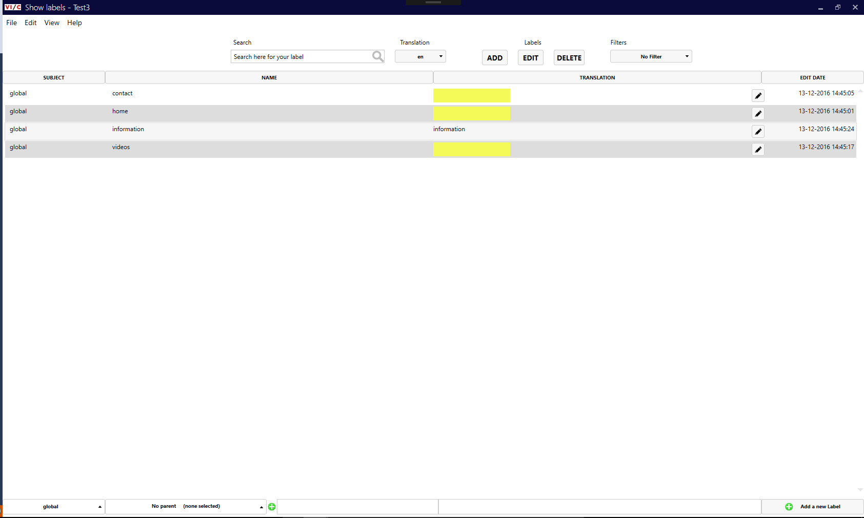

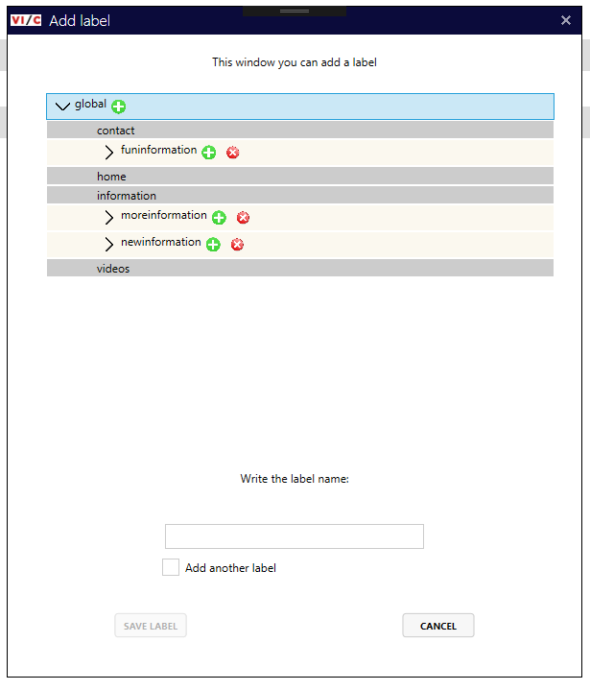

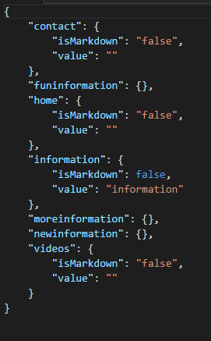

## Bewijsstuk D – Usability test

**Gebruikers informatie:**We hebben de test gemaakt voor werknemers van VI Company. De ene heeft een technische achtergrond en de andere niet. Iedereen weet hij wel wat vertaling labels zijn. Deze achtergrondinformatie heb je wel nodig om normaal met het programma te kunnen werken.

**Taken:**

1. Add project
2. Open project
3. Sync project
4. Add Label
5. Add Label Fast
6. Edit Label
7. Edit Label fast
8. Delete Label
9. Add Parent
10. Switch language
11. Add language
12. Switch project
13. Search Label
14. Filter Sort

**Uitvoering**De test is goed uitgevoerd. We moesten wel op sommige punten een klein beetje uitleggen, maar daar hebben ook help voor gemaakt.

**Verbeterpunten:**4 & 5 Hoofdletter wel toestaan

6 Externe browser openen

6 Preview Markdown kan uit worden gezet

7 Short cut enter voor het opslaan

7 Snel opslaan van parent

8 Maak een bevestiging voor het verwijderen

11 Maak een andere default

13 Maak de search een debounce search

## Bewijsstuk E – Skills Bedrijfscultuur

**VI Company cultuur**  
VI Company heeft een familiecultuur. Het is een klein kantoor met 30 werknemers. Iedereen is gelijk aan elkaar en werknemers willen elkaar graag helpen. Hierdoor voel je dat iedereen erg betrokken is. Als je een probleem hebt, dan kun je dat altijd bespreken. Je mag een keer te laat komen en volgende keer weer wat langer doorwerken. Als er iets gebeurd is, dan leeft iedereen met je mee. Het bedrijf heeft een paar kleine tradities, zoals een weekend weg met zijn allen, elke vrijdag gaat de bier tap open bij de vrijdagmiddagborrel. We eten met het hele bedrijf aan een tafel voor de lunch.

**Prettige cultuur**  
Ik vind dit een prettige manier van werken, omdat je weet wat je aan elkaar hebt. Het is erg gezellig en je bent geen concurrenten van elkaar. Iedereen wilt heel graag meedenken om bijvoorbeeld mijn stageopdracht beter te maken. Ook willen ze graag zien hoe het product eruitziet. Sinds oktober gaat het bedrijf hun bedrijfsstructuur omgooien. Ze gaan het veranderen naar Holacracy (HolacracyOne , 2016). Deze structuur zorgt ervoor dat niemand meer een baas heeft, maar je hebt je eigen verantwoordelijkheid. Dus iedereen let op elkaar en daarom past dat ook bij een familiecultuur. Verder kan iedereen tegen een grapje. Als ik een bedrijf tegen kom die dezelfde cultuur heeft, dan zou ik er graag willen werken. Alleen bij het bedrijf als VI Company zijn er weinig cultuurverschillen en dat is jammer. Ik zou het liefst willen werken bij een bedrijf met een familiecultuur. Maar ik zou ook niet erg vinden om bij een bedrijf met een adhocratiecultuur of een marktcultuur te werken. Op basis van de laatste twee beschrijvingen zou ik niet zeker kunnen weten of ik dat zou willen. Bij adhocratie vind ik de creatieve deel van de cultuur erg goed en bij marktcultuur vind ik de competitieve sfeer wel te doen. Maar dat vind ik het minste van de drie. Ik kan niet erg goed met druk om gaan.

**Geen cultuur voor mij**  
Waar ik zeker niet wil werken is in een hiërarchische cultuur. Ik vind het lekker als het een beetje gestructureerd is. Maar ik houd er niet van als je verteld wordt wat je moet doen en dan zonder tegenspraak. Ik moet het gevoel hebben dat ik vrij ben.

# Bijlage 3. Advies bedrijfsbegeleider

**Student informatie**

Naam student: Oscar Veldman  
Studentnummer: 0879062

**Advies bedrijfsleider**  
De student wordt onder andere beoordeeld op de competenties, zoals deze zijn terug te vinden in bijlage 1. Als u kijkt naar deze competenties en u vergelijkt dit met hetgeen de student bij uw organisatie gedaan heeft, hoe vindt u dan dat de student per competentie beoordeeld zou moeten worden (uit te drukken in voldoende, onvoldoende en zwak)?

**Part 1**

Beheren

Analyseren

Adviseren

Ontwerpen

Realiseren

Skills

**Part 2**

*Waaruit blijkt dat de student professioneel en integer gedrag heeft vertoond? (denk hierbij aan werkhouding, collegialiteit, eigen initiatief, zelfstandigheid)*

*Waaruit blijkt dat de student zich aan organisatorische regels en planningen heeft gehouden?*

*Wat kunt u zeggen over de samenwerking van de student met de bedrijfsbegeleider en collega’s? En wat kunt u zeggen over de contactuele eigenschappen van de student?*

*Op welke wijze heeft de student blijk gegeven van voldoende beheersing van kennis en vaardigheden om de opdracht/werkzaamheden uit te voeren?*

*Op welke wijze heeft de student aan persoonlijke kennisontwikkeling gewerkt? En heeft de student nieuwe technieken/nieuwe inzichten aangetoond?*

*Hoe heeft de student kennis doorgegeven in uw organisatie?*

**Bedrijfsbegeleider informatie**Bedrijf/organisatie:  
Naam begeleider:  
Datum:  
Handetekening: