Continuous-Integration Process Guide

Preface

Author’s Note
- Nothing in this document is original in any way, but the value is the convergence of many information tidbits about Agile development from the sfMIL perspective.

Definitions
- Automated Functional Testing (AFT) – UI-based testing that programmatically submits commands to supported browsers, which simulates actual user interaction. TestLink is a popular suite for this activity.
- Diligently merge – Carefully select the changes that are exclusively related to the story.
- Jenkins – An open-source, highly configurable, build automation tool that is widely used in the industry. Alternatives include products like AutoRABIT and Gearset.
- Positive communication – Convey the message and receive feedback acknowledging the message.
- SCRUM – The Agile, project management discipline employed for projects.
- Source code management (SCM) – The concept of journaling the source code so that all changes are retained and organized in a manner that facilitates branching and merging. Git is the current protocol used by sfMIL.
- Sprint code-base org (SCBO) – The sandbox that represents the code base to which the sprint is targeted, i.e. the Mario sandbox for Team Mario.
- Reset sandbox – Return the sandbox to the sprint base state, which should be the state of SCBO. Cloning a sandbox from SCBO is probably the most complete way of doing so, although one may deploy the sprint-base branch to the sandbox as well.

Actors (typical team roles)
- Architect – Understanding of Salesforce platform and enterprise-application development. Provides development standards and practices employed by the team. Leads efforts to investigate technical designs and investigate complex issues.
- Business Analyst (BA) – Understands the business and Salesforce platform features. Translates the stakeholders’ needs into high-level stories. Reviews potential bugs to determine validity and further insight.
- Developer – Understands declarative and Apex programming. Creates the Salesforce metadata that satisfies a story. Supports story through positive completion.
- Release Manager – Understands metadata management practices in the Salesforce paradigm. Designs, manages and executes SCM implementation.
- SCRUM Master – Understands the SCRUM process and overall software life cycle. Ensures all aspects of the SCRUM process are being executed well.
- Stakeholder – The business representative empowered to decide upon business functionality and priorities. Interfaces with BA to create and detail stories and SCRUM Master to prioritize story fulfillment.
- Quality Assurance Professional (QA) – Understands automated and manual facets of testing Salesforce functionality. Creates and maintains automated and manual test scenarios. Assesses stories to specify sufficient test measures. Executes testing and compiles performance reports.

Tools
- Integrated Development Environment (IDE) – Programming software that facilitates developers with SCM and other activities. VS Code and Webstorm with Illuminated Cloud are popular solutions.
- Release automation – System that interfaces with SCM, SCRUM management, and Salesforce to automate the flow of story artifacts from inception to final deployment. Jenkins and Gearset are popular solutions.
- Salesforce – Platform on which business logic is executed and accessed by the stakeholders.
- SCM – Electronic file, version-control system which contains the code, test scenarios. Git and Github are popular solutions.
- SCRUM management – Content-management system facilitating the SCRUM process and containing business and development information. The Jira and Confluence suite is a common solution.
- Test Automation – System that records, organizes, and executes automated and manual test scenarios. Selenium-based systems, like Katalon, are popular solution. TestLink is a good system for managing test execution.

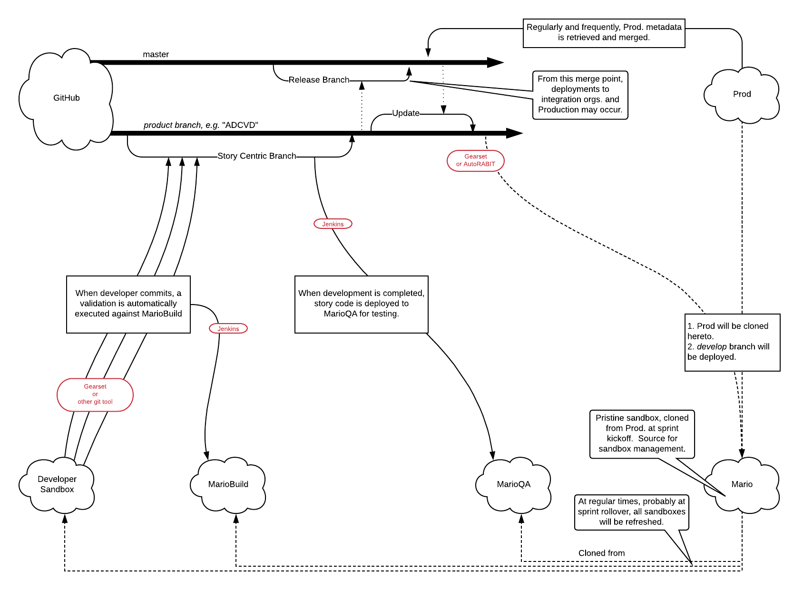
Sprint Activities

Generalities
- During grooming, each story shall receive sufficient technical details that all developers feel confident that they could be assigned the story and complete it with minimal initial questions. However derived questions routinely emerge during development.
- Each story shall contain a detailed description of the testing required to ensure quality. This could reference a hierarchically organized structure of test cases.
- The story’s assignee is responsible for progressing the story through successful completion of testing.
- Code commits and pushes should occur at least once per day.
- The package.xml file contains wildcards for all of the significant types.

Story grooming
- Is a typical SCRUM activity where the team analyzes and adds information to a story to the point that all developers are comfortable with beginning work with minimal remaining questions. Sometimes extensive technical conversation is required to evolve a story that “ready for development” point, thus the story should be moved to Technical Grooming.
- Actively participate by asking questions. Many junior developers have asked obvious questions that senior developers and architects overlooked. “There’s no such thing as a stupid question.”
- Consider the story as if it might be assigned to you.
- Consider if you could begin work and anticipate significant progress without asking basic questions, although every project inevitably has emergent questions as the code is further explored.
- Consider how the story will be tested. Ask the QA professional how the story will be tested and what the test scenarios will be.

Technical grooming
- After all of the business-centric discussion has occurred for a story, Technical Grooming may be necessary to further define expectations and measures for being done. TG may include class needs, design concerns, library usage, any other matter that is outside the scope of business people.
- Actively participate by asking questions. Many junior developers have asked obvious questions that senior developers and architects overlooked. “There’s no such thing as a stupid question.”
- Consider the story as if it might be assigned to you.
- Consider if you could begin work and anticipate significant progress without asking basic questions, although every project inevitably has emergent questions as the code is further explored.
- Consider how the story will be tested. Ask the QA professional how the story will be tested and what the test scenarios will be.

Sprint Planning
- Consider how many days it will take to complete the story. The smallest unit for sprint planning is ½ day, and the total story completion time should not exceed 60% of your capacity – targeting 50%.

Developer begins work on a story.
- At the beginning of the sprint, the SCM repo may not be fully updated and refreshed sandboxes may not be available. Although work may begin in this case, be cognizant that the story branch and sandbox will require merging and refreshing, which may impact the story work.
- Ensure sandbox provides a reliable copy of the SCBO. Although previous work may be done in the same sandbox, the code pertaining to the story should match the SCBO.
- Create a SCM, story branch from develop, naming in the format "feature/AD####-VeryShortDescription", and push.
- Begin work.

Note:
Unlike fine wine, branches do not get better with age. The longer a branch exists the greater the likelihood that surrounding code changes elsewhere and the greater the chances of improperly merging later. Simply put; keep branches as short as feasible.

With our base branch being develop, the sooner we can get our code merged into it; the better. Avoid long-term branches. If a story’s development is delayed, consider terminating work in that branch and starting a new branch with a diligent merge from the old (and a fresh sandbox), when development begins again.

If a story’s life begins to lengthen due to unexpected scope increase, consider reviewing and breaking the story into multiple smaller ones that can be developed within shorter terms.

Routine Commit.
- Only code changes directly related to the Story should be included in commits, otherwise the branch should be identical to the parent branch. Working directly from a story branch could ease the burden of commits. However the developer must be very careful to only commit work related to the story, as opposed to changes that the org has made for unrelated reasons.
- Verify that all unit tests successfully pass. This should be provided by Jenkins but if not, then the developer is responsible for doing so.
- Diligently merge working code into the story branch. Review for correctness.
- Commit and push branch.
- Monitor Jenkins validation build for issues, resolving any that arise.

Regular activities during development.
- Monitor the story’s branch in comparison to it’s parent. If the parent merges code, then merge the parent into the story’s code.
- Add comments to Jira whenever significant events or decisions occur. Document Jira with details about blockers or others issues that arise, while raising the matter in Slack.
- After reasonable due diligence, be proactive in seeking consulting help from others when issues arise. Development leaders are generally delighted with an opportunity to handle a teaching moment or tackle a different challenge.
- Monitor Github for new and updated PRs. All developers are highly encouraged to review and comment of PR which affords the team two significant benefits. One, more eyes looking at code increases the likelihood that syntactical or logical issues are identified earlier. Two, seeing others’ code helps you to code better too. Please leave a “I was here” comment that you looked at the code, if you don’t other comments.

Other code needed for story. A story may be dependent upon other stories.
- Benchmark unit tests. Ensure all pass or document the broken ones and reasons.
- Merge other story branch into this story’s branch.
- Review changes.
- Commit and push.
- Deploy changes to sandbox.
- Execute unit tests ensuring current results match the benchmark. Otherwise resolve issues.

Create a pull request (PR). To be done early during development.
- Perform routine-commit items (see “Routine Commit” above).
- Initialize pull request.
- Verify the PRs title and description. The title should use the format “ticket_number - Description of story”.
- Add all team members to the reviewers list.
- Specify the developer as the assignee. It is the developer’s responsibility to ensure timely review. Don’t hesitate to urge reviewers to look at the PR.

Story development is completed (finalize PR).
- Perform a validation deployment to an SCBO sandbox to ensure the branch can be deployed. Fix any issues.
- Perform steps for “Create a pull request” if not previously done.
- Review code.
  - All obsolete-code commenting is removed.
  - Adhere to coding standards documentation.
- Change the label to “Final”.

Developer reviews pull request.
- Highly encouraged to add comments. At least, comment that you looked at the PR.
- Code-difference viewer may show you the actual changes, but often, the overall context is missing. Reviewing the overall context in the IDE provides greater insight thus a more valuable review.
- DO NOT approve.

Approving reviewer decides to approve pull request.
- Mark PR approved.
- DO NOT merge.
- Approving reviewer positively informs story assignee.
- Story assignee positively informs Tester that it’s ready.

Tester preparing to test a story.
- Ensure testing sandbox is fresh and clean for testing. If the preceding testing involved extensive code changes that were not related to this story, then reset the sandbox.
- In Jenkins, deploy the desired branch to the testing sandbox.
- Begin testing.
- When done testing either pass or fail, positively inform the story assignee.
- When testing completes successfully, story assignee positively collaborates with Team to coordinate deployment.

Story is ready to deploy to Prod.
- Merge story’s PR to develop.
- Add a tag to most recent Develop branch event preceding the merge point, in the format “AD####-prerelease”.
- Create a “Salesforce Deployment” ticket in Jira.

Closing the current sprint. Normally executed during sprint rollover.
- Begin sandbox creation or refresh of the SCBO from Prod. Done here to ensure the creation process, which can take up to an hour or more, is completed for a successive step below.
- Retrieve a full copy of the production org’s code, using the package.xml defined by the Release Manager.
- Commit and push all changes to the master branch. Tag accordingly.

Note: sfMIL’s Release Manager is currently preparing to retrieve and commit Prod. metadata many times per day. This emerging process may supplant this specific need.

- Branch from the develop branch. For these instructions, let’s call the branch “XYZ”.
- Diligently compare metadata, using the file comparison tool of your choice, from master branch into the XYZ branch. This is the most time consuming and tedious task in this process. Prod. will likely have many changes that are irrelevant to your product, but identifying pertinent changes from noise is not easy. ADCVD is considering a process for document sanctioned Prod. changes for better accuracy with persisting Prod.-originating changes.
- Validate the XYZ branch’s code to the SCBO (if the sandbox creation is complete and is activated). Resolve any issues based on the preceding sprint’s code base. When all issues are resolved or deemed not significant (currently several non-ADCVD tests fail because the SCBO does not have pre-requisite data) to Mario, deploy code to SCBO, without running tests since you’ve just overseen test execution results.
- Merge the XYZ branch into the develop branch.
- Inform the development team that the develop branch and SCBO is ready for cloning.
- Clone the QA and build sandboxes from the SCBO. Update related users’ email addresses and reset passwords, as needed.

References
- Agile Development – A series of articles that summarize many aspect of Agile development.
Agile Development (atlassian.com)
- Git Workflows – Defines the repository management scheme implemented here.
Git Workflows (atlassian.com)
- SCRUM – Variety of Agile project management employed by sfMIL.
Scrum Alliance (scrumalliance.org)
- Sandbox Management Best Practices – Overview of practices generally used in Salesforce development
Sandbox Management Best Practices (Salesforce Help)
- Selenium – Browser-based testing system.
SeleniumHQ (project web site)
- TestLink – Web-based test management system that facilitates software quality assurance.
TestLink (Wikipedia)

