

**COE457 Internet and IoT Programming**

**Lab 5: HTML and CSS**

**Academic Integrity Pledge**

|  |
| --- |
| As a student of American University of Sharjah, I here by state that I will abide by the AUS Integrity Pledge that:   * I will hold myself accountable for all that I say and write. * I will hold myself responsible for the academic integrity of my work * I will not carry out unauthorized copying or printing of the work of others * I will not misrepresent my work nor give or receive unauthorized aid * I will behave in a manner that demonstrates concern for the personal dignity, rights and freedoms of all members of the community * I will respect university property and the property of others; and * I will not tolerate a lack of respect for these values.   **Student Name: Saif AlNajjar**  **Student IDs: 73250**  **Student Name: Ramy Gendy**  **Student IDs: 74249** |

**Note: You must submit the HTML and CSS files as well.**

**Exercise 1: Smart lab dashboard website**

* Paste the HTML code of Home.html

<!DOCTYPE html>

<html>

    <head>

        <title>Home Page</title>

        <link rel="stylesheet" href="styles.css">

        <meta charset="utf-8">

        <meta name="viewport" content="width=device-width, initial-scale=1">

    </head>

    <body>

        <a href="http://auscse.com/" > <img src="http://auscse.com/main/images/banner.png" alt="CSE Logo" width="300"> </a>

        <div class="navbar">

            <a href="HomePage.html">Home</a>

            <a href="Sensors.html">Sensors</a>

        </div>

        <p> You can set up the lights, AC and temperature of the room by filling the form below. </p>

        <div class="sensorForm">

            <form method="POST">

                <h2 class="formHeader"> <b> COE457 Smart Lab Set Up</b> </h2>

                <br>

                <label>  <b> Lab Lights:  </b></label>

                <input type="radio" name="lights">On

                <input type="radio" name="lights">Off

                <br>

                <br>

                <label>  <b> AC Mode: </b></label>

                <input type="radio" name="AC">On

                <input type="radio" name="AC">Off

                <br>

                <br>

                <label> <b> Temperature Threshold: </b> </label>

                <input type="text" placeholder="in degrees celsius" name="Temperature">

                <br><br>

                <input type="submit" value="Save">

            </form>

        </div>

        <div class="Footer">

            <footer>

                <p> <b> © Ramy Gendy and Saif AlNajjar <b> </p>

            </footer>

        </div>

    </body>

</html>

* Paste the HTML code of sesnors.html

<html>

    <head>

        <link rel="stylesheet" href="styles.css" />

    </head>

    <body>

        <a href="http://auscse.com/" > <img src="http://auscse.com/main/images/banner.png" alt="CSE Logo" width="300"> </a>

        <div class="navbar">

            <a href="HomePage.html">Home</a>

            <a href="Sensors.html">Sensors</a>

        </div>

        <h1 class="headerSensors">Sensors Available</h1>

        <br>

        <body>

            The sensors data used in this application is streamed from SensorLog applicatation.

            <br>

            Here is a list of the sensors and data available:

            <br>

            <br>

            <div>

                <img src="https://is5-ssl.mzstatic.com/image/thumb/Purple113/v4/94/7b/38/947b38f5-bc34-379a-a628-f2b4db34235c/AppIcon-1x_U007emarketing-0-7-0-85-220.png/246x0w.png" class="smallImage">

                <ul class="sameLineList">

                    <li>Temprature</li>

                    <li>Light</li>

                    <li>Accelerometer</li>

                    <li>Magnetometer</li>

                </ul>

            </div>

            <div class="Footer">

                <footer>

                    <p> <b> © Ramy Gendy and Saif AlNajjar <b> </p>

                </footer>

            </div>

        </body>

    </body>

</html>

* Paste screenshot of the home page in the browser

*Show the hovering over the navigation bar*

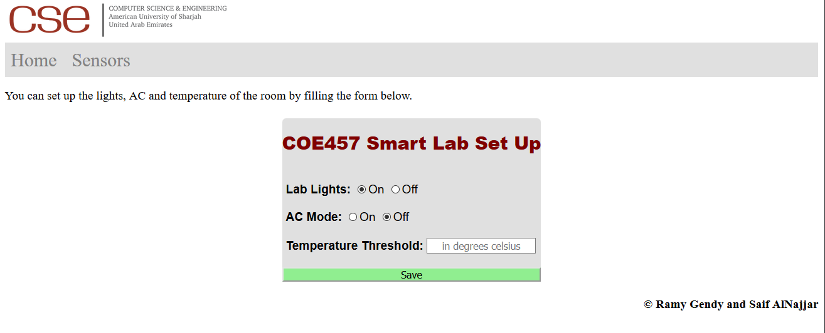

* Paste screenshot of the sensors page in the browser

*Show the hovering over the navigation bar*

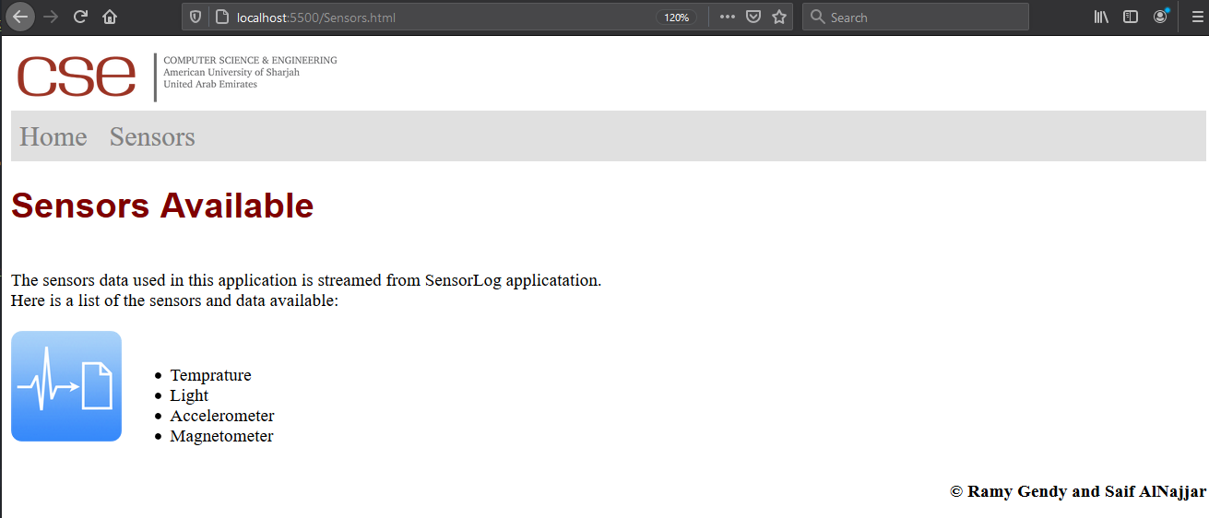

**Exercise 2: CSS**

1. Paste the CSS code.

.navbar {

    width: 100%;

    background-color: #e0e0e0;

  }

  .navbar a {

    padding: 8px;

    text-decoration: none;

    font-size: 25px;

    color: #818181;

    display: inline-block;

  }

  .navbar a:hover {

      color: #FFFFFF;

      background-color: #888888;

  }

.sensorForm {

    width: 100%;

    display: flex;

    justify-content: center;

    font-family: "Arial";

}

.headerSensors {

    font-family: "Arial";

    color: maroon;

}

.bodySensors {

    font-family: "Arial";

    font-size: 14px;

}

form input[type="submit"] {

    background-color: lightgreen;

    width: 100%;

}

.sensorForm label {

    margin-left: 5px;

}

form {

    margin: 5px;

    background-color: #e0e0e0;

    border-radius: 5px;

}

.formHeader {

    font-family: "Arial";

    font-size: 14;

    color: maroon;

}

.sameLineList {

    display:inline-block;

}

.smallImage  {

    height: 100px;

    width: 100px;

    border-radius: 10%;

}

input[type="text"]::placeholder {

    text-align: center;

}

.Footer {

    display: block;

    justify-content: right;

}

.Footer footer {

    display: flex;

    justify-content: right;

}