**Types of IoT Protocols**

1. **Infrastructure** (ex: 6LowPAN, IPv4/IPv6, RPL)
2. **Identification** (ex: EPC, uCode, IPv6, URIs)
3. **Comms / Transport**(ex: Wifi, Bluetooth, LPWAN)
4. **Discovery** (ex: Physical Web, mDNS, DNS-SD)
5. **Data Protocols** (ex: MQTT, CoAP, AMQP, Websocket, Node)
6. **Device Management** (ex: TR-069, OMA-DM)
7. **Semantic** (ex: JSON-LD, Web Thing Model)
8. **Multi-layer Frameworks** (ex: Alljoyn, IoTivity, Weave, Homekit)

**Types of Network topology:**

1. Point to Point (P2P)
2. Star
3. Mesh
4. Hybrid

**Communication / Transport layer**

**Wifi**

1. Characteristics:

* Low power consumption
* Low Range
* High bandwidth

1. Limitation: Wifi coverage is not available in the whole exhibit
2. Protocol Examples:

* ~~802.11a, 802.11b, 802.11g, 802.11n, and 802.11ac~~
* ~~WiFi HaLow (802.11ah)~~
* ~~HEW (802.11ax)~~

**Local RF**

1. Characteristics:

* Low power consumption
* Low Range

1. Limitations:

* Lower bandwidth

1. Protocol Examples:

* Bluetooth (2.4 GHz limitation)
* NFC
* ~~RFID (the zoo used RFID in the exhibit, interference might happen)~~
* Eddystone, BLE

**LPWAN**

1. Definition: LPWAN (Low Powered Wide Area Network) is NOT a standard. It’s a broad term encompassing various implementations and protocols, both proprietary and open-source, that share common characteristics
2. Characteristics:

* Low power: Operates on small, inexpensive batteries for years
* Wide area: Has an operating range that is typically more than 2 km in urban settings

1. Limitations:

* A physical limitation to achieve low power and wide range is small data size. Most LPWAN technologies can only send less than 1,000 bytes of data per day or less than 5,000 bits per second.

1. Applications:

* Dense locations: cities or big buildings for smart lighting, smart grid, and asset tracking
* Long-term monitoring: sensors and meters to be installed and monitored over a long period of time (e.g. water metering, gas detectors, smart agriculture, and remote door locks).

1. Protocol Examples:

* ~~SigFox~~
* ~~LoRa~~
* ~~Symphony Link~~
* ~~Weightless~~
* ~~RPMA~~

**Cellular**

1. Limitations:

* Poor Battery life
* Sunsetting technology (i.e Change from 2G to 3G)
* Expensive

1. Protocol examples:

* ~~2G/3G~~
* ~~LTE-M2~~
* ~~NB-IoT~~
* ~~EC-GSM~~
* ~~5G IoT~~

**LR-WPANs (**IEEE 802.15.4**)**

Definition: technical standard which defines the operation of [low-rate wireless personal area networks](https://en.wikipedia.org/wiki/Personal_area_network) (LR-WPANs)

<https://www.sensorsmag.com/components/what-a-mesh-part-2-networking-architectures-and-protocols>

**ZigBee, 6LowPAN, Wireless HART, MiWi, and ISA 100.11a, Thread, z-wave, SNAP,** [ISA100.11a](https://en.wikipedia.org/wiki/ISA100.11a)

**Other**

**XBee Digimesh, Poin-to multipoint, EnOcean, ANT,**

Frequency range, data rate, power usage, Cost of development +hardware, Compatibility with microcontrollers)

Luis: z-wave, Thread, 6LoWPAN

Nicolle: Wireless HART, Point to Multipoint, EnOcean

Ana: Digimesh, zigbee, SNAP, ANT, ISA 100.11a

Best Protocols for Mesh networking

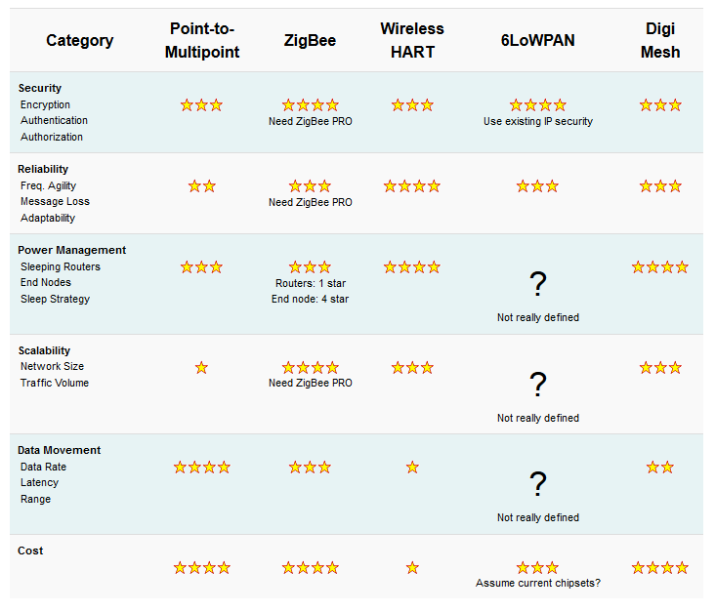

<https://www.digi.com/videos/choosing-the-right-mesh-networking-technology-for>

<https://blog.particle.io/2018/04/28/how-to-build-a-wireless-mesh-network/>

[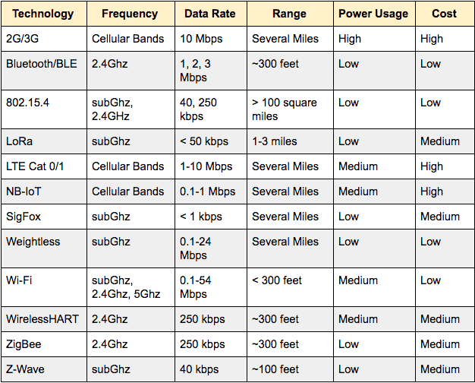](https://www.postscapes.com/wp-content/uploads/2018/03/1_T75ssuHY8ygRiuheqfXJgA.png)

Recommended reading:

<https://www.iotforall.com/free-ebook-iot-connectivity/>

# z-wave:

* Freq:
  + 908Mhz
* Data Rate:
  + 40 kbps
* Cost:
  + Dev: free
    - Open SDK
    - Openzwave
  + Hardware: See below
* Microcontrollers:
  + All:
    - <https://www.amazon.com/Aeotec-Z-Stick-Z-Wave-create-gateway/dp/B00X0AWA6E/ref=as_li_ss_tl?ie=UTF8&qid=1545046930&sr=8-2&keywords=aeotec+z-stick&linkCode=sl1&tag=selfhostedh0c-20&linkId=62d337d4ad771e2dbbdc894e9e48b6e8&language=en_US>
    - **$45**
  + Pi:
    - <https://z-wave.me/products/razberry/>
    - <https://www.zwaveoutlet.com/products/razberry-pi-razberry2-z-wave-plus-daughter-card?variant=32552766023&gclid=CjwKCAjw2cTmBRAVEiwA8YMgzVvnnzu-wmhsA8So5kam_YURt7Y8MipA_Z1cfpJkq4MyG8q12LJrWhoCwH8QAvD_BwE>
    - **$655**
  + Arduino:
    - <http://vi.raptor.ebaydesc.com/ws/eBayISAPI.dll?ViewItemDescV4&item=322243985207&category=162&pm=1&ds=0&t=1526967305000&ver=0>
    - **$12**

# Thred/6LoWPAN:

* Freq:
  + 2.4Ghz
* Data Rate:
  + Up-to 250Kbits/s
* Cost:
  + Hardware:
    - Either free or:
    - https://openlabs.co/store/Raspberry-Pi-802.15.4-radio
      * $10
  + Software
    - I have no clue how to work with this