Let us now configure Jenkins as master and slave for this we want two machine with Jenkins installed

Click on Manage jenkins

then select the Manage nodes

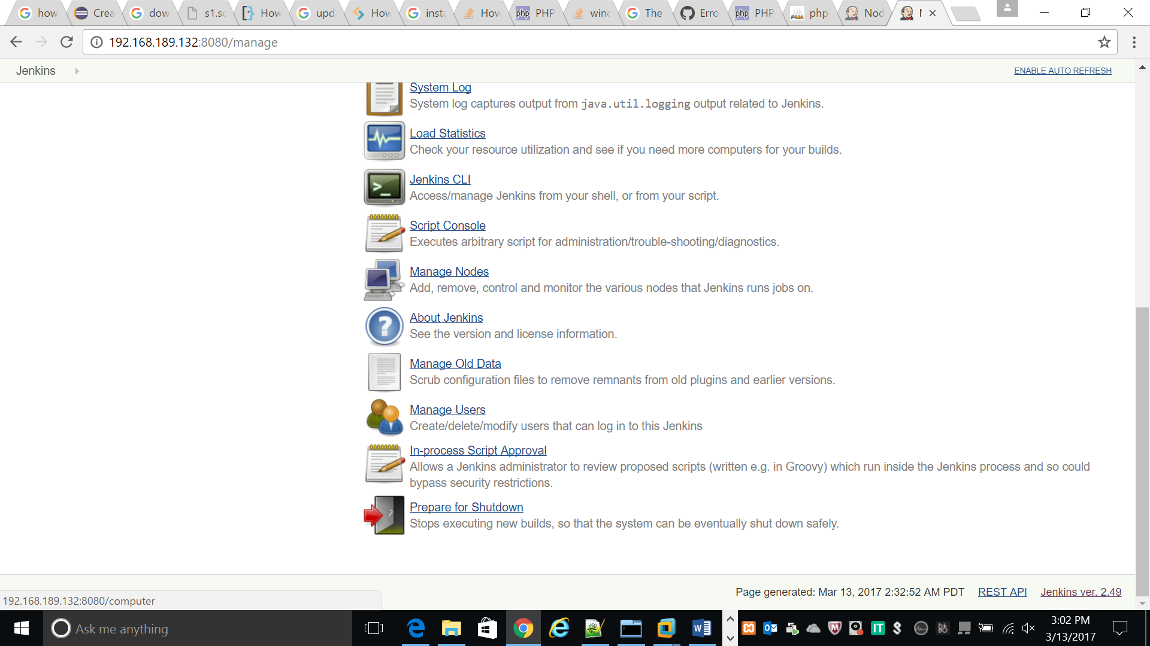

Set name for machine

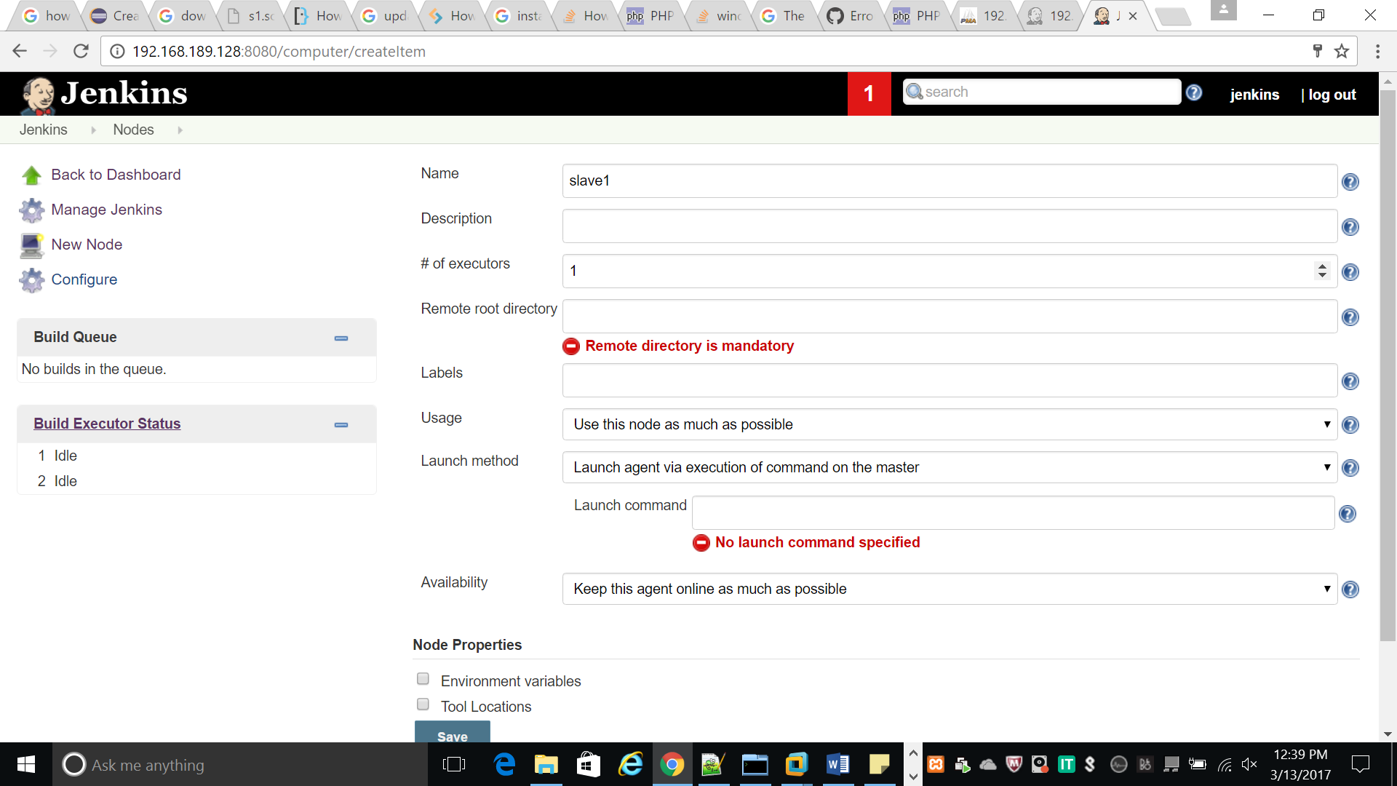

Now set Remote root directory :/var/lib/Jenkins :which is Jenkins remote directory

Launch method : select Launch slave agent via ssh

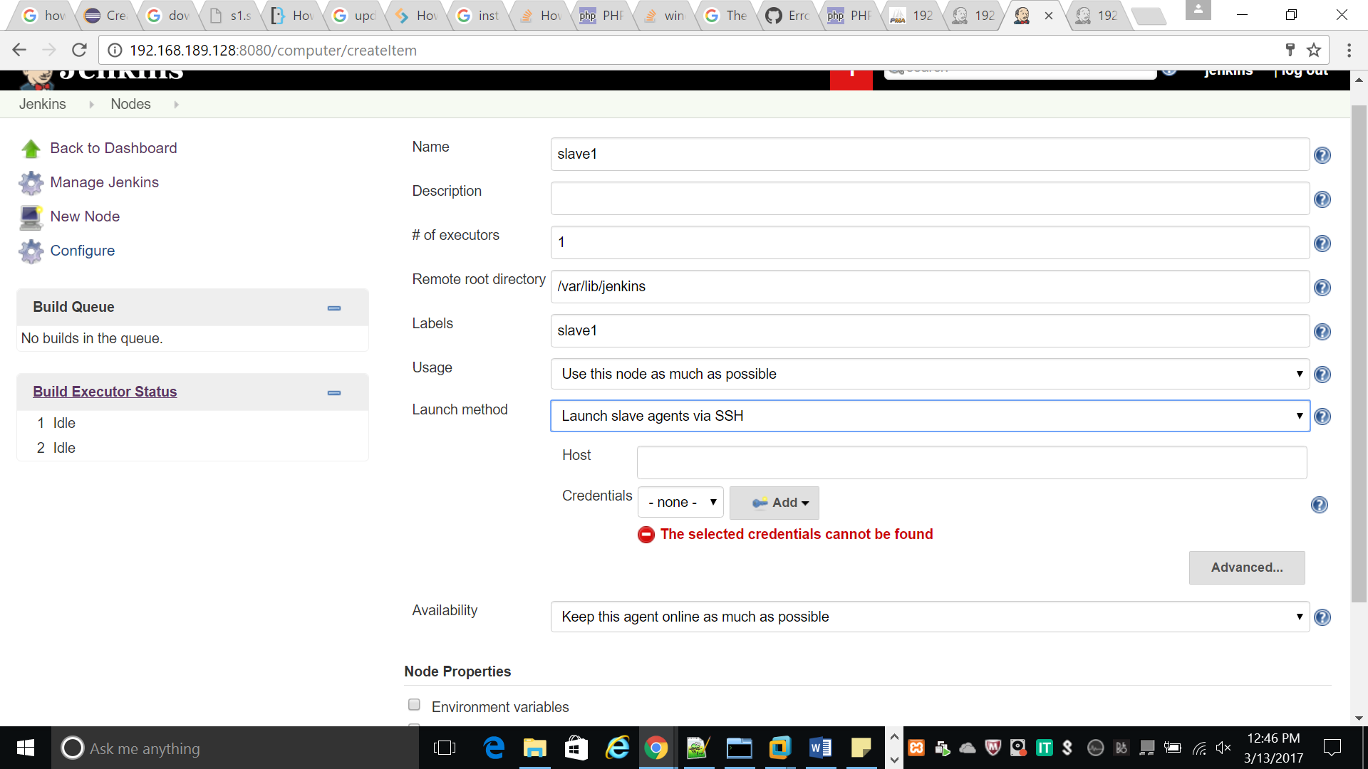

Set the host id of slave i.e slave machine’s ip

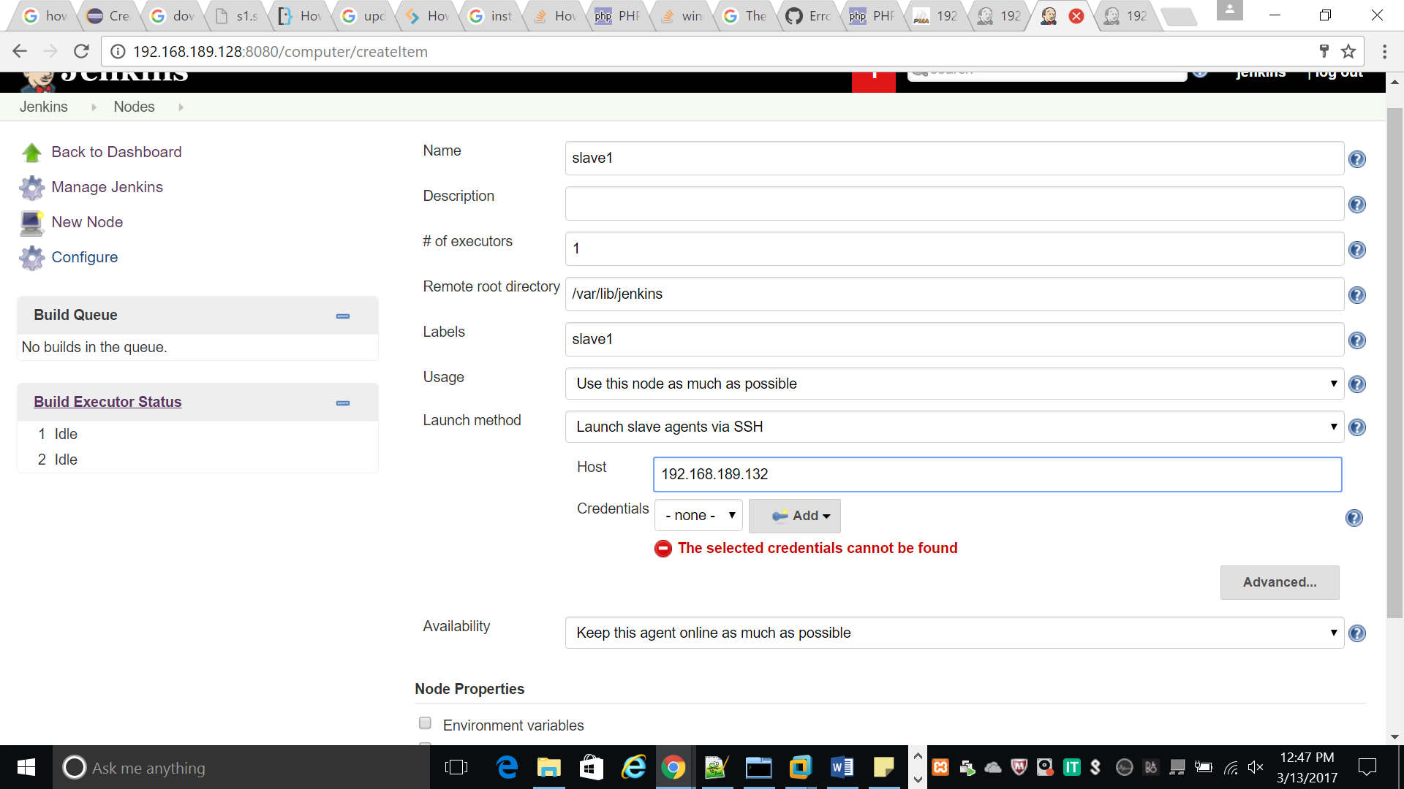

Set the credentials to jenkins

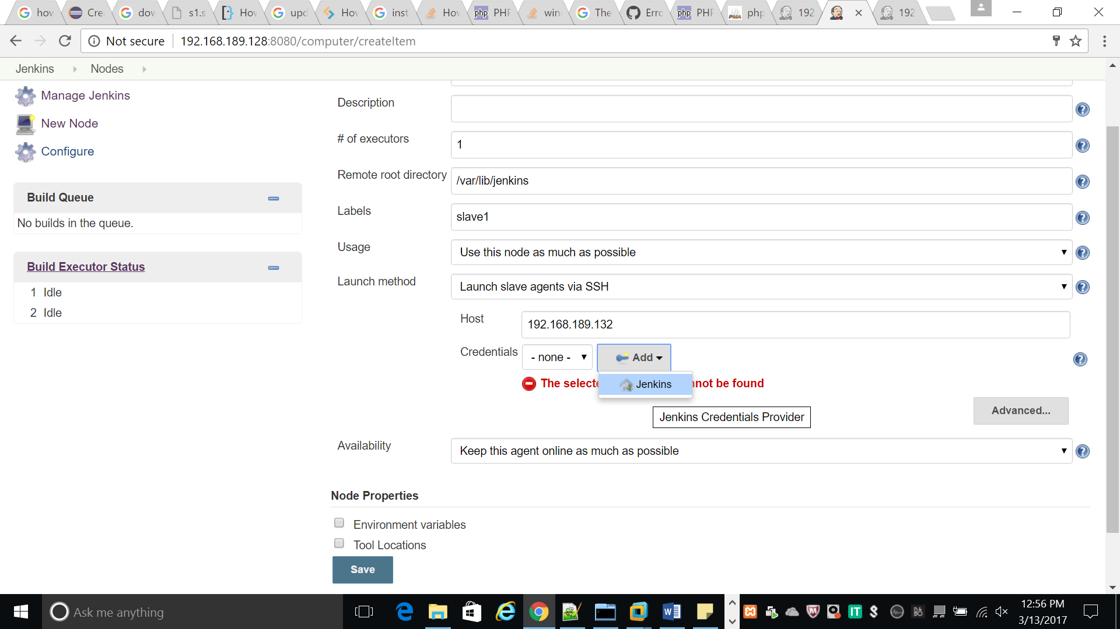

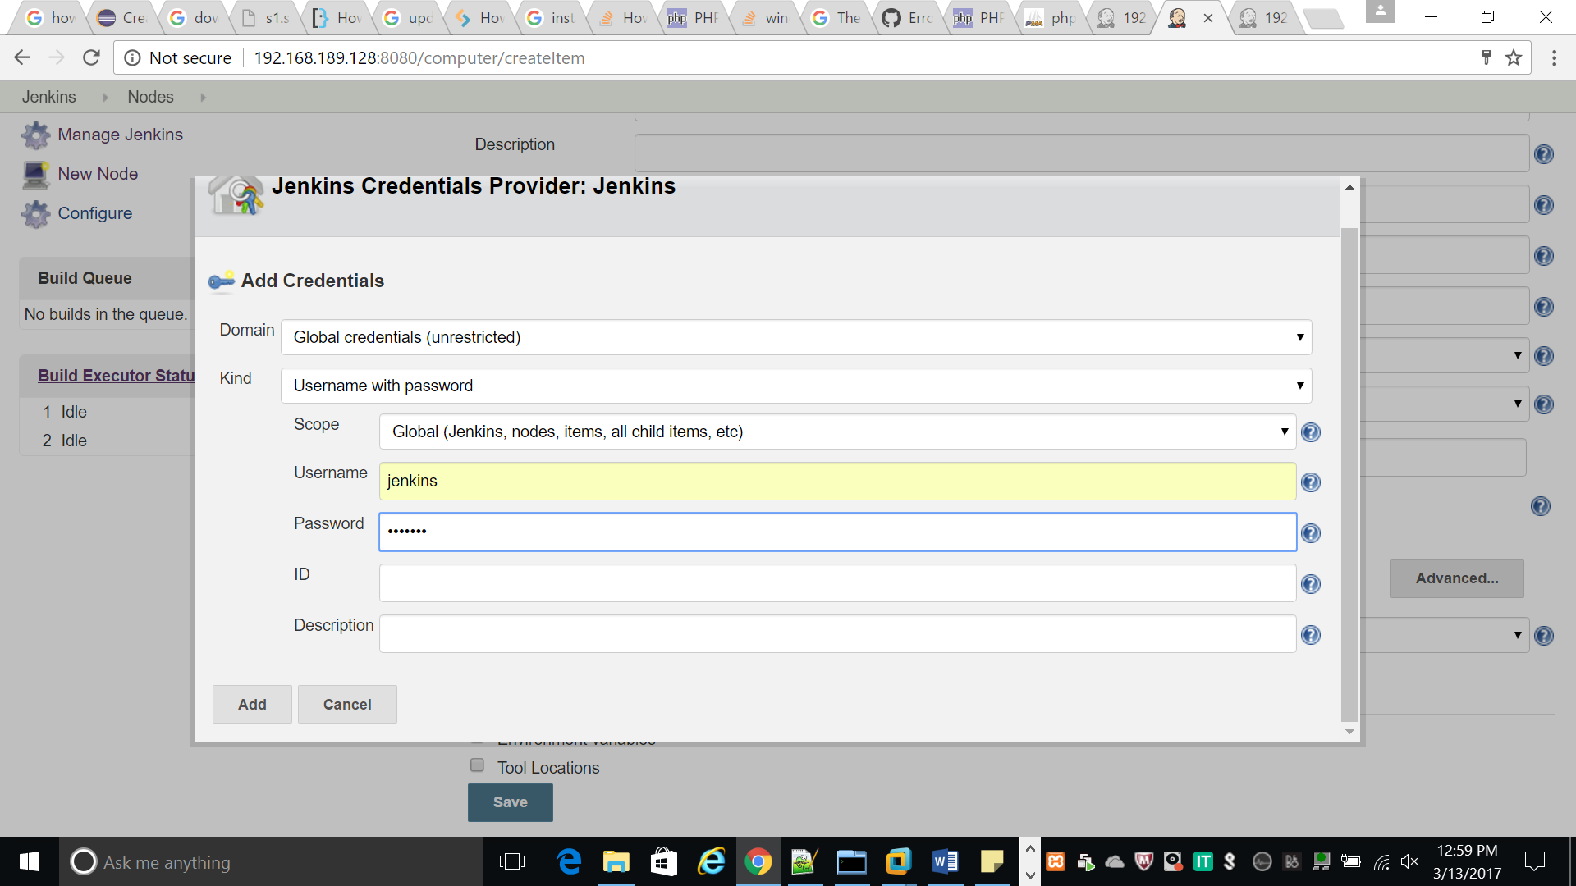

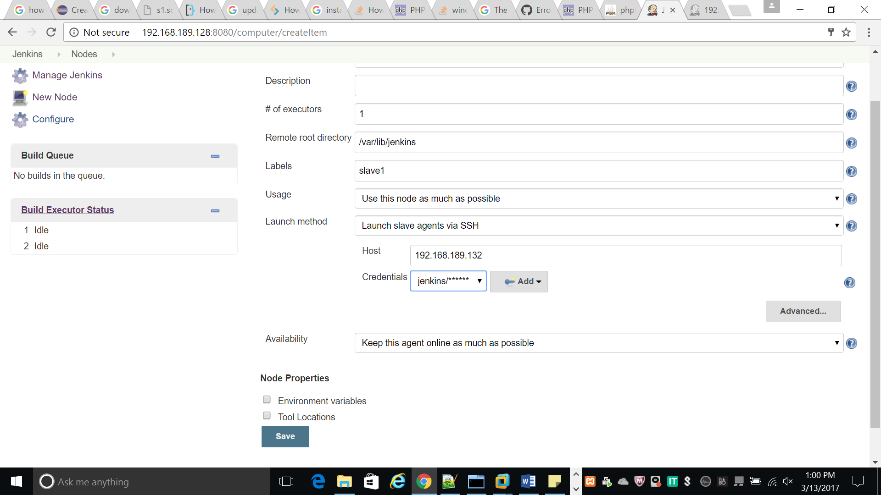

Add credentials as root

