In order to create our own user we do following configuration

Do select

* Manage Jenkins
* Configure global security

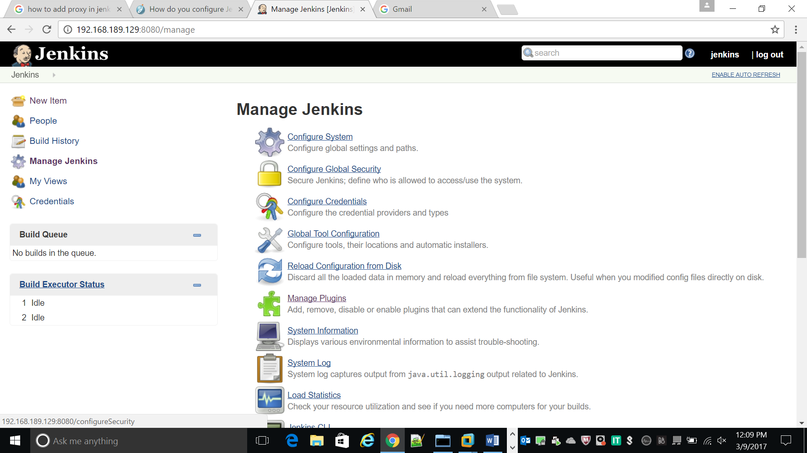

After first we have set the security enable check

In Access control

Check Jenkins own databases

* Check Allow user to sign up

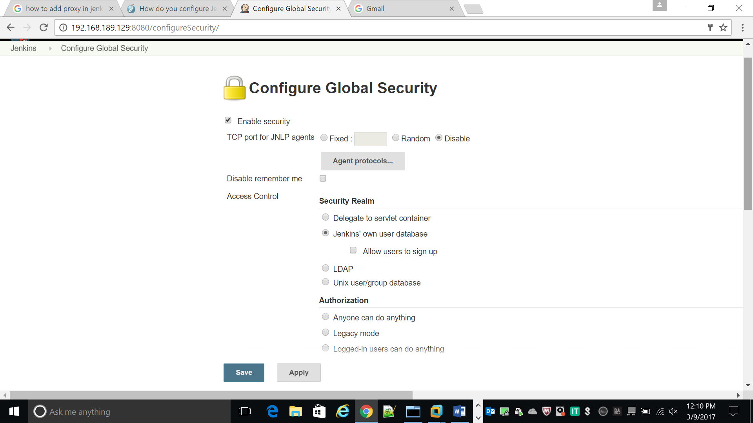

Then in Authorization

Check matrix-based security

And select the permission for each user

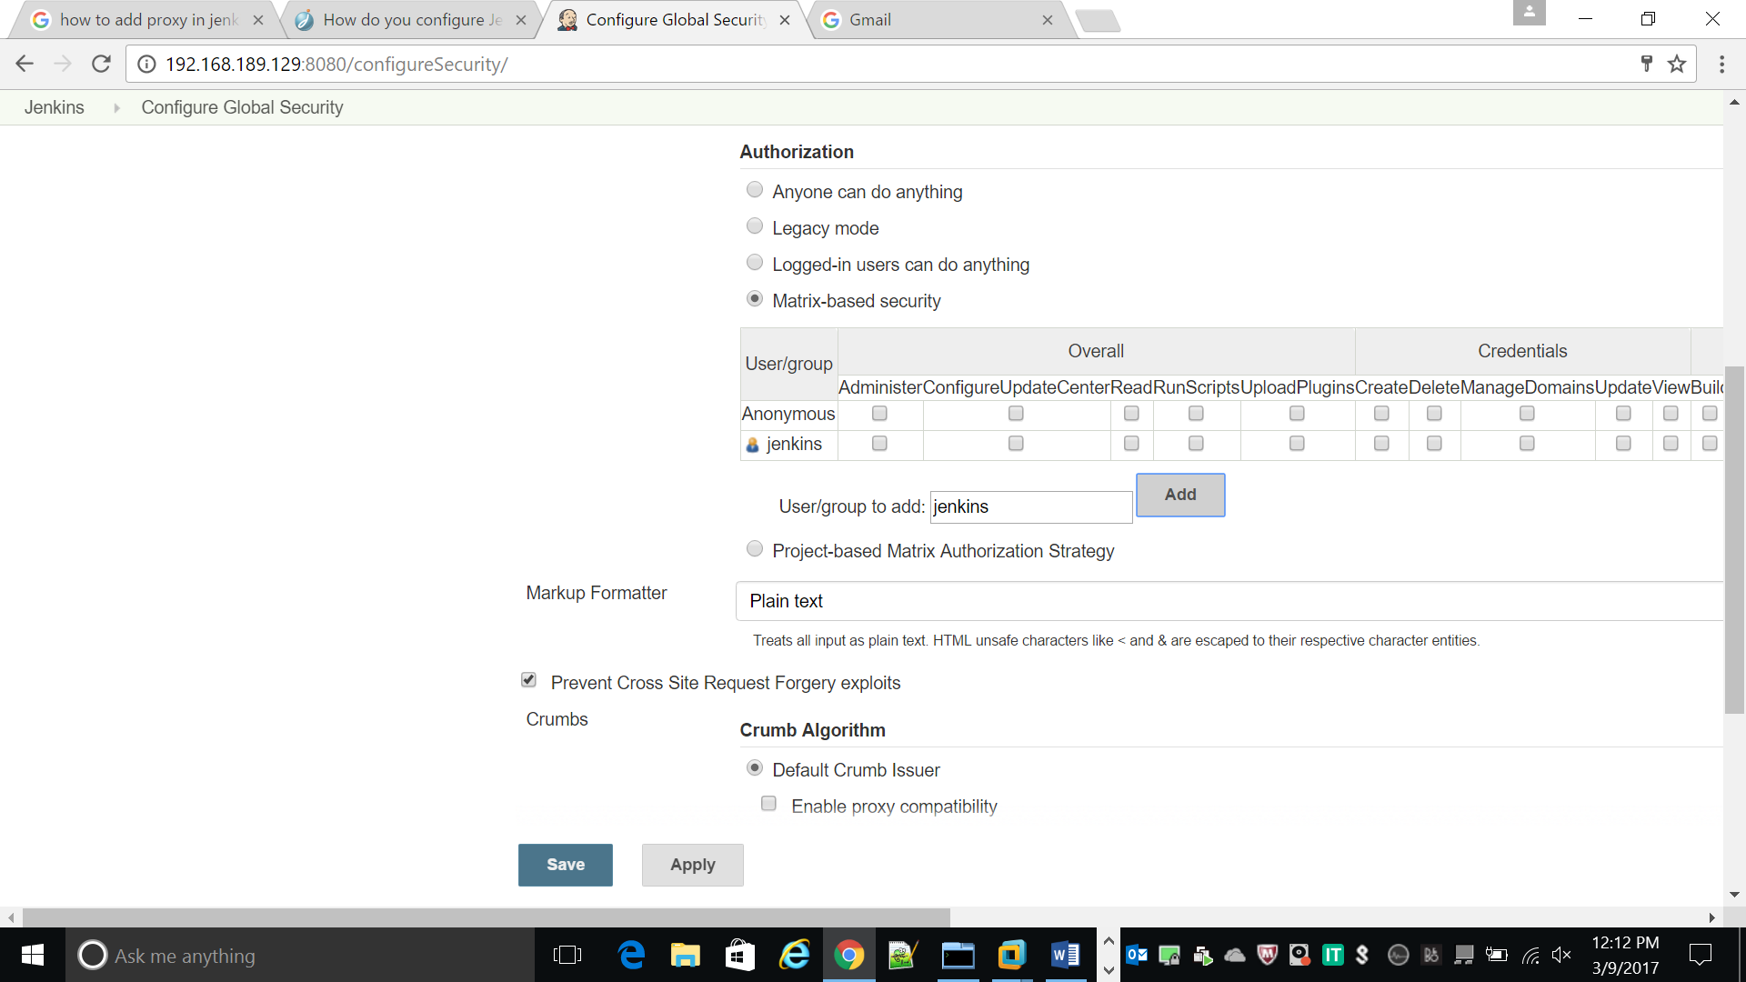

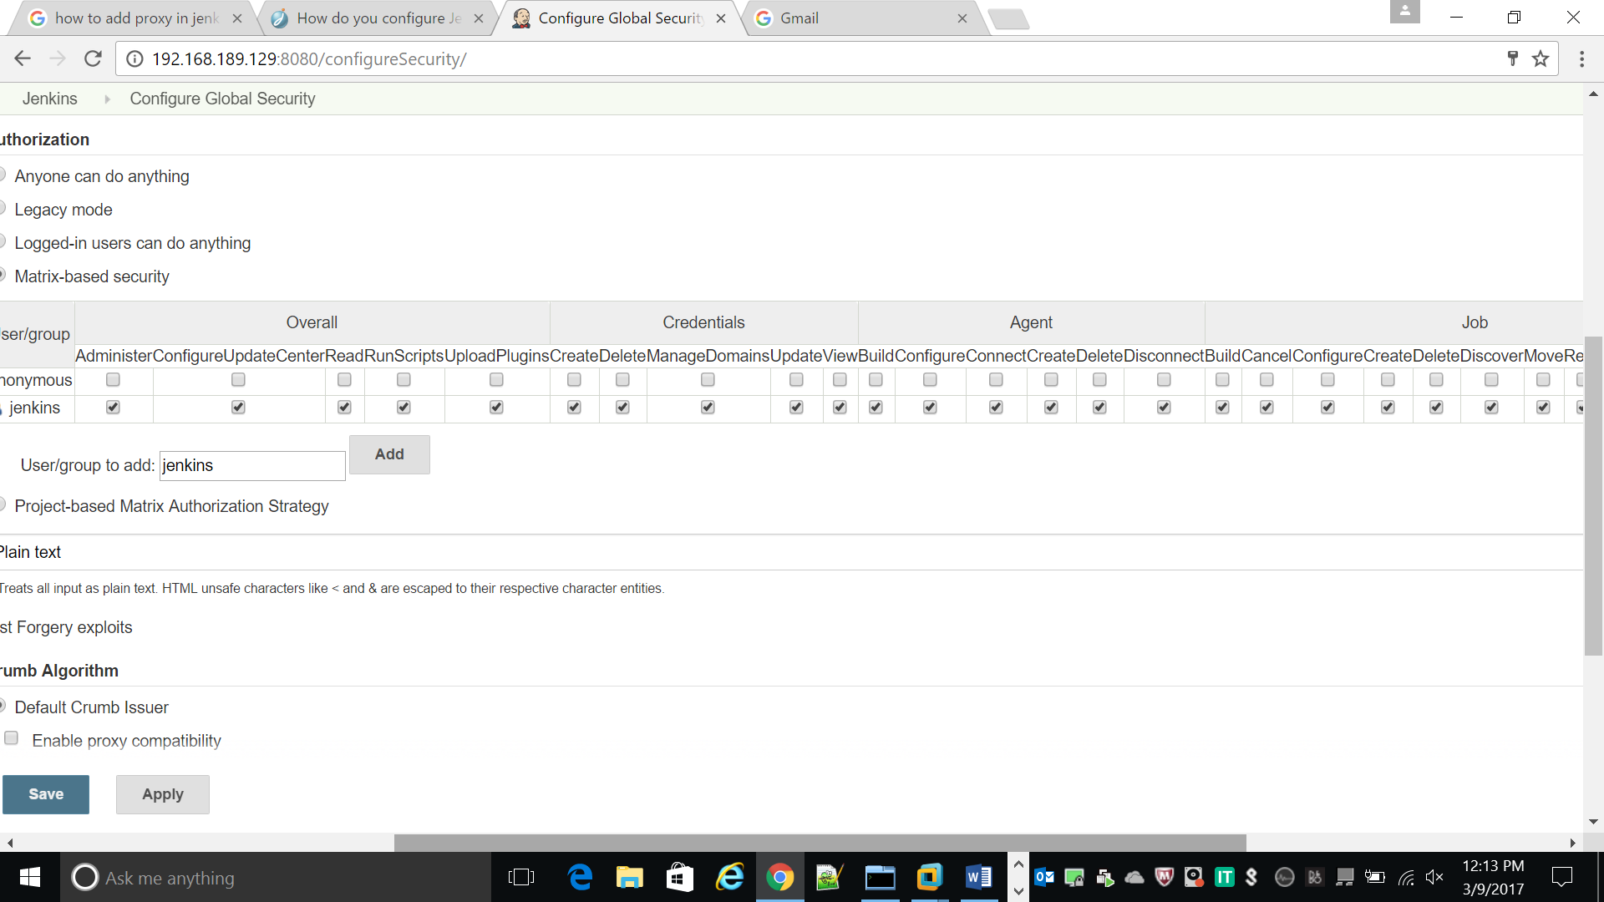

Then click save and apply

After setting this we can get signup option in the right side of window

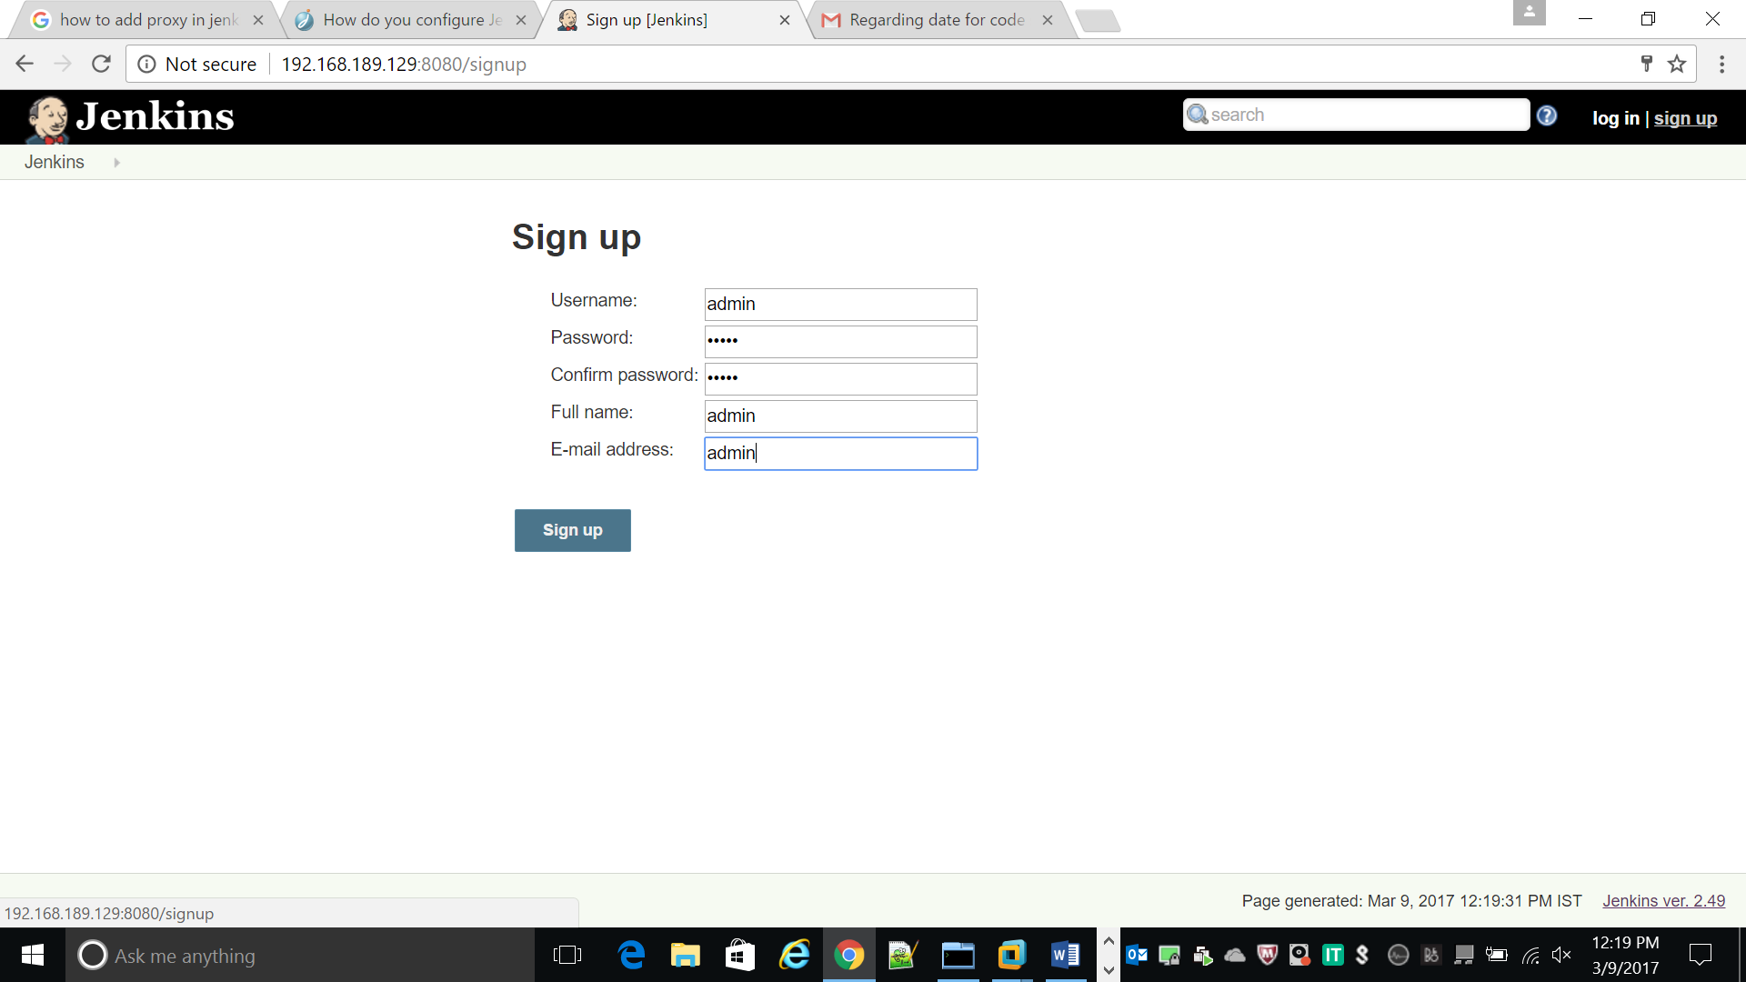

After Goto

asynch people

we can view all user in jenkins

