**Create-A-Thon**

|  |  |
| --- | --- |
| **Team Name** | CODE BREAKERS |
| **Team Members** | 1. KAUSHAL GUPTA  2. YASHIKA NAVIN  3. DHRUV ARYA  4. SHIVANGI  5. SHWETA RAWAT |
| **Theme** | OWN THEME |

**One line pitch of your idea**

BAGGAGE INSPECTION MACHINE WITH ARTIFICIAL INTELLIGENCE

**Problems, WE are solving**

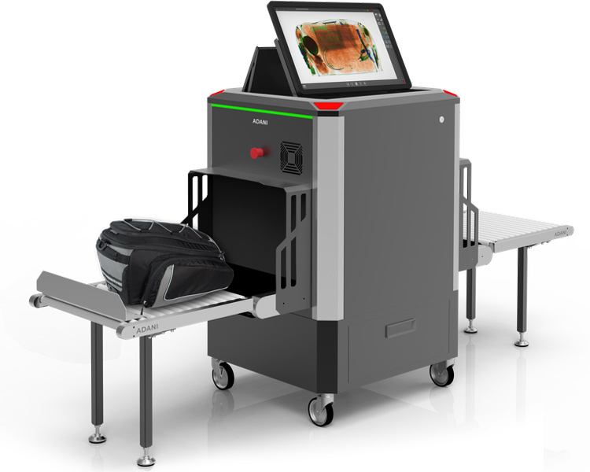

In the ordinary baggage inspection machine, we put the luggage in the machine from one side and the luggage passes through a chamber where X-rays penetrate through the luggage to identify objects inside the luggage and draw their image on the screen . There is a person who recognizes each object inside the luggage which is shown on the screen. So, there may be a chance that the person who is inspecting the screen might misinterpret some items which causes security breach .

Many times it may happen that the inspecting person stops the passengers to show their bags and when he checks the bag manually it doesn’t have any banned item . So it’s just the waste of time and power for inspecting person as well as for passengers . Even sometimes the inspecting person is not able to identify the difference between real and fake items (eg. real or toy gun ) as the human eyes are not so powerful to differentiate between the actual and the fake one.

**Description of Solution/Product provided**

VIDEO

SIGNAL

CONTAINER

DETECOTOR

The working of the machine is similar to the ordinary machine. The luggage is put on one side of the machine and a conveyor belt carries the luggage into the container section where the X-rays passes through the luggage. Then the detector detects the reflected rays from the luggage and projects the items inside the luggage on the screen.

Now, the object recognition code will run to recognize each object in the chamber section and it will map the screen with names of the each item like purse, pen, lipsticks, etc. So, one doesn’t need to put so much effort to understand the objects inside the container chamber. Whenever some suspicious object is identified by machine then it will play an alarm and the moving conveyor belt will stop . So, the luggage is easily captured which consist of any banned item .

**Competitors (Put it simply using SWOT Analysis)**

**Advantages of Baggage inspection machine with Artificial intelligence**

1. It doesn’t need someone to look every time on the screen.
2. It saves the time as it does not need one to look after the machine.
3. It improves the security as compared to ordinary machine.
4. It will automatically recognize any suspicious item.
5. It will ring the alarm if any suspicious item is encountered.

**Disavantages of Baggage inspection machine with Artificial intelligence**

1. Advance Technology Required
2. Difficult to implement
3. Huge installation cost
4. Large Data Set required

**What innovation WE are bringing?**

The baggage inspection machine with AI can be a solution for many day-to-day problems faced by the people in places like metro stations, railway stations, airports, etc. Overall, this machine can help in smooth functioning of the system.