**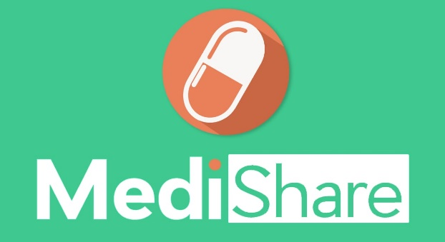*MEDI-SHARE*   
*intuitive platform for Crowdsourcing and sharing of medicine***

**___**

**By team WE_SHARE**

***Introduction :***

During this time of lockdown through out the country, even if medicine stores are kept open still people are not able to reach till medicine stores due to several restriction.

Our idea is to provide a platform where people can procure their important medication ( *like pills for Asthma Patients, thyroid Medicine etc which can get injurious if medication dosage is skipped*) from their **local neighbourhood** without loosing their quarantine.

This will solve another bigger problem of **reducing medical wastage** in our homes. Many a times it has been found that we buy medicines more than the required dosage from the stores(*we buy the whole strip of 20 tablets while we only require a dosage of 15)* and it gets wasted after getting expired. So people can choose to share this extra medicines with the needy and get money in exchange.

So we have planned to create an App (*Medi-Share*) which would help to solve these problems.

**Medi-Share** will be one in all app to keep in track of all your medicine, generously share your extra available dosage and indeed provide a platform to buy those medicine from the local neighbourhood.

This feature rich app will stand helpful not only during this time of the pandemic but also will solve a bigger problem of every household after that by **providing medicine to economically weaker people** at half of the original cost.

Details of the Idea:

1. ***Dashboard to keep in track of all the medication***

Users can instantly add all the medicines available with them by using the QR/BAR Code available on the medicine or merely entering the name. They can mention the number of dosages prescribed by their doctors for the mobile app to prompt the user for taking necessary medication regularly.

The dashboard will contain all the information about their medications to provide a quick information to the users. The app will automatically detect the necessary medicines which the intended user can generously share after their medication dosage is properly completed.

Features will be:

1. Personal memo for all the medication details
2. Reminder notification for taking medicine
3. Showing extra available medicines to share

2. ***Easy Sharing of medicine***

The user can easily select the medicine they will like to share for half of the price by the details prompted by our app.

There will be another option where people can select to share the medicines free of cost.

3. ***Effortless Searching***

Currently we will be using normal database available with us. After this Hackathon we will try to generate dedicated API for Medicine Searching.

With our API’s available it will help the users to select the medicine from search prediction even if they enter the incorrect spelling .

5. ***Proper Verification***

To prevent any kind of illegal distribution of drugs ,the users would need to upload the prescription of the medicine they want which would be verified by registered pharmacists. If prescription is not present then the users can prompt a request to the pharmacists(Except Schedule H Drugs and Narcotics : Prescription is compulsory for them) .

6. ***Intuitive UI*** ***for payment and location sharing***

After the Verification of the prescription, the user would be redirected to the UPI payment gateway, after which the location of the Medicine Host would be discovered. In built Maps API would help the user to conveniently reach the location.

7. ***Completion of dosage***

There are certain antibiotics which needs to be taken as complete dosage. It wont be effective by taking one or two tablets. So our app will help the user to find the complete dosage by linking from more than one seller. (As it is possible that one seller may not be having the required amount of dosage). This will help the person to gather the total medication from their local neighbourhood only.

***BASIC APP DESIGN :***

*The App will have two login option :*

*1. Normal users*

*It will contain all the above-mentioned features.*

*2. Pharma Users*

*It will contain all the above-mentioned features along with another tab where they will get the uploaded prescriptions from different users. They will have to upload their digital signature and verify the prescription.*

*Inside the app the user will have a dashboard where he/she can find all the details of the medicines uploaded (1. Number of dosages remaining, 2. Its expiry date, 3. Reminder option)*

*The user can define the radius for searching of medicine in the locality under the setting option.*

*As the user selects the medicine to buy, the app will prompt to upload the image of the prescription for verification. If the user declines then app will prompt to send a request to the pharmacist for the purchase.*

*After confirmation from the pharmacist the app will redirect to UPI payment gateway (as mentioned above in the details) and the location would be shared after successful payment.*

*Under the purchased dashboard the user will be able to see :*

1. *All the medicines purchased*
2. *Number of dosage available*
3. *Expiry date of the medicines*

***Revenue system***

This App is created for lending a hand to the **economically weaker** section of our society, aiming to provide them medicines at a much cheaper rate than normal medicine store.

Presently we have decided people buying medicine would only need to pay **50%** of the price of the original medicine**(40% to the seller , 10% to the pharmacist)**. If the seller is sharing the medicine for free of cost then the user can purchase it by providing the minimal fee of the Pharmacist (**10 % of the medicine price)**.

*Income Source for many Pharmacists*

Using our app many pharmaceutical persons will get an extra income source by doing a simple task of verifying the prescriptions uploaded by the users.