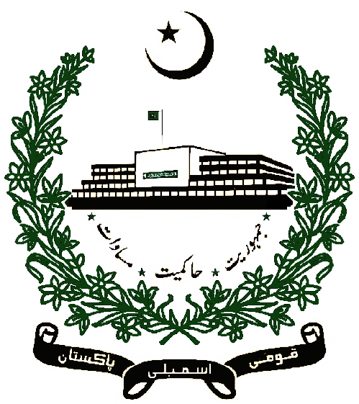

**Book Review, Policy Paper & Internship Report**

**By Muhammad Sufyan Sadiq**

**Intern at The National Assembly of Pakistan**

**Date: 29/07/2025**