SHELFIE
Shelf Compliance Detection — Technical Report
Zero-Shot Prototype Pipeline — Notebook Documentation
· Runtime: Google Colab (GPU)

1. Overview
This document records the full contents, methodology, and results of the shelf compliance detection notebook. The pipeline takes two photographs of the same physical shelf — a reference (planogram) image and a current (query) image — and automatically determines which products are compliant, misplaced, or missing, without any manual auditing.
This is the zero-shot prototype version of the pipeline: every model used (detection and similarity comparison) is a pretrained, off-the-shelf model, used as-is. No training or fine-tuning was performed on the team's own data in this notebook.

1.1 Input images
- Reference image — IMG_5630 (1).jpeg — the organized/expected shelf state
- Query image — IMG_5632.jpeg — the current shelf state to be checked
- Both images: 4032 × 2614 pixels, captured with a handheld camera from slightly different positions

2. Pipeline Stages

2.1 Setup
The notebook installs Ultralytics (YOLO) and imports OpenCV, NumPy, PyTorch, and PIL. GPU availability is detected automatically via torch.cuda.is_available().
!pip install ultralytics -q
import os, cv2, numpy as np, torch
from PIL import Image as PILImage
from ultralytics import YOLO
from IPython.display import Image, display
from google.colab import files
device = "cuda" if torch.cuda.is_available() else "cpu"

2.2 Image upload
The reference and query photos are uploaded interactively through the Colab file picker.
uploaded_ref = files.upload()
real_ref_path = list(uploaded_ref.keys())[0]
uploaded_query = files.upload()
real_query_path = list(uploaded_query.keys())[0]

2.3 Image alignment
Because the two photos were taken by hand from slightly different positions, corresponding products do not sit at the same pixel coordinates in both images. This step corrects that by finding matching visual features between the two photos (ORB keypoint detection) and computing a homography transform that warps the query image onto the reference image's coordinate frame.
def align_images(ref_path, query_path, out_path="query_aligned.jpg"):
ref = cv2.imread(ref_path)
qry = cv2.imread(query_path)
ref_gray = cv2.cvtColor(ref, cv2.COLOR_BGR2GRAY)
qry_gray = cv2.cvtColor(qry, cv2.COLOR_BGR2GRAY)
orb = cv2.ORB_create(5000)
kp1, des1 = orb.detectAndCompute(ref_gray, None)
kp2, des2 = orb.detectAndCompute(qry_gray, None)
bf = cv2.BFMatcher(cv2.NORM_HAMMING)
matches = bf.knnMatch(des1, des2, k=2)
good = [m for m, n in matches if m.distance < 0.75 * n.distance]
src_pts = np.float32([kp1[m.queryIdx].pt for m in good]).reshape(-1, 1, 2)
dst_pts = np.float32([kp2[m.trainIdx].pt for m in good]).reshape(-1, 1, 2)
H, mask = cv2.findHomography(src_pts, dst_pts, cv2.RANSAC, 5.0)
h, w = ref.shape[:2]
aligned_query = cv2.warpPerspective(qry, np.linalg.inv(H), (w, h))
cv2.imwrite(out_path, aligned_query)
return out_path
Result: 812 good keypoint matches were found between the two photos, of which 448 were geometrically consistent ("inliers") and used to compute the alignment transform.
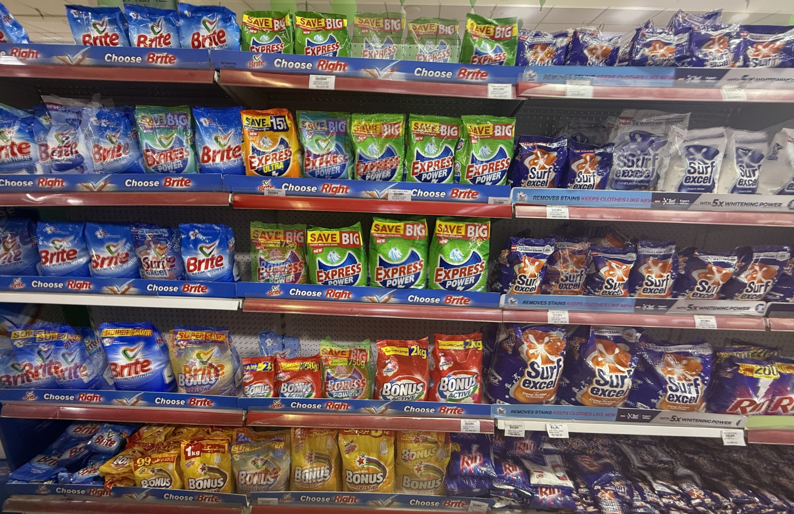
Figure 1 — 50/50 blend of the reference photo and the aligned query photo. Sharp, non-doubled edges confirm the alignment is accurate; only minor ghosting remains at the image edges.

2.4 Product detection
Products are detected on the reference image using YOLOv8-World, a zero-shot object detector. Instead of being trained on the team's own products, it is given plain-text class names at inference time and scores image regions against them.
DETECT_CLASSES = ["bag", "package", "product"]
DETECT_CONF = 0.05
model = YOLO("yolov8s-world.pt")
model.set_classes(DETECT_CLASSES)
results = model(real_ref_path, conf=DETECT_CONF)
ref_boxes = [box.xyxy[0].tolist() for box in results[0].boxes]
Result: 36 product bounding boxes were detected on the reference image at a confidence threshold of 0.05. This low threshold was chosen because narrower, more descriptive class names (e.g. "detergent packet") returned zero detections in earlier testing — short, generic nouns performed far better with this model.

2.5 Similarity comparison
For each detected reference box, the corresponding region in the aligned query image is inspected in two steps:
- Emptiness check — if the pixel intensity variation (standard deviation) in that region is very low, it is treated as an empty slot and marked missing.
- Visual similarity check — otherwise, both crops are converted into numeric embeddings using a pretrained ResNet-18 network, and compared using cosine similarity. A high similarity score means the same product is still there (compliant); a low score means something different is now in that slot (misplaced).
def is_region_empty(crop, std_threshold=15):
gray = cv2.cvtColor(crop, cv2.COLOR_BGR2GRAY)
return gray.std() < std_threshold
def compare_shelves_v3(ref_img_path, query_img_path, ref_boxes,
std_threshold=15, sim_threshold=0.85):
report = {"missing": [], "misplaced": [], "compliant": []}
for rbox in ref_boxes:
x1, y1, x2, y2 = map(int, rbox)
ref_crop = ref_img[y1:y2, x1:x2]
query_crop = query_img[y1:y2, x1:x2]
if is_region_empty(query_crop, std_threshold):
report["missing"].append(rbox); continue
emb_ref, emb_query = get_embedding(ref_crop), get_embedding(query_crop)
sim = cosine_similarity(emb_ref, emb_query)
(report["misplaced"] if sim < sim_threshold else report["compliant"]).append(rbox)
return report
Configuration used for this run: std_threshold = 15, sim_threshold = 0.85.

3. Results
Of the 36 reference product slots detected, the pipeline classified each as follows:
0  Missing | 9  Misplaced | 27  Compliant

This gives a compliance rate of 75% (27 of 36 detected slots). No slots were classified as missing in this run — the query image had a detectable product in every reference slot location; differences found were in product identity (misplaced), not empty shelf space.
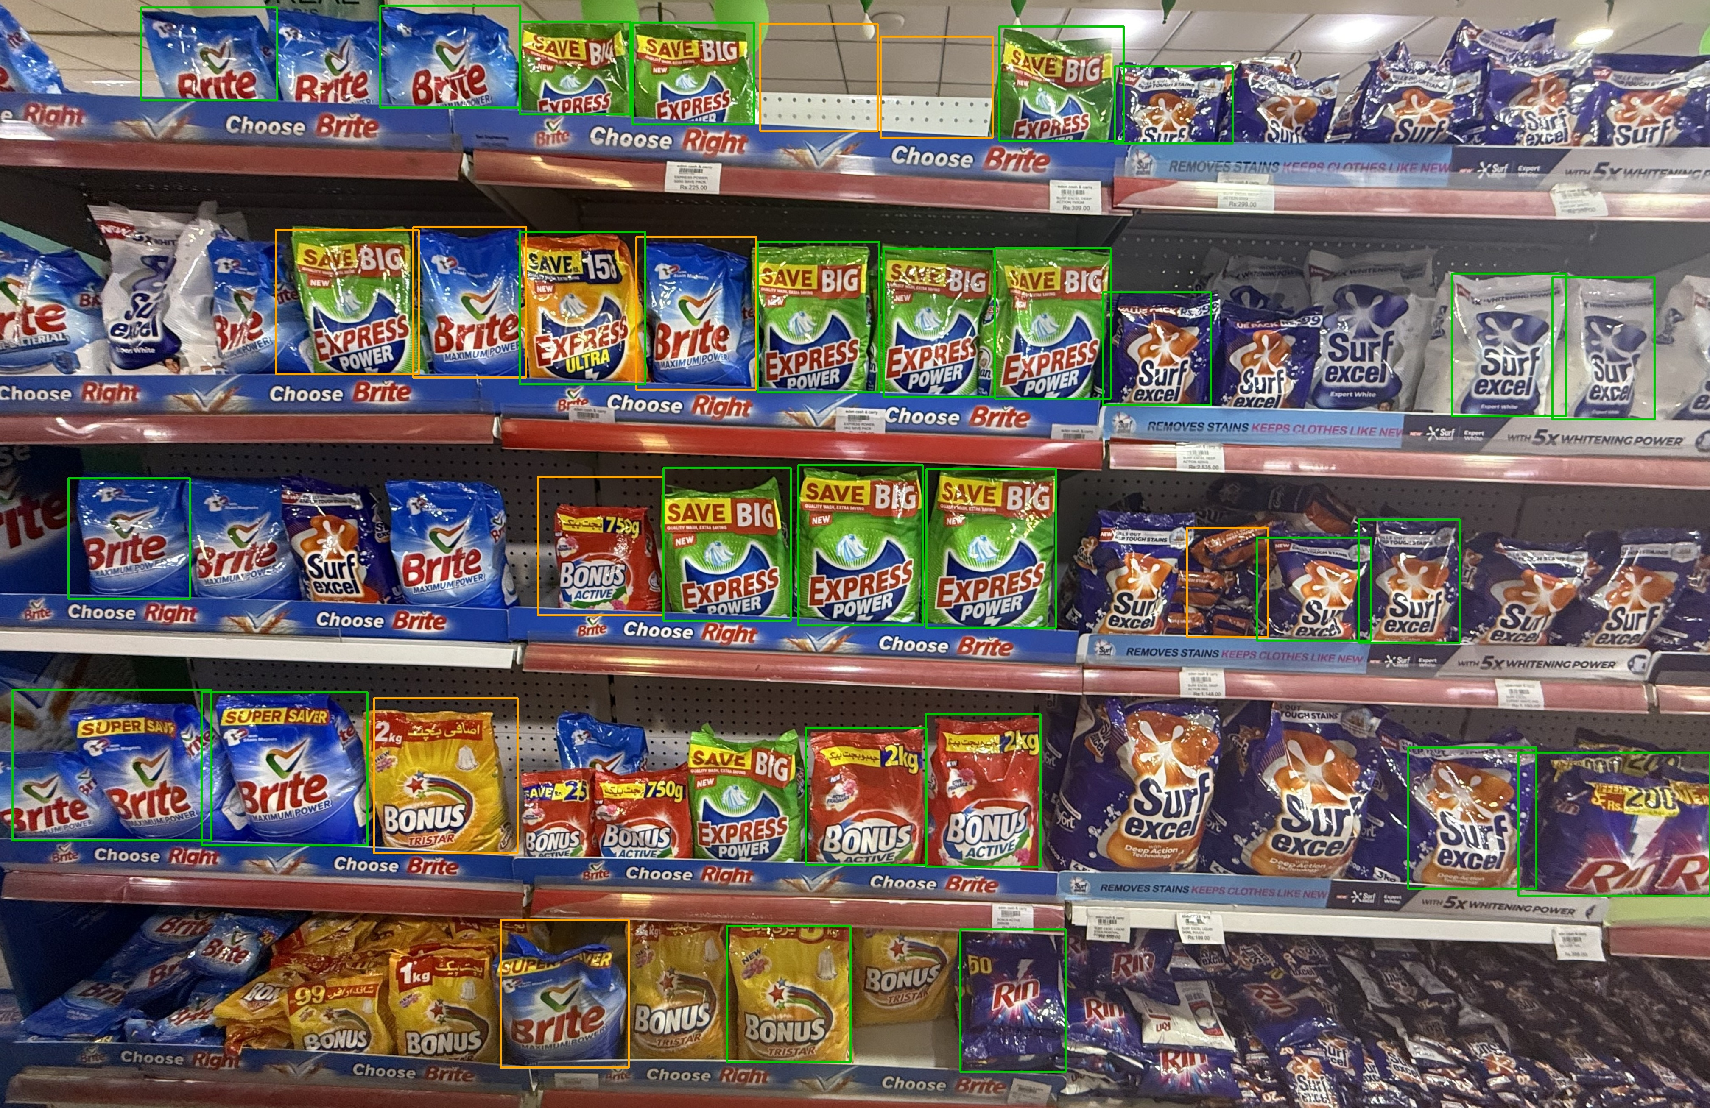
Figure 2 — Final annotated report on the aligned query image. Green = compliant, orange = misplaced, red = missing (none present in this run).

3.1 Interpretation of the misplaced flags
Manual review of the annotated image (Figure 2) identified two distinct causes behind the 9 "misplaced" flags, which is a known limitation of this zero-shot configuration:
- Background false positives — a small number of reference boxes were drawn over bare pegboard/background rather than an actual product, because the detector (at a very low 0.05 confidence threshold) occasionally misread background texture as a "package". These slots cannot meaningfully be "misplaced" since there was no real product there to begin with.
- Alignment/threshold sensitivity — the remaining flags are believed to be visually identical products whose ResNet-18 similarity score fell just under the 0.85 threshold, most likely due to minor blur or pixel shift introduced by the homography warp in the alignment step, rather than a genuine product change.
Both causes point to concrete next steps: filtering reference boxes that sit on low-variation (background) regions before comparison, and loosening the similarity threshold to absorb minor alignment artifacts — both addressed in a later iteration of this pipeline, outside the scope of this notebook.

4. Models and Methods Used
Stage | Model / Method | Role in pipeline
Detection | YOLOv8-World (yolov8s-world.pt) | Zero-shot product detection using text prompts ("bag", "package", "product") — pretrained, not fine-tuned
Alignment | ORB + RANSAC homography | Classical computer vision — matches keypoints between photos and geometrically warps one to match the other
Similarity | ResNet-18 (ImageNet pretrained) | Converts product crops into embeddings for cosine-similarity comparison — pretrained, not fine-tuned
Emptiness check | Pixel standard deviation threshold | Flags visually flat/uniform regions as empty shelf slots

None of these models were trained or fine-tuned on the team's own shelf photos in this notebook. Every result above reflects a zero-shot / off-the-shelf configuration.

5. Limitations and Next Steps
- Tested on a single reference/query image pair — results have not been validated against a larger, independently-labeled test set.
- The 0.05 detection confidence threshold, while necessary to detect all real products, also introduces occasional background false positives that should be filtered before comparison.
- The 0.85 similarity threshold appears sensitive to minor blur/shift introduced by the alignment warp; a review of this threshold is recommended.
- No brand/product-name identification is performed in this notebook — flagged items are located and categorized (missing / misplaced / compliant) but not named.
- Longer-term: fine-tuning a detector on the team's own labeled shelf photos is expected to reduce both false positives and threshold sensitivity, since the model would then recognize the team's actual products rather than generic text prompts.

