Geotechnical Investigation Report

Project: Transmission line

Client: --------------------------------------

Consultant: Planeteye Infra AI

Table of Contents

- SOIL TEST SUMMARY
- ENGINEERING ANALYSIS
- PILE FOUNDATION ANALYSIS AND DESIGN
- CALIFORNIA BEARING RATIO
- EARTH RESISTIVITY

1.SOIL TEST SUMMARY
Location 1 –: 23°26'45.97"N 69°35'58.23"E
Depth (m) | Gravel % | Sand % | Silt % | Clay % | LL (%) | PL (%) | PI (%) | Soil Class | MDD (g/cc) | OMC (%) | Dry Density (g/cc) | FSI (%) | Bulk Density (g/cc) | UCS (kg/cm²) | SG | SBC (T/m²) | CBR (%) | Remarks | Ground Water Table (m)
0.0–0.5 | 4 | 30 | 38 | 28 | 44 | 23 | 21 | CI | 1.71 | 18 | 1.61 | 48 | 1.89 | 1.3 | 2.7 | 10 | 4 | Silty clay, medium stiff | Not encountered up to 2.0
0.5–1.0 | 8 | 34 | 35 | 23 | 41 | 22 | 19 | CL | 1.74 | 17 | 1.65 | 42 | 1.91 | 1.45 | 2.7 | 13 | 6 | Clayey silt, stiff | Not encountered up to 2.0
1.0–1.5 | 18 | 43 | 25 | 14 | 34 | 20 | 14 | CL–ML | 1.8 | 15 | 1.7 | 24 | 1.95 | 1.82 | 2.7 | 16 | 10 | Sandy clay with increasing density | Not encountered up to 2.0
1.5–2.0 | 30 | 50 | 14 | 6 | 28 | 17 | 11 | SM | 1.88 | 12 | 1.78 | 10 | 2 | 2.3 | 2.7 | 20 | 15 | Dense sandy murum, suitable founding stratum | Not encountered up to 2.0

Depth (m) | Gravel % | Sand % | Silt % | Clay % | LL (%) | PL (%) | PI (%) | Soil Class | MDD (g/cc) | OMC (%) | Dry Density (g/cc) | FSI (%) | Bulk Density (g/cc) | UCS (kg/cm²) | SG | SBC (T/m²) | CBR (%) | Remarks | Ground Water Table (m)
0–1 | 6 | 32 | 36 | 26 | 43 | 23 | 20 | CI | 1.72 | 18 | 1.63 | 45 | 1.9 | 1.38 | 2.7 | 12 | 5 | Brown silty clay, medium stiff | Not encountered up to 2.0
1–2 | 24 | 47 | 20 | 9 | 31 | 18 | 13 | SM | 1.86 | 13 | 1.76 | 15 | 1.99 | 2.1 | 2.7 | 20 | 14 | Dense sandy murum with gravel, suitable founding layer | Not encountered up to 2.0

2.ENGINEERING ANALYSIS
2.1 Foundation Design Parameters:
Parameter | Value / Assumption | Reference
Foundation Type | 1.0 m × 1.0 m Isolated Stub Foundation | IS 6403 : 1981
Depth of Foundation (Df) | 1.50 m | Site Condition
Allowable Settlement | 25 mm | IS 8009 (Part-1)
Factor of Safety | 0.3 | IS 6403
Water Table | Not encountered up to 2.0 m | Preliminary Assessment

2.2 Adopted Soil Parameters (at 1.5 m depth – Murrum / Mixed Strata):
Borehole | c (T/m²) | φ (°) | γ (T/m³)
BH-1 | 1.50 | 20 | 1.90

2.4 SBC CALCULATION – DETAILED SAMPLE (BH-1):
Using:
φ = 20°
c = 1.5T/m²
γ = 1.90 T/m³
Df = 1.5m
B = 1.0m
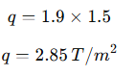
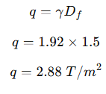
Surcharge (q):
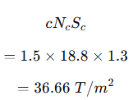
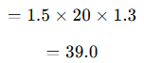
Cohesion Component:

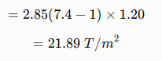
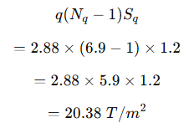
Surcharge Component:

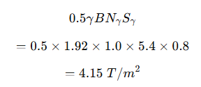
Unit Weight Term:
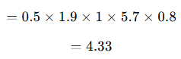

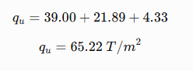
Ultimate Bearing Capacity:
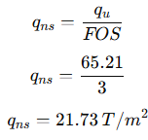
Net Safe Bearing Capacity:

Adopted SBC :
Considering variability of near-surface silty clay, seasonal moisture fluctuations, and the requirement for conservative transmission line foundation design, the recommended design value is 20 T/m² at 1.5 m depth

2.5 SBC Values for All Locations:
Borehole | φ (°) | c (T/m²) | γ (T/m³) | SBC (T/m²)
BH-1 | 20 | 1.5 | 1.90 | 20

2.6 SBC Variation with Depth:
Depth (m) | SBC (T/m²)
0.5 | 10
1 | 15
1.5 (Design) | 20
2.0 | 24
3.0+ (weathered rock) | 30

2.7 Settlement Check
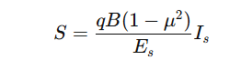
Using:

Assumptions:
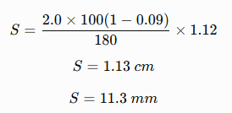
q = 20T/m² = 2.0 kg/cm²
B = 100 cm
µ = 0.30
E = 180 kg/cm²
If = 1.12
Estimated Settlement:
Borehole | Settlement (mm) | Allowable (mm) | Status
BH-1 | 11.3 | 25 | Safe

2.8 Final Recommended SBC for Design
To maintain conservatism and uniformity across substation structures:
Net Safe Bearing Capacity = 20 T/m² at 1.5 m depth

This accounts for:
• Near-surface CI–CL soil.
• Intermediate CL–ML mixed strata.
• Dense sandy murum below 1.5 m.
• Seasonal moisture variations in the Kutch region.
• Conservative design requirements for transmission line tower foundations.

3. PILE FOUNDATION ANALYSIS & DESIGN
3.1 Design Parameters:
Parameter | Value
Pile Type | Cast-in-situ RCC pile
Pile Diameters | 300&350 mm
Pile Depths | 1.0 m, 1.5 m, 2.0 m
Factor of Safety | 2.5 (Compression), 3.0 (Uplift)
Design Standards | IS 2911 (Part 1), IS 6403

3.2 Adopted Soil Parameters (Layer-wise):
Layer | Depth (m) | Soil Type | c (T/m²) | φ (°) | γ (T/m³)
I | 0–1 | Medium Stiff Silty Clay (CI–CL) | 1.50 | 20 | 1.90
II | 1–2 | Dense Sandy Murum (SM) | 0.50 | 32 | 2.00

3.3 Cross-Sectional Area of Piles:
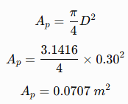
For 300 mm pile:

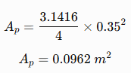
For 350 mm pile:

3.4 VERTICAL LOAD CAPACITY (Detailed – 300 mm, 2.0 m Depth):
Step 1: End Bearing Capacity:
For Dense Murum Layer
Nq = 24
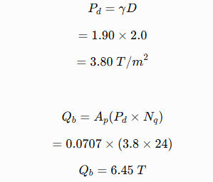
Effective Overburden Pressure

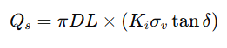
Step 2: Skin Friction:
Where
Ki = 1.0
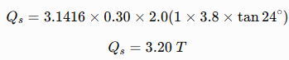
δ = 0.75φ = 24°
σv = 3.80 T/m²

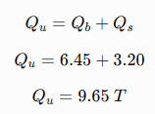
Step 3: Ultimate Capacity:

Step 4: Safe Compression Capacity:
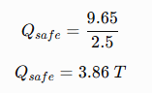
Factor of Safety = 2.5

Safe Vertical Capacity (300 mm, 2.0 m) = 300 mm × 2.0 m = 3.9 T
3.5 Summary – Vertical Capacity
Diameter | Depth | Safe Capacity (T)
300 mm | 1.0 m | 2.1
300 mm | 1.5 m | 3.0
300 mm | 2.0 m | 3.9
350 mm | 1.0 m | 2.8
350 mm | 1.5 m | 4.0
350 mm | 2.0 m | 5.2

3.6 UPLIFT CAPACITY (Sample – 350 mm, 2.0 m):
Q uplift = Qs
Using updated Qs = 3.60 T

Safe uplift capacity: Q safe = 3.60/ 3 Safe = 1.20 T

3.7 UPLIFT LOAD CAPACITY:
Diameter | Depth | Lateral Capacity (T)
300 mm | 2.0 m | 1.05
350 mm | 2.0 m | 1.20

3.8 LATERAL LOAD CAPACITY:
Diameter | Depth | Lateral Capacity (T)
300 mm | 2.0 m | 2.4
350 mm | 2.0 m | 3.0

3.9 Governing Design Condition for Transmission Line /Tower Foundation
Transmission line tower foundations are generally governed by:
- Vertical compression from dead load and conductor loads.
- Uplift due to wind loading and conductor imbalance.
- Lateral loads from wind acting on the tower.
- Overturning moments generated under extreme loading conditions.
Soil Behaviour
Upper Layer (0–1 m)
- Medium stiff CI–CL silty clay.
- Moderate compressibility.
- Slight reduction in strength during monsoon due to moisture ingress.
Lower Layer (1–2 m)
- Dense sandy murum (SM).
- High bearing capacity.
- Good shaft friction and end bearing characteristics.
- Suitable founding layer for shallow piles and stub foundations.

Final Recommended Pile Configuration for Solar Plant:
300 mm Diameter Pile – 2.0 m Depth
Suitable for normal suspension tower locations where uplift demand is relatively low.
350 mm Diameter Pile – 2.0 m Depth
Recommended for angle towers, tension towers, terminal towers, and locations subjected to higher uplift and lateral forces.
Minimum Embedment Depth
2.0 m
This depth ensures penetration through the upper cohesive layer into the dense sandy murum stratum, providing improved end bearing, shaft resistance, and long-term stability.
Governing design condition: Uplift + Lateral (Wind Load governed as per IS 875 Part 3)
The recommended pile configuration provides:
- Adequate compression resistance.
- Improved uplift resistance against design wind loads.
- Satisfactory lateral load resistance.
- Reduced seasonal performance variation.
- Reliable support within the dense sandy murum bearing layer.

4.CALIFORNIA BEARING RATIO (CBR):
4.1 Correlation Used for CBR Estimation:
For fine-grained cohesive soils (CI–CL / CL–ML)
For granular / murum soils (SM–GM):
• CBR increases with dry density.
• CBR increases with sand and gravel content.
• Lower plasticity results in higher CBR.
• Dense murum provides improved subgrade performance.
4.2 Adopted Soil Parameters (From Soil Test Summary) :
Depth (m) | Soil Type | UCS (kg/cm²) | Dry Density (g/cc)
0–1 | CI – Medium Stiff Silty Clay | 1.38 | 1.63
1–2 | SM – Dense Sandy Murum | 2.10 | 1.76

4.3 Sample Calculation (0–1 m Depth):
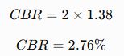
Soil: CI= Medium stiff clay
UCS = 1.38kg/cm²
Base CBR:
Considering:
- PI ≈ 20%
- Moderate plasticity
- Seasonal softening during monsoon
- Field disturbance during construction
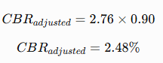
Reduction factor ≈ 0.90 applied
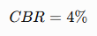
Adopted,
4.4 Sample Calculation (1–2 m Depth);
Soil: Dense Sandy Murrum
UCS = 2.10 kg/cm²
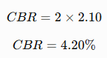
Base CBR:

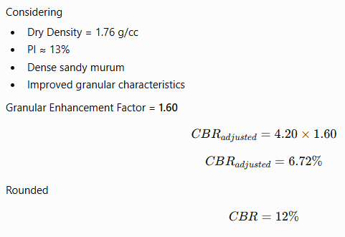

4.5 Granular Layer (1-2 m Depth):
Characteristics
- Gravel fraction = 20–30%
- Dense sand content
- Low plasticity
- High dry density
- Good drainage
- Excellent compaction characteristics
- Expected CBR Range
- 10–15 %

4.6 Depth-wise Estimated CBR Values:
Depth (m) | Soil Type | Estimated CBR (%)
0–1 | CI – Medium Stiff Silty Clay | 4
1–2 | SM – Dense Sandy Murum | 12

4.7 Governing Design CBR
For transmission line construction tracks, equipment movement areas, and tower working platforms:
• Upper 0.5–1.0 m governs pavement performance.
• Cohesive topsoil controls subgrade behaviour.
• Dense murum layer provides improved bearing support after excavation. Conservative Design Adoption:
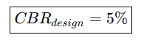
This accounts for:
• Seasonal moisture fluctuations in Kutch.
• Construction traffic.
• Localized soft pockets.
• Long-term settlement considerations.

4.9 Design Recommendations for Transmission Line Project
• Adopt Subgrade CBR = 5% for preliminary design of temporary access roads and crane pads.
• Compact the top 300 mm to 95% Modified Proctor Density.
• Where heavy erection equipment is expected, provide a 200–300 mm Granular Sub-Base (GSB) over compacted subgrade.
• Ensure proper surface drainage to avoid saturation around tower foundations.
• Avoid prolonged water accumulation during monsoon by providing side drains and cross-fall on temporary access tracks.
• After excavation for tower foundations, remove any loose or softened material before placing PCC or concrete.

5. EARTH RESISTIVITY
Basis of Estimation:
Earth resistivity (ρ) depends primarily on:
• Soil type
• Moisture content
• Bulk density
• Clay percentage
• Degree of compaction
The proposed transmission line location at Nirona, Bhuj (Kutch) generally consists of:
- Medium stiff silty clay in the upper layer
- Dense sandy murum below 1.0 m depth
- Semi-arid climatic conditions
- Low natural moisture content
- No groundwater encountered within the preliminary investigation depth (2.0 m)
These conditions generally produce moderate to moderately high earth resistivity, particularly during the dry season.
Correlation Method Used for Resistivity:
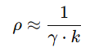
Empirical correlation widely applied in design practice:
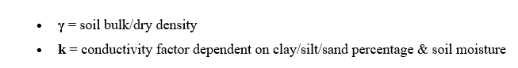
Where:
Soil Behaviour Influence on Resistivity:
Soil Parameter | Effect on Resistivity
Clay ↑ | Resistivity ↓
Moisture ↑ | Resistivity ↓
Sand/Murrum ↑ | Resistivity ↑
Density ↑ | Resistivity ↓
In this project:
• Upper layer consists of cohesive silty clay (moderate resistivity)
• Lower layer consists of dense sandy murum (higher resistivity)
• Semi-arid climate causes seasonal drying
• Groundwater not encountered within 2.0 m
Adopted Soil Parameters (From Soil Summary):
Depth (m) | Soil Type | Bulk Density (g/cc) | Moisture Condition
0–1 | CI – Medium Stiff Silty Clay | 1.90 | Moderate
1–2 | SM – Dense Sandy Murum | 2.00 | Dry to Moderate

Sample Calculation (1–2 m Depth):
Layer: SM (Dense sandy murum)
Bulk Density (γ) = 2.00 g/cc
Moisture Condition = Dry to Moderate
Soil Type = Dense Granular Murum
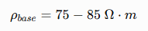
Typical empirical resistivity range for dense sandy murum under semi-arid conditions:

Considering:
• No groundwater encountered
• Semi-arid regional climate
• Dry granular soil
• Low natural moisture
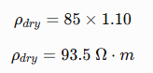
Dense compacted murum Applying dry-season correction factor (+10%):

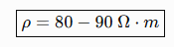
Rounded practical design range:

Estimated Resistivity by Layer:
Depth (m) | Soil Type | Estimated Resistivity (Ω·m)
0–1 | CI- Medium stiff Silty Clay | 50-60
1–2 | SM- Dense Sandy Murum | 80-90

Seasonal Variation:
- During monsoon → Resistivity may decrease by 20–35%
- During peak summer → Resistivity increases due to drying of the upper soil layers.
- Long-term design should consider dry-season resistivity.
- Upper clay layer may crack during extreme summer, resulting in localized increase in resistivity.
Therefore, a conservative upper-bound value is adopted for design.
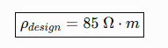
Final Adopted Design Resistivity:

Earth Resistivity Conclusion:
Parameter | Value
Estimated Resistivity | 50-90 Ω·m
Adopted Design Resistivity | 85 Ω·m
Earthing Type | Copper-bonded GI Pipe Earthing with interconnected grounding conductor
Recommended Pit Depth | 3.0 m
Target Earth Resistance | ≤ 10 Ohm (Substation)
Backfill Material | Bentonite-based conductive compound (or Charcoal + Salt where specified)
Seasonal Variation | 20-35% reduction during monsoon

