Data Visualisation with Google Fusion Tables

Workshop Exercises

Dr Luc Small | 12 April 2017 | 1.5

1. Introduction

Google Fusion Tables is shaping up to be a powerful and accessible data visualisation tool. While still in "beta", this cloud-based application has a useful feature set that is destined to grow with time.

In this exercise we use Google Fusion Tables to create a "heat map" of NSW highlighting crime hotspots. In order to accomplish this we will draw in and combine data from two sources.

The first is a comma-separated-values (CSV) file containing crime statistics for all Local Government Areas (LGAs) in NSW. The 152 LGAs in NSW are variously referred to as shires, councils, cities, etc. You can read all about them here:

* <http://en.wikipedia.org/wiki/Local_government_areas_of_New_South_Wales>

The crime statistics, meanwhile, can be obtained here:

* <http://www.bocsar.nsw.gov.au/Pages/bocsar_crime_stats/bocsar_onlinedatatools.aspx>

The second data source is a keyhole mark-up language (KML) file that describes the boundaries of all the LGAs in NSW using geospatial coordinates. This dataset is available here:

* <http://www.tallyroom.com.au/maps>

Once combined in Fusion Tables, we'll be able to generate visualisations like this:

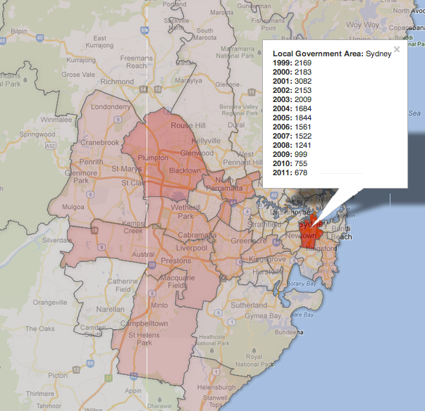

1. Download your datasets

The first step is to download a copy of the datasets you'll need for the exercise.

First grab the LGA boundaries KML file by following this link:

* <http://bit.ly/Ntvncs>

Save the downloaded file to a convenient location, such as your Desktop.

The file is zipped to speed up the download, so double-click on the file to extract it.

You should now have a file at your chosen location (say the Desktop) called:

* AUS-NSW-LGA-2012.kml

Next, visit the "Specific Crime Information Tool" provided by the NSW Government by following this link:

* <http://bit.ly/J47gkw>

Select the "Region by Year" radio-box and click "Go to Step 2 >":

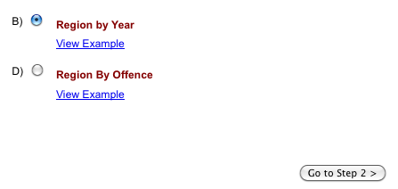

Next, select an "Offence Type" that you're interested in seeing on the "heat map" and click "Go to Step 3>":

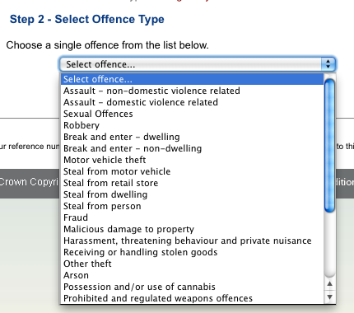

Finally, select "* All premises types *" from the "Premises Type" dropdown list and click "Show Results":

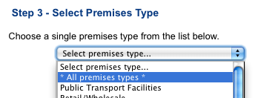

Crime statistics will be displayed for all LGAs for the selected offence type:

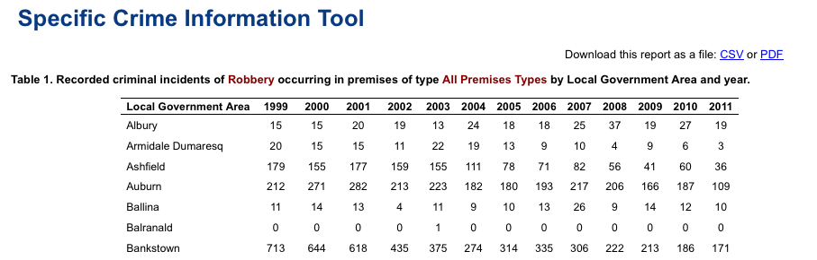

Click on the "Download this report as a file: CSV" link and save the file to a convenient location, such as the desktop. Note down the name of the file for future reference. You now have the two datasets you need to complete the exercise.

1. Clean up your data with Excel

The downloaded crime statistics CSV file contains some extraneous information that we need to remove.

Launch Excel and open the crime statistics CSV file.

There is some textual information in the CSV file, before the table of data begins. These lines need to be deleted. Start by locating the line that begins with "Local Government Area", in this case it is line 9. Delete all the lines above it:

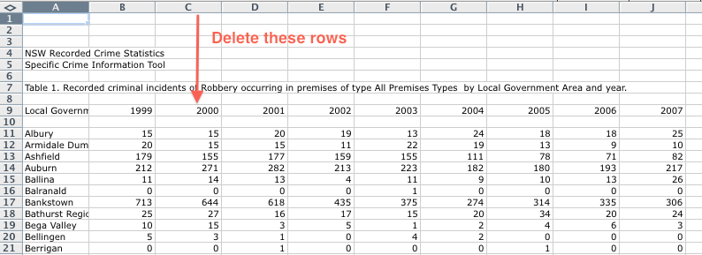

The spreadsheet will now look like this:

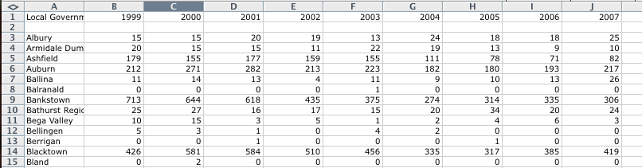

The next step is to delete the blank line between the first row (the "header row") and the third:

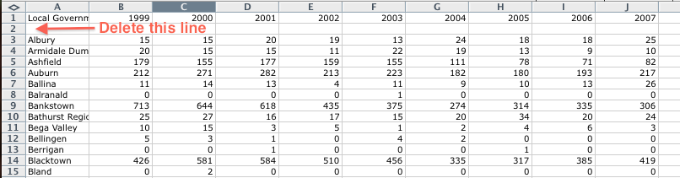

The spreadsheet will now look like this:

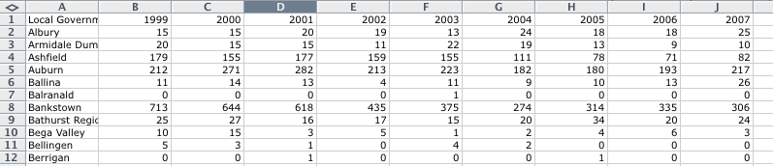

Now scroll to the bottom of the spreadsheet and delete all the lines from the line beginning "Total" to the end of the file:

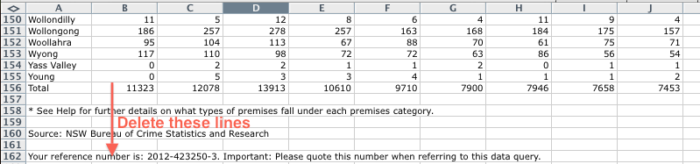

The spreadsheet will now look like this:

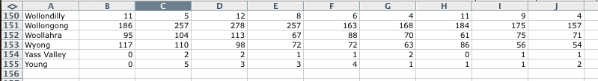

Save the updated CSV file and quit Excel.

1. Sign into Google Drive

You need a Google Account in order to use Fusion Tables. If you don't already have one, you can create one here:

* <https://accounts.google.com/NewAccount>

The next step is to sign into Google Drive by browsing to:

* <https://drive.google.com/>

And logging into your Google Account.

Once you're logged into Google Drive, the interface should look similar to this:

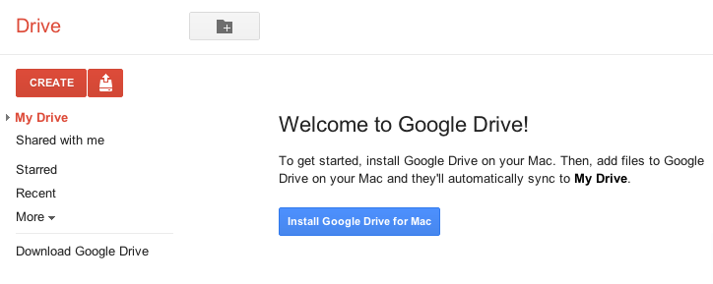

1. Importing the LGA boundaries

Start by clicking on the "Create" button, then mouse over "More" and select the "Fusion Table" option:

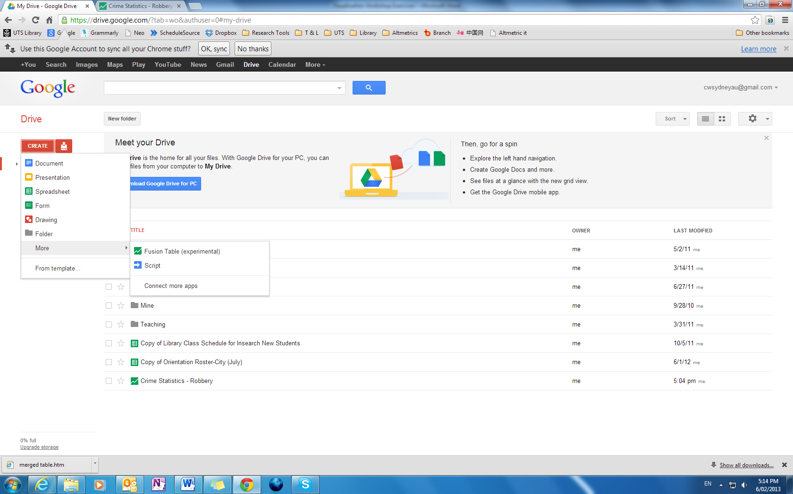

The first screen will ask you to Import a table:

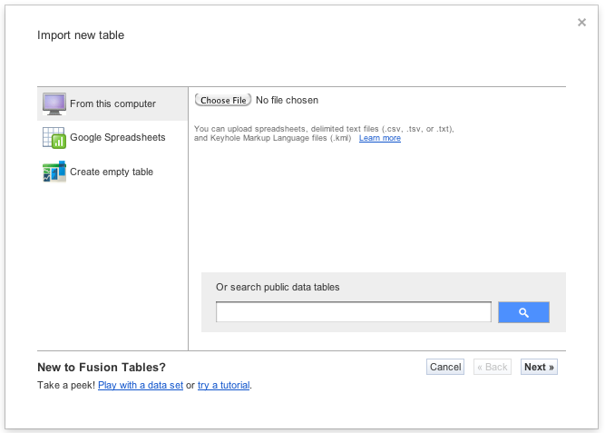

Ensure "From this computer" is selected and then click the "Choose File" button. In the dialog box that appears, browse to the folder containing the "AUS-NSW-LGA-2012.kml" (e.g. the Desktop) and select the file, and close off the dialog box. The screen should now look like this:

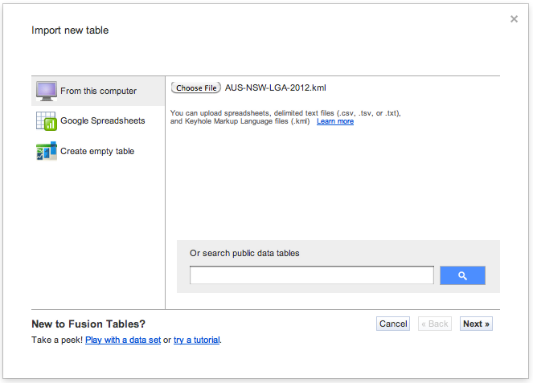

Click the "Next >>" button.

The next screen will look like this:

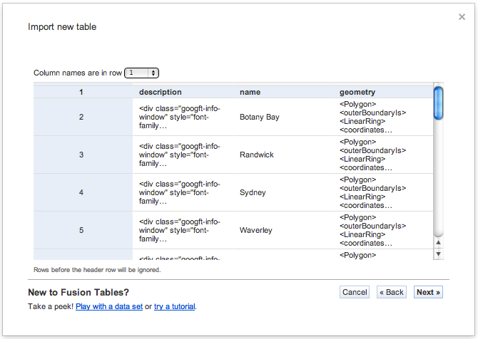

There's no need to change any of the default settings, so just click the "Next >>" button again. On the next screen, complete some basic metadata about your table, as follows:

|  |  |
| --- | --- |
| Table name | New South Wales LGA Boundaries |
| Allow export | *Un-tick this check box* |
| Attribute data to | Tally Room |
| Attribution page link | <http://www.tallyroom.com.au/maps> |
| Description | Boundary definitions of NSW LGAs, based on a source KML file provided by the Tally Room website under a Creative Commons Attribution Non-Commercial licence. |

The screen should look something like this:

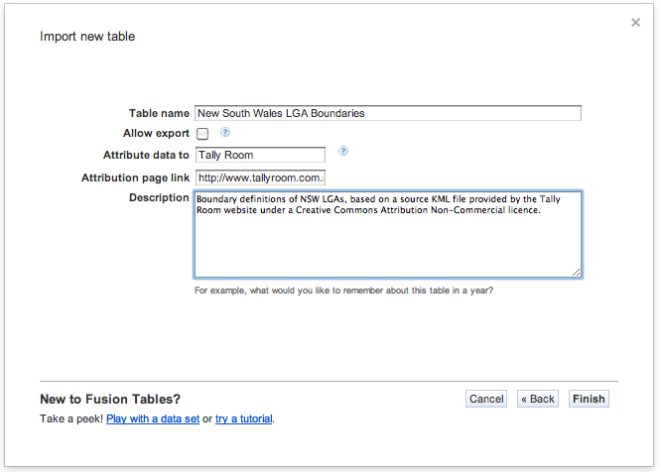

Click the "Finish" button. The main Fusion Tables interface should open, with a default tabular view.

Verify your work by selecting the "Map" option from the visualise menu. The map drawn should look like this:

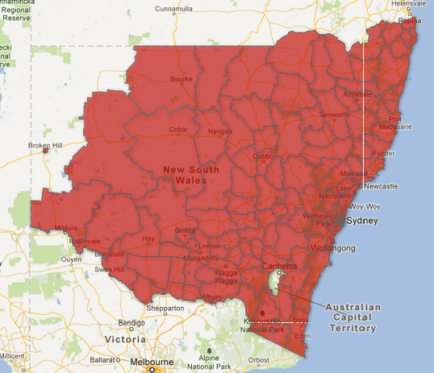

1. Importing the Crime Statistics

Return to the Google Drive tab in your browser:



Repeat the process of creating a Google Fusion Table by clicking on the "Create" button, then mouse over "More" and select the "Table (beta)" option:

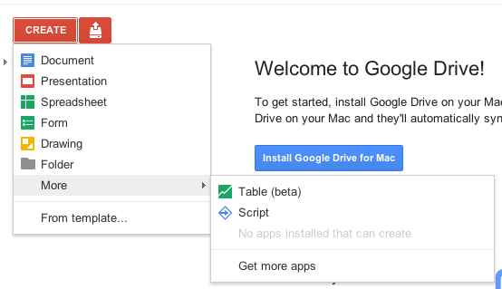

The first screen will ask you to Import a table:



Ensure "From this computer" is selected and then click the "Choose File" button. In the dialog box that appears, browse to the folder containing your downloaded crime statistics file (e.g. the Desktop) and select the file, and close off the dialog box. The screen should now look approximately like this:

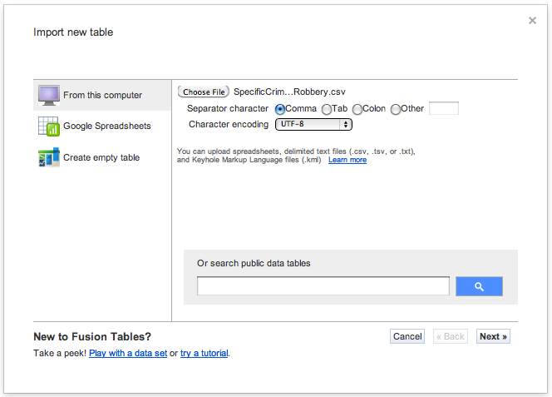

Leave all the settings as their defaults and click the "Next >>" button.

A new screen will appear. In the "Column names are in row" drop down box, leave the default of "1". In the preview area, verify that the bold row contains columns for "Local Government Area" and the years from 1999. Click "Next >>".

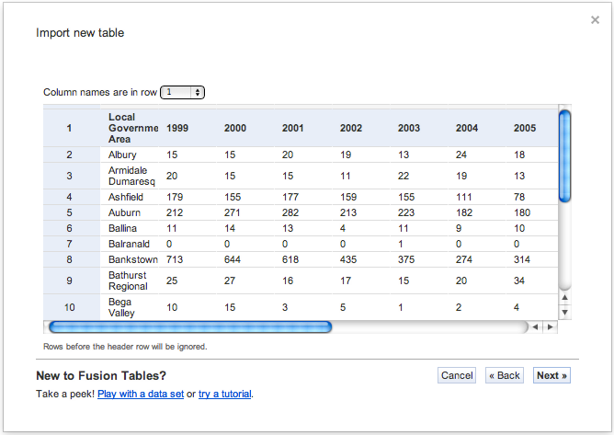

On the next screen, complete some basic metadata about your table, as follows:

|  |  |
| --- | --- |
| Table name | Crime Statistics - *<Your chosen type of crime>* |
| Allow export | *Un-tick this check box* |
| Attribute data to | NSW Bureau of Crime Statistics and Research |
| Attribution page link | <http://www.bocsar.nsw.gov.au/> |
| Description | Data sourced from the NSW Bureau of Crime Statistics and Research Online Data tools. |

The screen should look something like this:

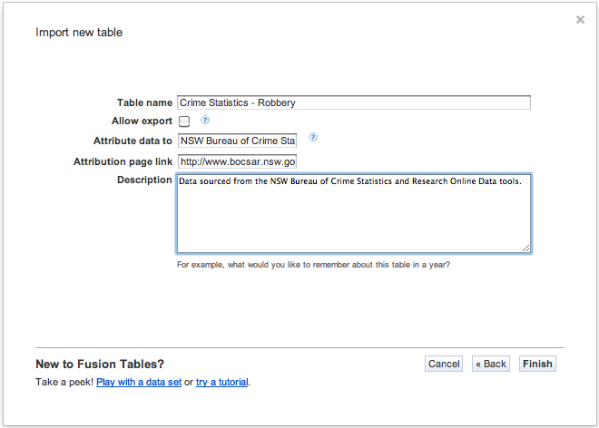

Click the "Finish" button. The main Google Fusion Tables interface will open:

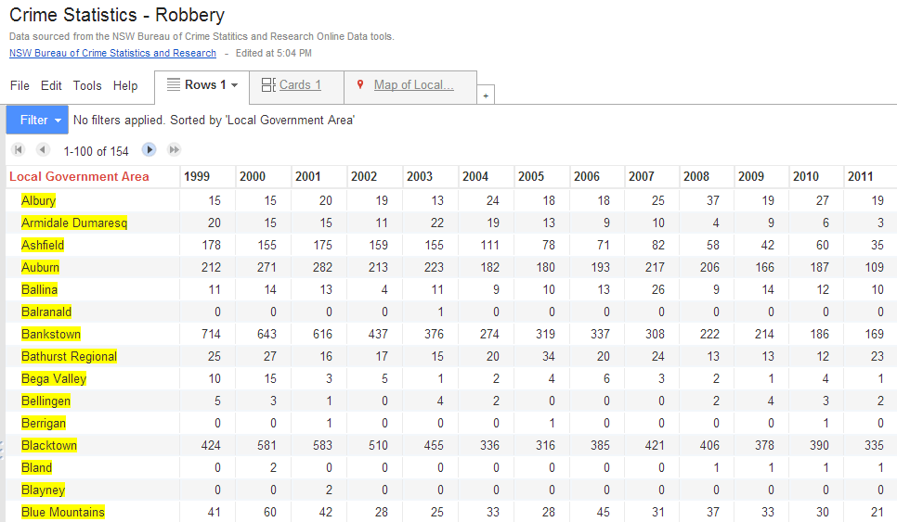

Click the "2011" column and select "Sort 100-1":

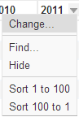

The first row of the table will now contain the LGA in which the chosen type of crime occurred most frequently in 2011. Note down the figure in the 2011 column for this row since we'll need it later. In the case of robberies, this figure is 674:



1. Merging the Tables

Next we need to merge our tables, so that the crime statistics and geographic information are together in the same table.

While still in your Crime Statistics table, from “File”, click the "Merge". The following dialog box will appear:

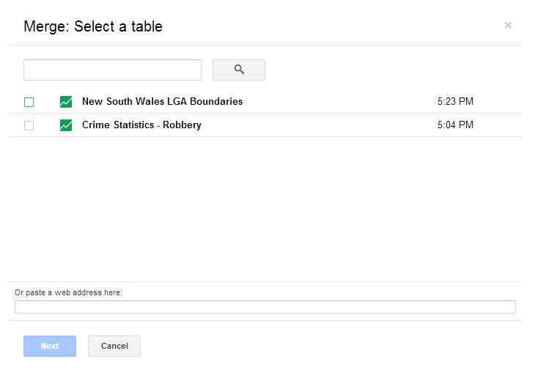

Select “New South Wales LGA Boundaries”:

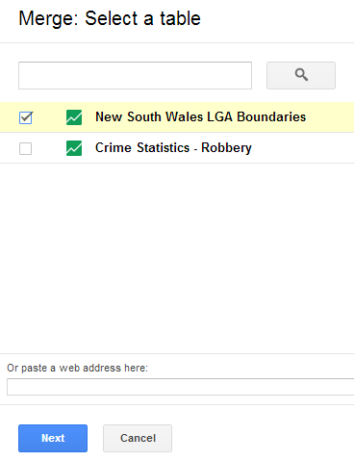

Click “Next” button. The next screen will look like this:

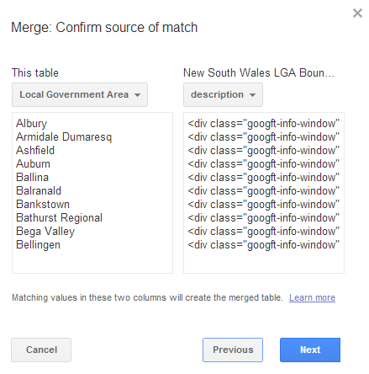

You have to click “description” and select “name”. The screen will look like this:

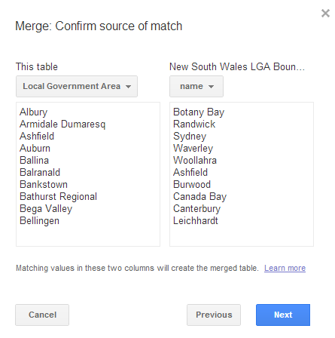

Click “Next”:

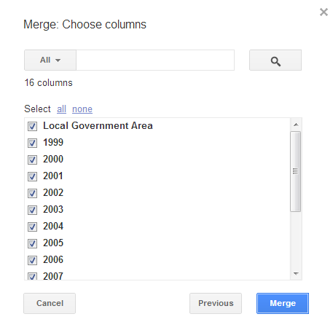

Keep all years selected and click “Merge” button. You will receive the following message:

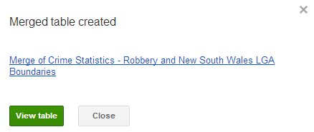

Click the “View table” button. You will see the merged table:

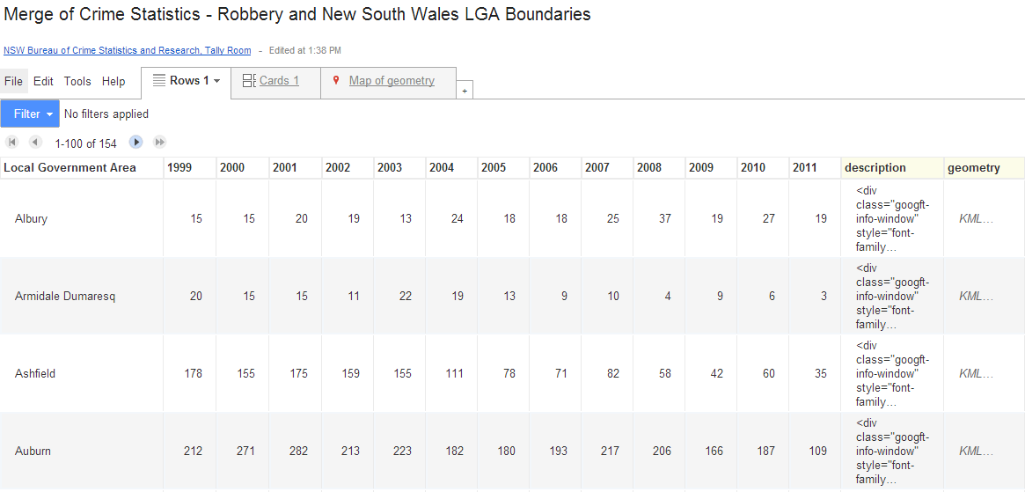

1. Creating the "Heat Map"

On the merged table, click “. A map will appear like this:

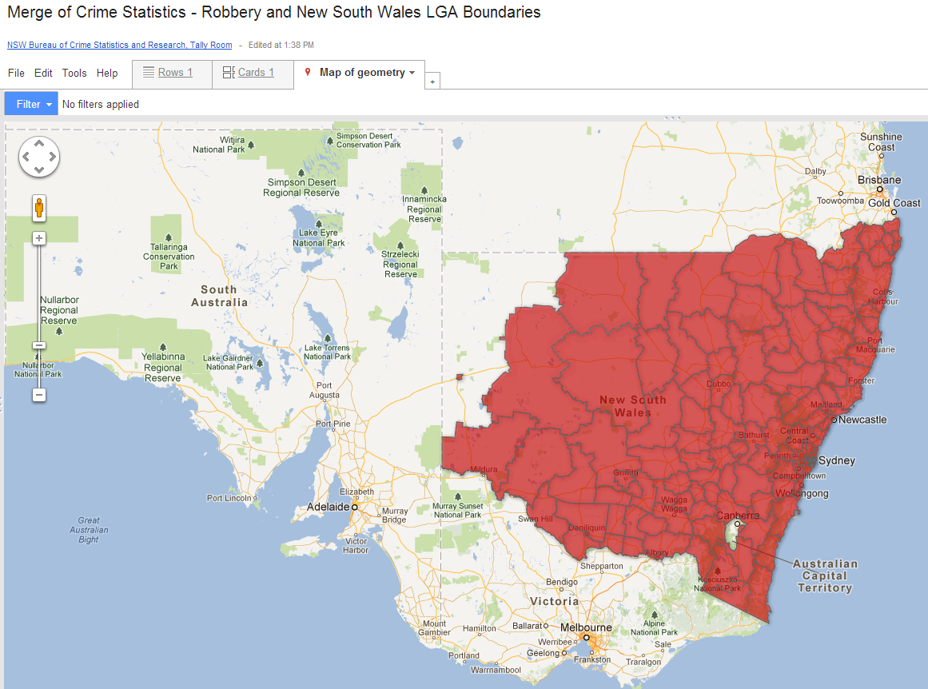

From “Tools”, select “Change map styles…”:

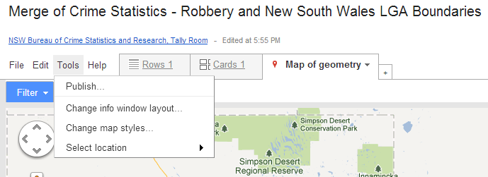

You will see a dialogue box looking like this:

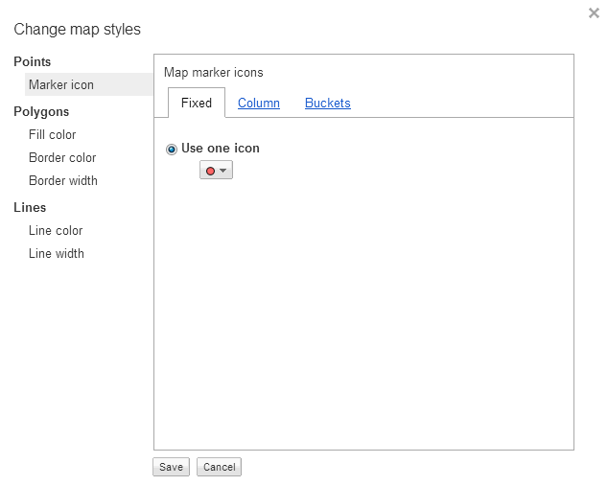

Select "Fill color" under "Polygons". Then select the “Gradient” tab. The following dialogue box will be displayed:

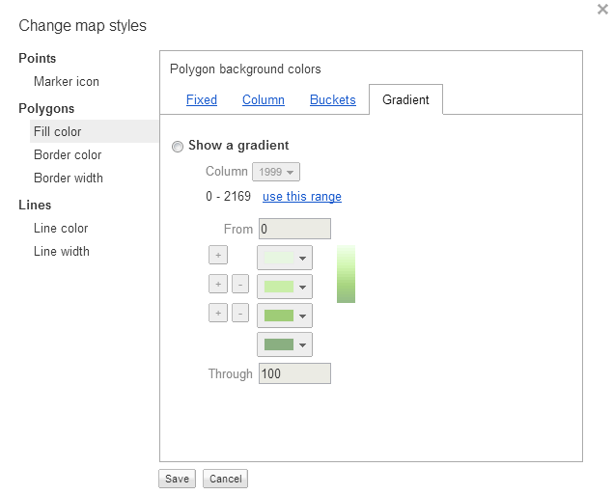

Once that's done:

1. Click "Show a gradient" and choose "2011" from the drop down list of columns.
2. Click the two minus signs, so that you only have two gradient color boxes shown.
3. Leave "From" as 0 and change "Through" to reflect the highest value for the "2011" column as determined above. *In the case of robberies, this figure was 674, but I've rounded up the value to 700.*

The dialog box should now look similar to below:

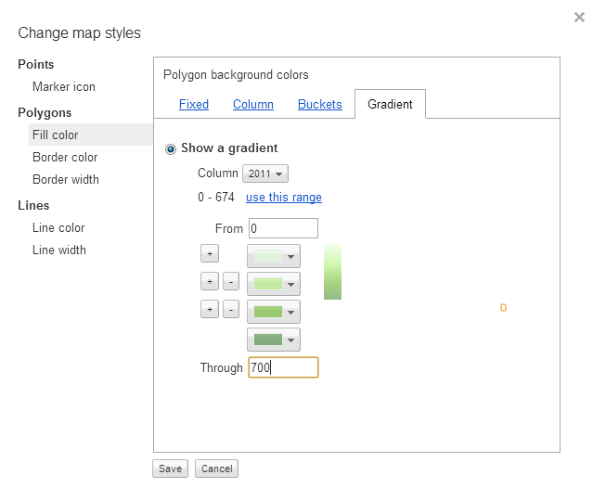

Now click the "Save" button. You should now see a "heat map", showing the absolute occurrence of the selected type of crime. Darker shades indicate higher levels of occurrence:

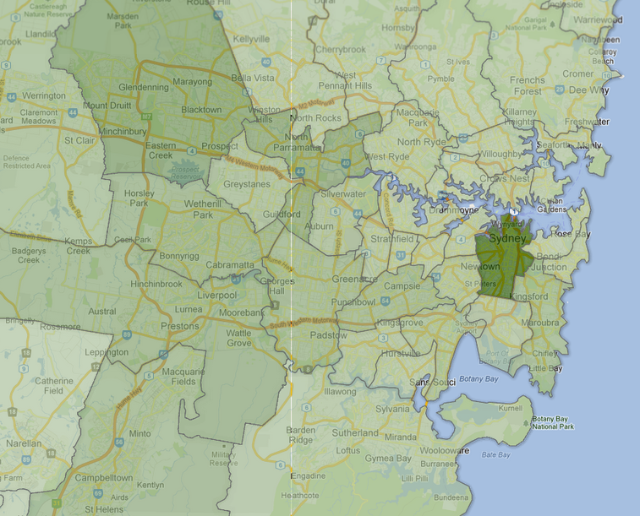

By clicking within any LGA, you can look at the statistics since 1999:

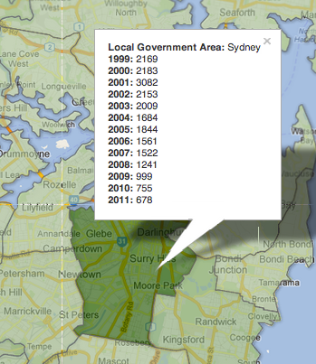

If you want to change the display years, you can simplify go to “Tools” and select “Change info window layout…”

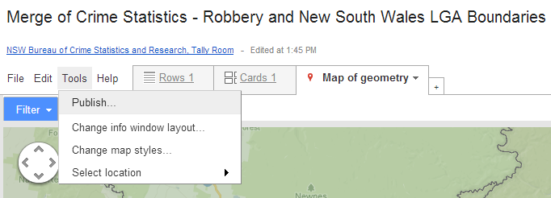

Select years, then “Save” it:

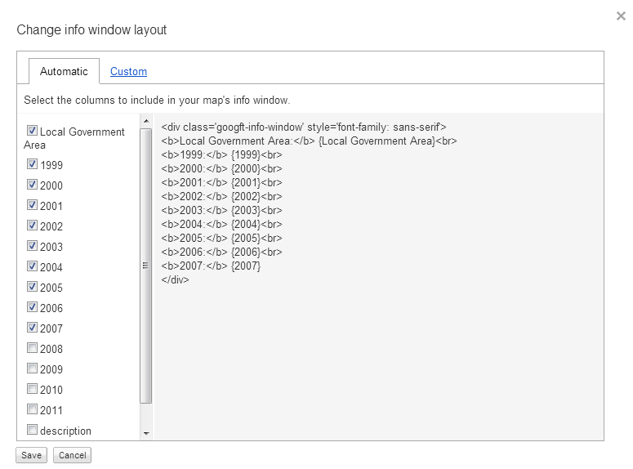

Other Things to Try

Here are some suggestions for further experimentation:

* Try changing the heat map to reflect the statistics for a different year.
* Try “Change info window layout” to display only some of the columns.
* Try changing the colour of the gradient on the heat map.

Revision History

|  |  |  |  |
| --- | --- | --- | --- |
| Version No. | Revision Date | Summary of Changes | Revised by |
| 1.0 | 16 July 2012 | Initial Document | Dr Luc Small |
| 1.1 | 19 July 2012 | Changed to include Excel section | Dr Luc Small |
| 1.2 | 23 July 2012 | Small adjustments following trial presentation | Dr Luc Small |
| 1.3 | 07 February 2013 | Presentation updated to match changes to new Google drive lay out. | Wei Cai |
| 1.5 | 12 April 2017 | Updated link to new BOCSAR website | Richard Berry |