**Interserve Facilities Services Ltd**

**BBC Maximo**

**Person Data Import from BBC AD Deployment Document**

**http://premaximo.bbc-irv.co.uk/maximo**

**http://maximo.bbc-irv.co.uk/maximo**

**Martin Radbon**



**Document History**

|  |  |  |  |
| --- | --- | --- | --- |
| Issue | Date | Author | Changes |
| 0.1 | 04/08/2014 | Martin Radbon | Initial Document |
|  |  |  |  |
|  |  |  |  |
|  |  |  |  |

Contents

1. Introduction 4

2. Deployment Steps 4

# Introduction

The BBC provide a data dump from their Active Directory currently on a weekly basis to Interserve to allow the creation of new person records within the Maximo CAFM system.

However not all BBC AD records will create new Maximo person records as there appears to be no data cleansing carrried out by the BBC or their agents before the data is forwarded to Interserve and duplication of records occurs frequently.

To date the data has been cleansed by an Interserve solutions specialist and the resultant Maximo import file configured with no duplication or errors.

# Deployment Steps

All data will be loaded through the Maximo Integration Framweork (MIF) using the components as detailed below

* DATALOAD External System
  + IRV_PERSON Enterprise Service for the Asset files

There is no requirement to run any SQL scripts against the backend SQL Server Database.

* Log into BBCMaximo Pre Prod (<http://prepmaximo.bbc-irv.co.uk/maximo>) with a user who has access to the Maximo Integration Framework application if promoting the deployment to Pre Prod.

OR

* Log into BBCMaximo Live (<http://maximo.bbc-irv.co.uk/maximo>) with a user who has access to the Maximo Integration Framework application if promoting the deployment to LIVE.
* Ensure you have the relevant load file in an easily accessible place – The load file to be used on this deployment are
  + PERSON FILE
    - BBC_PERSON_AD_Update_Live_v2.csv
* Navigate to the application and proceed with the import of the BBC_PERSON_AD_Update_Live_v2.csv file
  + Go To ----- Integration ----- External Systems

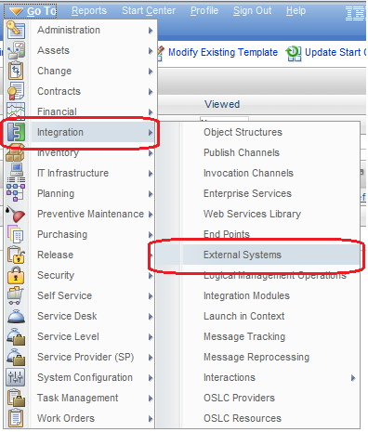

* Click on External Systems
  + Enter dataload into the empty filter box under System and press Enter

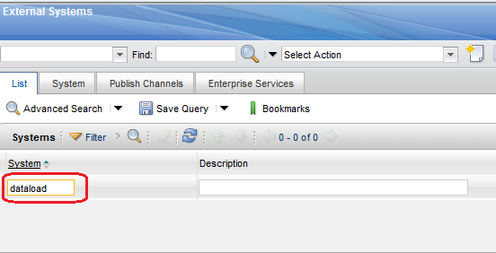

* + Click on the hyperlink DATALOAD

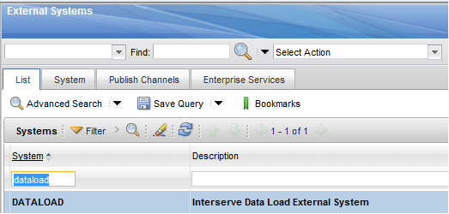

* + - Click on the Enterprise Services tab and then click on Filter to display a blank filter field. Enter **irv_person** into this field and press Enter
* The IRV_PERSON Enterprise Service is now selectable

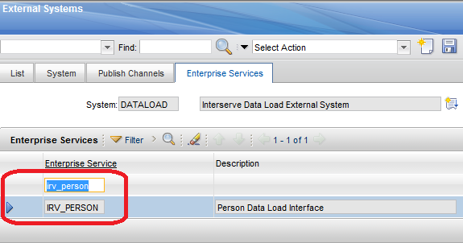

* Locate the Data Import button place the cursor on the button and click once

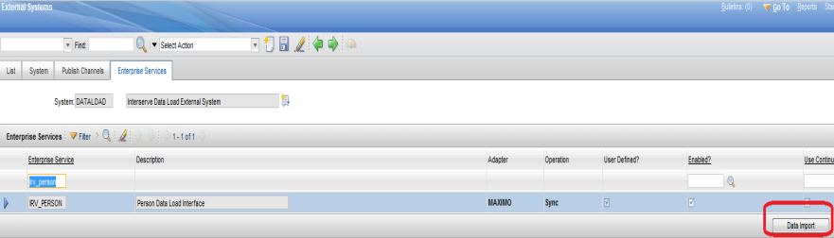

* + A dialogue box will be displayed giving various options

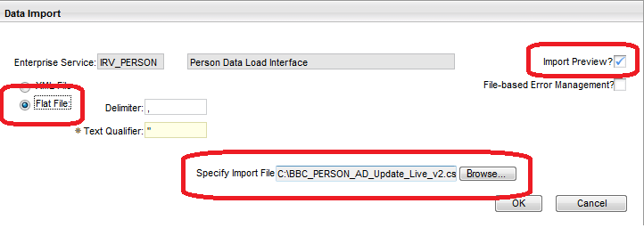

* + - Import Preview – this is for checking a small test batch of the data to be loaded, if you try and preview files with a large number of records <500 you will probably get an Internal Server 500 Error – all import files presented for this deployment were successfully previewed in DEV and SIT
      * (<http://devmaximo.bbc-irv.co.uk/maximo>)
      * (<http://sitmaximo.bbc-irv.co.uk/maximo>)
    - Flat File – This is selected for the import file in this deployment
    - Browse.... – You use this button to ‘browse’ to where you stored the import file prior to the deployment (I have shown an example in the screenshot)
  + If you wish to preview the import file then tick the Import Preview? Check box – Click OK

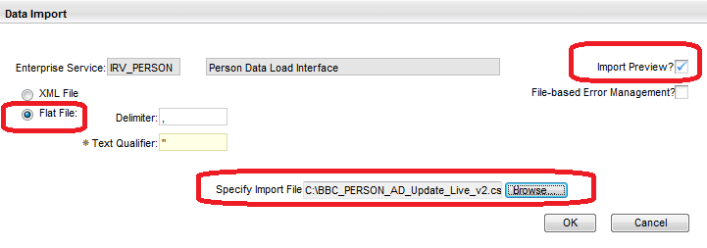

* If there are NO errors then Maximo will display a dialogue box indicating a successful import file preview

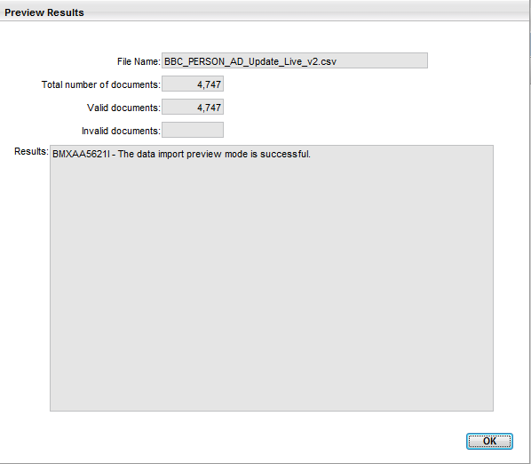

Click OK

* + If you DO NOT wish to preview the import file then DO NOT tick the Import Preview? Check box – instead make sure the File Based Error Management checkbox is ticked as this gives a good indication of any import errors.

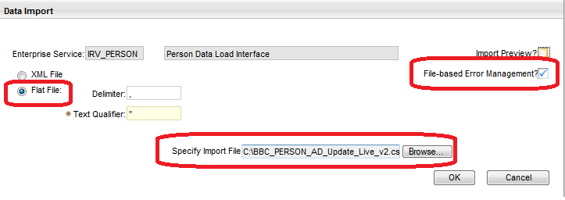

* Once happy that the correct dataload file is ready to import click OK and Maximo should display this system message

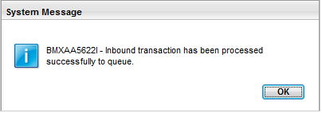

* + After successfully importing the BBC_PERSON_AD_Update_Live_v2.csv file navigate to
    - Go To -----Integration ----- Message Reprocessing

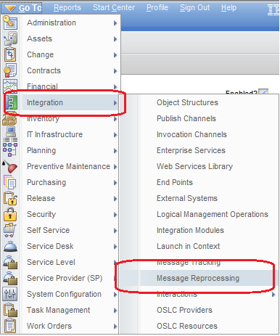

* Providing the File Based Error Management checkbox was ticked you will be able to see the imported file, how many records were in the file, how many records were processed and how many records had errors (if any) – you can view the imported files

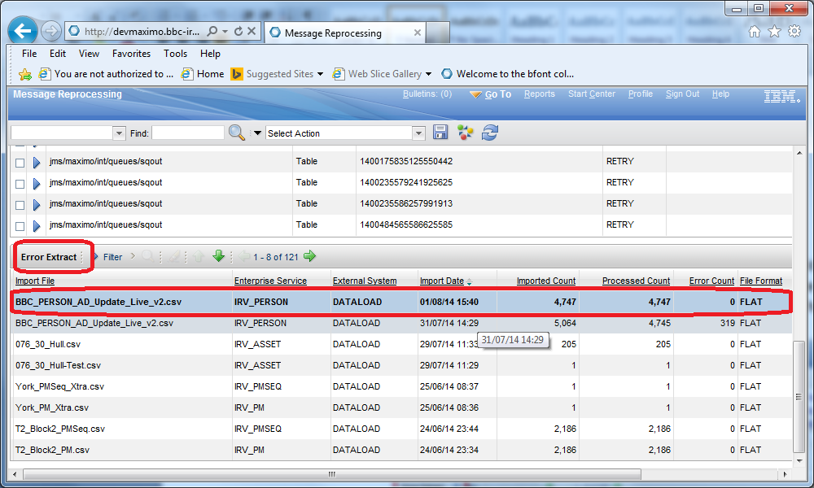

* + If there are any records that error this will be indicated in this section as per the displayed error count
  + If there are error records (new person records may be added manually by NSC help desk users which may cause duplication) please notify the author of this document but the error records **Do Not** prevent the deployment

This concludes the deployment package for the creation of new PERSON records from BBC AD data