

**Interserve Facilities Services Ltd**

**BBC Maximo**

**Update to Millbank Locations and Assets**

**&**

**Re-Alignment of Brock House, Perivale & Lighthouse PPM Records**

**http://maximo.bbc-irv.co.uk/maximo**

**Martin Radbon**

**Document History**

|  |  |  |  |
| --- | --- | --- | --- |
| Issue | Date | Author | Changes |
| 0.1 | 10/07/2014 | Martin Radbon | Initial Document |
| 0.2 | 06/08/14 | Martin Radbon | Amendment to instruct on deletion of Millbank locations |
|  |  |  |  |
|  |  |  |  |

Contents

1. Introduction 4

2. Deployment Steps 4

# Introduction

This deployment aims to fix 2 issues recently discovered whilst other issues were being investigated.

* Millbank is missing locations and assets
* Brock House, Perivale and Lighthouse PPM records hhave become mis-aligned and therefore require re-aligning

All data will be imported using the Maximo MIF and will use the following External System/Enterprise Services

* DATALOAD/IRV_ASSET for asset files
* DATALOAD/IRV_LOCATIONS for location files
* DATALOAD/IRV_PM for pm files
* DATALOAD/IRV_PMSEQ for pm sequence files

There are no SQL statements or scripts to be run or processed.

There are corrupt location records for Millbank that have to be deleted and then reloaded to ensure correct alignment and that the correct levelof data is held against each location record. This is facilitated by running the first 2 files as detailed in the load order provided.

The relevant files for this deployment are

* 01_Millbank_Rooms_Delete.csv
* 02_Millbank_Floors_Delete.csv
* 03_Millbank_Rooms.csv
* 04_Millbank_Floors.csv
* 05_Millbank_Assets.csv
* 06_Lighthouse_Assets_Updt.csv
* 07_Brock_House_PM.csv
* 08_Brock_House_PMSeq.csv
* 09_Perivale_PM.csv
* 10_Perivale_PMSeq.csv
* 11_Lighthouse_All_PM.csv
* 12_Lighthouse_All_PMSeq.csv

# Deployment Steps

* Log into BBC Maximo Pre Prod (<http://premaximo.bbc-irv.co.uk/maximo>) or BBC Maximo LIVE (<http://maximo.bbc-irv.co.uk/maximo>) – depending on BBC Maximo environment required with a user who has access to the Maximo Integration Framework application.
* Navigate to the application and proceed with the import of the location files
  + Go To ----- Integration ----- External Systems

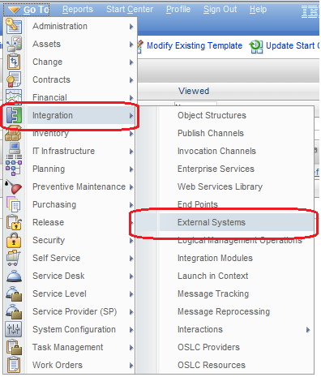

* Click on External Systems
  + Enter dataload into the empty filter box under System and press Enter

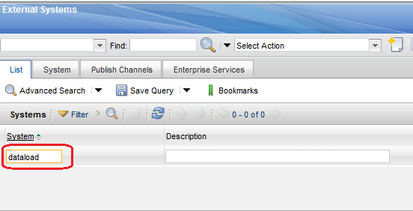

* + Click on the hyperlink DATALOAD

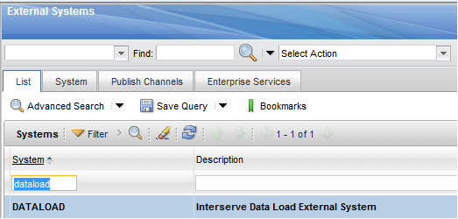

* + Click on the Enterprise Services tab and then click on Filter to display a blank filter field. Enter **locat** into this field and press Enter
  + The IRV_LOCATIONS Enterprise Service is displayed

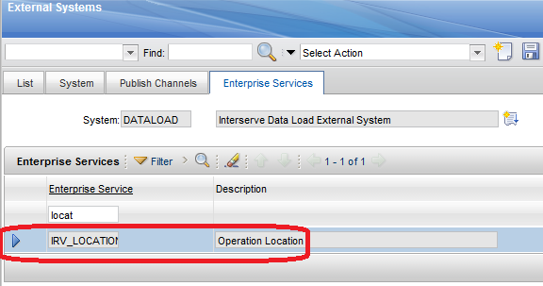

* Locate the Data Import button place the cursor on the button and click once

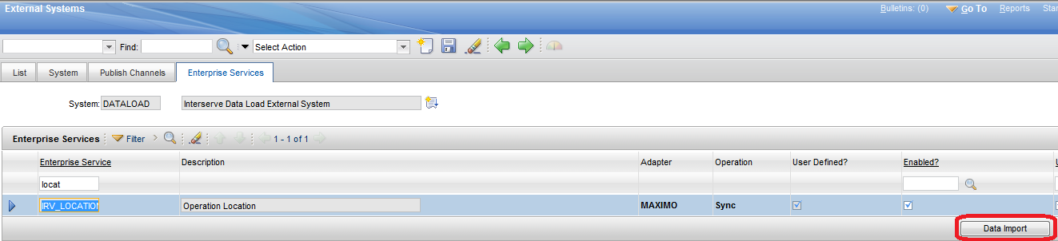

* + A dialogue box will be displayed giving various options

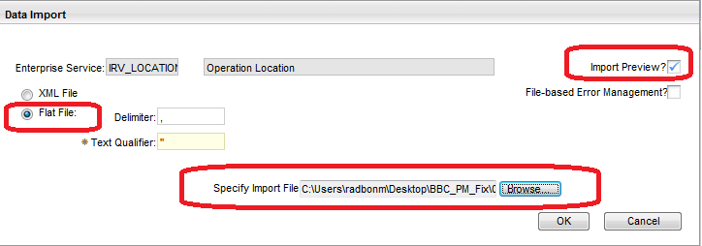

Select the first file 01_Millbank_Rooms_Delete.csv

* + - If you wish to Import Preview then ensure checkbox is ticked
    - Flat File must be selected
    - Browse to where the file is saved
  + Click OK – Maximo will process the import file to validate the columns and the data –if there are no problems Maximo will display a system message stating the preview was successful
  + To import the file click on the Data Import button again but when the Data Import dialogue box is displayed select File Based Error Managment and Flat File
  + If you DO NOT wish to preview the import file then DO NOT tick the Import Preview? Check box – instead make sure the File Based Error Management checkbox is ticked as this gives a good indication of any import errors.
  + Once happy that the correct dataload file has been selected click OK and Maximo should display this system message

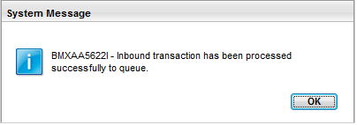

* + Follow the same process for files
    - 02_Millbank_Floors_Delete.csv
    - 03_Millbank_Rooms.csv
    - 04_Millbank_Floors.csv
  + After importing files 01_Millbank_Floors.csv and 02_Millbank_Rooms.csv navigate to
    - Go To -----Integration ----- Message Reprocessing

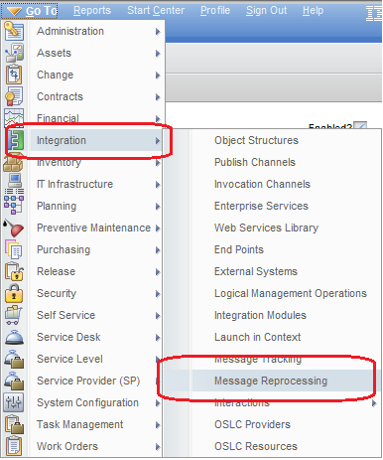

* Providing the File Based Error Management checkbox was ticked you will be able to see the imported file, how many records were in the file, how many records were processed and how many records had errors (if any) – you can view the imported files (The screenshot is provided as an example only)

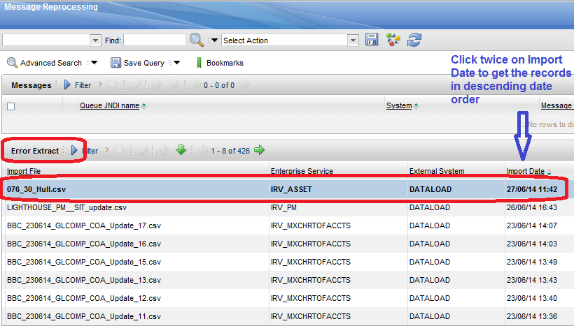

* + The asset files now need to be imported – Enter asset into the filter field under Enterprise Service and press enter The IRV_ASSET Enterprise Service is now selectable

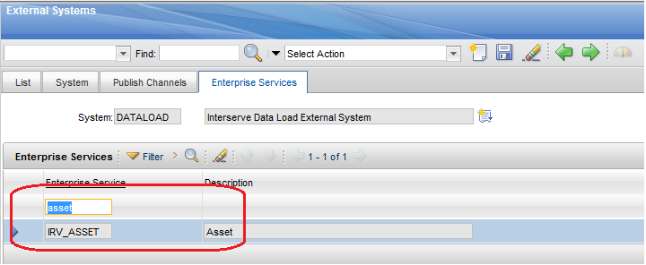

* Locate the Data Import button place the cursor on the button and click once

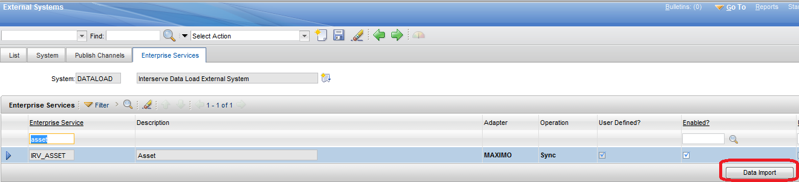

* + A dialogue box will be displayed giving various options

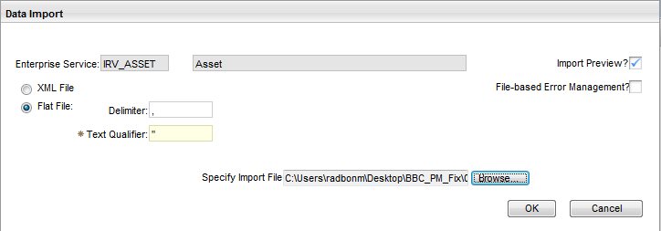

Select the first file 05_Millbank_Assets.csv

* + - If you wish to Import Preview then ensure checkbox is ticked
    - Flat File must be selected
    - Browse to where the file is saved
  + Click OK – Maximo will process the import file to validate the columns and the data –if there are no problems Maximo will display a system message stating the preview was successful
  + To import the file click on the Data Import button again but when the Data Import dialogue box is displayed select File Based Error Managment and Flat File
  + If you DO NOT wish to preview the import file then DO NOT tick the Import Preview? Check box – instead make sure the File Based Error Management checkbox is ticked as this gives a good indication of any import errors.
  + Once happy that the correct dataload file has been selected click OK and Maximo should display this system message



* + Follow the same process for file
    - 06_Lighthouse_Assets_Updt.csv
  + After importing files 05_Millbank_Assets.csv and 06_Lighthouse_Assets_Updt.csv navigate to
    - Go To -----Integration ----- Message Reprocessing



* Providing the File Based Error Management checkbox was ticked you will be able to see the imported file, how many records were in the file, how many records were processed and how many records had errors (if any) – you can view the imported files (The screenshot is provided as an example only)



* + The PM/PM Sequence files now need to be imported – Enter irv_pm% into the filter field under Enterprise Service and press enter The IRV_PM and IRV_PMSEQ Enterprise Services are now selectable

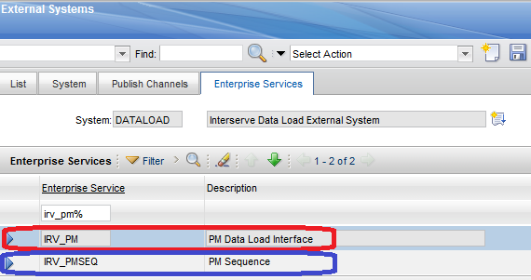

* Ensure you select the correct Enterprise System and then locate the Data Import button place the cursor on the button and click once

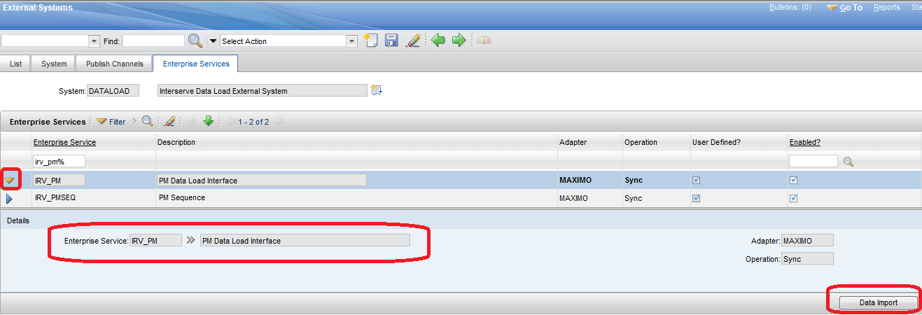

* + A dialogue box will be displayed giving various options

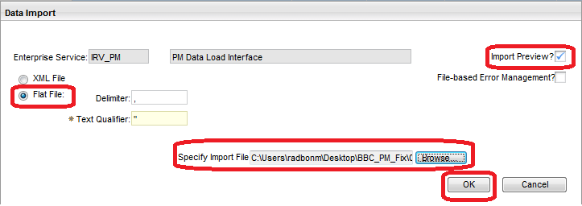

Select the file 07_Brock_House_PM.csv

* + - If you wish to Import Preview then ensure checkbox is ticked
    - Flat File must be selected
    - Browse to where the file is saved
  + Click OK – Maximo will process the import file to validate the columns and the data –if there are no problems Maximo will display a system message stating the preview was successful
  + To import the file click on the Data Import button again but when the Data Import dialogue box is displayed select File Based Error Managment and Flat File
  + If you DO NOT wish to preview the import file then DO NOT tick the Import Preview? Check box – instead make sure the File Based Error Management checkbox is ticked as this gives a good indication of any import errors.
  + Once happy that the correct dataload file has been selected click OK and Maximo should display this system message



* Now the associated PM Sequence file needs to be imported – Select the IRV_PMSEQ Enterprise Service - Locate the Data Import button place the cursor on the button and click once

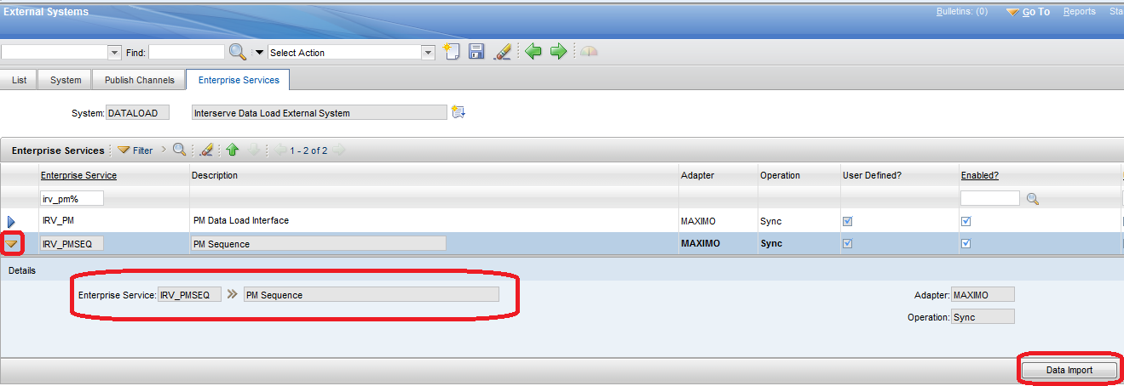

* + A dialogue box will be displayed giving various options

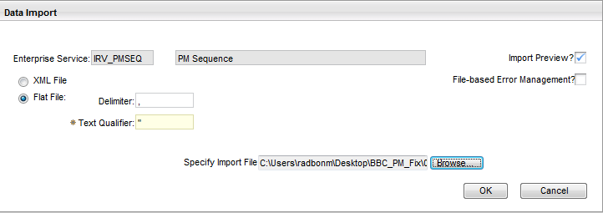

Select the file 08_Brock_House_PMSeq.csv

* + - If you wish to Import Preview then ensure checkbox is ticked
    - Flat File must be selected
    - Browse to where the file is saved
  + Click OK – Maximo will process the import file to validate the columns and the data –if there are no problems Maximo will display a system message stating the preview was successful
  + To import the file click on the Data Import button again but when the Data Import dialogue box is displayed select File Based Error Managment and Flat File
  + If you DO NOT wish to preview the import file then DO NOT tick the Import Preview? Check box – instead make sure the File Based Error Management checkbox is ticked as this gives a good indication of any import errors.
  + After importing files 07_Brock_House_PM.csv and 08_Brock_House_PMSeq.csv navigate to
    - Go To -----Integration ----- Message Reprocessing



* Providing the File Based Error Management checkbox was ticked you will be able to see the imported file, how many records were in the file, how many records were processed and how many records had errors (if any) – you can view the imported files (The screenshot is provided as an example only)



* + Follow the same PM/PMSEQ import process as used for 05_Brock_House_PM.csv and 06_Brock_House_PMSeq.csv on the following files
    - 09_Perivale_PM.csv
    - 10_Perivale_PMSeq.csv
    - 11_Lighthouse_All_PM.csv
    - 12_Lighthouse_All_PMSeq.csv
* This concludes the deployment for this issue fix