## Reflection in Java

Reflection is an API which is used to examine or modify the behavior of methods, classes, interfaces at runtime.

* The required classes for reflection are provided under java.lang.reflect package.
* Reflection gives us information about the class to which an object belongs and also the methods of that class which can be executed by using the object.
* Through reflection we can invoke methods at runtime irrespective of the access specifier used with them.

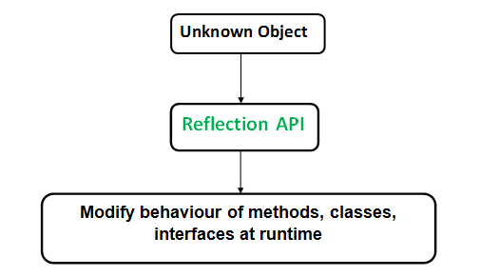

Reflection can be used to get information about –

1. **Class** The getClass() method is used to get the name of the class to which an object belongs.
2. **Constructors** The getConstructors() method is used to get the public constructors of the class to which an object belongs.
3. **Methods** The getMethods() method is used to get the public methods of the class to which an objects belongs.