# Graph Data Stucture

A graph data structure is a collection of nodes that have data and are connected to other nodes.

Let's try to understand this through an example. On facebook, everything is a node. That includes User, Photo, Album, Event, Group, Page, Comment, Story, Video, Link, Note...anything that has data is a node.

Every relationship is an edge from one node to another. Whether you post a photo, join a group, like a page, etc., a new edge is created for that relationship.

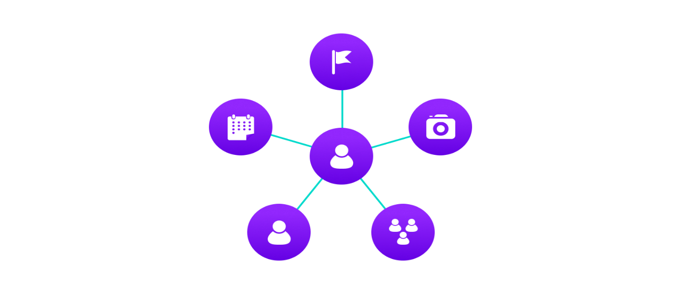

**Example of graph data structure**

All of facebook is then a collection of these nodes and edges. This is because facebook uses a graph data structure to store its data.

More precisely, a graph is a data structure (V, E) that consists of

* A collection of vertices V
* A collection of edges E, represented as ordered pairs of vertices (u,v)

 Vertices and edges

In the graph,

V = {0, 1, 2, 3}

E = {(0,1), (0,2), (0,3), (1,2)}

G = {V, E}

## Graph Terminology

* **Adjacency**: A vertex is said to be adjacent to another vertex if there is an edge connecting them. Vertices 2 and 3 are not adjacent because there is no edge between them.
* **Path**: A sequence of edges that allows you to go from vertex A to vertex B is called a path. 0-1, 1-2 and 0-2 are paths from vertex 0 to vertex 2.
* **Directed Graph**: A graph in which an edge (u,v) doesn't necessarily mean that there is an edge (v, u) as well. The edges in such a graph are represented by arrows to show the direction of the edge.