# Adapter Pattern

**Definition**: Convert the interface of a class into another interface that clients expect.

**Problem: Adapter** lets classes work together that couldn’t otherwise because of incompatible interfaces.

**Solution:**AClass Adapter — Based on (Multiple) Inheritance

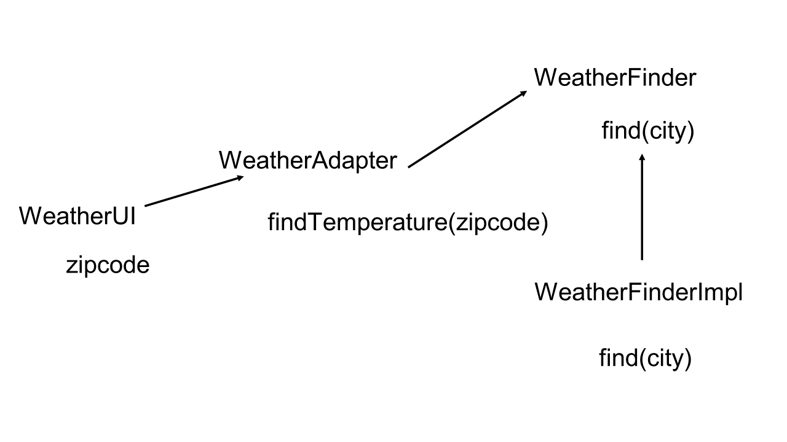

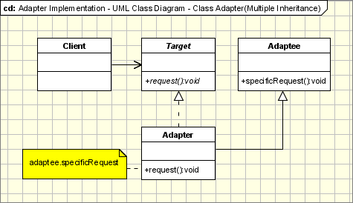

**Participants**:

* **Target** — defines the domain-specific interface that Client uses/expects.
* **Adapter** — adapts the interface Adaptee to the Target interface.
* **Adaptee** — defines an existing interface that needs adapting.
* **Client** — collaborates with objects conforming to the Target interface.