Solidfire Sla violation details

SOLODFIRE SLA LOGIC DRAFT

Reviewed by

Engineering Manager, CSE CPE: Sukanya R

MTS SW : Anjaiah Induri

Prepared by

Haramohan Sahu

Abstract

This document explains the SolidFire Jira Sla violation logic and other scripts details.

Contents

Backend Scripts - SolidFire JIRA Escalations 2

Alerts 2

Reminder Mail: 2

Report Mail: 2

Close the Burt ID If it is associated Jira Case is closed or JIRA_STATUS is Resolved and JIRA_RESOLUTION is DONE. 2

Close the Active CPE Escalations if SAP Cases closed. 2

SLA RULE Escalation Report Mail: 3

What is the SLA timeline for a Jira Case? 3

What is Report Mail? 6

DB Table Details: 7

The format of the Report Mail is pasted here. 8

What is Reminder Mail? 9

Report Mail Field Details: 9

Scripts Location 9

Scripts Check in Location: 10

Confluence page link: 10

State Of Jira Case 10

Script Details 10

Sequence Diagram of Escalation Report Mail: 12

How to execute scripts: 12

Types of Jira Resolution: 13

Jira Status Field: 14

Burt_main table fields in Burt online ( BOO): 18

BURT STATES in Burt Tool: 18

# [Backend Scripts - SolidFire JIRA Escalations](https://confluence.ngage.netapp.com/display/CPE/Backend+Scripts+-+SolidFire+Escalations+JIRA)

## **Alerts**

* Manager Alerts: Sent on everyday Morning 9 AM.
* Escalation Engineer Reminder:  Sent on every day [Mon - Fri] Evening 6.00 PM.

## **Reminder Mail:**

* This shell script (**runSlaReminderMail.sh**) is periodically run every day at 6.00 PM. This script will send reminder mail to every Solid Fire Engineer who is responsible for tor the Jira Id.

## **Report Mail:**

* This shell script (runSlaMissReport.sh) is periodically run everyday morning at 9.00 AM. This script will send report mail to manager of every Solid Fire Engineer who is responsible for the Jira Id.  In the report mail, this script will list out all the Jira Ids which are violated the SLA Rule, along with other information and update the DB Table (**sf_sla_test_table) & metric Table (sf_metrics_data).**

## **Close the Burt ID If it is associated Jira Case is closed or JIRA_STATUS is Resolved and JIRA_RESOLUTION is DONE.**

* These Burt Ids are in New/Open state, but the associated Jira case has been closed/Resolved. Hence these Burt Ids must be closed.

## **Close the Active CPE Escalations if SAP Cases closed.**

* These CPE escalations are in ACTIVE state, but the associated SAP case has been closed. Hence These CPE escalations must be closed.

## **SLA RULE Escalation Report Mail:**

Jira Escalation Cases must be updated with the SLA timeline by SolidFire Engineer, Otherwise It violates SLA.

If there is a Jira Case, then it has 3 types of priority SLA TimeLine Table mentioned Below:

# Priority TimeLine  
-----------------------  
1. P1 Critical - 1 Day  
2. P2 High - 3 Days  
3. P3 Medium - 5 Days

Any Jira Case need to be updated within the certain time lime. This certain time is called as Service Level Agreement (SLA). The SLA response times usually refer to how quickly you will respond to a technical issue being raised.

## **What is the SLA timeline for a Jira Case?**

A Jira Case must be updated within 1 day if it is a P1 Critical, 3 Days for P2 High, and 5 Days for P3 Medium.

If a Jira Case’s Priority set and any other priorities other then P1, P2 and P3 are not considered for SLA as of now.

**How script identify an engineer a SolidFire Engineer?**

It checks the Cost Center value as "CSE SolidFire CPE", the engineer a SolidFire Engineer.

**How SLA Violated?**  
In a simple term, if any Jira Case is not updated by SolidFire Engineer in "Escalation Next Steps" section within the SLA agreed timeline, then it has violated the SLA.

**Broadly there are 3 Cases for SLA Violation.**

**Case 1**: Jira case has "Escalation Next Steps”, and "Escalation Next Steps" section is updated by SolidFire Engineer

**Case 2**: Jira case has "Escalation Next Steps”, and "Escalation Next Steps" section is **not** updated by SolidFire Engineer.

**Case 3**: Jira case has **no** "Escalation Next Steps" section at all.

Here a Jira Case is not considered for SLA, if it does not have Escalation Priority set. In Raw JSON Object, The field

**“customfield_15192**” is related to Escalation Priority. This customfield_15192 must have value like P1-Critical, “P2-High”,” P3-Medium”. Any other priority is not considered for SLA at this point of time.

**How To calculate the Number of Days, the Case not updated (DAYS_SINCE_LAST_MODIFIED field in Report Mail)?**

**Rule 1**: Take the last update Date of "Escalation Next Steps" section in Jira Case and subtract it from the current date (script running date) and exclude the Saturdays and Sundays.

The function which does this task is **SlaMiss::countOnlyWeekDays().**

**Remember**:  If "Escalation Next Steps" update is done by SolidFire Engineer then only **Rule 1** applies and LAST_UPDATED_COMMENT would be the last comment given by any SolidFire Engineer in "Escalation Next Steps" section of Jira Case.

**Rule 2:**If "**Escalation Next Steps**" is not at all there or it is there but it is not updated by SolidFire Engineer

**Remember**, **Here Rule 1 does not apply**. and, LAST_UPDATED_COMMENT would be like “**No Update available in Escalation Next Steps by CSE SolidFire CPE Engineer".**

**DAYS_SINCE_LAST_MODIFIED = It takes the constant value based on Priority i.e.** 1 day for P1 Critical, 3 Days for P2 High, and 5 Days for P3 Medium.

**Examples of Rules apply for DAYS_SINCE_LAST_MODIFIED calculation**

**Case 1**: Jira case has "Escalation Next Steps" and "Escalation Next Steps" section is updated by SolidFire Engineer

**DAYS_SINCE_LAST_MODIFIED= Rule 1 apply.**

**Case 2**: Jira case has "Escalation Next Steps" and "Escalation Next Steps" section is **not** updated by SolidFire Engineer

**DAYS_SINCE_LAST_MODIFIED= Rule 2 apply.**

**Case 3**: Jira case has **no** "Escalation Next Steps" section at all.

**DAYS_SINCE_LAST_MODIFIED= Rule 2 apply.**

**Note**: Since **DAYS_SINCE_LAST_MODIFIED**takes the priority time in case of **Rule 2,** then Jira Case must have priority field set**,** otherwise it ignores Jira Case.

**Script does not consider any other priority other then P1, P2, P3. It does not consider Jira Cases whose Priority is not SET as well.**

**Note: As per Anji, we only consider P1, P2 and P3 for at this point of time for SLA.**

**Let us have an example of SLA Violation:**

**P1 Critical - 1 Day**  
=============  
#1  
This kind of Jira Cases need to be updated by SolidFire Engineer on daily basis as SLA timeline is 1 day for this type of Jira Case. That means, every 24 hours, this P1 category Jira Cases must be updated By SolidFire Engineer. Otherwise, it attracts SLA Violation.  
#2  
There is an **Escalation Next Steps** section in the Jira Case (<https://jira.ngage.netapp.com/browse/CSD-4749>). This section must be updated by SolidFire Engineer on daily basis i.e., every 24 hours.  As this Jira Case is a P1 Critical, SLA TimeLine for this case is 1 Day. Escalation Next Steps scree shoot pasted below:

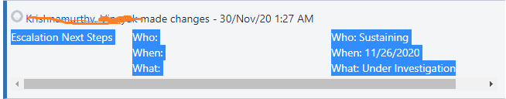

Here the script reads the "Escalation Next Steps" section update and check If the update done by SolidFire Engineer or not. If it is by SolidFire Engineer, then checks the date of its update and take the diff between the Update Date by SolidFire Engineer and the current date. While taking the days diff, it excludes the **Saturdays** and **Sundays**. The function which does this task is **SlaMiss::countOnlyWeekDays().**

In the Escalation report mail, It displays that, this Particular Jira Case has not been updated for these many days (Here it shows the diff days).

If the Days difference is exceeding 1 days, then it has violated the SLA.

In Escalation report mail, one more crucial information it provides like Last Comment given by SolidFire Engineer.

If there is no update done by SolidFire Engineer, then It shows “No Update available in Escalation Next Steps by CSE SolidFire CPE Engineer”.

**Case 1:  Here Jira case has "Escalation Next Steps" & "Escalation Next Steps" is updated by SolidFire Engineer.**

**Details of Escalation Next Steps.**  
#3.1  
If Jira case has **one** "Escalation Next Steps" & "Escalation Next Steps" is updated by SolidFire Engineer, then take the DATE on which SolidFire Engineer has given the UPDATE, for SLA calculation.

**Example**:

1. "Escalation Next Steps", 🡪 One is updated by **SolidFire Engineer** on Date **2021-May-06**

Here we take the Date **2021-May-06 for SLA** calculation**, as on this date, SolidFire Engineer has given update on Escalation Next Steps.**

#3.2  
If there are many "Escalation Next Steps" section update in JIRA Case, then SLA will consider only the "Escalation Next Steps" section update, done by SolidFire Engineer. SLA rule is, when is the last update done by SolidFire Engineer, that date is taken for SLA calculation.

If there are, say example 5 "Escalation Next Steps" section update and all are not (**only few are updated by SolidFire Enginee**r) updated by SolidFire Engineer.

Then, in this case just check for latest "Escalation Next Steps" section update, where update done by SolidFire Engineer.  
**Example**:

1. "Escalation Next Steps",🡪 One is updated by CSC CPE Engineer on Date **2021-May-1**
2. “Escalation Next Steps",🡪 One is updated by CSC CPEEngineer on Date **2021-May-03**
3. "Escalation Next Steps", 🡪 One is updated by **SolidFire Engineer** on Date **2021-May-05**
4. "Escalation Next Steps", 🡪 One is updated by **SolidFire Engineer** on Date **2021-May-19 🡪 This will be taken for SLA**
5. "Escalation Next Steps",🡪 One is updated by CSC CPE Engineer on Date **2021-May-28**

Here, we only consider the Update done by SolidFire, and the latest update done by any SolidFire Engineer is “**2021-May-19”. So, 4th Escalation Next Steps date is taken, though 2021-May-28 is the Latest one, but we will not consider it, as it has not been Updated by SolidFire Engineer.**

#3.3

If there are 5 "Escalation Next Steps" section update and **all are updated by SolidFire Engineer**, then in this case SLA takes the last Update done by SolidFire Engineer.

**Example**:

1. "Escalation Next Steps", 🡪 One is updated by **SolidFire Engineer** on Date **2021-May-06**
2. "Escalation Next Steps",🡪 One is updated by **SolidFire Engineer** on Date **2021-May-03**
3. "Escalation Next Steps", 🡪 One is updated by **SolidFire Engineer** on Date **2021-May-06**
4. "Escalation Next Steps",🡪 One is updated by **SolidFire Engineer** on Date **2021-May-03**
5. "Escalation Next Steps", 🡪 One is updated by **SolidFire Engineer** on Date **2021-May-06🡪 This one will be taken**

**Case 2:  Jira case has "Escalation Next Steps”, and "Escalation Next Steps" section is not updated by SolidFire Engineer.**  
**Case 3: Jira case has no "Escalation Next Steps" section at all.**

Here**Case 2 and Case 3** falls into one category.  
**Example:**  
1) If there are, say example 5 "Escalation Next Steps" section update and None of it are updated by SolidFire Engineer.   
2) If there are no "Escalation Next Steps" section at all.

Here there will be no calculation of days difference. SLA time will take the Priority time of the Case. In the report mail, it shows the days not updated as priority time which is mentioned below.  
  
1. P1 Critical        - 1 Day  
2. P2 High           - 3 Days  
3. P3 Medium     - 5 Days

***P2 High - 3 Days***  
============  
Here the same above SLA rule applies, Only thing is, we need to take the 3 days for calculation as it is a High case.  
***P3 Medium - 5 Days***  
==============  
Here the same above SLA rule applies, Only thing is, we need to take the 5 days for calculation as it is a Medium case.

## **What is Report Mail?**

* An email is sent to a manager DL which consists of all SLA Violated Jira Cases along with few more related Information. This Report Mail is sent everyday morning at 9.00Am.
* It also inserts all these violated data into DB Table.
* Also insert Metric related info into Metric Table.

## **DB Table Details:**

**MySQL Database Name = sf_sla_testDB**

1. Report table Name = sf_sla_test_table
2. Metric Table Name= sf_metrics_data

DB Username = root

DB Password=netapp

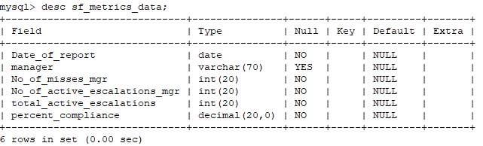

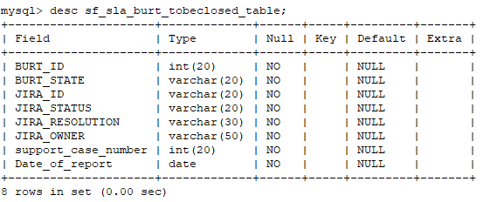

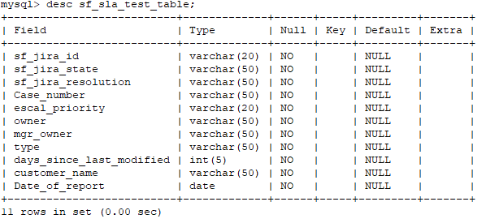

## **The format of the Report Mail is pasted here.**

---------------------------------------------------------------Example Report Mail--------------------------------------------------------------------

Hi All,  
  
Please find the list of CPE JIRA Cases whose Resolution is Unresolved for which ESCALATION_STATUS section has not been updated with ‘customer consumable update’ as per SLA. This is an absolute CPE minimum expected deliverable as part of ownership and accountability

**Total number of Active Escalations: 56**

**Percentage compliance for today: 61**

P1-Critical: 1 day

P2-High: 3 days

P3-Medium: 5 days

**Manager wise classification:**

|  |  |
| --- | --- |
| mgr_owner | count |
| adavies | 4 |
| pkarurma | 9 |
| jtiffan | 5 |
| jbowman | 2 |
| reddy | 2 |

**SolidFire CPE BURT Details:**



#####This is an automated daily report. Please ignore if no actions are pending from your end.####  
  
**SolidFire SLA Miss Escalations script details available at**   
<https://confluence.ngage.netapp.com/display/CPE/Backend+Scripts+-+SolidFire+Escalations+JIRA>  
Date : 27-05-21 09:11:39

---------------------------------------------------------------Example Report Mail Ends Here-------------------------------------------------------

## What is Reminder Mail?

An email is sent to each Jira Owner who have violated the SLA along with few more related Information. This Reminder Mail is sent everyday Evening at 6.00 Pm.

Reminder mail does not do any DB related things. It just sends a reminder mail.

## Report Mail Field Details:

|  |  |  |  |  |  |  |  |  |  |  |
| --- | --- | --- | --- | --- | --- | --- | --- | --- | --- | --- |
| JIRA_ID | JIRA_STATE | PRIORITY | CASE_NUMBER | ESCAL_STATUS | OWNER_OF_JIRA_ID | MGR_OWNER | ESCAL_TYPE | DAYS_SINCE_LAST_MODIFIED | CUSTOMER_NAME | LAST_UPDATED_COMMENT |

* **JIRA_ID** - It is Jira id e.g CSD-4673
* **JIRA_STATE** - It indicates the state of the Jira Id which is mentioned below.
* **PRIORITY** - Says about the priority of Case like P1 Critical - 1 Day, P2 High - 3 Days, P3 Medium - 5 Day
* **CASE_NUMBER** - Says about the escalation case number.
* **ESCAL_STATUS** - It says about Resolution like Whether it is Resolved/closed etc.
* **OWNER_OF_JIRA_ID** - Who owns the case.
* **MGR_OWNER** - Manager of the solid fire engineer who is working on it.
* **ESCAL_TYPE** - It is related to CPE Escalation.
* **DAYS_SINCE_LAST_MODIFIED** - How many days it is not modified by Solid Fire Engineer to till date.
* **CUSTOMER_NAME** - Who is the Customer of this case.
* **LAST_UPDATED_COMMENT** - The Last comment made Solid Fire engineer.

## **Scripts Location**

Host= [froyo.rtp.openeng.netapp.com](http://froyo.rtp.openeng.netapp.com/)

Code Path= /var/www/html/jira_sla_scripts

## **Scripts Check in Location:**

<https://bitbucket.ngage.netapp.com/projects/CPE-TOOLS-BB/repos/sla_miss_script_solidfire>.

## **Confluence page link:**

In this page, same details are updated.

https://confluence.ngage.netapp.com/display/CPE/Backend+Scripts+-+SolidFire+Escalations+JIRA

## **State Of Jira Case**

1. IN PROGRESS
2. NEW, CLOSED
3. RESOLVED
4. UNDER INVESTIGATION
5. DEV COMPLETE
6. DONE
7. WAITING
8. FIX IN PROGRESS
9. DROPPED
10. IN QUEUE
11. IN TEST
12. NEED MORE INFO
13. REOPEN
14. WAITING FOR RELEASE
15. NEED TRIAGE
16. MONITORING
17. TRIAGING

This script is reading the state for calculating the SLA miss, from the **slaConfig.cfg** file. Any state mentioned above, if included in this conf file, then, while calculating the SLA, these states will not be considered.

## **Script Details**

1. **sendReminderMail.php**
   1. This script is responsible to send the reminder mail to the owner of the Jira Case. This script internally uses many more script like SlaMiss/SlaMiss.php , sendMail/sendMail.php and htmlReportTable/reminderMail.php to send reminder mail.
2. **SlaMiss/SlaMiss.php**
   1. This file is the heart of all the script. weather report mail or reminder mail, this file has the required logic and calculate   required thing and populate the json object and create the list of all the Jira id which has violated the SLA Rule.
3. **sendMail/sendMail.php**
   1. As name suggest, this file is dealing with sending email.
4. **htmlReportTable/reminderMail.php**
   1. This file is dealing with creating a <SENDERNAME>.html file in htmlReportTable/HTML/ path and this content is read into a buffer by the sendReminderMail.php script and use the file content as email body.  Before creating any .html file, It delete all previous .html file and creates new one.
5. **htmlReportTable/createHtmlTableFromJSONList.php**
   1. This file is dealing with creating a report html file in htmlReportTable path.  This content is read into a buffer by the getSlaMissJiraBugInfo.php script and use the file content as email body
6. **mysql/insert_into_slaDB.php**
   1. This file deals with logging sla miss report records into MySQL **DB**
7. **config/slaConfig.cfg**
   1. This is a configurable file. Any JIRA states mentioned here will be taken and will be used to exclude these mentioned states, while calculating the SLA logic for every Jira IDs.
   2. So, any states mentioned in this file, will not be considered for SLA Logic.
   3. TO_MAIL and CC_MAIL also can be set with this config file. [TO_MAIL=XXXXX@netapp.com,YYYY@netapp.com](mailto:TO_MAIL=XXXXX@netapp.com,YYYY@netapp.com) like this you can add the mail id or DL. same thing can be done in CC_MAIL as wel..
8. **getSlaMissJiraBugInfo**.**php**
   1. This file is dealing with sending everyday morning SLA miss report email and update the **MySQL** DB for the each every sla miss for that Day.
9. **runSlaReminderMail.sh**
   1. When this is being executed, Basically, it executes "**sendReminderMail**.**php**” and send reminder mail to all the individuals.
10. **runSlaMissReport.sh**
    1. When this is being executed, Basically, it executes "**getSlaMissJiraBugInfo**.**php**” and send report mail to all managers & update the DB.
11. **SlaMiss/getSolidFireEmpParserInfo.php**
    1. This file gets SolidFire Employee and manager information by parsing the https://onestop.netapp.com/dir/username.
12. **SlaMiss**/**getSolidFireEngDetail.pl**
    1. This file queries Oracle DB and get information like whether engineer is a SolidFire Eng or not, His/Her manager  SSO etc.
13. **Util/Util.php**
    1. This file is utility file, which is being user internally.
14. **SlaMiss/getSolidFireEmpInfo.php**
    1. When this is being executed, Basically, it internally calls getSolidFireEngDetail.pl file, which in turns connect to Oracle DB (host:burtdw-open.rtp.openeng.netapp, Port=1526, SID=burtopen, User Name=GtnB_18Hr51 & passowrd=netapp1) & Solid Fire Eng info etc.
    2. This file gets SolidFire Employee and manager information by querying Oracle DB.
15. **CheckBurtClose/BurtStatus.php**
    1. This file gets the information related a particular Burt Id, which internally calls checkBurtClose.pl.
16. **CheckBurtClose/checkBurtClose.pl**
    1. This actually query, Oracle DB **burt_main table** to get the Burt related information.
17. **CheckBurtClose/getAllJiraIdClose.php**
    1. This file deals with getting the all closed/ resolved Jira cases and check its corresponding Burt id's status by querying **burt_main** table and if it is not closed then it will try to close. But as of today, It is inserting these identified Burts into local table '**sf_sla_burt_tobeclosed_table**'.  This is temporary code. When this user story finished, it will close the Burts.
18. **findBurtIdWhenJiraCaseClosed.php**
    1. This gets all the Jira closed / resolved the id by using **CheckBurtClose/getAllJiraIdClose.php file** and try to write all these Burt Ids into file “/x/eng/sustools/MFT/CPE_SolidFire_Sync/froyo_solidfire_burtlist.txt” .
19. **closeBurtIdWhenJiraCaseClosed.py**
    1. This script reads all the burts from the file “/x/eng/sustools/MFT/CPE_SolidFire_Sync/froyo_solidfire_burtlist.txt” and try to close the burts.
20. **sendMailIfJiraUnResolvedBurtNull.php**
    1. It sends an email if, Jira cases where it’s Resolution is = Unresolved & does not have its associated BURT ID in Jira Tool.
21. **getAllJiraIdNull.php**
    1. It filters all the Jira cases where its associated Burt id is not there and return the Object which contains all the information. It is called from sendMailIfJiraUnResolvedBurtNull.php
22. **sendMailWhenJiraUnResolvedBurtClose.php**
    1. It sends an email if JIRA resolution is unresolved, but BURT is closed/resolved.

## **Sequence Diagram of Escalation Report Mail:**

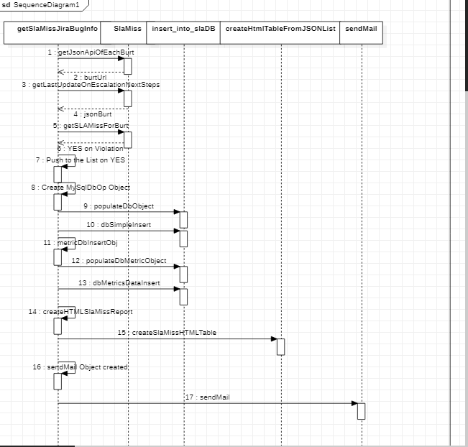

## **How to execute scripts:**

A.  $./runSlaMissReport.sh **PARSER** or without **PARSER**. If developer pass command line argument like "**PARSER**” then it tries to invoke the **SlaMiss/getSolidFireEmpParserInfo.php**

or if not passed with command line argument, then it try to call **SlaMiss/getSolidFireEmpInfo.php.**Both are same, the only difference is, parser will parse the <https://onestop.netapp.com/dir/username> website to get the SolidFire employee and its manager information. The other one will get the same information by querying the Oracle DB.

## **Types of Jira Resolution:**

Abandoned – No Consensus

Achieved

Already Fixed/Implemented

Approved

As Designed

Bug Jira Filed

By Design

Canceled

Cancelled

Can Not Reproduce

Closed

Coding

Declined

Deleted

D-patch

Duplicate

Documentation Change

Done

Enhancement Jira Filed

Exception

Failed

False Alarm

Fixed

Fixed (Customer Environment)

Fixed (NetApp Code Changes)

Fixed (NetApp Work Around)

Fixed In Field

Future Story

Hardware Failure

Incomplete

Invalid

Known Error

Live On Production

Monitoring

Need More Information

NetApp Hardware Failure

NetApp Hardware Issue

No Code Changes

Not A Bug

Not Fixed

Obsolete

Online

Prod Success

Prod Backlog

QA-success-no-prod

Question Answered

Question Answered (from docs)

Question Answered (from engineering)

Question Answered (tribal knowledge)

Ready For Release

Redirected

Rejected

Re routed

Resolved

Restricted

Reworked

SDL Not followed

Signing Not Required

Software Failure

Support Case opened

Test Failed

Third Part Hardware Failed

Third Party Hardware Issue

Third Party Software Failure

Third Party Software Issue

To be fixed

Unresolved

Untestable

Untested

Upstream Review

Verified

Won’t do

Won’t Fix

Workaround

Works for me

## **Jira Status Field:**

@Vendor

Accept

Acceptance Complete

Acceptance Review

Accept Done

Accepted

Accepted to Continue

Accept- In Progress

Access Provided

Action in plan

Active

Add Go-Live Date

Agreement

Almost Done, Need Master merge

Analysis

Backlog

Backlog/Unassigned

Backlog-MM

Blocked

Blocked -Designed

Blocked -PM

BRANCH MERGE PENDING

Buffer

Bug Under Validation

Bug Waiting on External

Build Broken

Building

Build Verification

Call

Canceled

Card Estimated

Changes Needed

Check-In/QUAK

CLCA

Close

Close As Duplicate

Closed

Closed – Will Not Fix

Code Changes

Code Complete

Code Merged

Code Review

Declared Stable

Declined

Deferred

Defined

Delivered

Dependency in Other Teams

Deployed to Dev/Test

Deployed to QA

Deployed to Staging

Deprecated

Design

Design Awaiting Approval

Design QA

Design Exploring

Design Complete

Editorial Work

EEA

Emerging Work

Engineering Analysis

Engineering Review

Engineering Triage

EOA

EOL

EPIC IN PROGRESS

Epics

EQRM Review

Escalated

Escalation Management

Evaluate

Evaluated

Fail

Failed

Feasibility

Finalize

Final Production

Final QA

Final Review

Final Release

FIX_REJECT

Fix Available

Fixed

Fix In Progress

Fugbugz Bugs

Free Parking

FROZEN

General Availability

Graveyard

Groomed

Handed Off to NSS Support

Hired

Hold/Blocked

Hub Policy Violation Removed

Hyper Care support

Icebox

Identified

IE-Release Requested

Implementation

Implementation - Complete

Implementation – In Progress

Implemented

Implementing

Inactive

In Code Review

Incoming

In complete Ticket

Incubated

In Definition

In Design

Kick Off

Kick-Off-Customer

Kick-Off-Internal

L2

L2

L4

Legal Team Waiting for Reply

Limited Supported

LLP

Live

Merchandise/Amplify

Merge

Mitigation

MockUp

Monitor

Monitoring

Move To Production

NEED_INPUT

Need Approval

Need In

Need More Info

Nee Clarity

Need Setup

Needs QA

Ned remediation

Need Review

Need Triage

Negotiate

New

None

Normalization

Obsolete

Oh-Hold

On Hold

On Deck

On Hold Public Report

Online Public Report

Open

Open Public report

OPS

Origination

Overridden

Owned

Part Of GPL

Passed

Per review / Change Manager Approval

Pending

Pending/Resolved

Pending Additional Information

Pending Approval

Pending Assignment

Pending - Bug Fix

Pending Clarification

Pending DevSup

Pending - LQP

Pending Requirements

Pending Review

QA

QE Accepted

QSR

Radio Cut

RCA Approved

RCA Closed

RCA Corrective Action

RCA On Hold

RCA Part Received

RCA Staging Complete

RCA Summery Complete

RCA Test Complete

RCA Test Start

RCA Vendor FA Complete

RCA Vendor FA Start

## **Burt_main table fields in Burt online ( BOO):**

BURT_ID

STATE

SEVERITY

PRIORITY

PUBLIC_STATUS

TYPE

SUBTYPE

IMPACT

DOC_IMPACT

PUBS_STATE

OWNER

GENERATION

TITLE

CREATED_AT

CREATED_BY

UPDATED_AT

UPDATED_BY

LOADED_DATE

SUBTEAM

SUBTEAM_EXTERNAL_CODE

FOUND_BY

ESCALATION_STATUS

CUSTOMER_DISRUPTION_FLAG

CUSTOMER_DEFECT_TYPE

CUSTOMER_CASE_SCORE

ORIGINAL_CHANGE

PANIC_STRING

## **BURT STATES in Burt Tool:**

UNTESTED

FIXED

MULTISTATE

WONT_FIX

DUP

CLOSED

OBSOLETE

NEW

COSMIC

TESTME

OPEN

STUDY

The End