# Apache-Httpd 2.4.29 Upgrade Guide

**Version 2.4.29**

**Date : 16-04-2018**

**Prepared by : Haramohan Sahu**

Contents

1. Introduction
2. Reason for upgrade
3. Upgrade steps
4. Code Changes in case
5. Building Package
6. Unit Testing
7. Testing case output for Apache-Httpd

# Introduction

Apache-Httpd is used to provide Httpd service.

Apache-Httpd provides:

* The Apache HTTP Server Project is an effort to develop and maintain an open-source HTTP server for modern operating systems including UNIX and Windows. The goal of this project is to provide a secure, efficient and extensible server that provides HTTP services in sync with the current HTTP standards.
* Apache provides a variety of MultiProcessing Modules (MPMs), which allow Apache to run in a process-based, hybrid (process and thread) or event-hybrid mode, to better match the demands of each particular infrastructure. This implies that the choice of correct MPM and the correct configuration is important. Where compromises in performance need to be made, the design of Apache is to reduce latency and increase throughput, relative to simply handling more requests, thus ensuring consistent and reliable processing of requests within reasonable time-frames.

# Reason for upgrade

To resolve Burt ID 1099629 and 1113011 as per current Burts list Apache-Httpd has been upgraded. The upgrade will ensure that compatible versions of the Apache, Jetty, JDK are installed when the DFM server is installed.

# Upgrade Steps

Few important steps are as follows:

Apache-Httpd Upgrade

1. Download the latest code of Apache-Httpd 2.4.29 from https://httpd.apache.org/download.cgi .
2. Compiling and installing Apache-Httpd code. Run below commands inside Apache-Httpd folder:

perl configure --target=x64 --prefix=to/build/ root_path \

--enable-proxy --enable-ssl --enable-ssl-staticlib-deps \

--enable-rewrite --enable-headers --enable-unixd --enable-negotiation --enable-socache-dbm --enable-cgi \

--enable-mods-static='proxy proxy_http cgi ssl mime rewrite unixd env authz_core authz_host dir log_config alias headers autoindex negotiation setenvif socache_dbm' \

--disable-authn-file --disable-authz-groupfile \

--disable-filter --disable-status \

--with-mpm=prefork --with-included-apr --with-ssl=path/to/openssl/dir \

--disable-shared --with-expat=builtin --with-apr-iconv=../apr-iconv --without-pgsql --without-odbc;

./config

make

make install

1. Once compiled and installed successfully, check-in the executable and library files from /rlse/champagne_shared/Rchampagne_shared-Rchalupa.1Px_JREN_xxxxxx_xxxx/release to \depot\prod\shared_components\NetAppAdmin\champagne_shared\release/
2. Download the code from perforce path \depot\prod\champagne_shared\Rchampagne_shared-Rchalupa.1Px_JRE\src\apache\httpd-2.4.29\ or follow step 5 and open in windows visual studio and give build. Take the output from DriveLetter:\Apache24 and check-in in to perforce \depot\prod\shared_components\NetAppAdmin\champagne_shared\release/
3. Or use this Bundle of Project file for windows build which is available in following path //depot/web/engineering/design-depot/appliance-mgmt/champagne/3rd-party-sw/
4. PCRE.h file must modified from PCRE_EXP_DECL to extern in the function declearation. (Not in macro define)
5. PCRE Libraray build command

cmake -G "Visual Studio 8 2005 Win64" -DPCRE_STATIC:BOOL="1" -DPCRE_STATIC_RUNTIME:BOOL="1" -DPCRE_BUILD_PCRECPP:BOOL="1" -DBUILD_STATIC_LIBS:BOOL="1" -DPCRE_BUILD_PCREGREP:BOOL="1" -DPCRE_SUPPORT_UNICODE_PROPERTIES:BOOL="1" -DINSTALL_MSVC_PDB:BOOL="1" -DPCRE_SUPPORT_UTF:BOOL="1" ..\

devenv PCRE.sln /useenv /nologo /build "Release|x64"

# Code Changes in case

Diff file attachment :-



Below is the list of files where code changes took place to suit DFM environment to work:

* httpd-2.4.29/build/ltmain.sh
* httpd-2.4.29/build/rpm/httpd.spec.in
* httpd-2.4.29/buildconf
* httpd-2.4.29/CMakeLists.txt
* httpd-2.4.29/configure
* httpd-2.4.29/configure.in
* httpd-2.4.29/httpd.spec
* httpd-2.4.29/INSTALL
* httpd-2.4.29/LICENSE
* httpd-2.4.29/Makefile.in
* httpd-2.4.29/Makefile.win
* httpd-2.4.29/modules/proxy/balancers/mod_lbmethod_heartbeat.c
* httpd-2.4.29/modules/ssl/mod_ssl.c
* httpd-2.4.29/modules/ssl/mod_ssl.dsp
* httpd-2.4.29/modules/ssl/mod_ssl.h
* httpd-2.4.29/modules/ssl/ssl_engine_config.c
* httpd-2.4.29/modules/ssl/ssl_engine_init.c
* httpd-2.4.29/modules/ssl/ssl_engine_io.c
* httpd-2.4.29/modules/ssl/ssl_engine_kernel.c
* httpd-2.4.29/modules/ssl/ssl_engine_ocsp.c
* httpd-2.4.29/modules/ssl/ssl_engine_vars.c
* httpd-2.4.29/modules/ssl/ssl_private.h
* httpd-2.4.29/modules/ssl/ssl_scache.c
* httpd-2.4.29/modules/ssl/ssl_util.c
* httpd-2.4.29/modules/ssl/ssl_util_ocsp.c
* httpd-2.4.29/modules/ssl/ssl_util_ssl.c
* httpd-2.4.29/modules/ssl/ssl_util_ssl.h
* httpd-2.4.29/modules/ssl/ssl_util_stapling.c
* httpd-2.4.29/NWGNUmakefile
* httpd-2.4.29/server/listen.c
* httpd-2.4.29/server/log.c

**Building Package**

### Build server for Linux:-

1. Linux build should use the special build BLDRH6SVL06.
2. Should have “VS2005” with “Service Pack” to avoid redistribution package error at run time.
3. Licensed copy of VS2005 is available in Umesh Home directory.
4. In windows the PCRE library open the pcre.h and change the function return type from PCRE_EXP_DECL to “extern” keyword in function itself function name called pcre_malloc, pcre_free, pcre_stack_malloc, pcre_stack_free, pcre_callout and pcre_stack_guard.

### Now build the package using:

**Windows** : **./make_dfm -W –p**

**Linux : ./make_dfm -L –p**

Now install the dfm server using installer on desired machine.

### Stop the dfm service using

**Linux : *Dfm services stop***

**Windows** : ***DFM services stop***

### Start the dfm service

**Linux : *Dfm services start***

**Windows** : ***DFM services start***

# Unit Testing

Server version: **Apache/2.4.29,**

cid:image005.png@01D3BBBC.AC5231F0



For port 8080/HTTP

Link: <http://scspr0414019002.gdl.englab.netapp.com:8080/start.html#st=0>

For port 8443/HTTPS

UI link: <https://scspr0414019002.gdl.englab.netapp.com:8443/start.html#st=0>

Verified the certificate information from the browser  Google chrome and IE for  verification and   it is picking up the right certificates  generated by dfm ssl setup and able to open successfully from Google chrome and IE, pasted the screen shot for the same

IE :UI

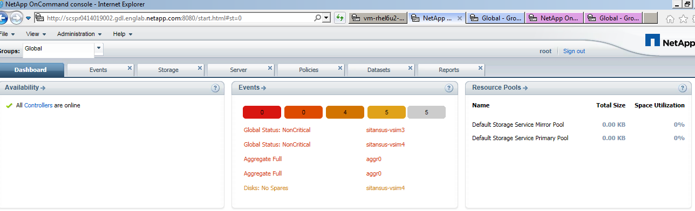

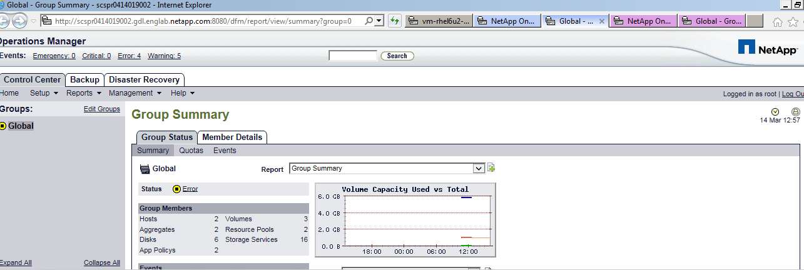

Chrome UI

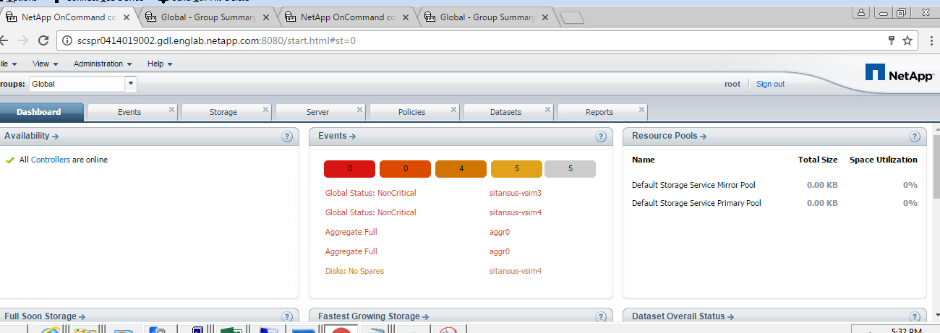

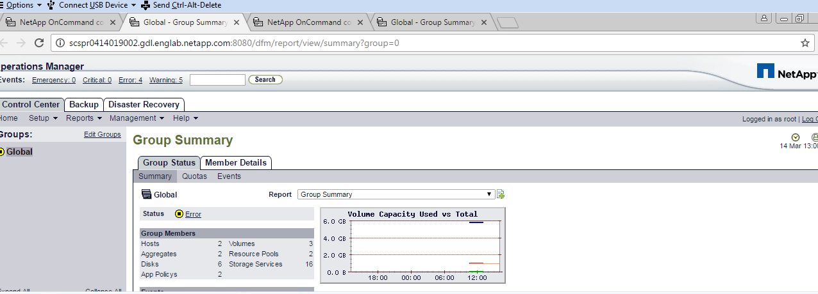

For port 8080/HTTP

Link: <http://scspr0414019002.gdl.englab.netapp.com:8080/start.html#st=0>

  Opsmngr link:  <http://scspr0414019002.gdl.englab.netapp.com:8080/dfm/report/view/summary?group=0>

For port 8443/HTTPS

UI link: <https://scspr0414019002.gdl.englab.netapp.com:8443/start.html#st=0>

               OpsMngr link: <https://scspr0414019002.gdl.englab.netapp.com:8443/dfm/report/view/summary?group=0>

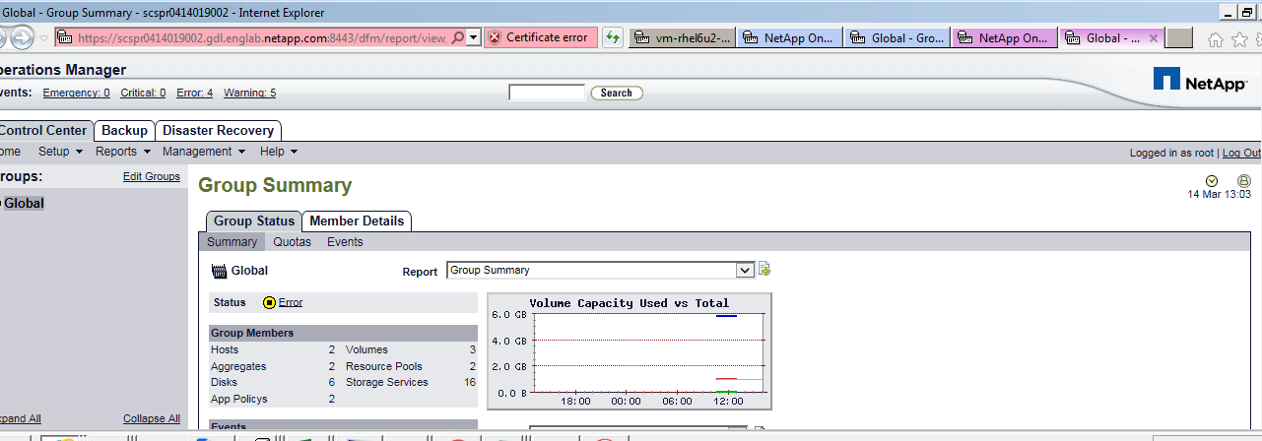

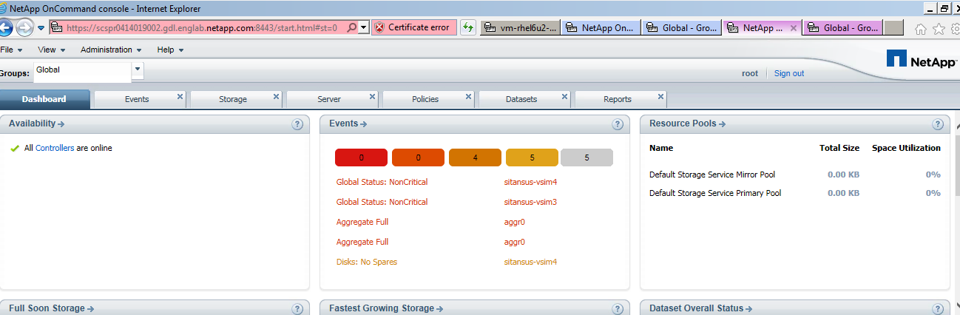

Ui for Chrome:

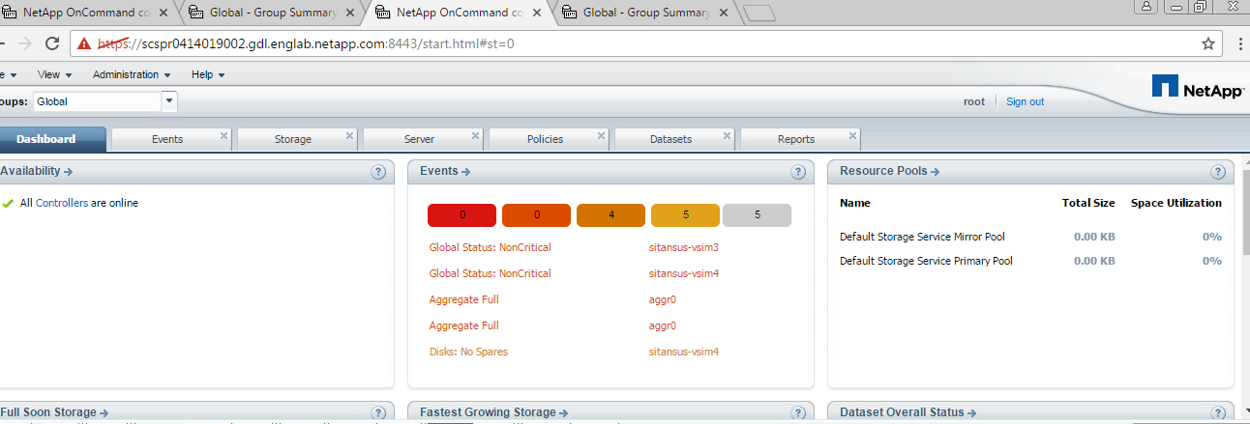

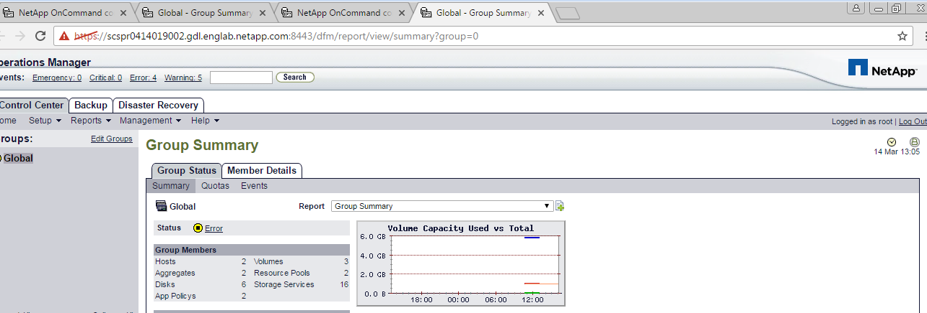

The browsers used to access Operations Manager must be Internet Explorer 6.0 or later, or Mozilla suite 1.7 or later, or Mozilla FireFox 1.5 or later. Operations Manager does not support Netscape Navigator.

The default URL mentioned above can be changed via subsequent customization. You can always view the current configuration in Operations Manager by selecting "Options" in the "Setup" menu, then select "Security", or by using the command:

$ dfm option list httpEnabled httpPort httpsEnabled httpsPort

Option          Value

--------------- ------------------------------

httpEnabled     Yes

httpPort        8080

httpsEnabled    No

httpsPort       8443

To change the ports, **"How do I enable HTTPS protocol for accessing Operations Manager**

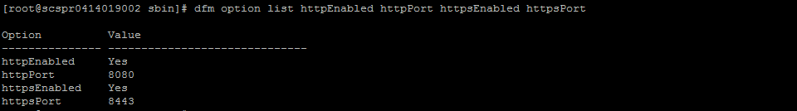

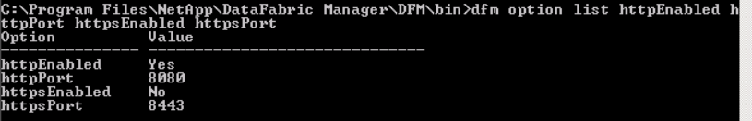

Access an Operations Manager page

Make sure that you are accessing Operations Manager using the correct URL which is:

*protocol*://*server*:*port*/

where:

* *protocol* is either HTTP or HTTPS depending on the security settings you have selected. Default is HTTP.
* *server* is the name or address of the system on which you installed DataFabric Manager.
* *port* is the port for the selected *protocol*. Default is 8080 for HTTP and 8443 for HTTPS.

The browsers used to access Operations Manager must be Internet Explorer 6.0 or later, or Mozilla suite 1.7 or later, or Mozilla FireFox 1.5 or later. Operations Manager does not support Netscape Navigator.

**Windows Unit Test Screen shot**

**After login to Ops Manager: -**

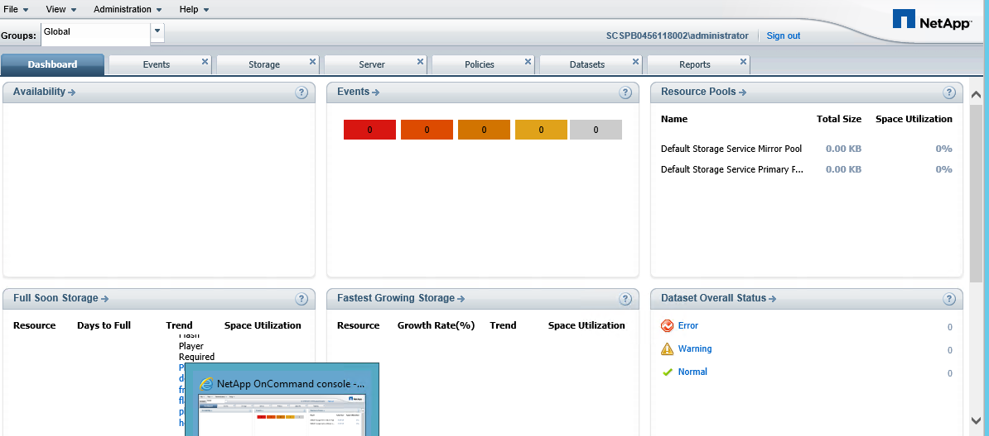

**Adding Filers into DFM:**

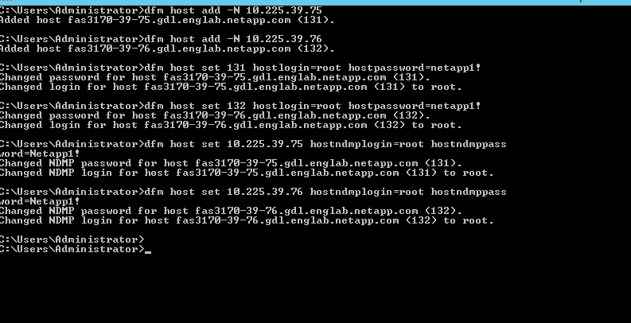

**After adding Filers into DFM:**

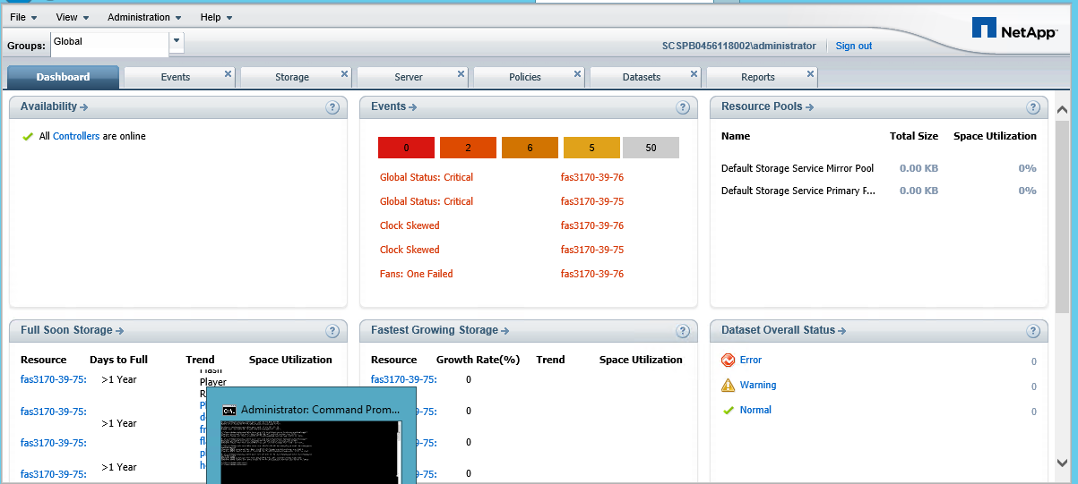

**Ops Manager: -**

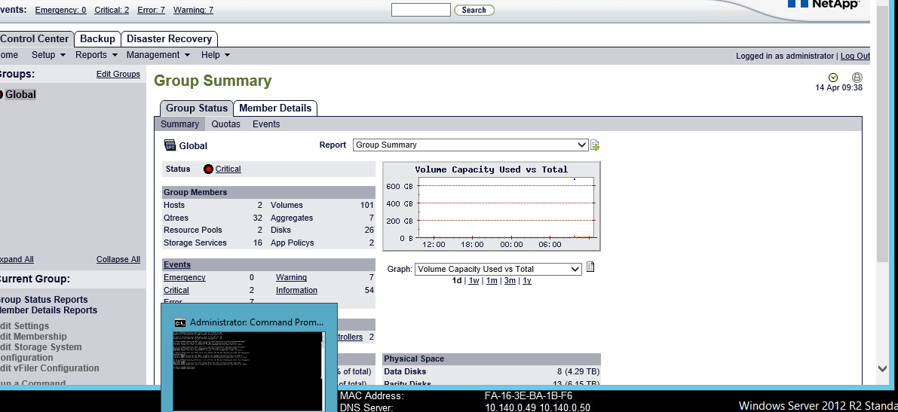

**NMC installing successfully: -**

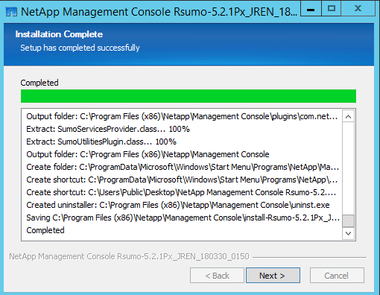

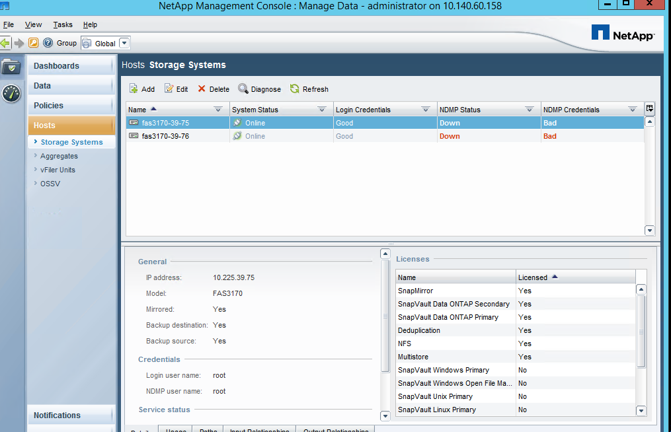

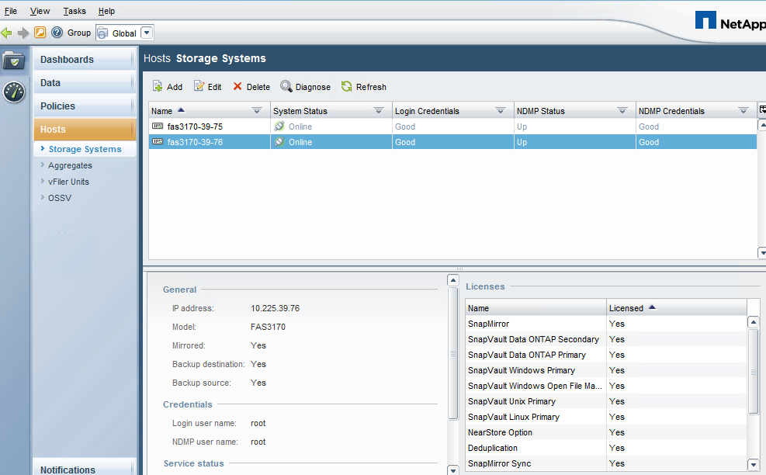

**Port: HTTPS/8448:**

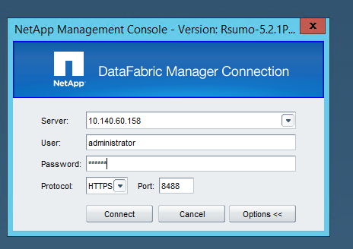

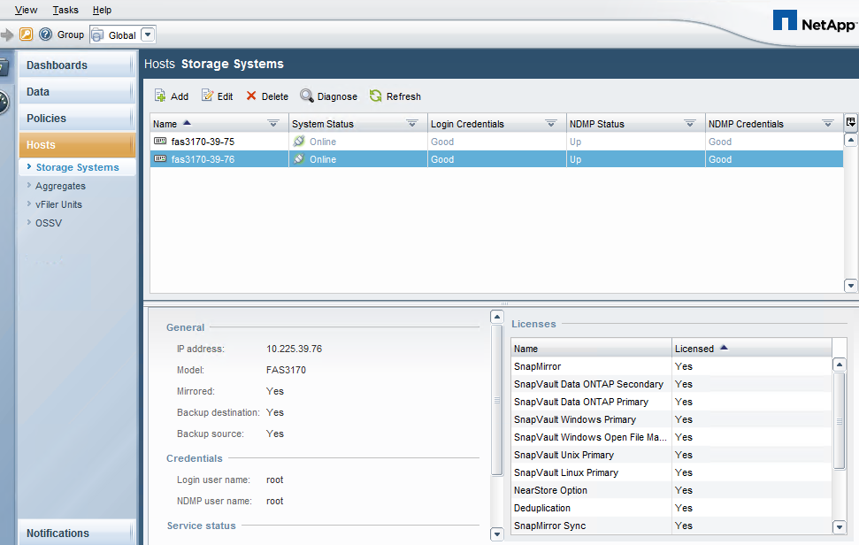

**Port :8088 Http:-**

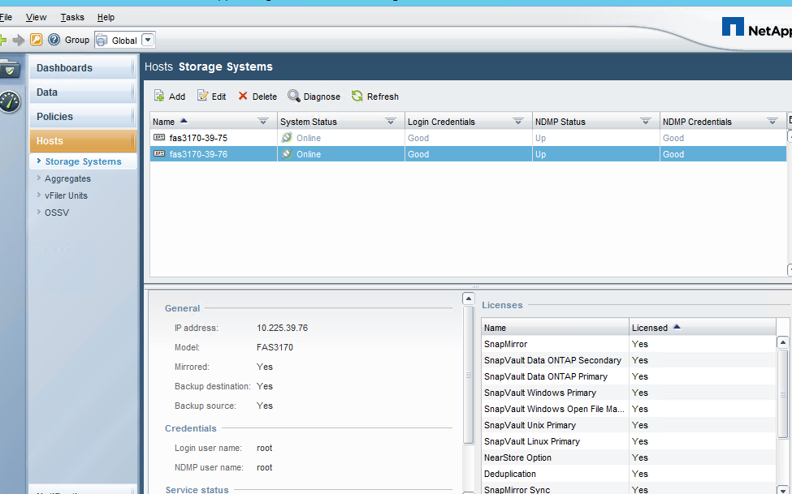

Reports tab:-

