Interview Application Documentation

Database Documentaiion :

CREATE SCHEMA IF NOT EXISTS `InterviewApp` ;

USE `InterviewApp` ;

Admin Query:

CREATE TABLE IF NOT EXISTS `InterviewApp`.`Admin` (
`Adminid` INT(4) NOT NULL AUTO_INCREMENT,
`Name` VARCHAR(20) NOT NULL,
`Email` VARCHAR(45) NOT NULL,
`Password` VARCHAR(20) NOT NULL,
`Role` VARCHAR(10) NOT NULL,
`EmptyCol1` VARCHAR(45) NULL DEFAULT NULL,
`EmptyCol2` INT NULL DEFAULT NULL,
`EmptyCol3` INT NULL DEFAULT NULL,
PRIMARY KEY (`Adminid`),
UNIQUE INDEX `Email_UNIQUE` (`Email` ASC) VISIBLE)
ENGINE = InnoDB;

ALTER TABLE Admin AUTO_INCREMENT = 100;
desc Admin;
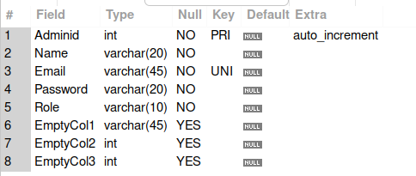

Admin Data sample

Insert into Admin(Name,Email,Password,Role)
values('Aniket','aniket1@gmail.com','aniket','admin');
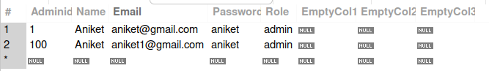
User Query:

CREATE TABLE IF NOT EXISTS `InterviewApp`.`Users` (
`Userid` INT(4) NOT NULL AUTO_INCREMENT,
`FirstName` VARCHAR(20) NOT NULL,
`LastName` VARCHAR(20) NOT NULL,
`Email` VARCHAR(45) NOT NULL,
`Password` VARCHAR(20) NULL,
`Mobile` VARCHAR(20) NOT NULL,
`Address` VARCHAR(45) NULL,
`Dob` DATE NOT NULL,
`Qualification` VARCHAR(20) NOT NULL,
`Profile` VARCHAR(45) NULL,
`LastModified` DATETIME NULL,
`Gender` VARCHAR(9) NOT NULL,
`Role` VARCHAR(9) NOT NULL,
`Adminid` INT NULL,
`EmptyCol1` INT NULL DEFAULT NULL,
`EmptyCol2` VARCHAR(45) NULL DEFAULT NULL,
`EmptyCol3` TINYINT NULL DEFAULT NULL,
`EmptyCol4` VARCHAR(45) NULL DEFAULT NULL,
`EmptyCol5` VARCHAR(30) NULL DEFAULT NULL,
`EmptyCol` TINYINT NULL DEFAULT NULL,
PRIMARY KEY (`Userid`),
UNIQUE INDEX `Email_UNIQUE` (`Email` ASC) VISIBLE,
INDEX `fk_admin_user_idx` (`Adminid` ASC) VISIBLE,
CONSTRAINT `fk_admin_control`
FOREIGN KEY (`Adminid`)
REFERENCES `InterviewApp`.`Admin` (`Adminid`)
ON DELETE NO ACTION
ON UPDATE NO ACTION)
ENGINE = InnoDB;

ALTER TABLE Users AUTO_INCREMENT = 001;

desc Users;

User Data Sample
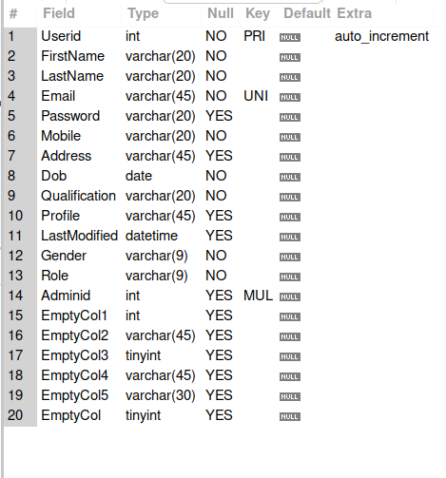

INSERT into Users (FirstName,LastName,Email,Password,Mobile,Address,Dob,Qualification,LastModified,Gender,Role)
values('Aniket','Pawar','aniket@gmail.com','user','9998887771','pune','1999-01-01','B.Tech',now(),'Male','User');

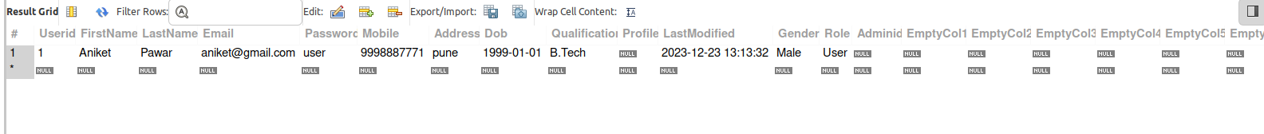

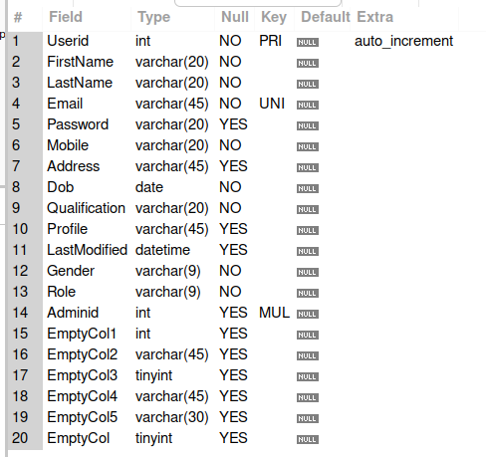
desc Users;

Interviewer Query:

CREATE TABLE IF NOT EXISTS `InterviewApp`.`Interviewers` (
`Interviewerid` INT(4) NOT NULL AUTO_INCREMENT,
`FirstName` VARCHAR(20) NOT NULL,
`LastName` VARCHAR(20) NOT NULL,
`Email` VARCHAR(45) NOT NULL,
`Password` VARCHAR(20) NOT NULL,
`Mobile` VARCHAR(20) NULL,
`Address` VARCHAR(45) NULL,
`Dob` DATE NOT NULL,
`CompanyPosition` VARCHAR(45) NULL,
`QualifiedDegree` VARCHAR(20) NOT NULL,
`Profile` VARCHAR(45) NULL,
`ProfileUpdated` DATETIME NULL,
`Gender` VARCHAR(9) NOT NULL,
`Role` VARCHAR(15) NOT NULL,
`Adminid` INT NULL,
`EmptyCol1` INT NULL DEFAULT NULL,
`EmptyCol2` VARCHAR(45) NULL DEFAULT NULL,
`EmptyCol3` VARCHAR(45) NULL DEFAULT NULL,
`EmptyCol4` VARCHAR(30) NULL DEFAULT NULL,
`EmptyCol5` TINYINT NULL DEFAULT NULL,
PRIMARY KEY (`Interviewerid`),
UNIQUE INDEX `Email_UNIQUE` (`Email` ASC) VISIBLE,
INDEX `fk_admin_Interviewers_idx` (`Adminid` ASC) VISIBLE,
CONSTRAINT `fk_admin_control_1`
FOREIGN KEY (`Adminid`)
REFERENCES `InterviewApp`.`Admin` (`Adminid`)
ON DELETE NO ACTION
ON UPDATE NO ACTION)
ENGINE = InnoDB;

ALTER TABLE Interviewers AUTO_INCREMENT = 1000;

INSERT INTO Interviewers(FirstName,LastName,Email,Password,Mobile,Address,Dob,CompanyPosition,QualifiedDegree,ProfileUpdated,Gender,Role)
values('Aniket','pawar','aniket@gmail.com','interviewer','999999999','pune','2000-01-01','Microsoft','M.Tech',now(),'Male','Interviewer');

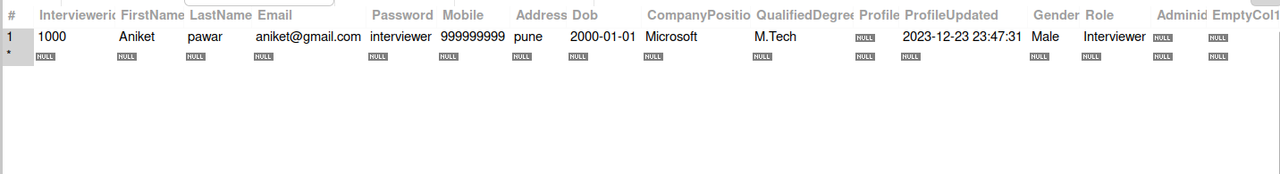
Students Api file Interviewer Api File Admin Api file
1. Login 1. Login 1. Login
2.Register 2.Register 2.Register
3.EditProfile 3.EditProfile 3.EditProfile
4.DeleteProfile 4.DeleteProfile 4.DeleteProfile
5.GetAllSubjectsTypes 5.GetAllSubjectsType s 5.GetAllSubjectsTypes
6.GetAllInterviewer 6.SelectBywhichStudent 6.AddSubjectsTypes
7.SetInterview 7.InterviewSceduled 7.DeleteSubjectsTypes
8.GettingFeedback 8.SetFeedbackForStu. 8.GetAllInteviewsDone
9.AddinRecords 9.FetchAllInterviews 9.AddDemoQuestions
10.EditDemoQuestions
11.DeleteDemoQuestions
10.FetchAllInterviews 10. GetAllStudents
11.GellAllDemoQuestions 11.DeleteAnyStudents
12.GetAllInterviewer
13.DeleteAnyInterviewer

