**Department of CSE**

**Lab Report**

|  |  |
| --- | --- |
| **Course Code and Name:**  CSE303 – Statistics for Data Science | |
| **Lab:** 02  **Intermediate Python Programming** | |
| **Name of Student:**  Intesar Islam Khan  ID: 2019-1-60-043 | **Course Instructor information:**  **Md Al-Imran**  Lecturer Department of Computer Science & Engineering |
| **Section:** 02 | **Date of Submission:**  21/10/2022 |

Source code: [CSE303-Statistics-for-Data-Science-LAB/Lab2 at main · IntesarEWU/CSE303-Statistics-for-Data-Science-LAB (github.com)](https://github.com/IntesarEWU/CSE303-Statistics-for-Data-Science-LAB/tree/main/Lab2)

**LABHW:**

1.

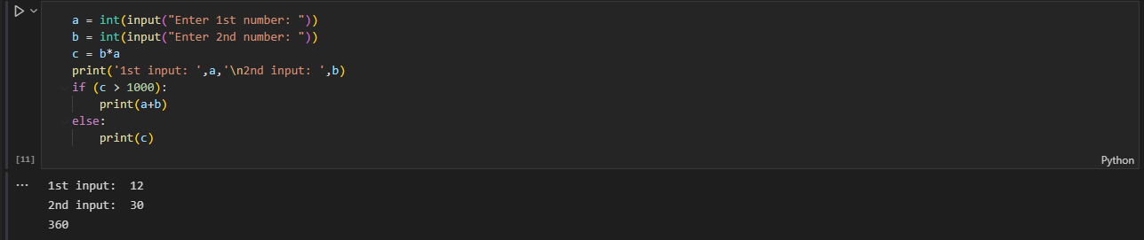

2.

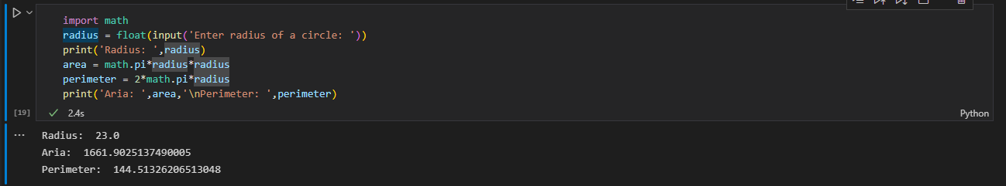

3.

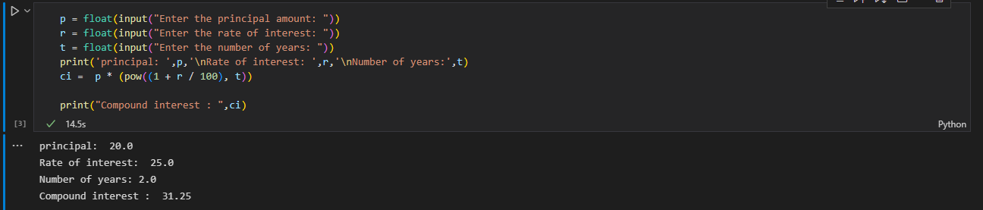

4.

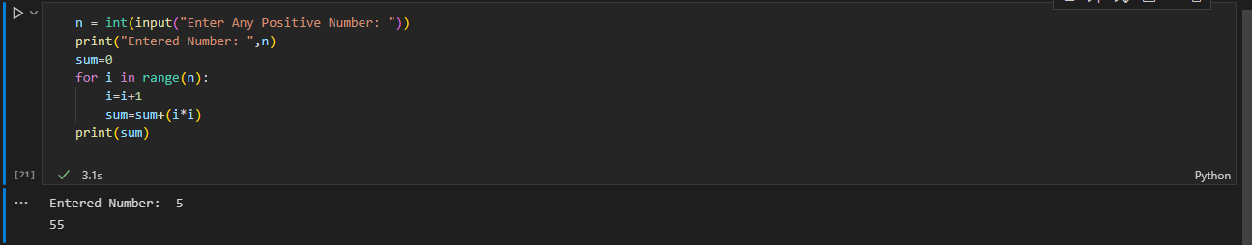

5.

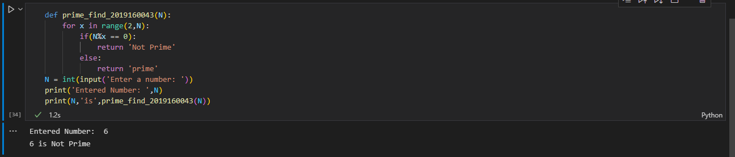

6.

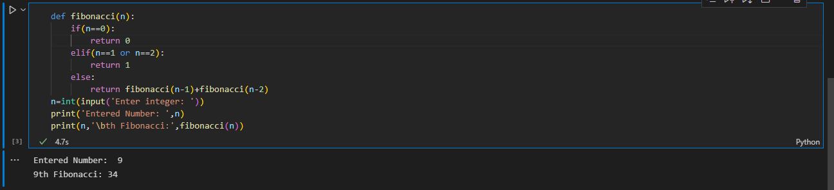

7.

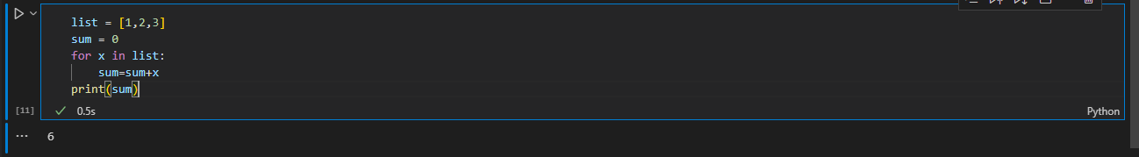

8.

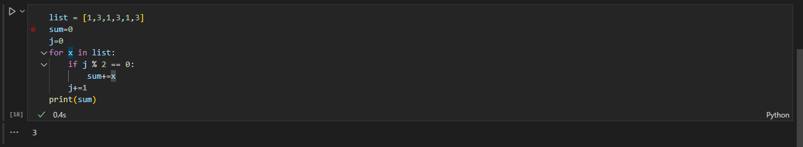

**Python String capitalize(): Converts first character to Capital Letter  
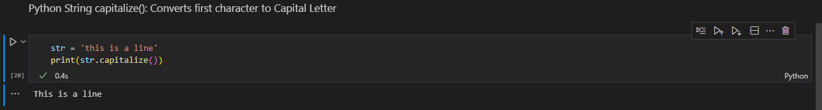**

**Python String casefold(): converts to case folded strings**

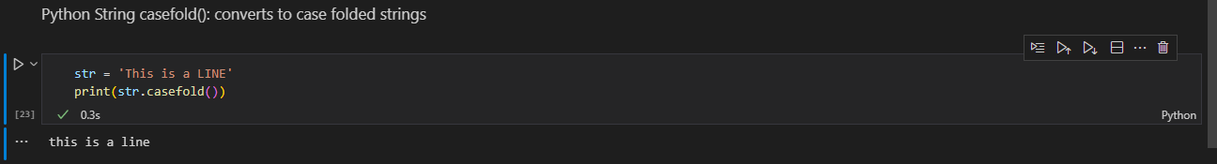

**Python String center(): Pads string with specified character**

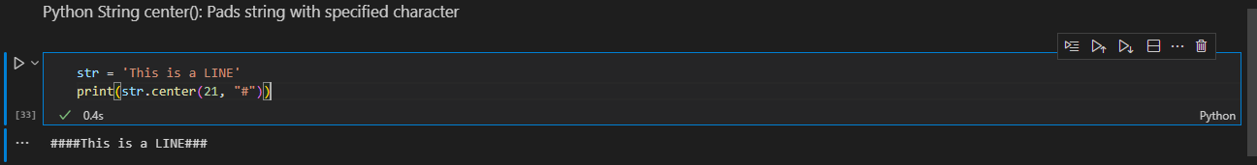

**Python String count(): returns occurrences of substring in string**

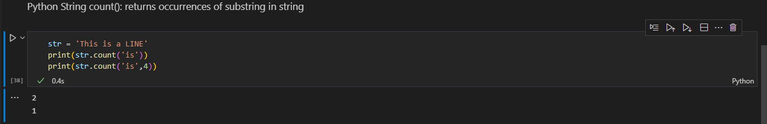

**Python String encode(): returns encoded string of given string**

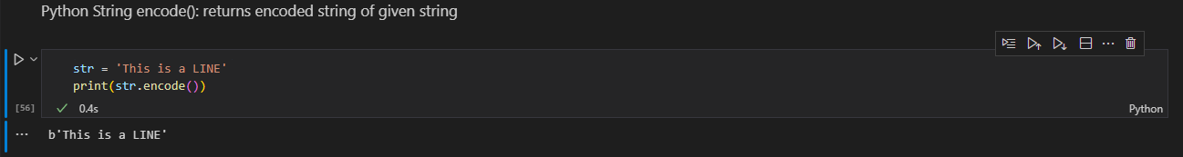

**Python String endswith(): Checks if String Ends with the Specified Suffix**

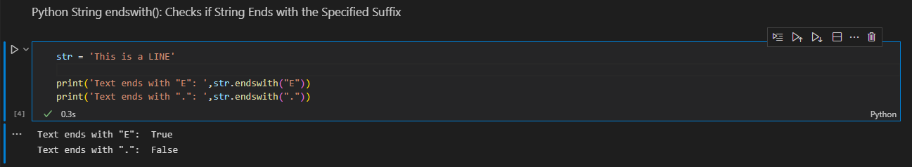

**Python String expandtabs(): Replaces Tab character With Spaces**

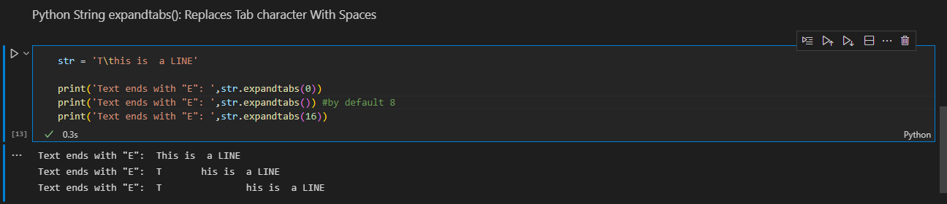

**Python String find(): Returns the index of first occurrence of substring**

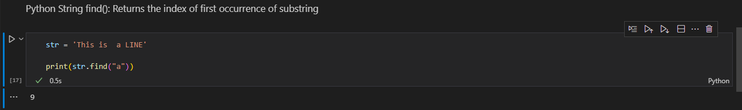

**Python String format(): formats string into nicer output**

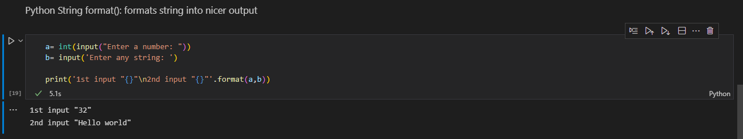

**Python String format_map(): Formats the String Using Dictionary**

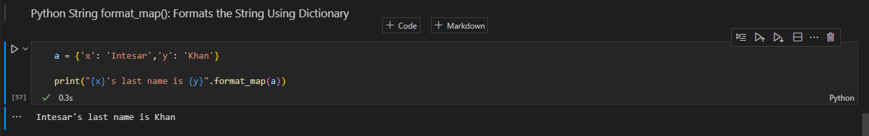

**Python String index(): Returns Index of Substring**

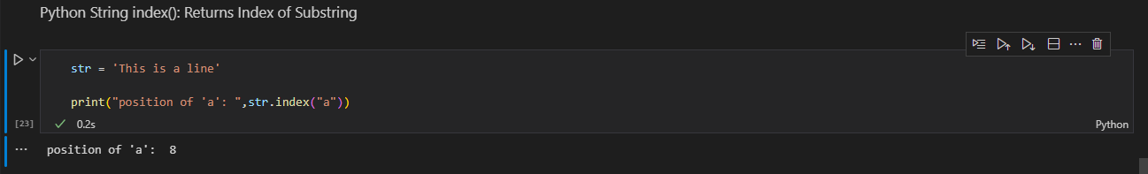

**Python String isalnum(): Checks Alphanumeric Character**

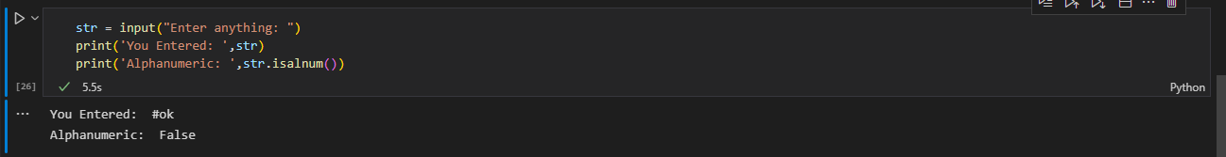

**Python String split(): Splits String from Left**

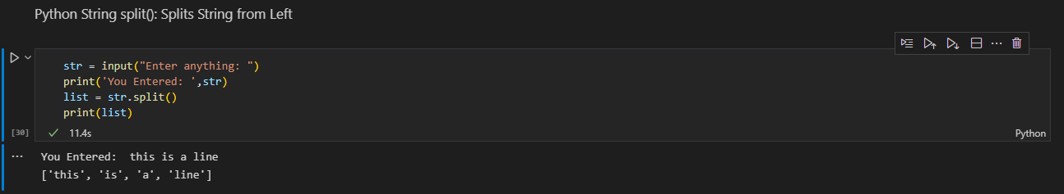

**Python String join(): Returns a Concatenated String**

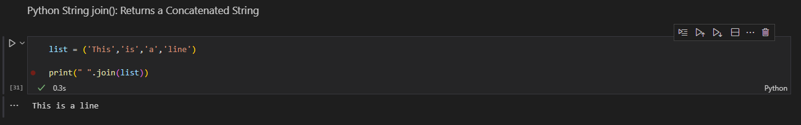

**Python String replace(): Replaces Substring Inside**

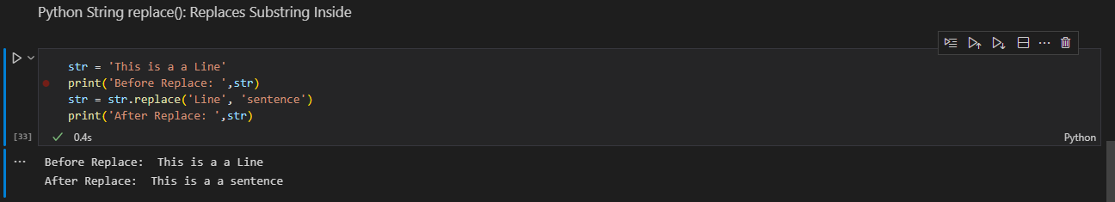

**Python String strip(): Removes Both Leading and Trailing Characters**

