CHAPTER 1­­

**INTRODUCTION**

A database management system (DBMS) refers to the technology for creating and managing databases. Basically DBMS is a software tool to organize (create, retrieve, update, manage) data in a database.

The main aim of a DBMS is to supply a way to store up and retrieve database information that is both convenient and efficient. By data, we mean known facts that can be recorded and that have embedded meaning. Normally people use software such as DBASE IV or V, Microsoft ACCESS, or EXCEL to store data in the form of database.

Database systems are meant to handle large collection of information. Management of data involves both defining structures for storage of information and providing mechanisms that can do the manipulation of those stored information. Moreover, the database system must ensure the safety of the information stored, despite system crashes or attempts at unauthorized access.

This project is aim at searching the restaurants according to the area and customer’s choice. Frontend and backend are implemented using PHP and MYSQL respectively. The project consists of three forms (entities) namely customer who will register the restaurant with its details, feedback where the customer gives the ratings to the restaurant and can give the comments to the restaurant.

This project aims in developing a computerized system to maintain the details of the restaurants in the desired locations. This project has features like user login and admin login. The user login feature helps the user to personalize the details like location, etc. The admin login feature helps the admin monitor the whole system. This database includes the images of the restaurant, the menu details of the food.

* 1. **Background Study**

**MySQL:**

MySQL is multithreaded, multi user SQL database management system (DBMS).The basic program run as server providing multiuser access to a number of databases.

MYSQL is a free and open – source software under the terms of GNU General Public License, and is also available under a variety of proprietary licenses. MySQL was owned and sponsored by Swedish Company MySQL AB, which was bought by Sun Microsystems.

MySQL is a component of the LAMP web application software stack, which is acronym for LINUX, APACHE, MySQL, PERL, PHP and PYTHON. MySQL is used by many database-driven web applications, including Drupal, Joomla and WordPress. MySQL is also used by many popular websites like – Facebook, Flickr, Twitter and YouTube.

**PHP:**

PHP is a server-side backend programming language. It executes in server along with maximum all available web servers like Apache, IIS (Internet Information Server) etc…, and return the response as required MIME type.

It is a Pre-Processor Hypertext; we could do many things on the server side by using PHP on server and coordinate with DB server for CURD (Create, Update, Read, Delete) actions.

Frontend in the séance, UI which interact the users, it can be done by HTML and UI behavior is defined in UI backend languages: Java Script, VB Script etc.

Characteristics of PHP

Five important characteristics make PHP's practical nature possible:

1. Simplicity.
2. Efficiency.
3. Security.
4. Flexibility.
5. Familiarity.

Chapter 2

**REQURIMENT SPECIFICATION**

A software requirements specification (SRS) is a comprehensive description of the intended purpose and environment for software under development. The SRS fully describes what the software will do and how it will be performed.

**2.1 Functional Requirements**

Functional requirements define the fundamental actions that system must perform. The functional requirements for the system are divided into two main categories, namely admin and user.

-Admin: can insert, analyze, update and delete the tables.

-User: can register their information, search the restaurant according to the cuisine and veg and non-veg, give ratings to the restaurant and can comment about the experience.

**2.2 Data Requirements**

-The system shall record the customer’s name.

-The system shall record the customer’s date-of-birth.

-The system shall allot the customer a customer-id.

-The system shall record the user name and password of the customer.

-The system shall record the restaurant’s name.

-The system shall allot the restaurant a restaurant-id.

-The system shall record the phone number, address of the restaurant.

-The system shall display the images of the restaurant and images of the menu after the customer selects a restaurant of his choice.

**2.3 Software Requirements**

MySQL console (Backend)

PHP (Frontend)

Notepad

WAMP Server

Operating System: Windows 10 Pro

**2.4 Hardware Requirements**

Processor: Intel i5 Core Processor

Clock Speed: 2.5GHz

Monitor: 1366*768 Pixels

Keyboard: QWERTY

RAM: 8GB

Input and output console for interaction

Printer for printing the reports and notes.

Chapter 3

**Design**

**3.1 E-R Diagram**

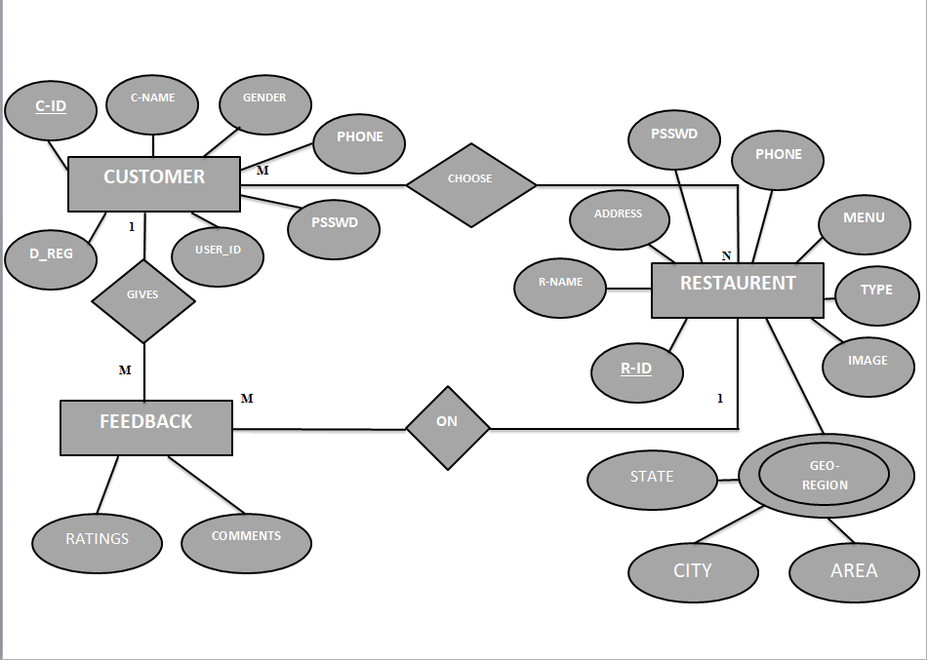

**Fig 3.1: E-R Diagram of Restaurant Advice Management System**

**3.2 Schema Diagram**

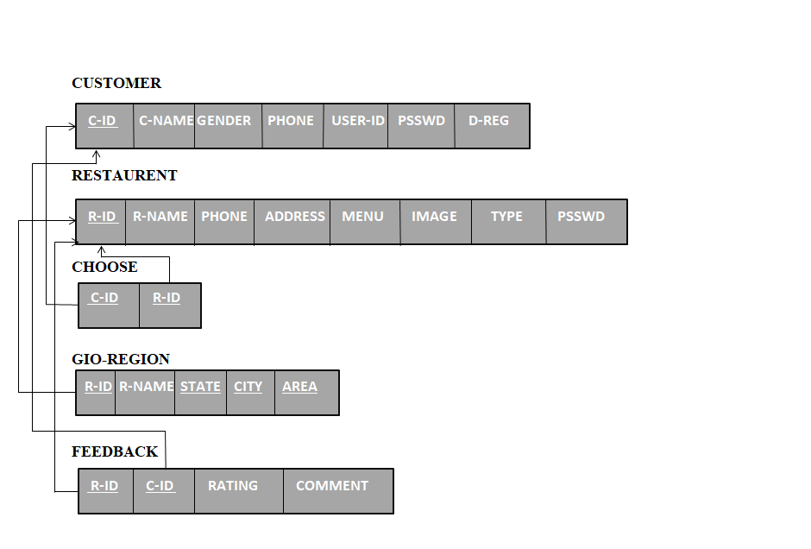

**Fig 3.2: Schema Diagram for Restaurant Advice Management System**

**3.3 Functional Dependences**

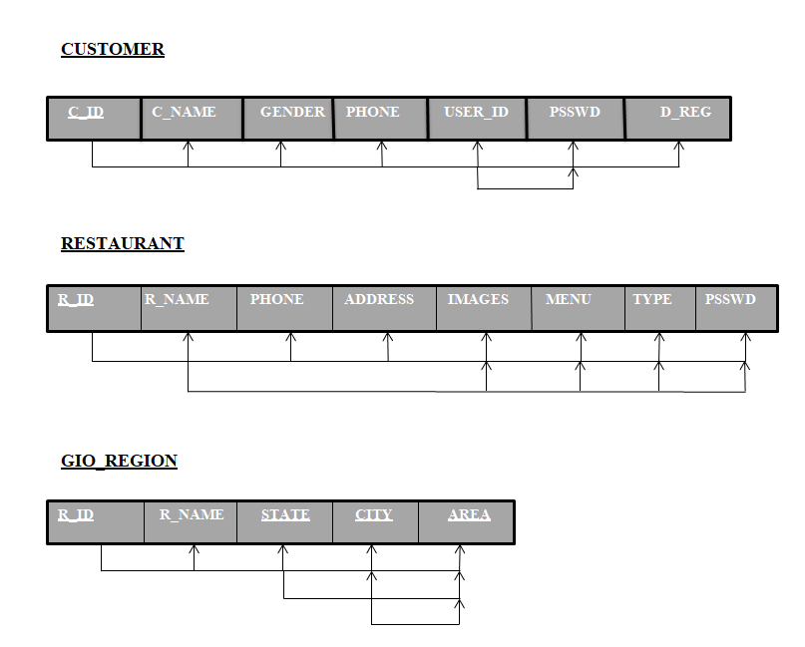

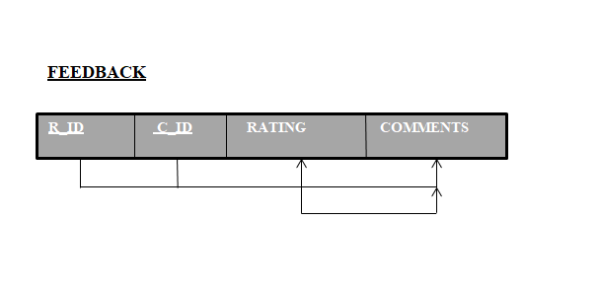

**3.4 Normalization**

Chapter 4

**IMPLEMENTATION**

**1. Implementation code to login page**

<?php

if(isset($_POST['btn_admin']))

{

header('Location:adminloginpage.php');

}

elseif(isset($_POST['btn_user']))

{

header('Location:userloginpage.php');

}

?>

<html>

<head>

<style>

body

{

background-image: url("http://localhost/miniproject/pics/loginpag.jpg");

background-repeat:no-repeat;

background-size: 100%;

}

.p{

color: white;

}

</style>

<body>

<h3><div id="LOGIN">

<fieldset=style="width:30%">

<legend><p class="p"> Select Admin/User</p></legend><br>

<label><p class="p">If you want to Add New Restaurant Log-In Here</p></label><br><br>

<input id="button" type="submit" name="submit" value="Admin" onClick="document.location.href='http://localhost/miniproject/adminloginpage.php'"/ color=white ><br><br>

<label><p class="p">If you want to view Restaurants Log-In Here</p></label><br><br>

<input id="button" type="submit" name="submit" value="User" onClick="document.location.href='http://localhost/miniproject/userloginpage.php'"/><br><br></fieldset=style="width:30%"></h2></div></h3>

</fieldset>

</div>

</body>

<html>

**2.Implementation code to add restaurant**

<html>

<head>

<style>

body

{

background-image: url("http://localhost/miniproject/pics/addrest.jpg");

background-repeat:no-repeat;

background-size: 100%;

}

.p{

color: white;

}

</style>

</head>

<body>

<h2><p class="p"> Insert new restaurant </h2>

<form action="<?php $_PHP_SELF ?>" method="POST">

<p class="p">Restaurant Name:<input type="text" name="t_name"> <br><br>

Restaurant ID:<p class="p"><input type="text" name="t_id" > <br><br>

Phone no:<p class="p"><input type="text" name="t_phone" > <br><br>

Address:<p class="p"><input type="text" name="t_address"> <br><br>

Image:<p class="p"><input type="text" name="t_image"> <br><br>

Menu:<p class="p"><input type="text" name="t_menu"> <br><br>

Type:<p class="p"> <input type="radio" name="t_type" value="veg">Veg

&nbsp;&nbsp;&nbsp;<input type="radio" name="t_type" value="nonveg">Non Veg<br><br>

Password:<p class="p"><input type="Password" name="t_psswd"><br><br>

<input type="submit" name="b_submit" value="Register"><br><br>

<label>After the Registration click here to add the gio_region</label><br><br>

<input type="submit" name="b_submit1" value="Add Gio_region"><br><br>

<input type="submit" name="b_submit2" value="Back">

</form>

</body>

</html>

<?php

if(isset($_POST['b_submit2']))

{

header('location:adminloginpage.php');

}

if(isset($_POST['b_submit1']))

{

header('location:addgio_region.php');

}

if(isset($_POST['b_submit'])){

$dbhost = 'localhost';

$dbuser = 'root';

$dbpass = ' ';

$db='miniproject';

$conn = mysql_connect($dbhost, $dbuser, $dbpass, $db);

mysql_select_db('miniproject');

if(! $conn ) {

die('Could not connect: ' . mysql_error());

}

$rn=' ';

$rid=' ';

$phno=' ';

$add=' ';

$i=' ';

$m=' ';

$p=' ';

if(isset($_POST['t_id'])){

$rn=$_POST['t_name'];

$rid=$_POST['t_id'];

$add=$_POST['t_address'];

$phno=$_POST['t_phone'];

$i=$_POST['t_image'];

$m=$_POST['t_menu'];

$p=$_POST['t_psswd'];

$sql= "insert into restaurant(r_id,r_name,phone,address,image,menu,type,psswd) values($rid,'$rn',$phno,'$add','$i','$m','$radioVal','$p')";

$res = mysql_query($sql,$conn);

if(!$res)

{

die('could not get data:'. mysql_error());

}

echo "<br>";

echo "Restaurant added successfully";

}

mysql_close($conn);

}

?>

**3. Implementation code to delete the restaurant**

<html>

<head>

<style>

body

{

background-image: url("http://localhost/miniproject/pics/del.jpg");

background-repeat:no-repeat;

background-size: 100%;

}

.p{

color: white;

}

</style>

</head>

<body>

<h2> <p class="p">Delete a Restaurant </h2>

<form action="<?php $_PHP_SELF ?>" method="POST">

<p class="p">Enter Restaurant ID:<input type="text" name="t_id" > <br><br>

<input type="submit" name="b_submit" value="Delete Restaurant">

<input type="submit" name="btn_home" value="Return to home">

</form>

</body>

</html>

<?php

if(isset($_POST['btn_home']))

{

header('Location:homepage.php');

}

$dbhost = 'localhost';

$dbuser = 'root';

$dbpass = '';

$db='miniproject';

$conn = mysql_connect($dbhost, $dbuser, $dbpass, $db);

mysql_select_db('miniproject');

if(! $conn ) {

die('Could not connect: ' . mysql_error());

}

if(isset($_POST['t_id'])){

$r=$_POST['t_id'];

$sql1= "delete from gio_region where r_id='$r'";

$sql= "delete from restaurant where r_id='$r'";

$res = mysql_query($sql1,$conn);

$res1 = mysql_query($sql,$conn);

if($res && $res1)

{

echo "Restaurant details deleted successfully";

}

else{

echo "<br>";

echo "No such Restaurant";

}

}

mysql_close($conn);

if(isset($_POST['btn_home']))

{

header('Location:homepage.php');

}

?>

**4. Implementation code to add the customer**

<html>

<head>

</head><style>

body

{

background-image: url("http://localhost/miniproject/pics/adcus.jpg");

background-repeat:no-repeat;

background-size: 100%;

}

.p{

color: black;

}

</style>

<body>

<h2> Insert new customer </h2>

<form action="<?php $_PHP_SELF ?>" method="POST">

<p class="p">Customer Name:<br><input type="text" name="t_name"> <br><br>

Customer ID:<p class="p"><input type="text" name="t_id" > <br><br>

Gender:<p class="p"><input type="radio" name="t_type" value="male">Male

&nbsp;&nbsp;&nbsp;<input type="radio" name="t_type" value="female">Female<br><br>

Phone<p class="p"><input type="text" name="t_phone"> <br><br>

User ID:<p class="p"><input type="text” placeholder="Enter your Email-Id" name="t_userid"> <br><br>

<label><p class="p">Password must contain maximum 8 characters</label><br><br>

Password:<p class="p"><input type="Password" name="t_password"> <br><br>

Date of Registration:<p class="p"><input type="Date" name="t_regdate"> <br><br>

<input type="submit" name="b_submit" value="Register"><br><br>

<label><p class="p">After Registration click here</label><br><br>

<input type="submit" name="b_home" value="Proceed">

</form>

</body>

</html>

<?php

if(isset($_POST['b_home'])){

header("Location:userhomepage.php");

}

$dbhost = 'localhost';

$dbuser = 'root';

$dbpass = '';

$db='miniproject';

$conn = mysql_connect($dbhost, $dbuser, $dbpass, $db);

mysql_select_db('miniproject');

if(! $conn ) {

die('Could not connect: ' . mysql_error());

}

$cn='';

$cid='';

$g='';

$phno='';

$u='';

$p='';

$d='';

if(isset($_POST['t_id'])){

$cn=$_POST['t_name'];

$cid=$_POST['t_id'];

$phno=$_POST['t_phone'];

$u=$_POST['t_userid'];

$p=$_POST['t_password'];

$d=$_POST['t_regdate'];

$sql= "insert into customer(c_id,c_name,gender,phone,user_id,psswd,d_reg) values($cid,'$cn','$g',$phno,'$u','$p','$d')";

$res = mysql_query($sql,$conn);

if(!$res)

{

die('could not get data:'. mysql_error());

}

echo "<br>";

echo "Registration successfully";

}

mysql_close($conn);

?>

Chapter 5

**SNAPSHOTS**

**CONCLUSION**

To conclude, this system is designed to be a useful application to the people so that they can check the Restaurants according to their choice and taste of interest and they can even call the Restaurant to reserve the tables or order the food and check for home delivery.

This project is a kind of advantage for the Restaurants so that, the Restaurant can be easily found without any kind of trouble. Good Ratings, positive comments about the Restaurant can attract some Customers and the ambiance of the Restaurant will attract some of the Customers.

**BIBLOGRAPHY**

1. Fundamentals of Database Management Systems (6th Edition)

-by Ramesz Elmasri and Shakant B Navathe

2. [www.wikipedia.org](http://www.wikipedia.org) for the information

3. Google Images for the images of the Restaurants.