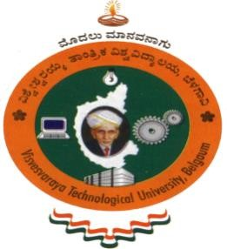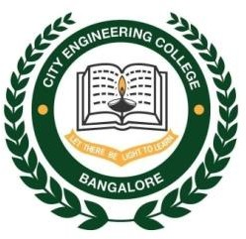

# VISVESVARAYA TECHNOLOGICAL UNIVERSITY

## JnanaSangama, Belgaum-590014

**A DBMS Mini Project Report**

**On**

**“RESTAURANT ADVICE MANAGEMENT”**

**Submitted in Partial fulfillment of the Requirements for the V Semester of the Degree of**

**Bachelor of Engineering In**

**Computer Science & Engineering By**

**S.BHAVYA SRI (1CE17CS098)**

**SAHANA.N (1CE17CS103)**

**Under the Guidance of Mrs. ARCHANA BHAT**

**Asst. Professor, Dept. of CSE**

**CITY ENGINEERING COLLEGE**

**Doddakallasandra, Kanakapura Road, Bengaluru-560061**

**CITY ENGINEERING COLLEGE**

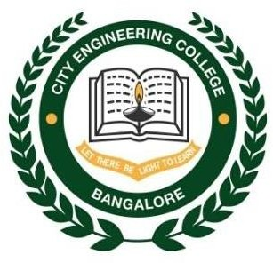

**Doddakallasandra, Kanakapura Road, Bengaluru-560061 DEPARTMENT OF COMPUTER SCIENCE AND ENGINEERING**

**CERTIFICATE**

Certified that the DBMS Mini Project work entitled **“RESTAURANT ADVICE MANAGEMENT”** has been carried out by **S.BHAVYA SRI (1CE17CS098) and SAHANA.N (1CE17CS103),** bonafide students of City Engineering College in partial fulfilment for the award of **Bachelor of Engineering in Computer Science and Engineering** of the Visveshvaraya Technological University, Belgaum during the year **2019-2020**. It is certified that all corrections/suggestions indicated for Internal Assessment have been incorporated in the Report deposited in the departmental library. The DBMS Mini Project Report has been approved as it satisfies the academic requirements in respect of project work prescribed for the said Degree.

|  |  |  |
| --- | --- | --- |
| **Mrs.Archana Bhat** | **Mr. B Vivekavardhana Reddy** | **Dr. V. S Rama Murthy** |
| Asst.Prof, Dept.of CSE | Head, Dept. of CSE | Principal |
|  |  |  |
|  | External Viva |  |
| Name of the examiners |  | Signature with date |

1.

2.