Swagger2注解使用
http://localhost:9090/yhportal/swagger/index.html

加入依赖

<dependency>
<groupId>io.springfox</groupId>
<artifactId>springfox-swagger2</artifactId>
<version>${swagger2-version}</version>
</dependency>
<dependency>
<groupId>io.springfox</groupId>
<artifactId>springfox-swagger-ui</artifactId>
<version>${swagger2-version}</version>
</dependency>

加入自动加载类

package com.yonghui.portal.util;

import org.springframework.context.annotation.Bean;
import org.springframework.context.annotation.Configuration;
import org.springframework.web.servlet.config.annotation.EnableWebMvc;
import springfox.documentation.builders.ApiInfoBuilder;
import springfox.documentation.builders.PathSelectors;
import springfox.documentation.builders.RequestHandlerSelectors;
import springfox.documentation.service.ApiInfo;
import springfox.documentation.spi.DocumentationType;
import springfox.documentation.spring.web.plugins.Docket;
import springfox.documentation.swagger2.annotations.EnableSwagger2;

/**
* swagger2 配置类
* Created by zhanghai on 2017/8/2.
*/

@EnableWebMvc
@EnableSwagger2
@Configuration
public class SwaggerConfig {

@Bean
public Docket createRestApi() {
return new Docket(DocumentationType.SWAGGER_2)
.apiInfo(apiInfo())
.select()
.apis(RequestHandlerSelectors.basePackage("com.yonghui.portal.controller")) // 指定controller的包
.paths(PathSelectors.any())
.build();
}

private ApiInfo apiInfo() {
return new ApiInfoBuilder()
.title("接口列表 v1.0.2") // 设置文档的标题
.description("数据化运营平台") // 设置文档的描述
//.termsOfServiceUrl("http://localhost:9090/swagger-ui.html") //设置文档的License信息
.version("1.0.2") // 设置文档的版本信息
.build();
}
}

加入包路径 以后路径下面的有@RequestMapping注解的方法都会自动扫描到。

加不加swagger api注解都可以。

注解使用

@Api
@Api：修饰整个类，描述Controller的作用
@Api(value="SwaggerController",description = "Swagger2学习", produces = MediaType.APPLICATION_JSON_UTF8_VALUE)

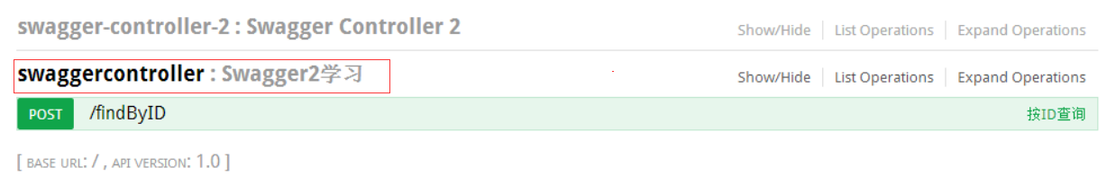

@ApiOperation
@ApiOperation：描述一个类的一个方法，或者说一个接口
@ApiOperation(value = "按ID查询", notes = "输入ID返回结果", httpMethod = "POST")

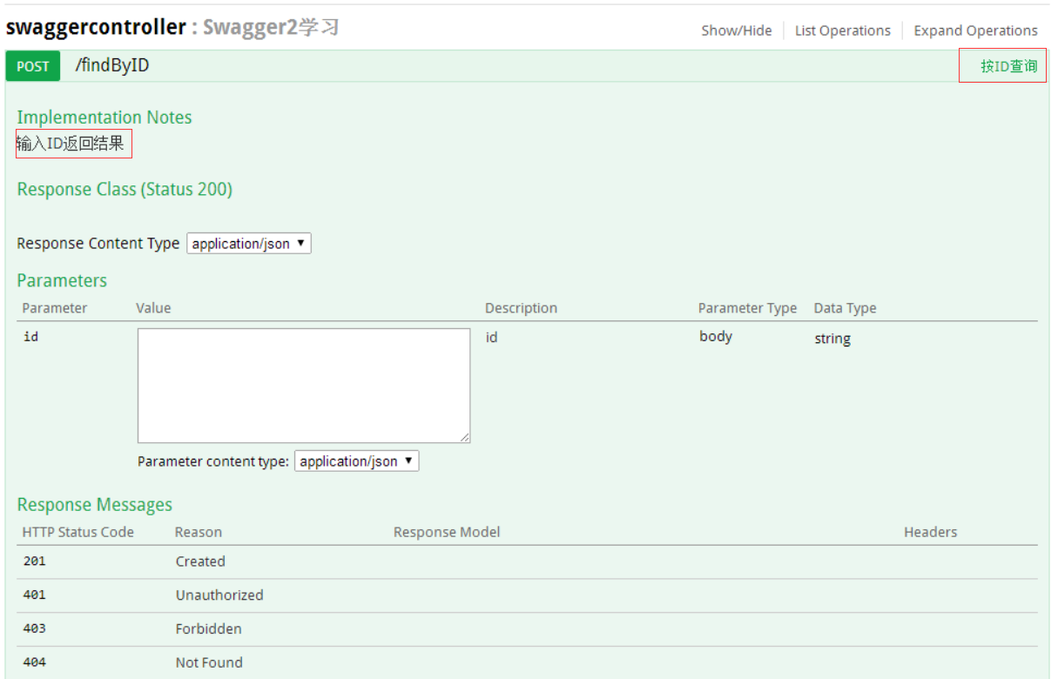

@ApiParam、@ApiImplicitParam
@ApiParam：单个参数前注解，括号里
@ApiImplicitParam 单个实体，括号外
public String findByID(@ApiParam(value = "编号", required = true) @RequestParam String id)

public User findByUser(@ApiParam(value = "user实体", required = true) @RequestBody User user)

@ApiImplicitParam(name = "user", value = "user实体", required = true, dataType = "User")

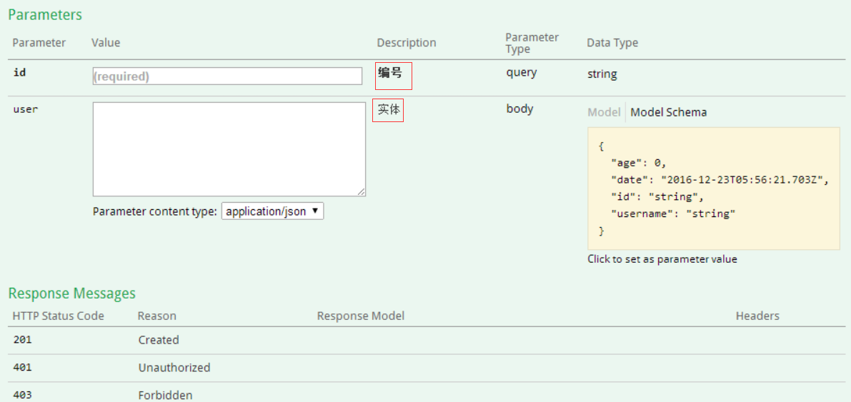

@ApiImplicitParams、@ApiImplicitParam
@ApiImplicitParams：用在方法上包含一组参数说明
@ApiImplicitParam：用在@ApiImplicitParams注解中，指定一个请求参数的各个方面
paramType：参数放在哪个地方
header-->请求参数的获取：@RequestHeader
query-->请求参数的获取：@RequestParam
path（用于restful接口）-->请求参数的获取：@PathVariable
body（不常用）
form（不常用）
name：参数名
dataType：参数类型
required：参数是否必须传
value：参数的意思
defaultValue：参数的默认值
ApiImplicitParam这个注解不只是注解，还会影响运行期的程序。
@ApiImplicitParams({
@ApiImplicitParam(paramType="query" , name = "id", value = "用户ID", required = true, dataType = "String"),
@ApiImplicitParam(name = "user", value = "用户详细实体user", required = true, dataType = "User")
})

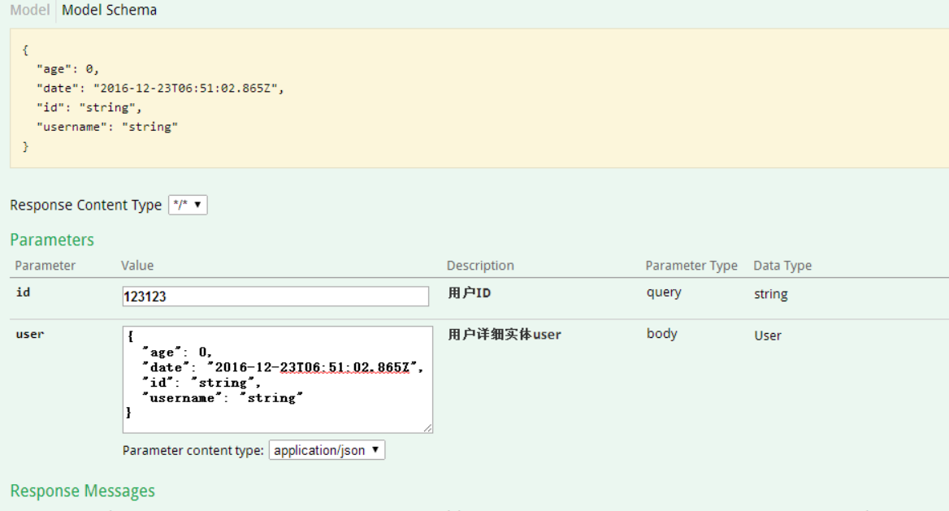

@ApiResponses、@ApiResponse
@ApiResponses：用于表示一组响应
@ApiResponse：用在@ApiResponses中，一般用于表达一个错误的响应信息
code：数字，例如400
message：信息，例如"请求参数没填好"
response：抛出异常的类
@ApiResponses({@ApiResponse(
code = 400,
message = "请求处理失败111"
), @ApiResponse(
code = 404,
message = ""
)})

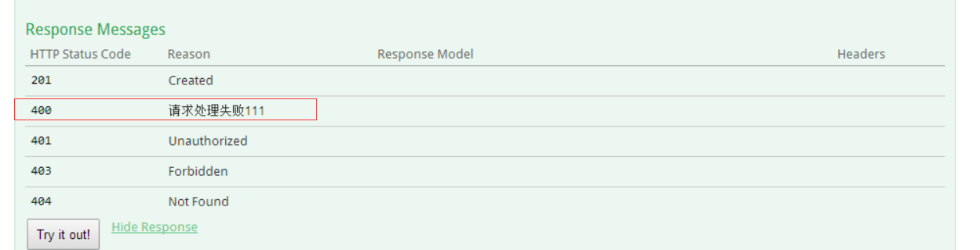

@ApiModel、@ApiProperty
@ApiModel：用对象来接收参数
@ApiProperty：用对象接收参数时，描述对象的一个字段
package com.zjs.swagger2.demo.domain;

import java.util.Date;

import io.swagger.annotations.ApiModel;
import io.swagger.annotations.ApiModelProperty;
@ApiModel(value = "User对象")
public class User {
@ApiModelProperty(value = "编号", required = true)
private String id;
@ApiModelProperty(value = "姓名", required = true)
private String username ;
@ApiModelProperty(value = "年龄", required = true)
private int age;
@ApiModelProperty(value = "时间", required = true)
private Date date;

public String getId() {
return id;
}
public void setId(String id) {
this.id = id;
}
public String getUsername() {
return username;
}
public void setUsername(String username) {
this.username = username;
}
public int getAge() {
return age;
}
public void setAge(int age) {
this.age = age;
}
public Date getDate() {
return date;
}
public void setDate(Date date) {
this.date = date;
}
@Override
public String toString() {
return "User [id=" + id + ", username=" + username + ", age=" + age + ", date=" + date + "]";
}

}

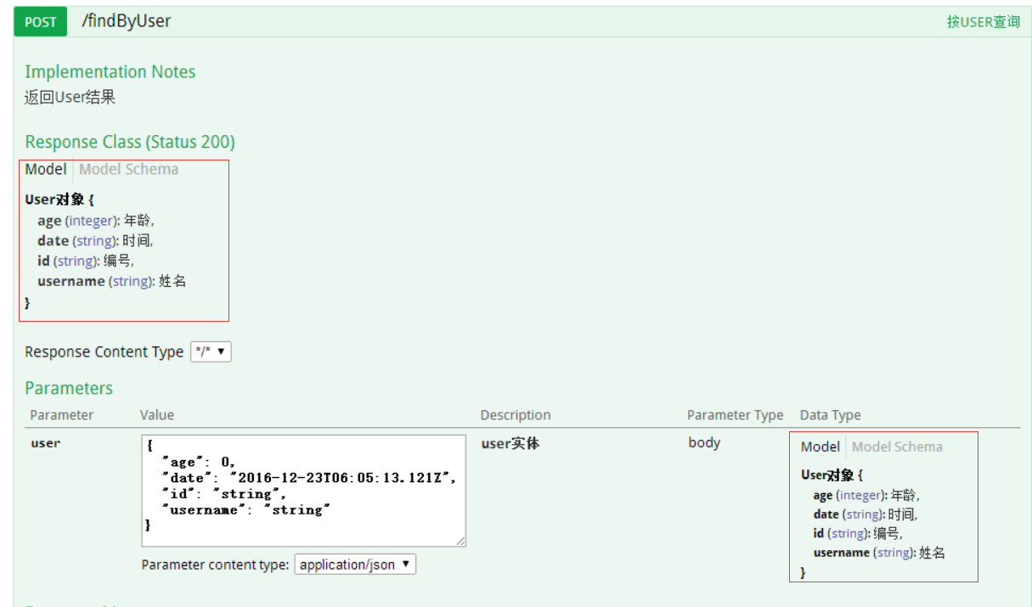

Controller代码

参考
Controller层代码

package com.zjs.swagger2.demo.web;

import java.util.List;
import java.util.Map;
import org.springframework.web.bind.annotation.PathVariable;
import org.springframework.web.bind.annotation.RequestBody;
import org.springframework.web.bind.annotation.RequestMapping;
import org.springframework.web.bind.annotation.RequestMethod;
import org.springframework.web.bind.annotation.RequestParam;
import org.springframework.web.bind.annotation.RestController;
import com.zjs.swagger2.demo.domain.User;
import io.swagger.annotations.Api;
import io.swagger.annotations.ApiImplicitParam;
import io.swagger.annotations.ApiImplicitParams;
import io.swagger.annotations.ApiOperation;
import io.swagger.annotations.ApiParam;
import io.swagger.annotations.ApiResponse;
import io.swagger.annotations.ApiResponses;

@Api(value="Swagger2学习举例")
@RestController
public class SwaggerController {

@ApiOperation(value = "按ID查询", notes = "返回String结果")
@RequestMapping(value = "/findByID", method = RequestMethod.POST)
public String findByID(@ApiParam(value = "编号", required = true) @RequestParam String id){
return "findByID Swagger2 "+id;
}

@ApiOperation(value = "按ID查询2", notes = "返回String结果")
@RequestMapping(value = "/findByID/{id}", method = RequestMethod.POST)
public String findByID2(@ApiParam(value = "编号", required = true) @PathVariable String id){
return "findByID Swagger2 "+id;
}

@ApiOperation(value = "按ID和Name查询", notes = "返回String结果")
@RequestMapping(value = "/findByIDAndName", method = RequestMethod.POST)
public String findByIDAndName(@ApiParam(value = "编号", required = true) @RequestParam String id,@ApiParam(value = "名称") @RequestParam String name){
return "findByID Swagger2 "+id+name;
}

@ApiOperation(value = "按USER查询", notes = "返回User结果",httpMethod="POST")
// @ApiImplicitParam(name = "user", value = "user实体", required = true, dataType = "User")
@RequestMapping(value = "/findByUser", method = RequestMethod.POST)
public User findByUser(@ApiParam(value = "user实体", required = true) @RequestBody User user){
return user;
}

@ApiOperation(value = "按List查询", notes = "返回list结果",httpMethod="POST")
// @ApiImplicitParam(name = "user", value = "user实体", required = true, dataType = "User")
@RequestMapping(value = "/findByList", method = RequestMethod.POST)
public List<User> findByList(@ApiParam(value = "user list", required = true) @RequestBody List<User> list){
return list;
}

@ApiOperation(value = "按ID和实体查询", notes = "返回USER结果")
@RequestMapping(value = "/findByIDAndUser", method = RequestMethod.POST)
public User findByIDAndUser(@ApiParam(value = "编号", required = true) @RequestParam String id,@ApiParam(value = "实体") @RequestBody User user){
user.setId(id);
return user;
}

@ApiOperation(value = "按ID和实体查询", notes = "返回USER结果")
@ApiImplicitParams({
@ApiImplicitParam(paramType="query",name ="id" , value = "用户ID", required = true, dataType = "String"),
@ApiImplicitParam(name = "user", value = "用户详细实体user", required = true, dataType = "User")
})
@ApiResponses({@ApiResponse(
code = 400,
message = "请求处理失败404"
), @ApiResponse(
code = 404,
message = ""
)})
@RequestMapping(value = "/findByIDAndUser2", method = RequestMethod.POST)
public User findByIDAndUser2(@RequestParam String id,@RequestBody User user){
user.setId(id);
return user;
}

@ApiOperation(value = "按map查询", notes = "返回map结果",httpMethod="POST")
@RequestMapping(value = "/findByMap", method = RequestMethod.POST)
public Map<String,Object> findByMap(@ApiParam(value = "map", required = true) @RequestBody Map<String,Object> map){
return map;
}

}

