Grants program
The text box in this file contains an image with no alt text. The image is inaccessible wherever it sits, so the image check should reach inside w:txbxContent and report it. Note the drawing is duplicated into the mc:Fallback copy, so a walk that does not skip the fallback will report the same image twice.
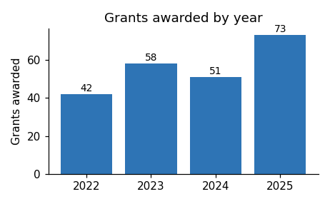
Applications for the next round open in March.

