Grants awarded by year
This file has meaningful alt text on the image. The descr attribute on wp:docPr describes what the chart shows.
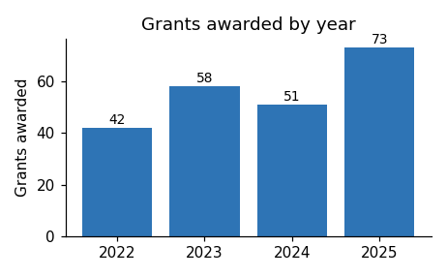
Applications for the next round open in March.

