Grants awarded by year
This file has no alt text on the image at all. The descr attribute is not present on wp:docPr, and neither is a title attribute.
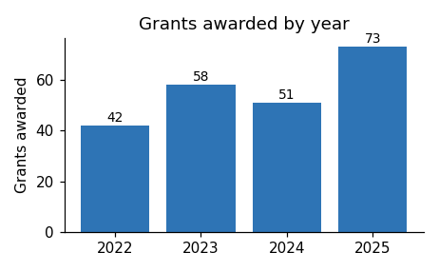
Applications for the next round open in March.

