Grants awarded by year
This file has an alt text attribute that is present but empty. The descr attribute exists on wp:docPr with a value of nothing at all. This is a different state from a missing attribute.
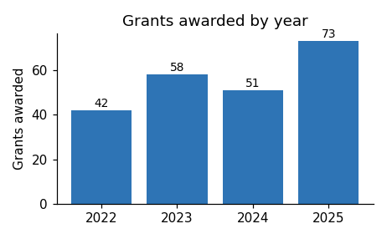
Applications for the next round open in March.

